Supplementary Material

Appendix 1 | PRISMA checklist
Appendix 2 | MOOSE checklist
Appendix 3 | Literature search strategy
Appendix 4 | Risk of bias assessment
Appendix 5 | Relative risks on exclusion of a study one at a time
Appendix 6 | Assessment of small study effects by funnel plot and Egger’s regression symmetry test
Appendix 7 | GRADE summary of findings

Appendix 1. PRISMA checklist

Section/topic | Item No | Checklist item | Reported on page No
Title
Title | 1 | Identify the report as a systematic review, meta-analysis, or both | 1
Abstract
Structured summary | 2 | Provide a structured summary including, as applicable, background, objectives, data sources, study eligibility criteria, participants, interventions, study appraisal and synthesis methods, results, limitations, conclusions and implications of key findings, systematic review registration number | 2
Introduction
Rationale | 3 | Describe the rationale for the review in the context of what is already known | Introduction
Objectives | 4 | Provide an explicit statement of questions being addressed with reference to participants, interventions, comparisons, outcomes, and study design (PICOS) | Introduction
Methods
Protocol and registration | 5 | Indicate if a review protocol exists, if and where it can be accessed (such as web address), and, if available, provide registration information including registration number | Methods
Eligibility criteria | 6 | Specify study characteristics (such as PICOS, length of follow-up) and report characteristics (such as years considered, language, publication status) used as criteria for eligibility, giving rationale | Methods
Information sources | 7 | Describe all information sources (such as databases with dates of coverage, contact with study authors to identify additional studies) in the search and date last searched | Methods
Search | 8 | Present full electronic search strategy for at least one database, including any limits used, such that it could be repeated | Appendix 3
Study selection | 9 | State the process for selecting studies (that is, screening, eligibility, included in systematic review, and, if applicable, included in the meta-analysis) | Methods
Data collection process | 10 | Describe method of data extraction from reports (such as piloted forms, independently, in duplicate) and any processes for obtaining and confirming data from investigators | Methods
Data items | 11 | List and define all variables for which data were sought (such as PICOS, funding sources) and any assumptions and simplifications made | Methods
Risk of bias in individual studies | 12 | Describe methods used for assessing risk of bias of individual studies (including specification of whether this was done at the study or outcome level), and how this information is to be used in any data synthesis | Methods
Summary measures | 13 | State the principal summary measures (such as risk ratio, difference in means). | Methods
Synthesis of results | 14 | Describe the methods of handling data and combining results of studies, if done, including measures of consistency (such as I² statistic) for each meta-analysis | Methods
Risk of bias across studies | 15 | Specify any assessment of risk of bias that may affect the cumulative evidence (such as publication bias, selective reporting within studies) | Methods
Additional analyses | 16 | Describe methods of additional analyses (such as sensitivity or subgroup analyses, meta-regression), if done, indicating which were pre-specified | Methods
Results
Study selection | 17 | Give numbers of studies screened, assessed for eligibility, and included in the review, with reasons for exclusions at each stage, ideally with a flow diagram | Results and Figure 1
Study characteristics | 18 | For each study, present characteristics for which data were extracted (such as study size, PICOS, follow-up period) and provide the citations | Results, Table 1
Risk of bias within studies | 19 | Present data on risk of bias of each study and, if available, any outcome-level assessment (see item 12). | Results, Table 1
Results of individual studies | 20 | For all outcomes considered (benefits or harms), present for each study (a) simple summary data for each intervention group and (b) effect estimates and confidence intervals, ideally with a forest plot | Results, Figure 2
Synthesis of results | 21 | Present results of each meta-analysis done, including confidence intervals and measures of consistency | Results, Figure 2
Risk of bias across studies | 22 | Present results of any assessment of risk of bias across studies (see item 15) | Table 1, Figure 3
Additional analysis | 23 | Give results of additional analyses, if done (such as sensitivity or subgroup analyses, meta-regression) (see item 16) | Results; Figure 3; Appendix 4
Discussion
Summary of evidence | 24 | Summarise the main findings including the strength of evidence for each main outcome; consider their relevance to key groups (such as health care providers, users, and policy makers) | Discussion
Limitations | 25 | Discuss limitations at study and outcome level (such as risk of bias), and at review level (such as incomplete retrieval of identified research, reporting bias) | Discussion
Conclusions | 26 | Provide a general interpretation of the results in the context of other evidence, and implications for future research | Discussion
Funding
Funding | 27 | Describe sources of funding for the systematic review and other support (such as supply of data) and role of funders for the systematic review | Funding section

Appendix 2. MOOSE checklist

Physical activity and risk of chronic kidney disease: systematic review and meta-analysis of 12 cohort studies involving 1,281,727 participants

Criteria |  | Brief description of how the criteria were handled in the review
Reporting of background
√ | Problem definition | Evidence on the association between physical activity and chronic kidney disease is inconsistent
√ | Hypothesis statement | Regular physical activity is associated with reduced risk of chronic kidney disease
√ | Description of study outcomes | Pneumonia
√ | Type of exposure | Physical activity
√ | Type of study designs used | Observational cohort studies
√ | Study population | Adult general populations with assessment of physical activity at study entry with at least 1 year follow-up
Reporting of search strategy should include
√ | Qualifications of searchers | Setor K. Kunutsor, PhD; Samuel Seidu, PhD
√ | Search strategy, including time period included in the synthesis and keywords | Time period: from inception to 02 May 2022  The detailed search strategy can be found in Appendix 3
√ | Databases and registries searched | MEDLINE, Embase, Web of Science
√ | Search software used, name and version, including special features | OvidSP was used to search Embase and MEDLINE  EndNote X9 used to manage references
√ | Use of hand searching | We searched bibliographies of retrieved papers
√ | List of citations located and those excluded, including justifications | Details of the literature search process are outlined in the flow chart. The citation list for excluded studies is available on request.
√ | Method of addressing articles published in languages other than English | Not applicable
√ | Method of handling abstracts and unpublished studies | Excluded
√ | Description of any contact with authors | None
Reporting of methods should include
√ | Description of relevance or appropriateness of studies assembled for assessing the hypothesis to be tested | Detailed inclusion and exclusion criteria are described in the Methods section.
√ | Rationale for the selection and coding of data | Data extracted from each of the studies were relevant to the population characteristics, study design, exposure, and outcome.
√ | Assessment of confounding | We assessed confounding by ranking individual studies on the basis of different adjustment levels and performed sub-group analyses to evaluate differences in the overall estimates according to levels of adjustment.
√ | Assessment of study quality, including blinding of quality assessors; stratification or regression on possible predictors of study results | The Cochrane Risk of Bias in Non-randomised Studies – of Interventions (ROBINS-I) tool was used to assess the risk of bias within individual observational studies
√ | Assessment of heterogeneity | Heterogeneity of the studies was quantified with I² statistic that provides the relative amount of variance of the summary effect due to the between-study heterogeneity and explored using meta-regression and stratified analyses
√ | Description of statistical methods in sufficient detail to be replicated | Description of methods of meta-analyses, sensitivity analyses, meta-regression and assessment of publication bias are detailed in the methods. We performed fixed effects meta-analysis with Stata 17.
√ | Provision of appropriate tables and graphics | Table 1; Figures 1-3; Appendix 4
Reporting of results should include
√ | Graph summarizing individual study estimates and overall estimate | Figure 2
√ | Table giving descriptive information for each study included | Table 1
√ | Results of sensitivity testing | Sensitivity analysis was conducted to assess the influence of omitting one study at a time on the pooled estimate.
√ | Indication of statistical uncertainty of findings | 95% confidence intervals were presented with all summary estimates, I² values and results of sensitivity analyses
Reporting of discussion should include
√ | Quantitative assessment of bias | Sensitivity analyses indicate heterogeneity in strengths of the association due to most common biases in observational studies. The systematic review is limited in scope, as it involves published data. Individual participant data is needed. Limitations have been discussed.
√ | Justification for exclusion | All studies were excluded based on the pre-defined inclusion criteria in methods section.
√ | Assessment of quality of included studies | Brief discussion included in ‘Methods’ section
Reporting of conclusions should include
√ | Consideration of alternative explanations for observed results | Discussion
√ | Generalization of the conclusions | Discussed in the context of the results.
√ | Guidelines for future research | We recommend individual participant data meta-analysis
√ | Disclosure of funding source | In “Acknowledgement” section

Appendix 3. Literature search strategy
Relevant studies, published from inception to 02 May 2022 (date last searched), were identified through electronic searches without language restrictions using MEDLINE and Embase databases. Electronic searches were supplemented by scanning reference lists of articles identified for all relevant studies (including review articles) and the Web of Science citation search
Database: Ovid MEDLINE(R) <1946 to present>
Search Strategy:
--------------------------------------------------------------------------------
1 Physical activity.mp. or exp Exercise/ (304389)
2 exp Sedentary Behavior/ or inactivity.mp. (27668)
3 chronic kidney disease.mp. or exp Renal Insufficiency, Chronic/ (158250)
4 kidney failure.mp. (106094)
5 exp Kidney Diseases/ (552443)
6 kidney insufficiency.mp. (739)
7 renal disease.mp. (64789)
8 renal failure.mp. (93315)
9 exp Proteinuria/ (41201)
10 cohort studies/ or longitudinal studies/ or follow-up studies/ or prospective studies/ or retrospective studies/ or cohort.ti,ab. or longitudinal.ti,ab. or prospective.ti,ab. or retrospective.ti,ab. (3014847)
11 1 or 2 (316345)
12 3 or 4 or 5 or 6 or 7 or 8 or 9 (638074)
13 10 and 11 and 12 (723)
14 limit 13 to (humans and ("young adult (19 to 24 years)" or "adult (19 to 44 years)" or "young adult and adult (19-24 and 19-44)" or "middle age (45 to 64 years)" or "middle aged (45 plus years)" or "all aged (65 and over)" or "aged (80 and over)")) (596)

***************************

Each part was specifically translated for searching the other databases (Embase and Web of Science)

Appendix 4. Risk of bias assessment
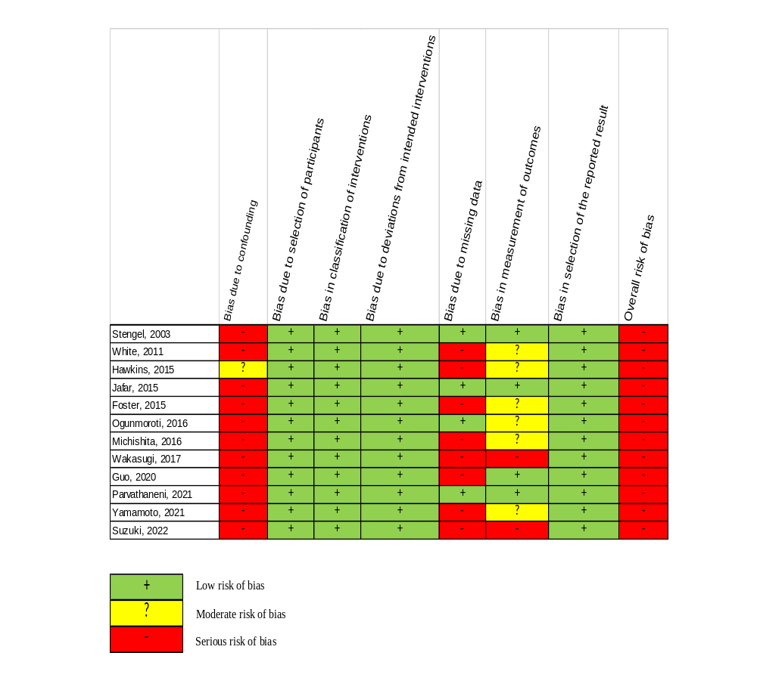

Appendix 5. Relative risks on exclusion of a study one at a time
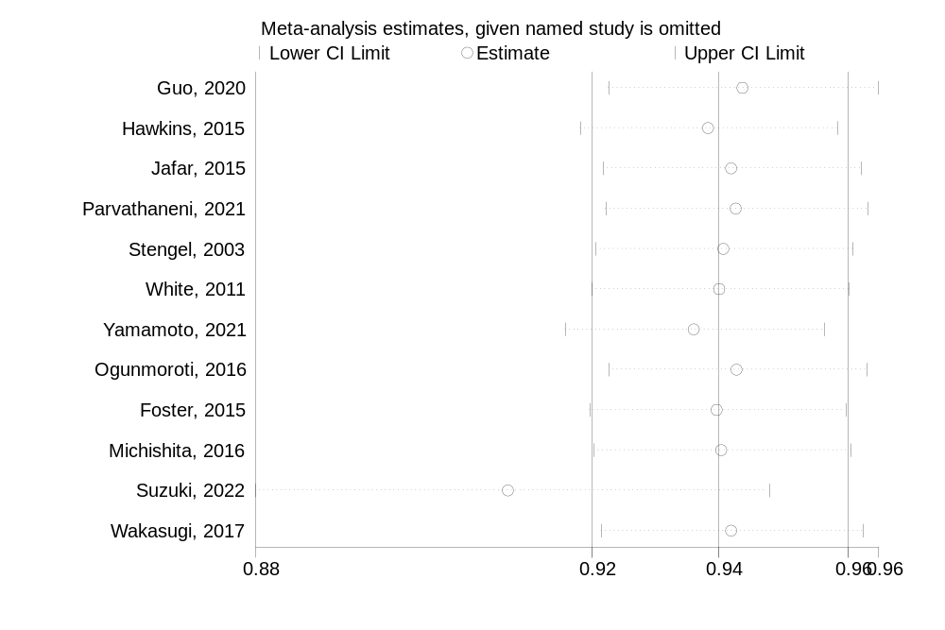

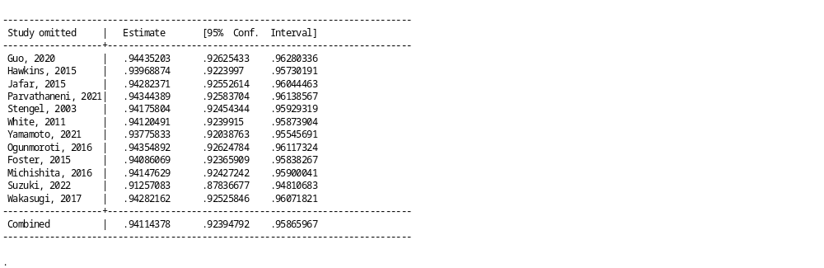
Appendix 6. Assessment of small study effects by funnel plot and Egger’s regression symmetry test
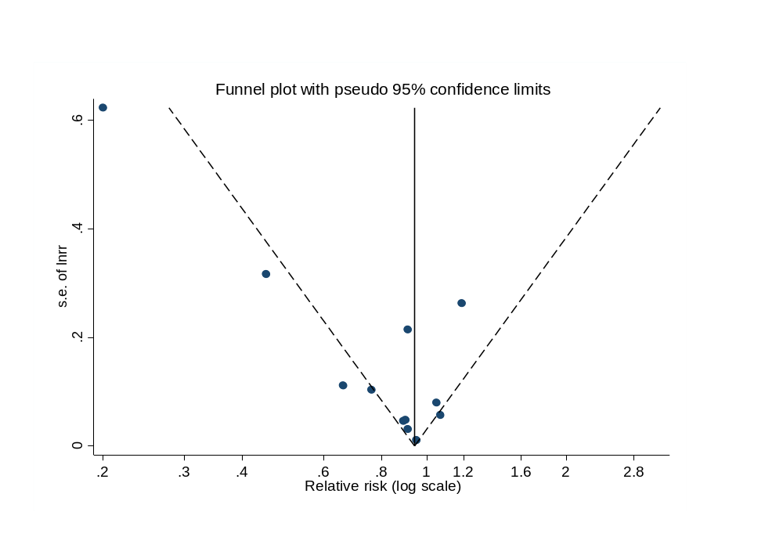

Appendix 7. GRADE summary of findings

Most physically active compared to least physically active for chronic kidney disease
Setting: General population
Intervention: Most physically active
Comparison: Least physically active
Outcomes | № of participants  (studies)  Follow-up | Certainty of the evidence  (GRADE) | Relative effect  (95% CI) | Anticipated absolute effects
 |  |  |  | Risk with Least physically active | Risk difference with Most physically active
CKD incidence in overall population | (12 observational studies) | ⨁◯◯◯  Very low^{a,b} | RR 0.91  (0.85 to 0.97) | 0 per 1,000 | 0 fewer per 1,000  (0 fewer to 0 fewer)
*The risk in the intervention group (and its 95% confidence interval) is based on the assumed risk in the comparison group and the relative effect of the intervention (and its 95% CI).
CKD, chronic kidney disease; CI, confidence interval; RR, risk ratio
GRADE Working Group grades of evidence
High certainty: we are very confident that the true effect lies close to that of the estimate of the effect.
Moderate certainty: we are moderately confident in the effect estimate: the true effect is likely to be close to the estimate of the effect, but there is a possibility that it is substantially different.
Low certainty: our confidence in the effect estimate is limited: the true effect may be substantially different from the estimate of the effect.
Very low certainty: we have very little confidence in the effect estimate: the true effect is likely to be substantially different from the estimate of effect.

Explanations
a. Overall risk of bias is serious
b. I-squared value of 71%

