Supplemental Information for:

Integration of metabolism and regulation reveals rapid adaptability to growth on non-native substrates.

Vikas D. Trivedi^{1,2}, Sean F. Sullivan¹, Debika Choudhury¹, Venkatesh Endalur Gopinarayanan¹, Taylor Hart¹, Nikhil U. Nair^{1*}

¹ Department of Chemical & Biological Engineering, Tufts University, Medford, MA
² Current: Department of Structural Biology and Center for Data Driven Discovery, St. Jude Children’s Research Hospital, Memphis, TN

* Corresponding author: nikhil.nair@tufts.edu; @nair_lab

Supplementary Table S1. List of plasmids used.

Plasmids | Description
pVEG11 (Xyl-REG) | pRS426, 2µ ori, URA3, ADH1t- Piromyces_XYLA*3- GAL1p/GAL10p -XKS1-HXT7t
pVEG15 (Xyl-CONS) | pRS426, 2µ ori, URA3, ADH1t- Piromyces_XYLA*3- TEF1p-TPI1p -XKS1-HXT7t
pVDT23 (Ara-REG) | pRS426, 2µ ori, URA3, ADH1t- araB- GAL1p/GAL10p -araA-HXT7t-GAL7p-araD-TEFt
pVDT22 (Ara-CONS) | pRS426, 2µ ori, URA3, ADH1t- araB- TEF1p-TPI1p -araA-HXT7t-GPM1p-araD-TEFt
pVDT29 | pIS385, URA3, GAL3P-GAL3-Syn4.1-TEF1t-ADH1t-GAL2.1-GAL1/10p-TAL1-Hxt7t
pVDT30 | pIS376, URA3, GAL1P-GAL3-Syn4.1-GAL3t
pVDT35 | pIS385, URA3, ADH1t-GAL2.1-TEF1p/TPI1p-TAL1-Hxt7t
pVDT14 | pRS416, CEN ori, URA3, ADH1t- araB- GAL1p/GAL10p -araA-HXT7t-GAL7p-araD-TEFt
pVDT38 | pRS416, CEN ori, URA3, ADH1t- araA- GAL1p/GAL10p -araB-HXT7t-GAL7p-araD-TEFt
pVDT39 | pRS416, CEN ori, URA3, ADH1t- araB- GAL1p/GAL10p -araD-HXT7t-GAL7p-araA-TEFt
pVDT40 | pRS416, CEN ori, URA3, ADH1t- araD- GAL1p/GAL10p -araB-HXT7t-GAL7p-araA-TEFt
pVDT41 | pRS416, CEN ori, URA3, ADH1t- araD- GAL1p/GAL10p -araA-HXT7t-GAL7p-araB-TEFt
pVDT42 | pRS416, CEN ori, URA3, ADH1t- araA- GAL1p/GAL10p -araD-HXT7t-GAL7p-araB-TEFt
pVDT48 | pRS413, CEN ori, HIS3, ADH1t- Piromyces_XYLA*3- GAL1p/GAL10p -XKS1-HXT7t
pVDT49 | pRS413, CEN ori, HIS3, ADH1t- Piromyces_XYLA*3- TEF1p-TPI1p -XKS1-HXT7t
pVDT53 | pRS426, 2µ ori, URA3, GAL1t- GAL1- GAL1p/GAL10p -GAL10-GAL10t-GAL7p-GAL7-GAL7t
pVDT54 | pRS423, 2µ ori, HIS3, GAL1t- GAL1- GAL1p/GAL10p -GAL10-GAL10t-GAL7p-GAL7-GAL7t
pVDT55 | pRS423, 2µ ori, HIS3, ADH1t- Piromyces_XYLA*3- GAL1p/GAL10p -XKS1-HXT7t
pVDT56 | pRS423, 2µ ori, HIS3, ADH1t- araB- GAL1p/GAL10p -araA-HXT7t-GAL7p-araD-TEFt
pVDT57 | pRS423, 2µ ori, HIS3, ADH1t- XKS1- GAL10p/GAL1p -TEF1t -GAL7p- Piromyces_XYLA*3-HXT7t
pVDT58 | pRS423, 2µ ori, HIS3, ADH1t- XKS1- GAL1p/GAL10p -TEF1t -GAL7p- Piromyces_XYLA*3-HXT7t
pVDT59 | pRS423, 2µ ori, HIS3, ADH1t- XKS1- GAL1p/GAL10p -Piromyces_XYLA*3-HXT7t
pVDT60 | pRS423, 2µ ori, HIS3, ADH1t- XKS1- GAL10p/GAL1p -Piromyces_XYLA*3-HXT7t
pVDT61 | pRS423, 2µ ori, HIS3, ADH1t- XKS1- GAL7p-TEF1t -GAL1p/GAL10p - Piromyces_XYLA*3-HXT7t
pVDT62 | pRS423, 2µ ori, HIS3, ADH1t- XKS1- GAL7p-TEF1t -GAL10p/GAL1p - Piromyces_XYLA*3-HXT7t

Table S2. List of strains used.

Strain | Description
W303-1a (GAL-REG) | MATa leu2-3,112 trp1-1 can1-100 ura3-1 ade2-1 his3-11,15
VEG16 | W303-1a, ΔGAL3; ΔGRE3; ΔGAL1; ΔGAL7; ΔGAL10
VDT13 | VEG16, GAL2.1-GAL1p-GAL10p-TAL1-GAL3p-GAL3-Syn4.1::lys2  GAL1p-GAL3-Syn4.1::leu2
VDT27 | VEG16, ADH1t-GAL2.1-TEF1p/TPI1p-TAL1-Hxt7t::lys2
VDT53 | VDT13 ΔASH1::KANMX
VDT54 | VDT13 ΔSKO1::KANMX
VDT55 | VDT13 ΔGLN3::KANMX
VDT56 | VDT13 ΔTEC1::KANMX
VDT57 | VDT13 ΔRTG3::KANMX
VDT58 | VDT13 ΔRTG1::KANMX
VDT59 | VDT13 ΔMET28::KANMX
VDT60 | VDT13 ΔMIG2::KANMX

Table S3. Variants identified from directed evolution of arabinose metabolic plasmid.

Plasmids | Description
N-3 (pVDT65) | pRS413 CEN ori HIS3 ADH1t- araD*(E8G-K6E)- GAL1p/GAL10p -araA*(K72M-N410Y-A422D-G467A)-HXT7t-GAL7p-araB*(N277Y)-TEFt
N-4 (pVDT66) | pRS413 CEN ori HIS3 ADH1t- araA*(A40S-D398G)- GAL1p/GAL10p -araB*( I441T)-HXT7t-GAL7p-araD*(N232K)-TEFt
N-12 (pVDT67) | pRS413 CEN ori HIS3, ADH1t- araA*(H225R)- GAL1p/GAL10p -araD-HXT7t-GAL7p-araB*(Y56H-A124S-E333V)-TEFt
N-16 (pVDT69) | pRS413 CEN ori HIS3 ADH1t- araA*(E94V)- GAL1p/GAL10p -araB*( F133L-E490G)-HXT7t-GAL7p-araD*(T116S-E208G)-TEFt

Table S4. Barcoded primers used to generate error-prone PCR library of cassettes for arabinose utilization.

Primer name | Sequence (5’→3’)*
14-BC-FP | ACTCACTATAGGGCGAATTGTACTGCAGGTCGACTGGATGGCGGCGTTAG
38-BC-FP | ACTCACTATAGGGCGAATTGGGACTCCTGTCGACTGGATGGCGGCGTTAG
39-BC-FP | ACTCACTATAGGGCGAATTGTAGGCATGGTCGACTGGATGGCGGCGTTAG
40-BC-FP | ACTCACTATAGGGCGAATTGTAAGGCGAGTCGACTGGATGGCGGCGTTAG
41-BC-FP | ACTCACTATAGGGCGAATTGCGTACTAGGTCGACTGGATGGCGGCGTTAG
42-BC-FP | ACTCACTATAGGGCGAATTGTATCCTCTGTCGACTGGATGGCGGCGTTAG
ARA-CMN-RP | CAATTAACCCTCACTTGCCGGTAGAGGTGTGGTC
*Red italics indicate the barcode.

Table S5 Primers used for gene expression studies.

Primer name | Sequence (5’→3’)
TFC1-F | GCGGTATTGACAGCAGGTTCAAA
TFC1-R | CCATCCAGTTAGTTCATTCGCCTTA
UBC6-F | ACCATCAGAAGAAGACATTAGCAAGA
UBC6-R | TCATCACCTGTATTTGCCGCAT
araDF_RT | AGCCTCATTAGTCAGCCAGCAC
araDR_RT | AGGCACTTGCACCATGCTTAC
araAF_RT | CTCACAACAAGCAAACCGC
araAR_RT | CGAGCAGGATCATCTTTACCC
araBF_RT | GGACGTTATGATTGCACAGG
araBR_RT | TGCAGTTTGCCGACAAGC

Table S6. Primers for amplicon sequencing of arabinose enrichment library.

Primer name | Sequence (5’-3’)
Ara-AmpEz-F-1 | ACACTCTTTCCCTACACGACGCTCTTCCGATCTAGCGATTACGATTAAGTTGGGTAACGC
Ara-AmpEz-F-2 | ACACTCTTTCCCTACACGACGCTCTTCCGATCTAGGAATTGCGATTAAGTTGGGTAACGC
Ara-AmpEz-F-3 | ACACTCTTTCCCTACACGACGCTCTTCCGATCTGGCTCAACCGATTAAGTTGGGTAACGC
Ara-AmpEz-F-4 | ACACTCTTTCCCTACACGACGCTCTTCCGATCTGTTGATGGCGATTAAGTTGGGTAACGC
Ara-AmpEz-F-5 | ACACTCTTTCCCTACACGACGCTCTTCCGATCTAGTTATACCGATTAAGTTGGGTAACGC
Ara-AmpEz-F-6 | ACACTCTTTCCCTACACGACGCTCTTCCGATCTACATTCCACGATTAAGTTGGGTAACGC
Ara-AmpEz-F-7 | ACACTCTTTCCCTACACGACGCTCTTCCGATCTGGCTATGTCGATTAAGTTGGGTAACGC
*Red italics indicate the barcode.

Table S7: Concentration of stressors used in the study.

Stressor | Concentration
5-Hydroxymethyl furfural (5HMF) | 20 mM
Veratraldehyde (Val) | 10 mM
Sodium acetate (NaAc) | 100 mM
Furfural (Fur) | 10 mM
Sodium chloride (NaCl) | 0.5 M
Mixture* | 5HMF (1 mM), Val (0.25 mM), NaAc (100 mM), Fur (2.5 mM),  NaCl (0.25 M)
* Serial dilutions made from this “1x” stock.

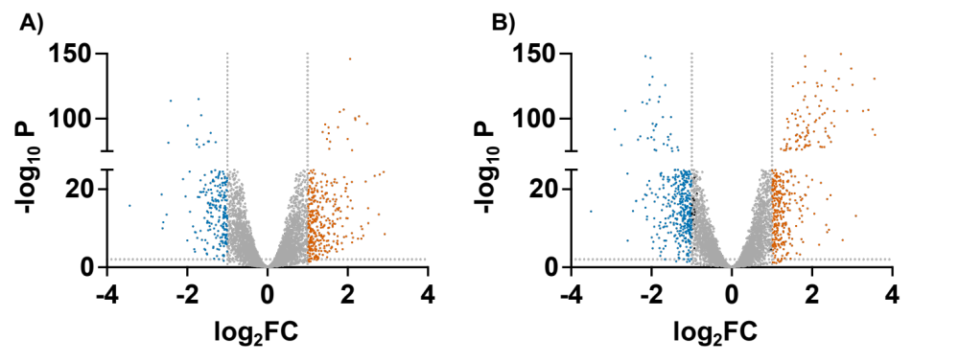
Figure S1. Volcano plot of differentially expressed genes A) ARA-REG and B) XYL-REG when compared to galactose.
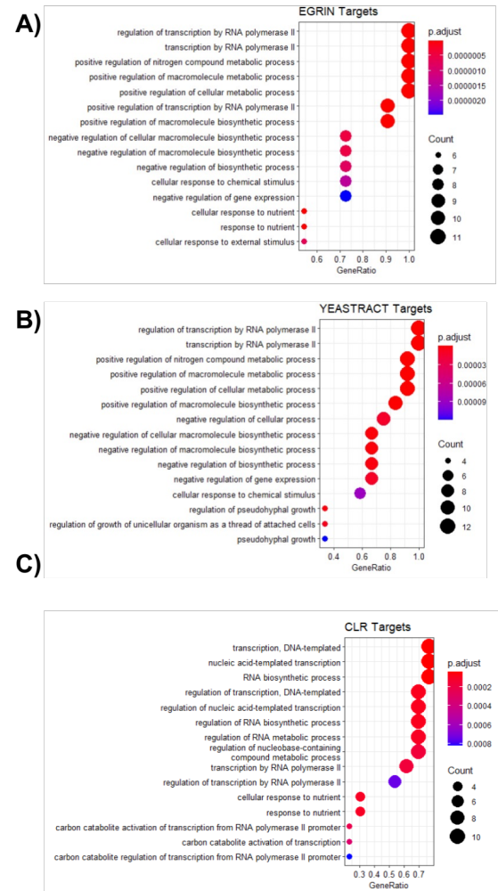
Figure S2. GO terms of targets from A) EGRIN, B) YEASTRACT, C) CLR mutual information network analysis.

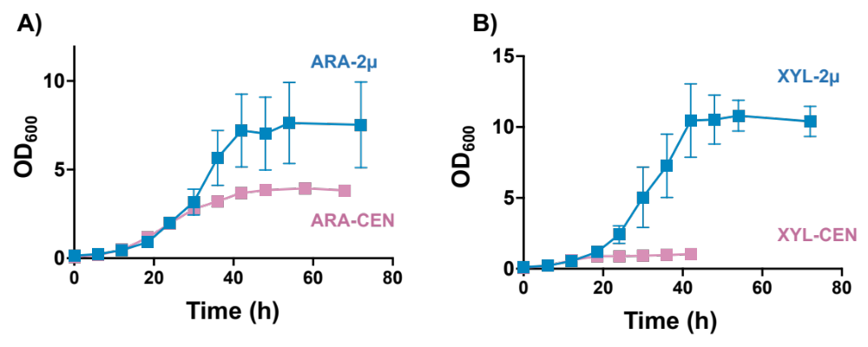
Figure S3. Effect of copy number on growth of REG-strain on A) arabinose and B) xylose.

A)
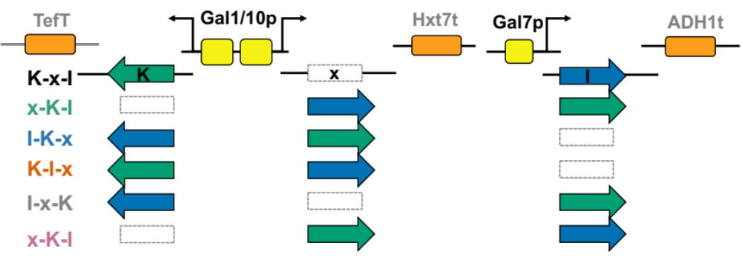

B)
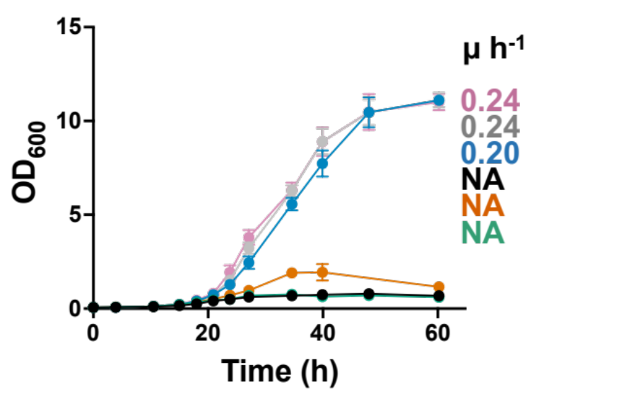
Figure S4. A) Schematic of six combinations for xylose generated via promoter-gene swap. B) Comparison of growth performance of different promoter-gene combination. l = Piromyces_XYLA*3, k = XKS1, x = empty. NA = not determined.

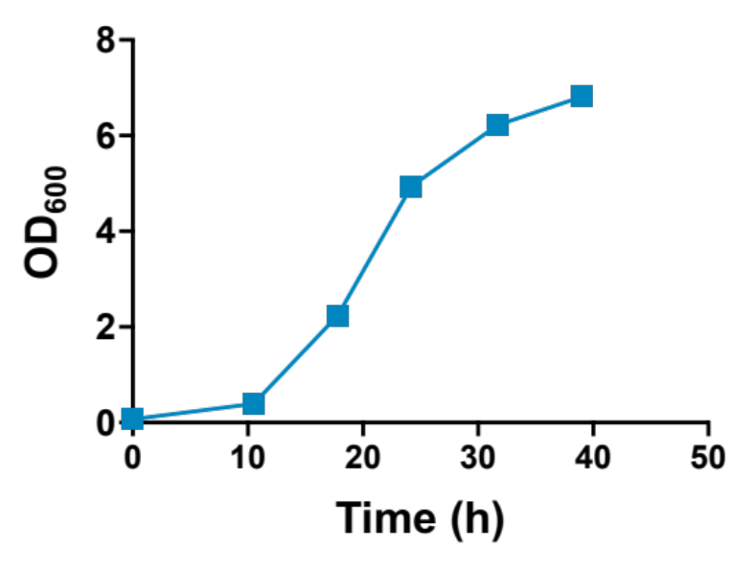
0.25 µ h⁻¹

Figure S5: Growth curve of a REG strain carrying galactose cassette for GAL1, GAL7, GAL10 on plasmid (pVDT54) under their native promoters. Chromosomal copies of GAL1-7-10 are deleted.

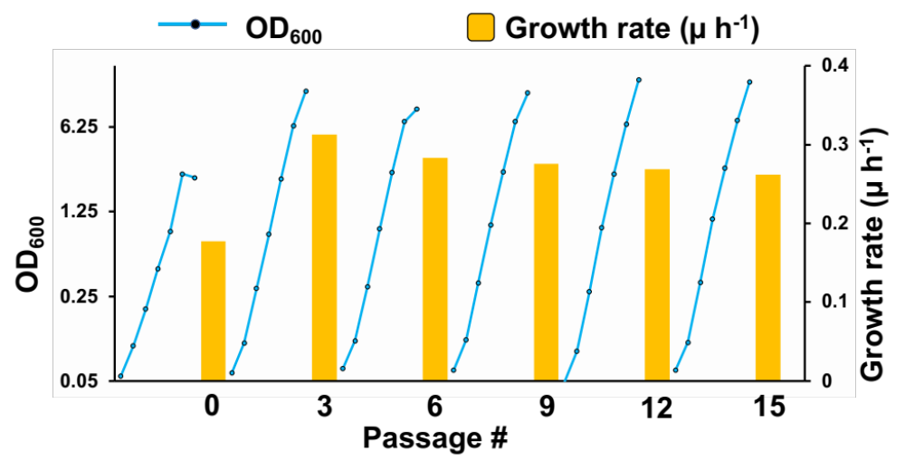
Figure S6: Enrichment of mutagenic araBAD library in 2YP+Ara.

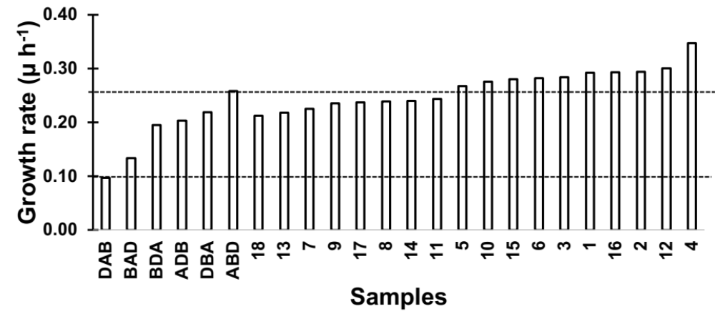
Figure S7. Growth rate of colonies screened after enrichment of library on SC+A.

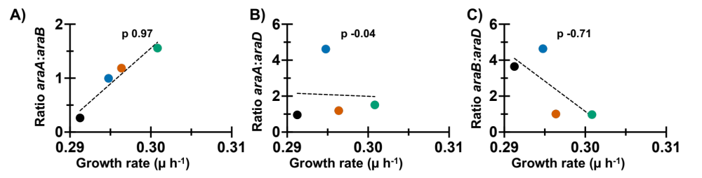

Figure S8. Correlation between growth rate and gene expression levels of A) araA:araB, B) araA:araD, and C) araB:araD on plasmids isolated from best performing strains after directed evolution. Values indicated are Pearson’s correlation coefficient.

