Supplementary Information for manuscript

Control of Monomeric Vo’s vs. Vo clusters in ZrO_{2-x} for Solar-Light H₂ Production from H₂O at High-Yield [millimoles gr⁻¹ h⁻¹]
Yiannis Deligiannakis^{1,4}*, Asterios Mantzanis¹, Areti Zindrou¹, Szymon Smykala³ and Maria Solakidou^{1,2}

¹ Laboratory of Physical Chemistry of Materials & Environment, Department of Physics, University of Ioannina, Ioannina, Greece
² Laboratory of Biomimetic Catalysis and Hybrid Materials, Department of Chemistry, University of Ioannina, GR45110 Ioannina, Greece
³Institute of Engineering Materials and Biomaterials, Silesian University of Technology, 18a Konarskiego St, 44-100 Gliwice, Poland
⁴ Institute of Environment & Sustainable Development, University Research Center of Ioannina, GR45110 Ioannina, Greece

* Corresponding author: Yiannis Deligiannakis (ideligia@uoi.gr)

Table S1. FSP-process conditions for the synthesis ZrO₂/ZrO_{2-x} materials.
Materials | Dispersion O₂ | Dispersion CH₄ | P/D | Sheath O₂(L/min) | Sheath N₂(L/min)
[F.O.] | 3 | 0 | 3.0/3.0 | 10 | 0
[3/0.1] | 3 | 0.1 | 3.0/3.1 | - | 10
[3/0.2] | 3 | 0.2 | 3.0/3.2 | - | 10
[2.3/0.7] | 2.3 | 0.7 | 3.0/3.0 | - | 10
[1.3/1.7] | 1.3 | 1.7 | 3.0/3.0 | - | 10

Table S2. Structural characteristics of the present FSP-made ZrO_{2-X} materials.
Material | Calcination T/time  (℃)/(Min) | Phase Comp.(%) |  | Crystallite size (nm) |  |  | SSA (m²g⁻¹)
Material | Calcination T/time  (℃)/(Min) | m-ZrO₂ | t-ZrO₂ | d_{XRD} |  | d_{BET} | SSA (m²g⁻¹)
[F.O] | - | 15 | 85 | 20 | 29 | 14 | 72
[3/0.1] | - | 15 | 85 | 19 | 28 | 16 | 64
[3/0.1]-60 | 400/60 | 30 | 70 | 18 | 26 | 17 | 58
[3/0.1]-120 | 400/120 | 35 | 65 | 16 | 24 | 18 | 55
[3/0.2] | - | 15 | 85 | 19 | 28 | 19 | 52
[3/0.2]-30 | 400/30 | 25 | 75 | 19 | 27 | 20 | 50
[3/0.2]-60 | 400/60 | 30 | 70 | 18 | 25 | 21 | 47
[3/0.2]-90 | 400/90 | 30 | 70 | 17 | 24 | 22 | 45
[2.3/0.7] | - | 15 | 85 | 18 | 24 | 23 | 44
[2.3/0.7]-30 | 400/30 | 27 | 73 | 18 | 24 | 24 | 42
[2.3/0.7]-60 | 400/60 | 30 | 70 | 17 | 23 | 25 | 40
[2.3/0.7]-90 | 400/90 | 30 | 70 | 17 | 22 | 27 | 38
[2.3/0.7]-120 | 400/120 | 33 | 67 | 16 | 22 | 27 | 37
[1.3/1.7] | - | 15 | 85 | 17 | 25 | 29 | 34
[1.3/1.7]-60 | 400/60 | 30 | 70 | 16 | 23 | 32 | 31

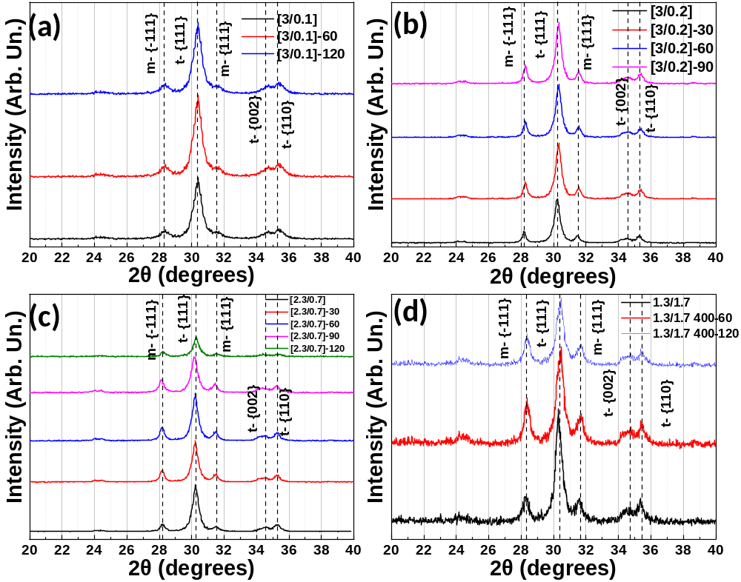
Figure S1. XRD patterns of (a) [3/0.1], (b) [3./0.2], (c) [2.3/0.7] and (d) [1.3/1.7] materials oxidized under ambient air at 400⁰C for the indicated time-periods (30,60,90,120 minutes).

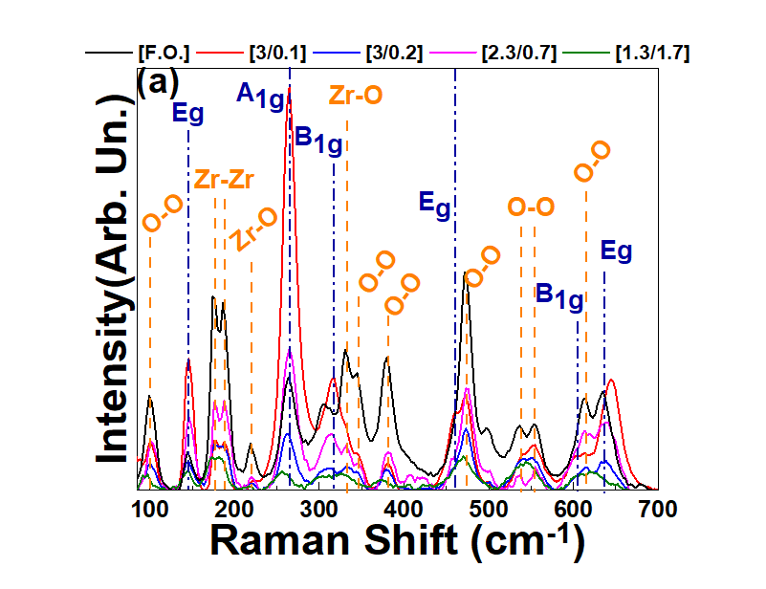
Figure S2. Raman spectra of [3/0.1], [3/0.2], [2.3/0.7] and [1.3/1.7].

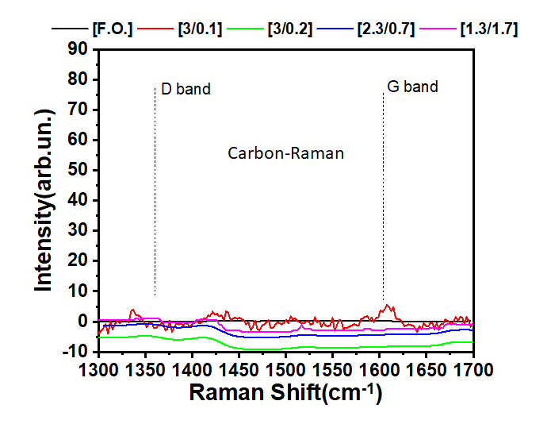
Figure S3. Raman spectra in the Carbon region, indicating the absence carbon-formation in the ΖrO_{2-x} materials made by FSP.

Table S3. Raman bond vibrations for t-ZrO₂ and m-ZrO₂.
Tetragonal Zirconia Modes |  | Monoclinic Zirconia Modes
Assignment | R.Shift (cm⁻¹) | Assignment | R.Shift (cm⁻¹) | Bond Vibration*
E_{g} | 145 | A_{g} | 102 | O-O
A_{1g} | 264 | A_{g} | 179 | Zr-Zr
B_{1g} | 320 | B_{g} | 179 | Zr-Zr
E_{g} | 460 | A_{g} | 190 | Zr-Zr
B_{1g} | 606 | B_{g} | 224 | Zr-O
E_{g} | 641 | A_{g} | 270 | Zr-Zr
- | - | A_{g} | 305 | Zr-O
- | - | B_{g} | 334 | Zr-O
- | - | A_{g} | 348 | O-O
- | - | B_{g} | 381 | O-O
- | - | B_{g} | 385 | O-O
- | - | A_{g} | 476 | O-O
- | - | B_{g} | 505 | O-O
- | - | B_{g} | 536 | O-O
- | - | A_{g} | 556 | O-O
- | - | B_{g} | 616 | O-O
 | - | A_{g} | 637 | O-O
Table S4. Raman shifts of ZrO_{2-x} materials.
Material | Mode(cm⁻¹) | Shift(cm⁻¹) | Assignment
[3.0/0.1] | 264 | -3 | Zr-Zr
[3.0/0.1] | 320 | -6 | -
[3.0/0.1] | 641 | -9 | -
[3.0/0.2] | 476 | +4 | O-O
[2.3/0.7] | 320 | -5 | -
[2.3/0.7] | 476 | +3 | -
[2.3/0.7] | 641 | -6 | -
[1.3/1.7] | 102 | -7 | O-O
[1.3/1.7] | 145 | -1 | -
[1.3/1.7] | 179 | -5 | Zr-Zr
[1.3/1.7] | 264 | -8 | Zr-Zr
[1.3/1.7] | 381 | -10 | O-O
[1.3/1.7] | 476 | -2 | O-O
[1.3/1.7] | 554 | -5 | O-O
[1.3/1.7] | 641 | -21 | -

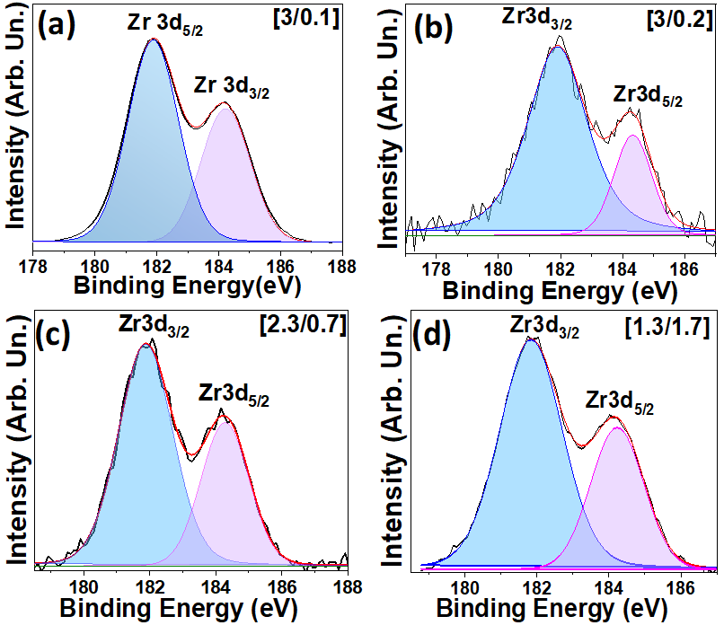
Figure S4. XPS spectra of the Zr doublet of (a) [3/0.1], (b) [3.0/0.2], (c) [2.3/0.7] and (d) [1.3/1.7].

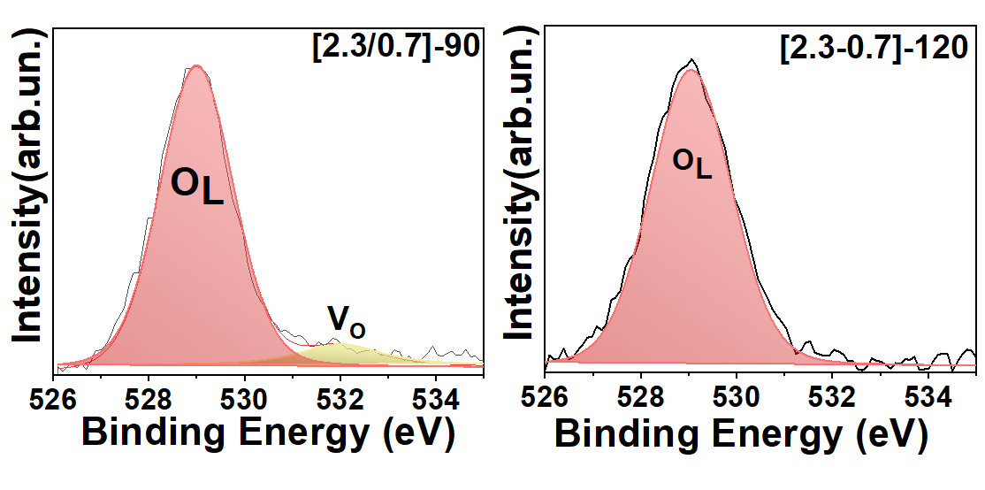
(b)bn
(a)bn
Figure S5. O1s XPS spectra of material [2.3/0.7] calcined for (a) 90 and (b) 120 min.

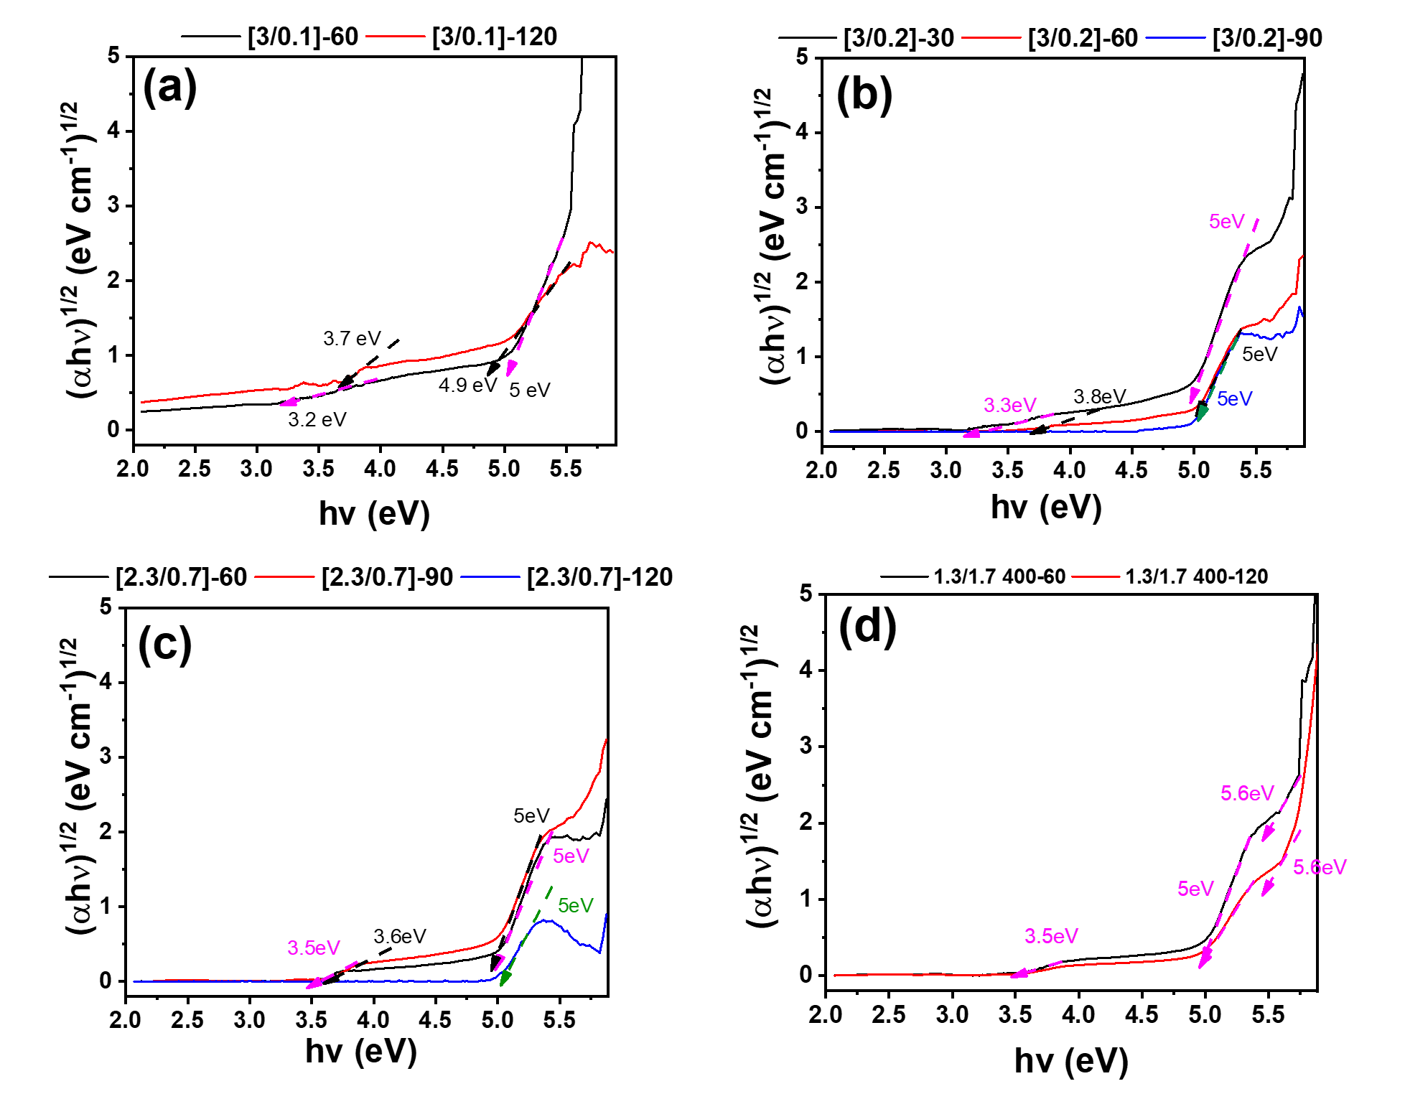
Figure S6. UV-Vis/DRS spectra of calcined (a) [3/0.1], (b) [3.0/0.2], (c) [2.3/0.7] and (d) [1.3/1.7] materials.

Table S5. EPR parameters for Vo signals in, ([3/0.1], [3/0.2], [2.3/0.7] and [1.3/1.7]).
Material | Monomer |  |  | ΔH(±0.1G) | Cluster | ΔH(±0.1G)
Material | g_{zz} | g_{yy} | g_{xx} | ΔH(±0.1G) | g_{iso} | ΔH(±0.1G)
3/0.1 | 2.0072 | 2.0037 | 2.0011 | 5 | - | -
400-60 | 2.0059 | 2.0042 | 2.0020 | 6 | - | -
400-120 | 2.0060 | 2.0046 | 2.0034 | 5.2 | - | -
3/0.2 | 2.0072 | 2.0037 | 2.0011 | 4.8 | 2.0028 | 6.5
400-60 | 2.0078 | 2.0041 | 2.0008 | 6.8 | - | -
400-90 | 2.0076 | 2.0040 | 2.0007 | 8.6 | - | -
400-120 | 2.0060 | 2.0043 | 2.0038 | 5.1 | - | -
2.3/0.7 | 2.0072 | 2.0037 | 2.0011 | 4.8 | 2.0028 | 6.5
400-60 | 2.0072 | 2.0037 | 2.0011 | 4.8 | 2.0028 | 6.5
400-90 | 2.0078 | 2.0045 | 2.0020 | 5.8 | -
400-120 | 2.0072 | 2.0041 | 1.9993 | 5.3 | -
1.3/1.7 | 2.0072 | 2.0037 | 2.0011 | - | 2.0028 | 6.5
400-60 | 2.0072 | 2.0037 | 2.0011 | 4.8 | 2.0028 | 6.5
400-90 | 2.0072 | 2.0037 | 2.0011 | 4.8 | 2.0028 | 6.5
400-120 | 2.0072 | 2.0037 | 2.0011 | 4.8 | 2.0028 | 6.5

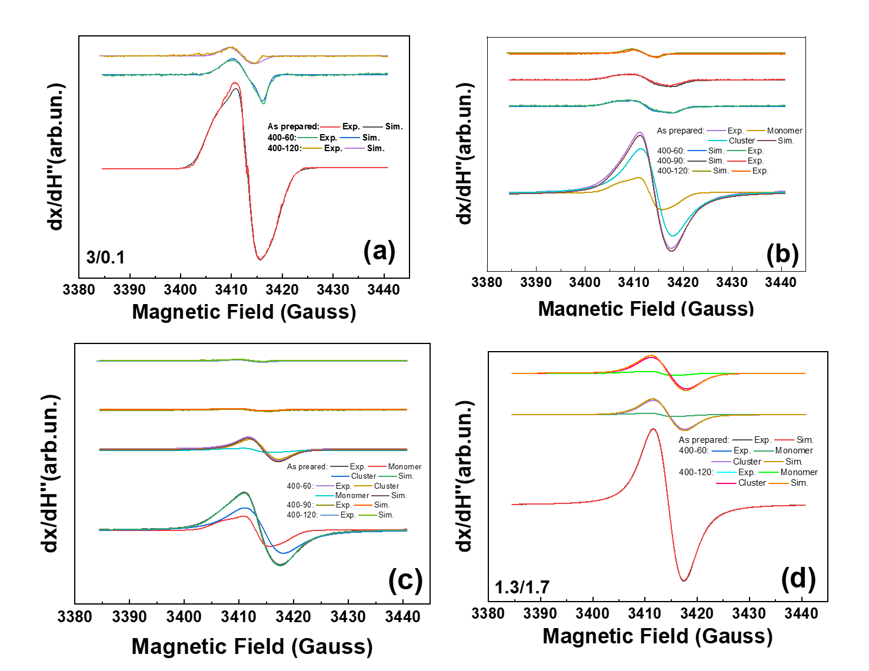
Figure S7. Experimental and fitted EPR spectra of [1.3/1.7] calcined at 400 $℃$ for (a) 60 min and (b) 120 min.

Table S6. EPR Quantitation of V_{O} centers in μmolg⁻¹ of [3/0.1], [3/0.2], [2.3/0.7], [1.3/1.7] and calculation of V_{O} / Zr atom ratio.
Materials | μmolg⁻¹ x10³ (V_{O}) | V_{O}/Ζr-atom (x10⁴)
[3/0.1] | 21 | 22
[3/0.2] | 24 | 25
[2.3/0.7] | 32 | 35
[1.3/1.7] | 148 | 159

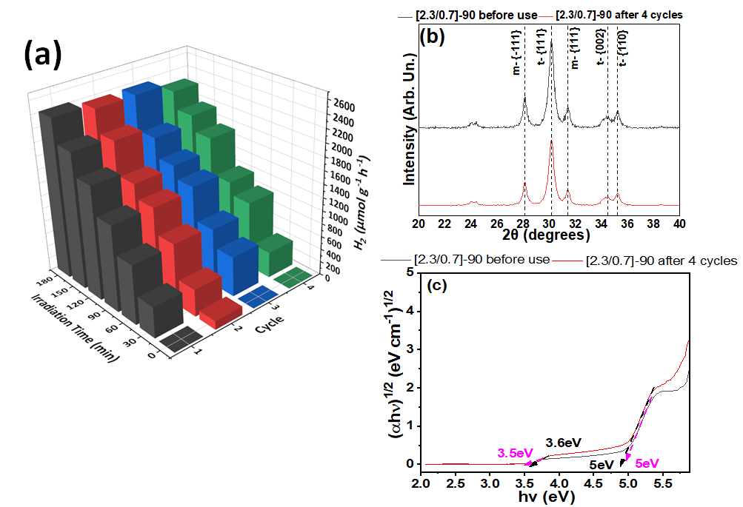
Figure S8. (a) Catalytic Reuse experiments of material [2.3/0.7]-90, (b) X-Ray Diffraction patterns and (c) DRS-UV/Vis spectra after 4 catalytic cycles.

Theoretical DFT Calculations: Theoretical calculations were conducted for the t-ZrO₂ phase, using DFT as implemented in the Quantum Espresso software¹. The projector augmented-wave (PAW) method was used to describe the core pseudopotential and the generalized gradient approximation (GGA) as simplified by Perdew, Burke, and Ernzerhof (PBE) was used for exchange-correlation effects. Ultrasoft pseudopotentials containing 12 valence electrons were used for Zr ([Kr] 5s2 5p0 4d2) and 6 valence electrons for O ([He] 2s2 2p4). A plane-wave energy cutoff of 45.551 Ry was used. Using the B.F.G.S routine, the structure was relaxed until the forces acting on each atom were <10⁻³ meV/Å. For geometry optimization and electronic structure calculations, (1 × 1 × 2) and (2 × 2 × 5) Monkhorst-Pack k-point grids were used respectively. Considering the strong correlations in transition metal oxides, we used the DFT+U approximation in the approach of Cococcioni and de Gironcoli² with a U-value of 4 eV applied on all structures.

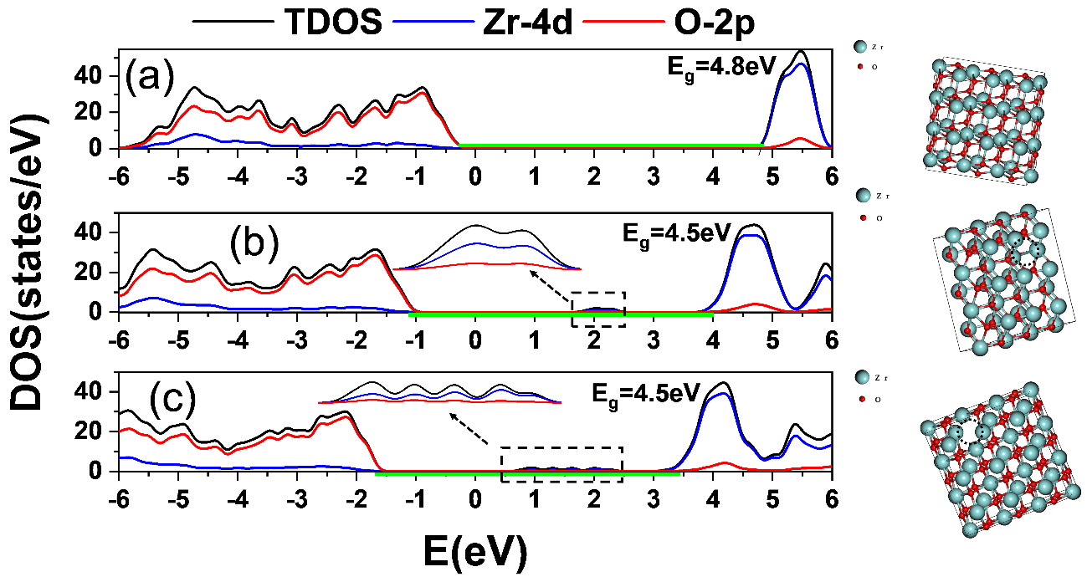
Figure S9. Theoretical DFT calculated electron Density of States for (a) ZrO₂, (b) ZrO₂-(with one Vo per 9-unit cells) and (c) ZrO₂-(with two Vo per 9-unit cells). The green-bar in (a) marks the Eg-value for pristine ZrO₂. In (b), (c) is re-marked to facilitate the visualization of the band-gap narrowing and the creation of DOS tail in the CB-bottom. (Right panels) the 9-unit cell structures used to calculate the DOS by DFT.
References:
1. Giannozzi, P. et al. QUANTUM ESPRESSO: a modular and open-source software project for quantum simulations of materials. J. Phys.: Condens. Matter 21, 395502 (2009).
2. Cococcioni, M. & de Gironcoli, S. Linear response approach to the calculation of the effective interaction parameters in the LDA + U method. Phys. Rev. B 71, 035105 (2005).

