Table 1. Drug-likeness properties of the compounds
 | Pharmacokinetics and Medicinal Chemistry |  |  |  | Druglikeness
Compounds | G1 Absorption | BBB  permeation | Pgp substrate | Pains | Lipinski | Ghose | Veber | Egan | Muagge
3a | High | No | No | 0 | Yes | Yes | Yes | Yes | No  1 violation: MW<200
3b | High | No | No | 0 | Yes | Yes | Yes | Yes | Yes
3c | High | No | No | 0 | Yes | Yes | Yes | Yes | No  1 violation: MW<200
3d | High | No | Yes | 0 | Yes | Yes | Yes | Yes | No  1 violation: MW<200
3e | High | No | No | 0 | Yes | Yes | Yes | Yes | Yes
3f | High | No | No | 0 | Yes | Yes | Yes | Yes | Yes
3g | High | No | No | 0 | Yes | Yes | Yes | Yes | Yes
3h | High | No | No | 0 | Yes | Yes | Yes | Yes | Yes
3i | High | No | No | 0 | Yes | Yes | Yes | Yes | Yes
3h | High | No | No | 0 | Yes | Yes | Yes | Yes | Yes
3i | High | No | No | 0 | Yes | Yes | Yes | Yes | Yes
3j | High | No | No | 0 | Yes | Yes | Yes | Yes | Yes
3k | High | No | No | 0 | Yes | Yes | Yes | Yes | Yes
3l | High | No | No | 0 | Yes | No; 1 violation: #atoms<20 | Yes | Yes | No; 1 violation: MW<200

Table 1. Drug-likeness properties of the compounds
 | Pharmacokinetics and Medicinal Chemistry |  |  |  | Druglikeness
Compounds | G1 Absorption | BBB  permeation | Pgp substrate | Pains | Lipinski | Ghose | Veber | Egan | Muagge
3m | High | No | No | 0 | Yes | No; 1 violation: #atoms<20 | Yes | Yes | No; 1 violation: MW<200
3n | High | No | No | 0 | Yes | No; 1 violation: #atoms<20 | Yes | Yes | No; 1 violation: MW<200
3o | High | No | No | 0 | Yes | No; 1 violation: #atoms<20 | Yes | Yes | No; 1 violation: MW<200
3p | High | No | No | 0 | Yes | Yes | Yes | Yes | Yes
3r | High | No | No | 0 | Yes | Yes | Yes | Yes | No; 1 violation: MW<200
3s | High | No | No | 0 | Yes | No; 1 violation: #atoms<20 | Yes | Yes | No; 1 violation: MW<200
3t | High | No | No | 2 alerts: hzone_phenol_A, hzone_phenol_B | Yes | Yes | Yes | Yes | Yes
3u | High | No | No | 0 | Yes | Yes | Yes | Yes | Yes
3v | Low | No | No | 0 | Yes | Yes | No;  1 violation: TPSA>140 | No;  1 violation: TPSA>131.6 | No;  1 violation: TPSA>150
3y | High | No | No | 0 | Yes | Yes | Yes | Yes | No; 1 violation: MW<200
Drug(Imatinib) | High | No | Yes | 0 | Yes | No; 2 violations: MW>480, MR>130 | Yes | Yes | Yes
These parmeters were determined with Swiss ADME and Admet SAR predictor.

Table 2. Pharmacokinetic Properties of Compounds

Drug-likeness properties | 3a | 3b | 3c | 3d | 3e | 3f | 3g | 3h | 3i | 3j
Molecular Weight (g/mol) | 193.27 | 209.27 | 179.24 | 197.23 | 213.69 | 258.14 | 224.24 | 239.29 | 239.29 | 215.22
H-Bond Acceptor | 1 | 2 | 1 | 2 | 1 | 1 | 3 | 3 | 3 | 3
H-Bond Donor | 2 | 2 | 2 | 2 | 2 | 2 | 2 | 2 | 2 | 2
GPCR ligand | -1.93 | -1.73 | -2.06 | -1.83 | -1.85 | -2,03 | -1.74 | -1.38 | -1.38 | -1.60
Ion channel modulator | -1.56 | -1.43 | -1.59 | -1.45 | -1.43 | -1,57 | -1.26 | -1.33 | -1.32 | -1.33
Kinase inhibitor | -1.73 | -1.54 | -1.86 | -1.59 | -1.69 | -1,74 | -1.54 | -1.24 | -1.26 | -1.32
Nuclear receptor ligand | -2.22 | -1.96 | -2.42 | -2.12 | -2.20 | -2,38 | -1.90 | -1.53 | -1.54 | -1.95
Protease inhibitor | -1.54 | -1.37 | -1.60 | -1.47 | -1.51 | -1,65 | -1.36 | -1.05 | -1.04 | -1.23
Enzyme inhibitor | -0,90 | 0.77 | -0.91 | -0.82 | -0.85 | -0,93 | -0.78 | -0.62 | -0.62 | -0.70
Water Solubility(Log S (ESOL)) | Soluble  -2.58 | Very soluble  -1.69 | Soluble  -2.30 | Soluble  -2.44 | Soluble  -2.23 | Soluble  -2.72 | Soluble  -2.13 | Very soluble  -1.69 | Soluble  -2.36 | Soluble  -2.18
Lipophilicity (Log Po/w (iLOGP)) | 1.98 | 2.00 | 1.73 | 1.80 | 1.97 | 2.07 | 1.36 | 2.17 | 2.38 | 1.91
TPSA (Å2) | 82.50 | 91.73 | 82.50 | 82.50 | 82.50 | 82.50 | 128.32 | 100.96 | 100.96 | 82.50
log Kp [cm/s] | -5.90 | -7.01 | -6.07 | -6.11 | -6.56 | -6.59 | -6.69 | -6.95 | -6.53 | -6.62

Drug-likeness properties | 3k | 3l | 3m | 3n | 3o | 3p | 3r | 3s | 3t | 3u | 3v | 3y | Drug( Imatinib)
Molecular Weight (g/mol) | 215.22 | 169.20 | 185.27 | 185.27 | 213.69 | 222.31 | 180.23 | 169.20 | 211.24 | 218.28 | 280.37 | 180.23 | 493.60
H-Bond Acceptor | 3 | 2 | 1 | 1 | 1 | 1 | 2 | 2 | 3 | 1 | 2 | 2 | 6
H-Bond Donor | 2 | 2 | 2 | 2 | 3 | 2 | 2 | 2 | 4 | 3 | 4 | 2 | 2
GPCR ligand | -1.60 | -2.64 | -2.69 | -2.32 | -2.10 | -1.48 | -1.96 | -2.19 | -1.57 | -1.14 | -1.05 | -1.78 | 0.10
Ion channel modulator | -1.33 | -1.96 | -2.22 | -1.85 | -1.54 | -1.21 | -1.46 | -1.67 | -1.39 | -1.04 | -0.91 | -1.46 | -0.09
Kinase inhibitor | -1.35 | -2.54 | -2.52 | -2.15 | -1.84 | -1.24 | -1.59 | -2.14 | -1.39 | -1.04 | -0.88 | -1.79 | 0.59
Nuclear receptor ligand | -1.94 | -3.29 | -3.19 | -2.81 | -2.54 | -1.70 | -2.48 | -2.75 | -1.64 | -1.66 | -1.23 | -2.44 | -0.40
Protease inhibitor | -1.25 | -2.08 | -1.90 | -1.80 | -1.78 | -1,17 | -1.55 | -1.82 | -1.19 | -1.07 | -0.74 | -1.45 | -0.08
Enzyme inhibitor | -0,72 | 1.36 | -1.26 | -1.17 | -0.75 | -0,62 | -0.77 | -1.05 | -0.60 | -0.41 | -0.38 | -0.66 | 0.07
Water Solubility  (Log S (ESOL)) | Soluble  -2.18 | Soluble  -2.06 | Soluble  -2.30 | Very Soluble  -1.68 | Very Soluble  -1.22 | Very Soluble  -2.17 | Very Soluble  -1.21 | Very soluble  -1.20 | Vey Soluble  -1.58 | Soluble  -2.28 | Vey Soluble  -1.73 | Soluble  -3.01 | Moderately soluble  -5.07
Lipophilicity (Log Po/w (iLOGP)) | 1.88 | 1.39 | 1.73 | 1.64 | 1.97 | 2.04 | 1.29 | 1.46 | 1.15 | 1.51 | 1.76 | 1.24 | 4.04
TPSA (Å2) | 82.50 | 95.64 | 82.50 | 110.74 | 98.29 | 85.74 | 95.39 | 95.64 | 122.96 | 98.29 | 165.00 | 95.39 | 86.28
log Kp [cm/s] | -6.62 | -6.17 | -6.07 | -6.81 | -7.10 | -7.10 | -7.31 | -7.14 | -7.24 | -6.69 | -7.67 | -6.41 | -6.81
Table 2. Pharmacokinetic Properties of Compounds

The bioavailability radar of compounds
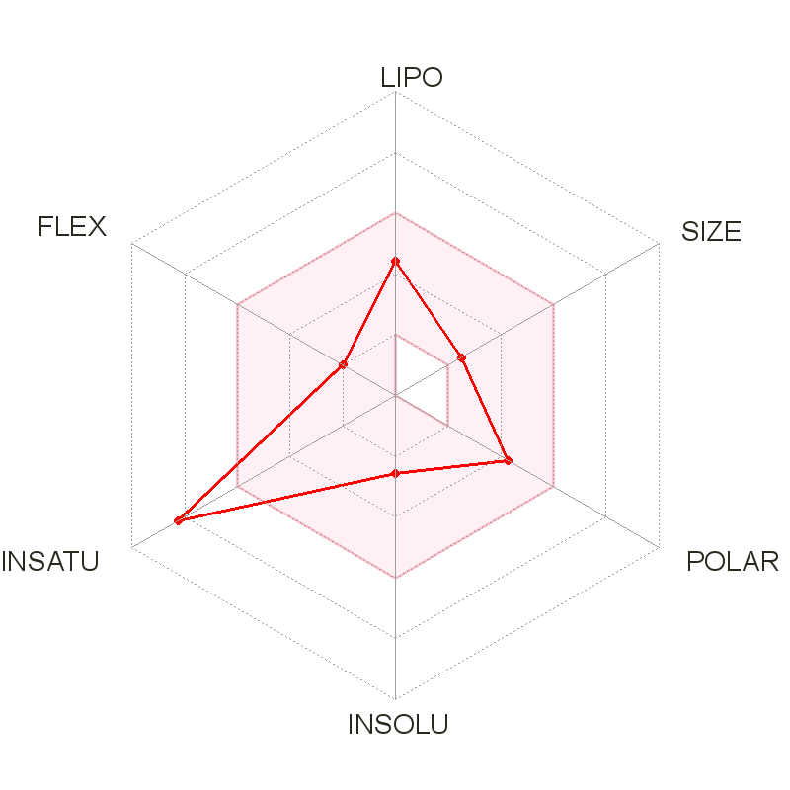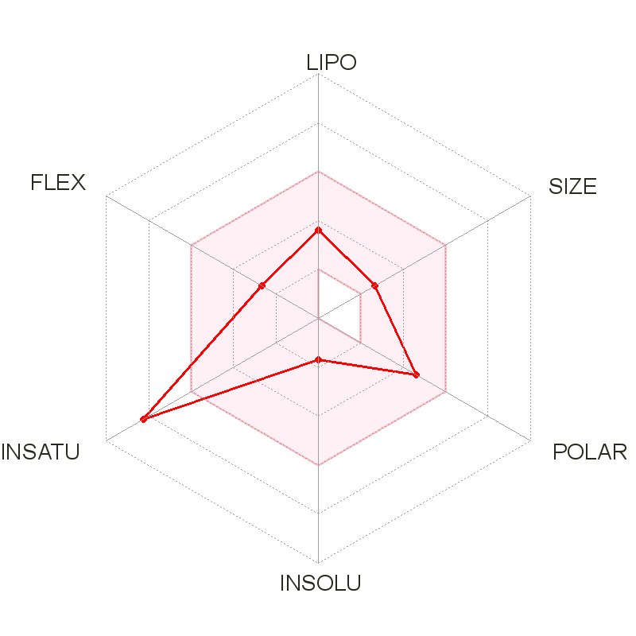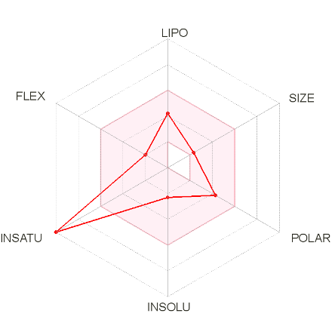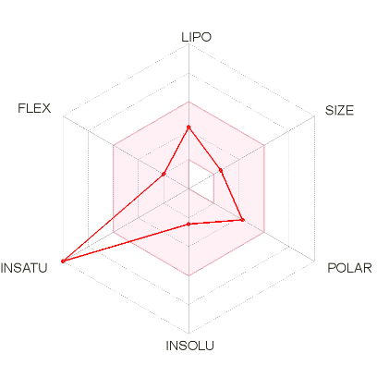
3a 3b 3c 3d
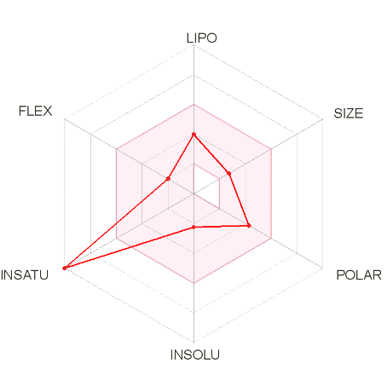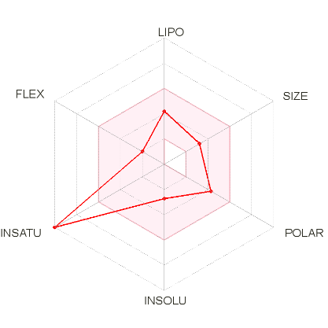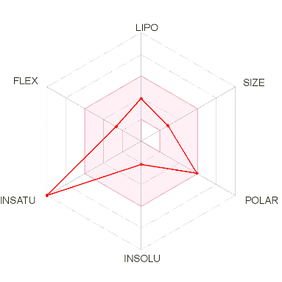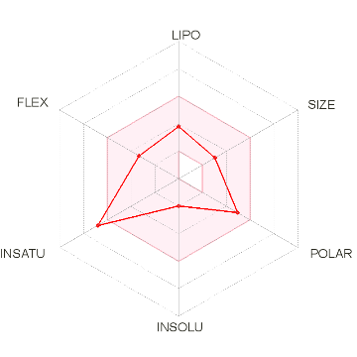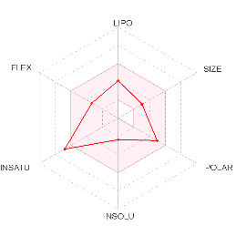
3e 3f 3g 3h 3i

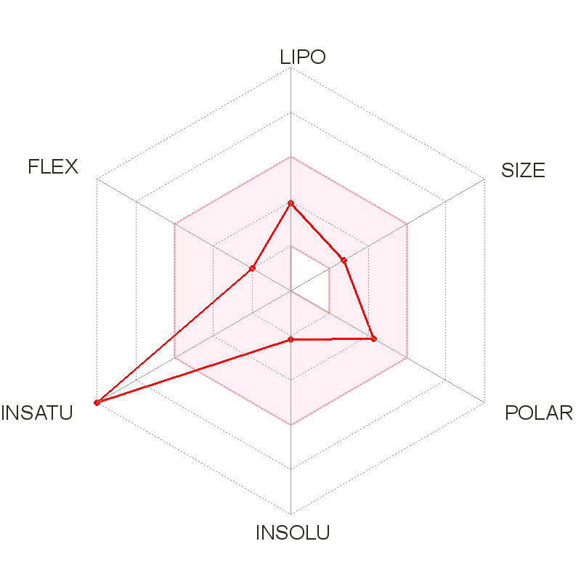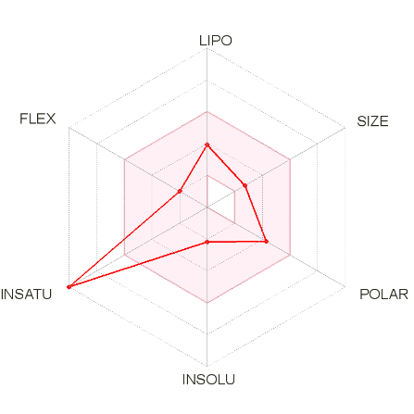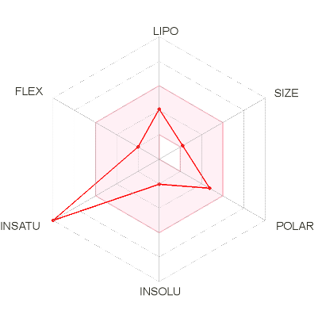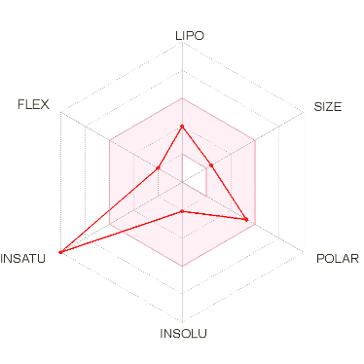
3j 3k 3l 3m

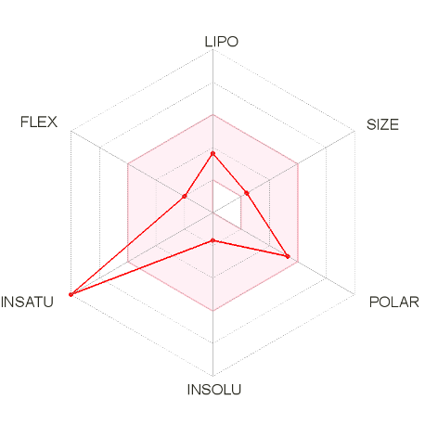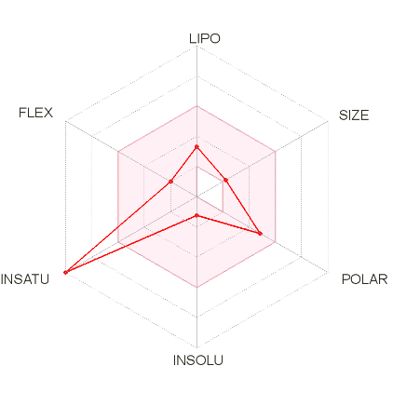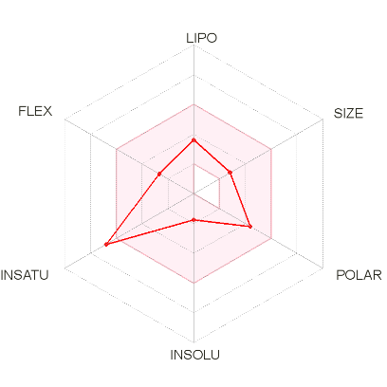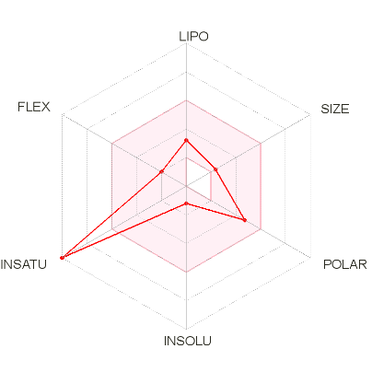
3n 3o 3p 3r

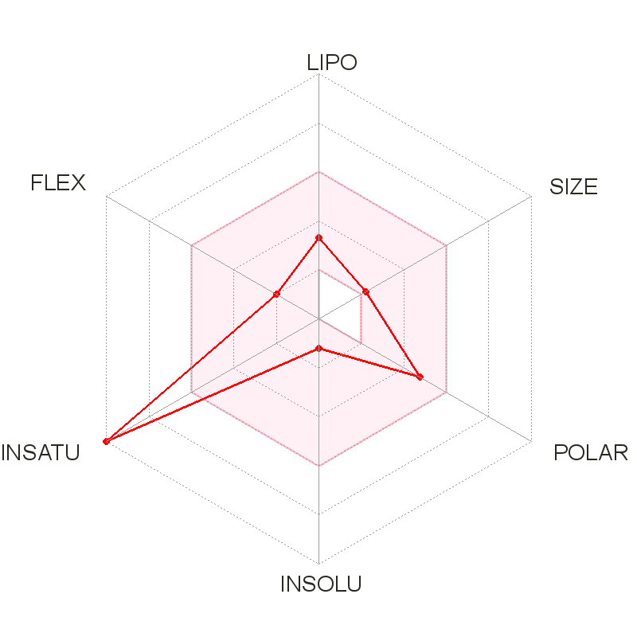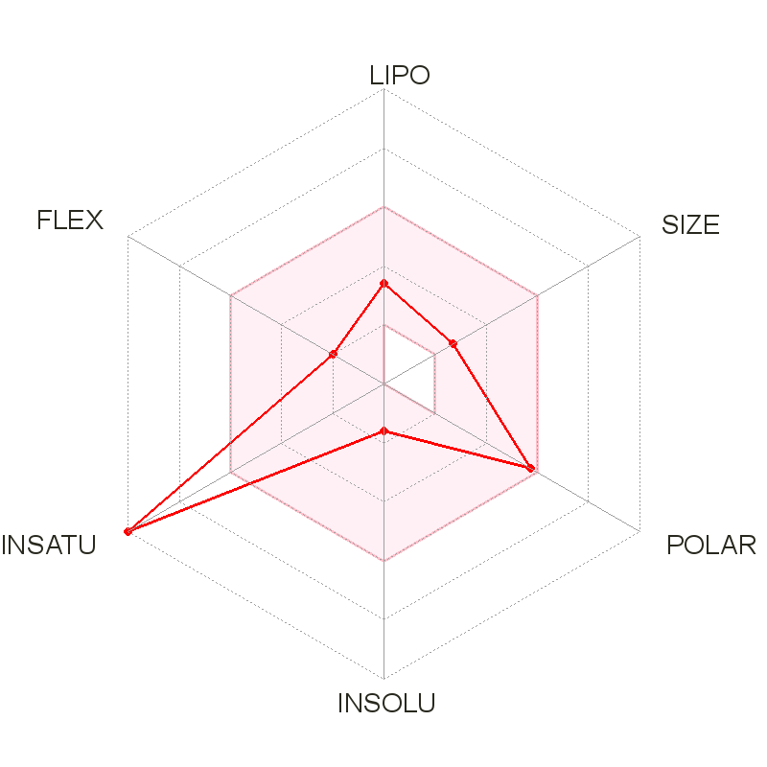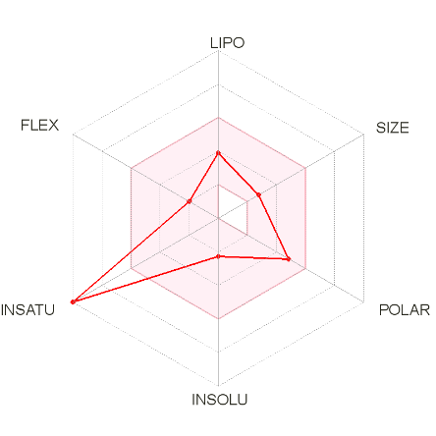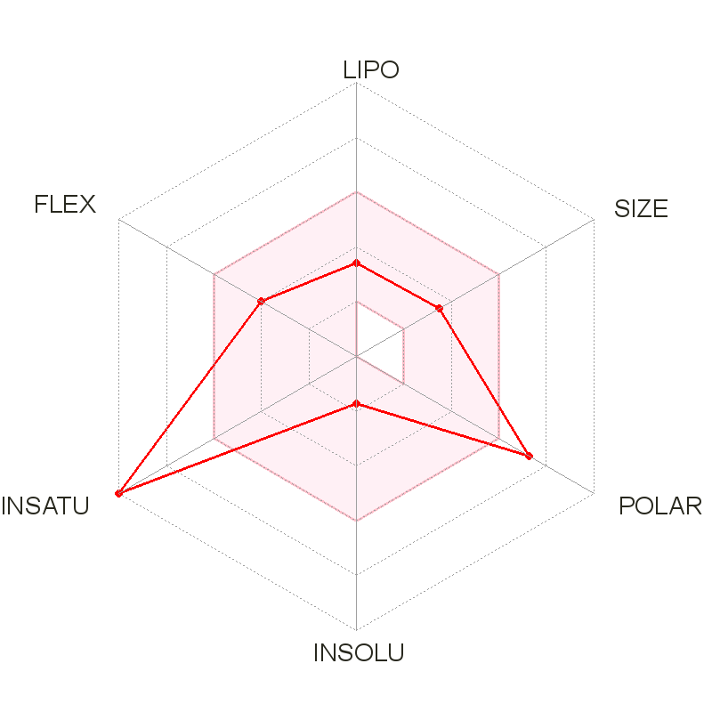
3s 3t 3u 3v

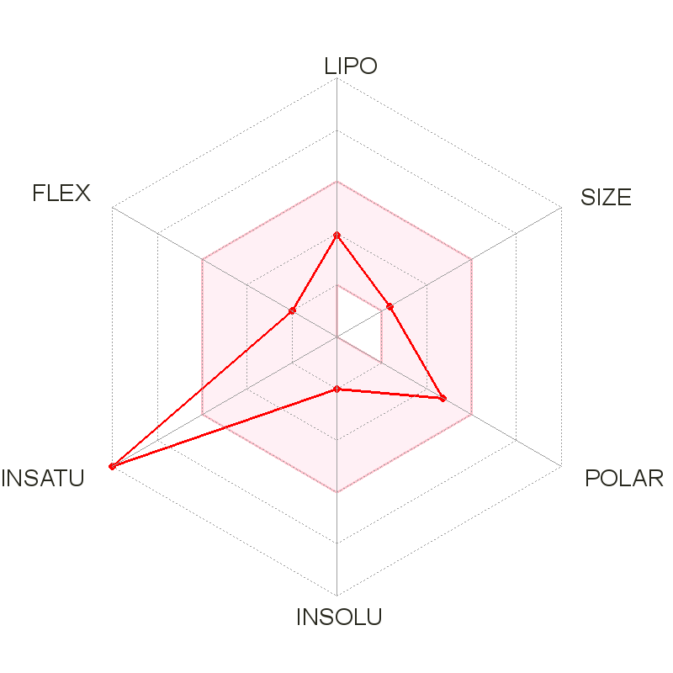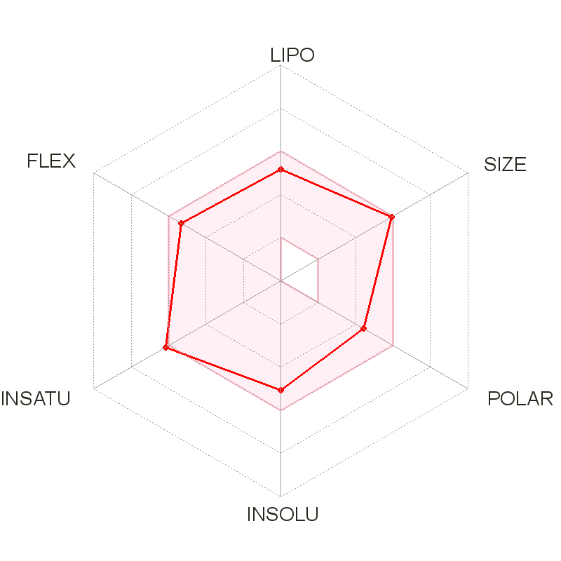
3y Drug (Imatinib)

