Sexual selection leads to positive allometry but not sexual dimorphism in the expression of horn shape in the blue wildebeest, Connochaetes taurinus.
Chloé Gerstenhaber and Andrew Knapp

Supplementary data

Note on sample and additional analyses
The sample consists of 75 C. taurinus skulls; 47 males and 28 females. Of these specimens, 5 were too severely damaged to place surface semilandmarks and so were excluded from the surface semilandmark analysis (i.e. patched specimens), and were analysed only with anatomical landmarks and semilandmark curves (i.e. curves only). Sex was known for certain (i.e., information was included on specimen labels) for 36 males and 22 female specimens. The sex of the remaining specimens was estimated by the authors and marked as ‘probable male’ or ‘probable female.’ The dataset was subdivided to include only specimens of certain sex (i.e. ‘strict’ as opposed to ‘all,’ which also included specimens with estimated sex), and analyses were rerun on the ‘strict’ subset. In addition, all analyses were run on individual sexes (Males only and Females only), for all specimens and only those of known sex. Because males outnumber females, the largest males were removed from the dataset to equalise the number of each sex (‘equal sample’), for both the ‘all’ and ‘strict’ subsets.
Specimens in the dataset represent all 5 subspecies of C. taurinus: C. t. taurinus (n = 36), C. t. johnstoni (n = 4), C. t. mearnsi (n = 4), C. t. albojubatus (n = 6) and C. t. cooksoni (n = 3). In addition, 15 specimens are of unknown subspecies. To account for possible differences in shape between these subspecies a MANOVA was applied to the entire dataset with subspecies as the independent grouping variable, which did not reveal a significant difference between any group (Supplementary Data Table S3). Nevertheless, all analyses were repeated solely on specimens of the best-represented subspecies, C. t. taurinus (n = 36). These analyses are reported as ‘subspecies analysis’ in the results tables below. The results of these analyses did not differ from our analysis of the entire dataset. Subspecies of C. taurinus are mainly distinguished by colouration and median body weight (Castelló, 2016), with horn shape being somewhat distinct in the Western White wildebeest, C. t. mearnsi (Estes, 2014; Castelló, 2016). Differences in horn shape that are independent of size are seen along PC2 of Fig. 1 of the main text, but are not sufficient to distinguish subspecies in this dataset. It may be the case that increasing the sample sizes of different subspecies may reveal more reliable differences between groups in this way.

Table S1: Specimen data. F = female, M = male, F_p = probable female, M_p = probable male.
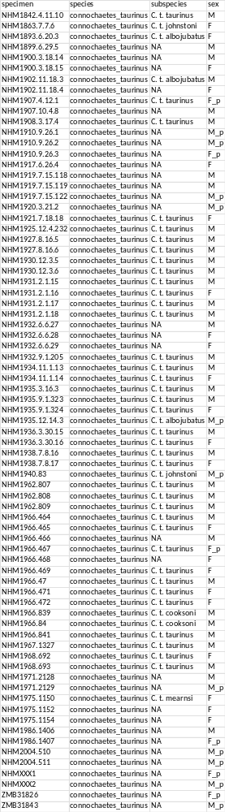

Modularity tests
Skull elements
1: Nasal
2: Premaxilla
3: Maxilla
4: Zygomatic
5: Lacrimal
6: Frontal
7: Parietal
8: Horn
9: Occipital
10: Temporal
11: Sphenoid
12: Palatine

Modularity hypotheses tested with ML method (EMMLi). Numbers in parenthesis correspond to skull elements listed above.
- All bones separate modules (1:12); 12 modules
- 1. Horn (8), 2. all other bones (1:7, 9:12); 2 modules
- 1. Face (1:5,12), 2. cranium (6,7,9:11), 3. horn (8); 3 modules
- 1. Face (1:5,12), 2. horn + cranium (6:11); 2 modules
- 1. Nasal (1), 2. Premaxilla + maxilla (2,3), 3. zygomatic + lacrimal (4,5), 4. frontal (6), 5. parietal (7), 6. horn (8), 7. occipital + sphenoid (9,11), 8. temporal (10), 9. palatine (12); 9 modules
- 1. Nasal (1), 2. premaxilla + maxilla (2,3), 3. zygomtic + lacrimal (4,5), 4. frontal (6), 5. parietal + occipital + sphenoid (7,9,11), 6. horn (8), 7. temporal (10), 8. palatine (12); 8 modules
- 1. Nasal (1), 2. premaxilla + maxilla (2,3), 3. zygomatic (4), 4. lacrimal (5), 5. frontal + parietal (6,7), 6. horn (8), 7. occipital + sphenoid (9,11), 8. temporal (10), 9. palatine (12); 9 modules

Table S2: Results of allometry analyses on shape data.
 | Curves only |  |  | Patched specimens
 | n | R² | p | n | R² | p
M+F - All | 75 | 0.22 | 0.001 | 70 | 0.38 | 0.001
M+F – All, equal sample | 56 | 0.18 | 0.001 | 54 | 0.33 | 0.001
M+F - Strict | 58 | 0.22 | 0.001 | 54 | 0.37 | 0.001
M+F – Strict, equal sample | 44 | 0.20 | 0.001 | 42 | 0.36 | 0.001
Males only – All | 47 | 0.14 | 0.001 | 43 | 0.25 | 0.001
Males only - Strict | 36 | 0.14 | 0.001 | 33 | 0.25 | 0.001
Females only – All | 28 | 0.15 | 0.001 | 27 | 0.24 | 0.001
Females only - Strict | 22 | 0.15 | 0.007 | 21 | 0.31 | 0.002
Subspecies analysis (C. t. taurinus only) | n/a | n/a | n/a | 36 | 0.37 | 0.001

Table S3: Comparison of Allometric slopes by sex.
 | Curves only |  |  | Patched specimens
 | n | R² | p | n | R² | p
All | 75 | 0.01 | 0.366 | 70 | 0.01 | 0.635
All, equal samples | 56 | 0.03 | 0.017 | 54 | 0.02 | 0.145
All, horns only |  |  |  | 70 | 0.003 | 0.848
Strict | 58 | 0.01 | 0.464 | 54 | 0.01 | 0.605
Strict, equal samples | 44 | 0.03 | 0.046 | 42 | 0.02 | 0.116
Subspecies analysis |  |  |  | 36 | 0.03 | 0.146

Table S4: MANOVA analyses of differences in shape by sex and subspecies. Significant results are shown in bold.
 | Curves only |  |  | Patched specimens
 | n | R² | p | n | R² | p
All | 75 | 0.16 | 0.001 | 70 | 0.21 | 0.001
All, equal samples | 56 | 0.12 | 0.001 | 54 | 0.15 | 0.001
All, allometry corrected | 75 | 0.04 | 0.005 | 70 | 0.02 | 0.206
All, equal samples, allometry corrected | 56 | 0.06 | 0.001 | 54 | 0.04 | 0.052
Strict | 58 | 0.19 | 0.001 | 54 | 0.24 | 0.001
Strict, equal samples | 44 | 0.17 | 0.001 | 42 | 0.19 | 0.001
Strict, allometry corrected | 58 | 0.05 | 0.005 | 54 | 0.03 | 0.139
Strict, equal samples, allometry corrected | 44 | 0.07 | 0.004 | 42 | 0.04 | 0.126
Subspecies analysis, all specimens |  |  |  | 53 | 0.11 | 0.107
C. t. taurinus subset, sex |  |  |  | 36 | 0.25 | 0.001

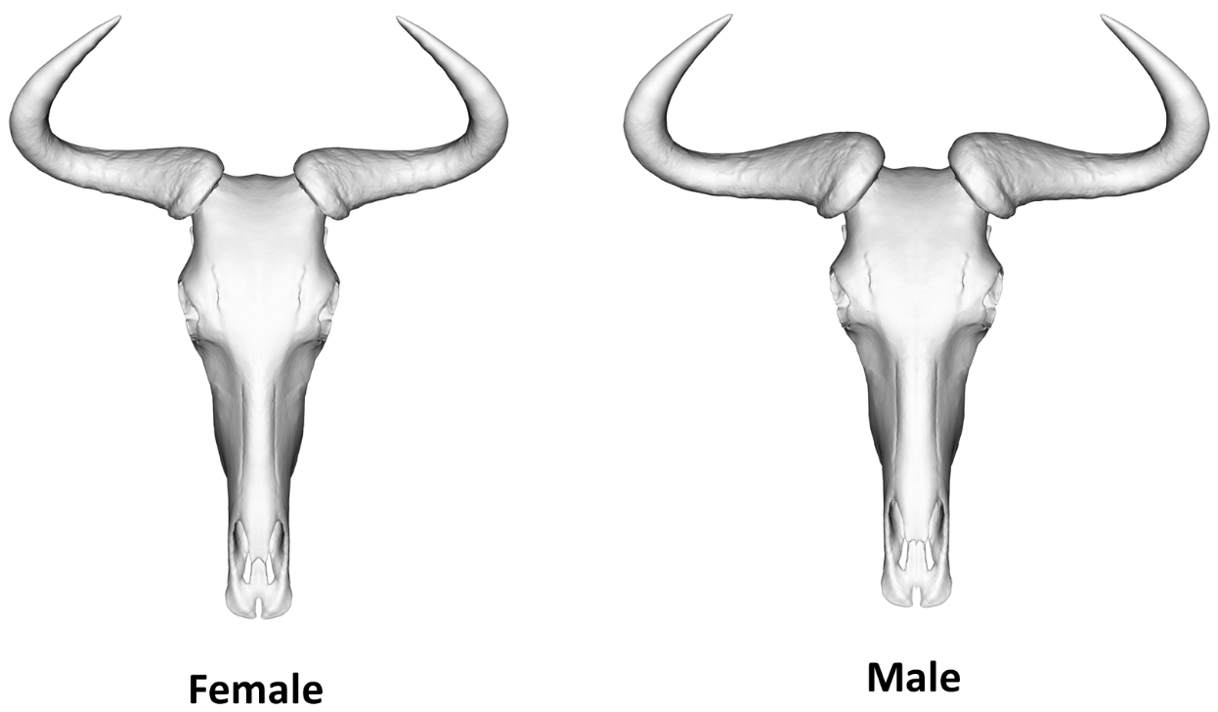
Figure S1: Warped meshes representing mean shape of female (left) and male (right) C. taurinus skull.
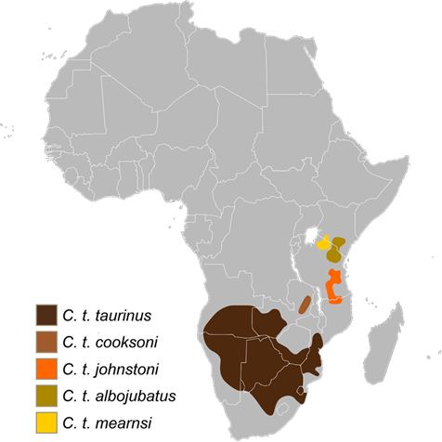
Figure S2: Distribution of C. taurinus subspecies across Africa (licensed under CC BY-SA 3.0).
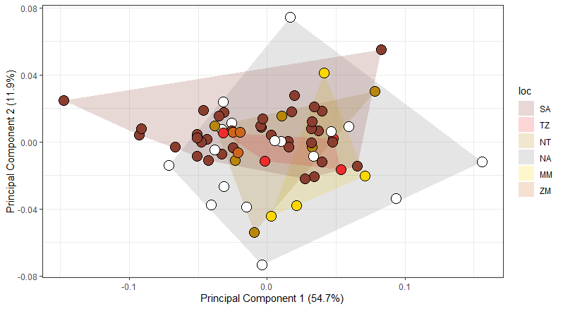
Figure S3: PCA of specimens coloured by subspecies. Convex hulls group subspecies, SA: C. t. taurinus ; TZ: C. t. johnstoni; NT: C. t. albojubatus; MM: C. t. mearnsi; ZM: C. t. cooksoni; NA: not known.

Table S5: Results of dip tests performed on shape and size data.
 | Raw shape data |  |  | Allometry-corrected data
 | PC proportion of variance (%) | D | p | PC proportion of variance (%) | D | p
Principal component 1 | 54.7 | 0.046 | 0.34 | 31.9 | 0.041 | 0.55
Principal component 2 | 11.9 | 0.029 | 0.98 | 18.4 | 0.044 | 0.38
Principal component 3 | 7.3 | 0.042 | 0.51 | 11.1 | 0.030 | 0.95
Principal component 4 | 4.3 | 0.039 | 0.65 | 6.0 | 0.024 | 1.00
Principal component 5 | 3.1 | 0.035 | 0.80 | 4.3 | 0.036 | 0.76
Principal component 6 | 2.6 | 0.029 | 0.98 | 4.1 | 0.034 | 0.86
Principal component 7 | 1.6 | 0.036 | 0.80 | 2.6 | 0.049 | 0.23
Principal component 8 | 1.5 | 0.034 | 0.83 | 2.1 | 0.032 | 0.89
Dip test, All, centroid size | n/a | 0.042 | 0.48 | n/a | n/a | n/a

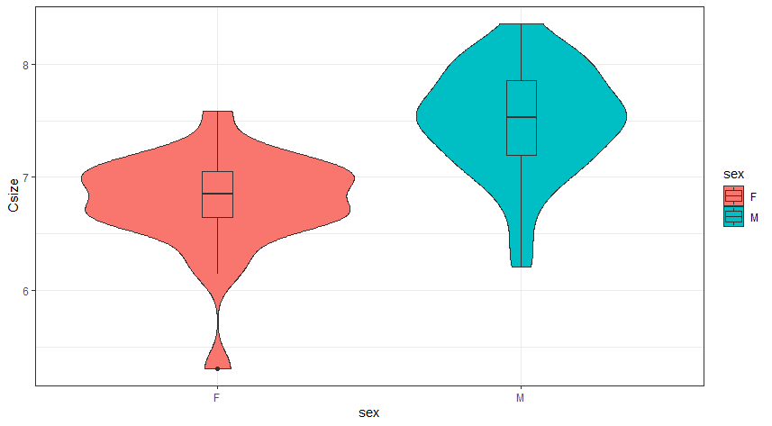
Figure S4: Violin plots of centroid size distributions for females (F) and males (M).

Table S6: ANOVA of centroid size by sex
 | Curves only |  | Patched specimens
 | F | p | F | p
All | 34.2 | <0.001 | 42.36 | <0.001
Strict | 30.72 | <0.001 | 40.55 | <0.001
All, horns only | n/a | n/a | 62.27 | <0.001
All, skull minus horns | n/a | n/a | 35.38 | <0.001

Table S7: Results of shape allometry analysis of individual modules for all specimens
 | EMMLi modules
 | n | Effect size | p
Nasal | 70 | 0.21 | 0.004
Premaxilla/maxilla | 70 | 0.31 | 0.004
Frontal/parietal | 70 | 0.19 | 0.004
Zygomatic | 70 | 0.15 | 0.004
Horn | 70 | 0.44 | 0.004
Temporal | 70 | 0.18 | 0.004
Lacrimal | 70 | 0.10 | 0.004
Occipital/sphenoid | 70 | 0.28 | 0.004
Palatine | 70 | 0.28 | 0.004
 | compare.CR modules
Face | 70 | 0.27 | 0.004
Cranium | 70 | 0.22 | 0.004
Horn | 70 | 0.44 | 0.004

Table S8: Results of k-means cluster analysis on whole-skull and individual module shape data, for raw and allometry-corrected shape data. Results show percentage of individuals correctly assigned to group. Values above 75% are shown in bold.
 | Raw shape data |  |  | Allometry corrected shape data
 | Males % correct | Females % correct | Total % correct | Males % correct | Females % correct | Total % correct
Whole skull | 81% | 89% | 84% | 56% | 48% | 53%
Nasal | 72% | 74% | 73% | 58% | 63% | 60%
Premaxilla/maxilla | 84% | 81% | 83% | 58% | 50% | 61%
Frontal/parietal | 65% | 89% | 74% | 70% | 37% | 50%
Zygomatic | 60% | 52% | 57% | 52% | 53% | 53%
Horn | 79% | 96% | 86% | 56% | 48% | 53%
Temporal | 72% | 48% | 63% | 51% | 52% | 51%
Lacrimal | 53% | 59% | 56% | 51% | 52% | 51%
Occipital/sphenoid | 65% | 85% | 73% | 56% | 44% | 51%
Palatine | 65% | 70% | 67% | 51% | 60% | 54%
Face (compare.CR) | 81% | 81% | 81% | 72% | 67% | 70%
Cranium (compare.CR) | 74% | 74% | 74% | 47% | 67% | 59%
Centroid size, whole skull | 72% | 93% | 80% | n/a

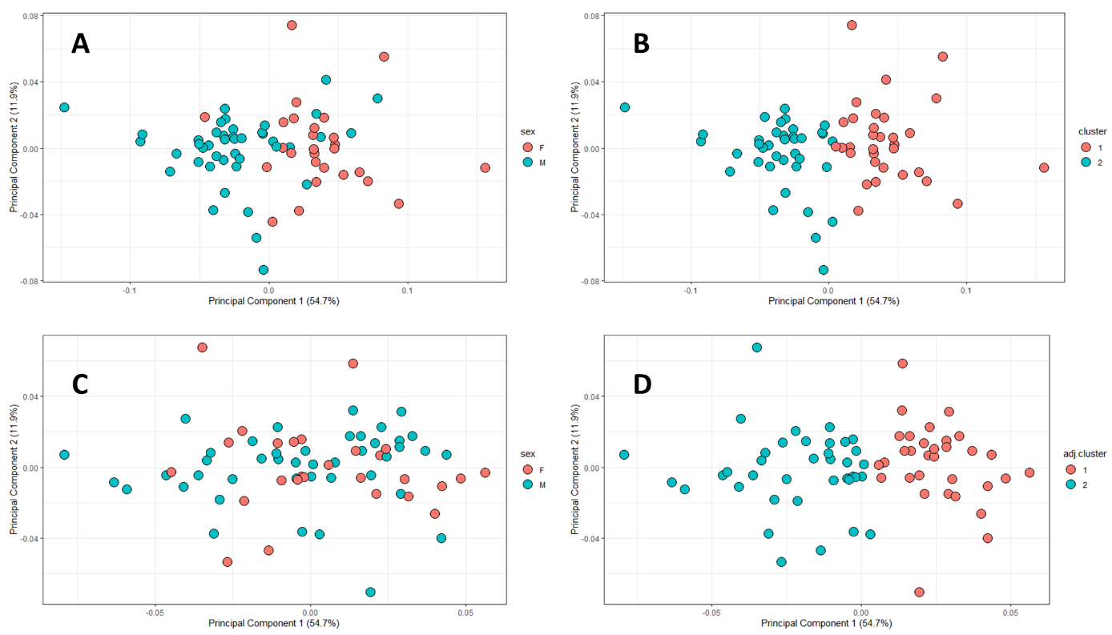
Figure S5: Results of K-means cluster analysis of sex for n = 2 clusters, whole—skull shape data. Shown are PCAs of A: Raw shape data, coloured by known sex; B: Raw shape data, coloured by cluster analysis estimate of sex; C: Allometry-corrected shape data, coloured by known sex; D: Allometry-corrected shape data, coloured by cluster analysis estimate of sex.

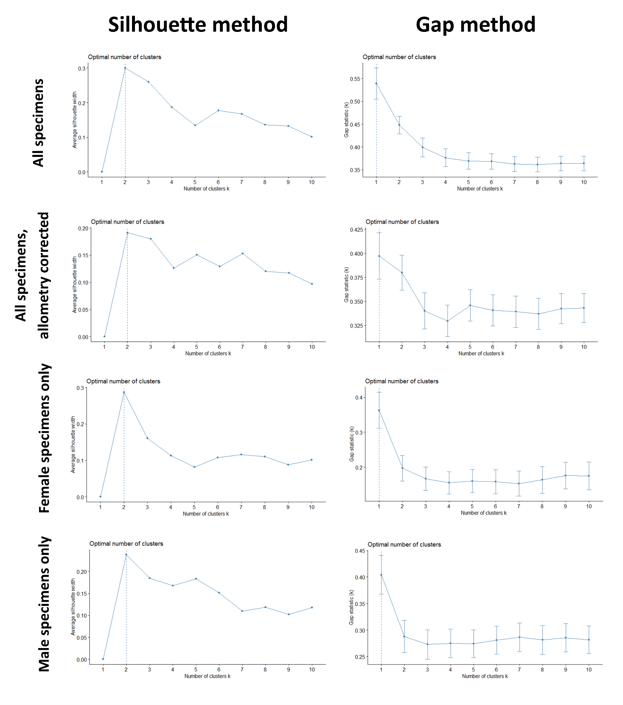
Figure S6: Results of optimum cluster number analysis. Left column shows results of ‘silhouette’ method for (top to bottom) all specimens (n = 70), allometry corrected specimens (n = 70), female specimens only (n = 27) male specimens only (n = 43). Right column shows results for ‘gap’ method for same subdivisions of dataset. Vertical dashed line in each plot represents calculated optimum cluster number.

Table S9: Morphological variance of whole skull and individual modules, for all data and separate sexes.
 | Raw data |  |  | Allometry corrected
 | All | Males | Females | All | Males | Females
Whole skull | 5.10 | 4.22 | 3.72 | 3.15 | 3.15 | 2.82
Face (compare.CR) | 1.95 | 1.62 | 1.60 | 1.43 | 1.28 | 1.42
Cranium (compare.CR) | 1.88 | 1.89 | 1.42 | 1.46 | 1.53 | 1.19
Horn | 14.61 | 11.66 | 10.29 | 8.24 | 8.40 | 7.33
Nasal | 1.61 | 1.34 | 1.43 | 1.26 | 1.02 | 1.32
Premaxilla/maxilla | 2.41 | 1.90 | 1.86 | 1.67 | 1.48 | 1.67
Frontal/parietal | 1.62 | 1.52 | 1.33 | 1.31 | 1.30 | 1.15
Zygomatic | 1.52 | 1.40 | 1.52 | 1.28 | 1.20 | 1.29
Lacrimal | 1.01 | 0.97 | 0.94 | 0.90 | 0.88 | 0.84
Temporal | 1.96 | 2.21 | 1.28 | 1.60 | 1.85 | 1.05
Occipital/sphenoid | 2.27 | 2.30 | 1.65 | 1.64 | 1.72 | 1.34
Palatine | 1.19 | 1.22 | 0.89 | 0.86 | 0.97 | 0.68

