Polyoxometalate based hybrids: Synthesis of metal complexes, investigation of electrochemical, photophysical and biological properties

Seyit Ali Güngör¹, Mete Karaboyun², Ferhan Tümer¹, Sevil Toroğlu², Mehmet Tümer^{1*}
¹Chemistry Department, Faculty of Science and Letters, Kahramanmaras Sutcu Imam University, Kahramanmaras, Turkey
²Biology Department, Faculty of Science and Letters, Kahramanmaras Sutcu Imam University, Kahramanmaras, Turkey

1. Experimental

1.1. General
All reagents and solvents were of reagent-grade quality and obtained from commercial suppliers (Aldrich or Merck) and used as received, unless noted otherwise. Elemental analyses (C, H, N) were performed using a Costech ECS 4010 (CHN). Infrared spectra were obtained using KBr disc (4000-400 cm⁻¹) on a Perkin Elmer Spectrum 100 FT-IR. The electronic spectra in the 200–900 nm range were obtained on a Perkin Elmer Lambda 45 spectrophotometer. ¹H and ¹³C NMR spectra were recorded on a Bruker 400 MHz instrument and TMS was used as an internal standard TMS. The ¹H NMR spectra of the ligands and ¹³C NMR spectrum of the ligand HL³ were investigated by CDCl₃ as solvent. On the other hand, the ¹³C NMR spectra of the ligands HL¹ and HL² were recorded by C₃D₆O as a solvent. The thermal studies of the compounds were performed on a Perkin Elmer STA 6000 simultaneous Thermal Analyzer under nitrogen atmosphere at a heating rate of 10 °C/min. The MS spectra of the ligands and their Cu(II) complexes were obtained using Agilent 6230 ESI/MS mass spectrometer. The mass spectra of the Pt(II) complexes were obtained in 2,5-dihydroxybenzoic acid (DHB) as MALDI Matrix using nitrogen laser accumulating 50 laser shots using Bruker Microflex LT MALDI TOF mass spectrometer.
The single-photon fluorescence spectra of the porphyrin-Schiff base compounds (HL¹-HL³) and their metal complexes were collected on a Perkin Elmer LS55 luminescence spectrometer. All samples were prepared in spectrophotometric grade solvents and analysed in a 1 cm optical path quartz cuvette. The solutions of the azo-imine compounds (1.0 x 10⁻³ mol L⁻¹) were prepared in the DMF solutions.
The 1x10^{–5} M DMF stock solutions of the azo-imine compounds HL¹-HL³ were used for the electrochemical studies. Cyclic voltammograms were recorded on a Iviumstat Electrochemical workstation equipped with a low current module (BAS PA–1) recorder. The electrochemical cell was equipped with a BAS glassy carbon working electrode (area 4.6 mm²), a platinum coil auxiliary electrode and a Ag⁺/AgCl reference electrode filled with tetrabutylammonium tetrafloroborate (0.1 M) in DMF solution and adjusted to 0.00 V vs SCE. Cyclic voltammetric measurements were performed at room temperature in an undivided cell (BAS model C–3 cell stand) with a platinum counter electrode and an Ag⁺/AgCl reference electrode (BAS). All potentials are reported with respect to Ag⁺/AgCl. The solutions were deoxygenated by passing dry nitrogen through the solution for 30 min prior to the experiments, and during the experiments the flow was maintained over the solution. Digital simulations were performed using DigiSim 3.0 for windows (BAS, Inc.). Experimental cyclic voltammograms used for the fitting process had the background subtracted and were corrected electronically for ohmic drop. Mettler Toledo MP 220 pH meters was used for the pH measurements using a combined electrode (glass electrode reference electrode) with an accuracy of ±0.05 pH.
1.2. Preparation of H₄[SiMo₁₂O₄₀]·3EtOH (A)
The ethanol solvated α-Keggin heteropolymolybdate (A) was prepared according to slightly modified method[1]. A Na₂MoO₄ was taken and prepared its solution (1 M, 120 mL). 37 mL of concentrated HNO₃ was added to solution of the Na₂MoO₄. Then, Na₂SiO₃ solution (0.2 M, 50 mL) was added dropwise; the resulting solution turned yellow. The reaction mixture was then stirred for 30 min at 80 °C during which the β→α isomerization took place. Excess of the acid was removed from the substance by extraction with (Et)₂O (80 mL). The obtained product was recrystallized by EtOH. The ethanol solvated α-Keggin heteropolymolybdate (A) was obtained as a light yellow single crystals.
1.3. Preparation of the azo imine compounds
The salicylaldehyde derivatives (1 mmol; 152 mg 3-, 4- and 5-methoxy salicylaldehyde for the ligands HL¹-HL³) in methanol (20 mL, absolute) and the azo amine compound [2,2'-((4-((4-aminophenyl)azo)phenyl)imino)bis(ethanol)] (1 mmol, 300 mg) in methanol (20 mL, absolute) were mixed and refluxed for about two days at 80 °C. The color of the solution changed to orange. After cooling the solution, the resulting precipitate was filtered and washed with cold methanol. Single crystals of the Schiff base compound (HL¹-HL³) suitable for X-ray diffraction study were obtained by slow evaporation of the compounds in methanol. Physical properties and other spectroscopic data are given below.
HL¹ : (C₂₄H₂₃N₄O₄). Yield: 80%, color: dark orange, m.p.: 217 °C. Elemental analyses, found (calcd.%): C, 66.37 (66.34); H, 6.05 (6.03); N, 12.92 (12.89). ¹H NMR (CDCl₃, δ (ppm)): 13.70 (s, 1H, Ph-OH), 8.64 (s, 1H, CH=N), 7.90–6.30 (m, 11H, Ar-H), 3.80 (s, 3H, OCH₃), 3.78 (t, 2H, O-CH₂), 3.30 (t, 2H, N-CH₂). ¹³C NMR (C₃D₆O, δ (ppm)): 167.80 (CH=N), 158.44–106.40 (Ar-C), 69.34 (O-CH₃), 60.08 (O-CH₂), 55.06 (N-CH₂). Mass spectrum (ESI/MS, m/z): calcd.: 434.48, found: 435.20 [M]⁺; calcd.: 435.49, found: 436.60 [M+1]⁺. FT-IR: (KBr, cm⁻¹): 3413 ν(-O-H), 2934 ν(-C-H)_{alph}, 1613 ν(-CH=N-), 1464 ν(-N=N-), 1394 ν(-C-OH).
HL²: (C₂₄H₂₃N₄O₄). Yield: 80%, color: orange, m.p.: 160 °C. Elemental analyses, found (calcd.%): C, 66.36 (66.34); H, 6.01 (6.03); N, 12.93 (12.89). ¹H NMR (CDCl₃, δ (ppm)): 8.53 ((s, 1H, CH=N), 7.86–6.45 (m, 11H, Ar-H), 3.90 (s, 3H, OCH₃), 3.68 (t, 2H, O-CH₂), 3.42 (t, 2H, N-CH₂). ¹³C NMR (CDCl₃, δ (ppm)): 165.44 (CH=N), 154.85–102.50 (Ar-C), 69.28 (O-CH₃), 60.12 (O-CH₂), 55.96 (N-CH₂). Mass spectrum (ESI/MS, m/z): calcd.: 434.48, found: 435.20 [M]⁺; calcd.: 435.49, found: 436.75 [M+1]⁺. FT-IR: (KBr, cm⁻¹): 3332 ν(-O-H), 2933 ν(-C-H)_{alph}, 1612 ν(-CH=N-), 1456 ν(-N=N-), 1390 ν(-C-OH).
HL³: (C₂₄H₂₃N₄O₄). Yield: 80%, color: dark orange, m.p.: 160 °C. Elemental analyses, found (calcd.%): C, 66.30 (66.34); H, 6.06 (6.03); N, 12.86 (12.89). ¹H NMR (CDCl₃, δ (ppm)): 12.68 (s, 1H, Ph-OH), 8.58 (s, 1H, CH=N), 7.85–6.69 (m, 11H, Ar-H), 3.89 (s, 3H, OCH₃), 3.74 (t, 2H, O-CH₂), 2.96 (t, 2H, N-CH₂). ¹³C NMR (C₃D₆O, δ (ppm)): 162.31 (CH=N), 155.59–112.18 (Ar-C), 60.77 (O-CH₃), 56.00 (O-CH₂), 55.16 (N-CH₂). Mass spectrum (ESI/MS, m/z): calcd.: 434.48, found: 435.21 [M]⁺; calcd.: 435.49, found: 436.15 [M+1]⁺. FT-IR: (KBr, cm⁻¹): 3355 ν(-O-H), 2949 ν(-C-H)_{alph}, 1599 ν(-CH=N-), 1488 ν(-N=N-), 1387 ν(-C-OH).
1.4. Preparation of the hybrids KL₁-KL³ containing Keggin type POM
In the synthesis of hybrid compounds containing Keggin type POM, many solvents have been tried and acetone has been preferred due to both the easy solubility of POM and the solubility of ligands. Keggin type polyoxometalate compound [H₁₆Mo₁₂Na₄O₄₈Si] was weighed 2.055 g (1 mmol) and taken into a 100 mL balloon and dissolved by adding 20 mL acetone on it. 1 mmol of the previously synthesized azo-imine ligands were taken and dissolved in 15 mL of acetone. The ligand solution was added dropwise onto the Keggin POM solution, which was stirred at 60 °C on a magnetic stirrer heater. The color of the solution changed immediately upon addition. After the addition of the ligand solution was completed, the mixture was stirred at the same temperature for 72 hours. At the end of this period, the precipitated part was filtered and separated from the solution. The resulting solid was washed several times with acetone and methanol and dried.
KL¹: Yield: %48, mp: > 250 °C. Color: yellow. ICP (Mo, % found (calcd.)): 45.80 (45.76). FTIR (cm⁻¹, ν, KBr): 3354 ν(OH), 2960 ν(C-H)_{alph}, 1582 ν(CH=N), 1540 ν(N=N), 989, 948 ν(Mo=O), 895, 775, 531 ν(Mo-O-Mo)_{bridge}. Mass (MALDI-TOF, m/z): Calcd.: 2.663,924, found: 2.663,383 [M+DHB+Na-3H]⁺; calcd: 2.313,597, found: 2.313,713 [POM+C₁₄H₁₆N₃O₂]⁺.
KL²: Yield: %48, mp: > 250 °C. Color: yellow. ICP (Mo, % found (calcd.)): 45.62 (45.76). FTIR (cm⁻¹, ν, KBr): 3354 ν(OH), 2961 ν(C-H)_{alph}, 1582 ν(CH=N), 1540 ν (N=N), 990, 948 ν(Mo=O), 896, 778, 531 ν (Mo-O-Mo)_{bridge}. Mass (MALDI-TOF, m/z): Calcd.: 2.648.942, found: 2.648,803 [M+DHB+5H]⁺.
KL³: Yield: %52, mp: > 250 °C. Color: yellow. ICP (Mo, % found (calcd.)): 45.58 (45.76). FTIR (cm⁻¹, ν, KBr): 3360 ν(OH), 2952 ν(C-H)_{alph}, 1582 ν(CH=N), 1540 ν(N=N), 989, 948 ν(Mo=O), 896, 776, 531 ν(Mo-O-Mo)_{bridge}. Mass (MALDI-TOF, m/z): Calcd.: 2.643,937, found: 2.644,442 [M+DHB]⁺; calcd.: 2.276,565, found: 2.276,148.
1.5. Preparation of the Cu²⁺ and Pt²⁺ complexes of the compounds KL¹-KL³ containing Keggin type POM
After synthesizing and characterizing Keggin type POM based hybrid compounds, the synthesis of transition metal complexes of Cu(II) and Pt(II) was carried out. The synthesis of transition metal complexes was carried out according to the known literature methods[2]. The hybrid compound was weighed 1 mmol and placed in a 100 mL balloon, and 25 mL of acetone was added to it and mixed on a magnetic stirrer heater until it dissolved at 40-45 °C. After the hybrid compound was completely dissolved, 1 mmol metal salt {CuCl₂.2H₂O or K₂[Pt(Cl)₄]} was weighed and dissolved in 10 mL alcohol and added dropwise on the hybrid compound. After the addition was complete, the mixture was refluxed on the heater for 72 hours. During this time, the color changes of the solution were carefully monitored. The solution was left to rest at room temperature, the precipitate was filtered off. The resulting complexes were washed first with warm distilled water and then with alcohol to remove the unreacted metal salts. After drying in a vacuum desiccator, the hybrid metal complexes were characterized by analytical and spectroscopic methods. The metal complex formation reaction is given in Figure 3.7 below. The analytical and spectroscopic data obtained are given below.
KL¹-Pt(II): Yield: %53, mp: > 250 °C. Color: Dark red. ICP (Mo, % found (calcd.)): 41.25 (41.38). FTIR (cm⁻¹, ν, KBr): 3305 ν(OH), 2971 ν(C-H)_{alph}, 1610 ν(CH=N), 1581 ν(N=N), 995, 948 ν(Mo=O), 914, 785, 571 ν(Mo-O-Mo)_{bridge}. Mass (MALDI-TOF, m/z): Calcd.: 2.907,480, found: 2.907,790 [M+DHB+H₂O]⁺; calcd.: 2.719,346, found: POM+C₁₃H₇N₃O)]⁺.
KL²-Pt(II): Yield: %48, mp: > 250 °C. Color: Red. ICP (Mo, % found (calcd.)): 41.49 (41.38). FTIR (cm⁻¹, ν,): 3340 ν (OH), 2970 ν (C-H)_{alph}, 1602 ν(CH=N), 1575 ν(N=N), 1000, 950 ν(Mo=O), 913, 797, 570 ν(Mo-O-Mo)_{bridge}. Mass (MALDI-TOF, m/z): Calcd.: 2.566,152, found: 2.566,132 [M-C₉H₁₇NO₂]⁺; calcd.: 2.478,794, found: 2.479,205 [M-PtClO]⁺.
KL³-Pt(II): Yield: %52, mp: > 250 °C. Color: Dark brown. ICP (Mo, % found (calcd.)): 41.53 (41.38). FTIR (cm⁻¹, ν, KBr): 3300 ν (OH), 2970 ν (C-H)_{alph}, 1600 ν(CH=N), 1575 ν (N=N), 1000, 949 ν (Mo=O), 913, 797, 572 ν (Mo-O-Mo)_{bridge}. Mass (MALDI-TOF, m/z): Calcd.: 2.774,435, found: 2.774,077 [M+K]⁺; calcd.: 2.471,802, found: 2.471,292 [M-PtClH₂O(OH)]⁺; calcd.: 2.379,120, found: 2.379,059 [POM+C₁₆H₂₂ClN₃O₂]⁺.
KL¹-Cu(II): Yield: %48, mp: > 250 °C. Color: Light red. ICP (Mo, % found (calcd.)): 43.29 (43.45). FTIR (cm⁻¹, ν, KBr): 3400 ν (OH), 2971 ν (C-H)_{alph}, 1604 ν(CH=N), 1540 ν (N=N), 990, 948 ν (Mo=O), 897, 782, 531 ν (Mo-O-Mo)_{bridge}. Mass (MALDI-TOF, m/z): Calcd.: 2.933,107, found: 2.933,905 [M+DIT+K+2Na]⁺; calcd.: 2.802,076.16, found: 2.802,397 [M+DIT-2Na]⁺; calcd.: 2.712,888, found: 2.712,736 [M+3Na+K+H]⁺.
KL²-Cu(II): Yield: %48, mp: > 250 °C. Color: Brown. ICP (Mo, % found (calcd.)): 43.58 (43.45). FTIR (cm⁻¹, ν, KBr): 3400 ν (OH), 2971 ν (C-H)_{alph}, 1604 ν(CH=N), 1540 ν (N=N), 990, 948 ν (Mo=O), 897, 782, 531 ν (Mo-O-Mo)_{bridge}. Mass (MALDI-TOF, m/z): Calcd.: 2.648,829, found: 2.648,803 [M+Na+H₂O+2H]⁺.
KL³-Cu(II): Yield: %50, mp: > 250 °C. Color: Dark brown. ICP (Mo, % found (calcd.)): 43.64 (43.45). FTIR (cm⁻¹, ν, KBr): 3350 ν (OH), 2970 ν (C-H)_{alph}, 1599 ν(CH=N), 1539 ν (N=N), 989, 948 ν (Mo=O), 897, 779, 533 ν (Mo-O-Mo)_{bridge}. Mass (MALDI-TOF, m/z): Calcd.: 2.710,886, found: 2.710,480 [M+3Na+K-3H]⁺; calcd.: 2.307,471, found: 2.307,711 [M+C₇H₇ClCuNO₃]⁺.
1.6. Materials and methods for the antimicrobial activity of the compounds
The tested microorganisms were provided from the culture collections of the Microbiology Laboratory of the Science and Art Faculty of the University of Çukurova, in Adana Turkey.
These include Staphylococcus epidermidis B-4268, Klebsiella spp., Staphylococcus aureus ATCC 6538, Pseudomonas aeruginosa, Escherichia coli K12 bacteria, and Penicillium spp., Aspergillus niger fungi. DMF-soaked discs were used as the negative control.
Confirmation of the identity of working strains was done by colony morphology and gram staining as described in the Textbook of Diagnostic Microbiology[3]. The bacterial isolate was maintained in Plate Count Agar (PCA) (Merck) slants at 4ºC. The fungal isolate was maintained in Sabouraud Dextrose Agar (SDA) (Merck) slants at 4ºC.
The chemical compounds obtained were individually injected into empty sterilized antibiotic discs of 6 mm diameter (Schleicher and Shull No: 2668, Germany). In addition, Standard antibiotic discs were also used. 100 µl of each chemical compounds were saturated to antibiotic discs for determination of inhibition zones[4].
The bacteria were incubated in Nutrient Broth (NB) (Merck) at 37±0.1 ºC for 24 hr, and the yeasts in Sabouraud Dextrose Broth (SDB) (Merck) at 25±0.1 ºC for 24 hr. The bacteria and yeast were injected into petri dishes (9cm) in the amount of 0.01 ml (10⁶ ml⁻¹ for the bacteria and 10⁵ ml⁻¹ for the fungi) (NCCLS, 2000). 15 ml of Mueller Hinton Agar (MHA, Merck) and Sabouraud Dextrose Agar (SDA) (Merck) (sterilized in a flask and cooled to 45-50 ºC) were homogenously distributed onto the sterilized petri dishes[5].
Sterilized blank paper discs 6 mm in diameter were saturated with 100 µl of chemical compound by micro pipette per disc. Standard antibiotic discs were unsaturated and saturated with 100 µl of chemical compound per disc then placed onto the agar plates which had previously been inoculated with the above organisms. The petri dishes were left at 4ºC for 2 hr, and then the injected plates with bacteria were incubated at 37±0.1 ºC for 24 hr, plates inoculated with fungi were incubated at 25±0.1 ºC for 48 hr[4]. At the end of the period, the diameter of inhibition zones was measured in mm. These studies were performed in triplicate.

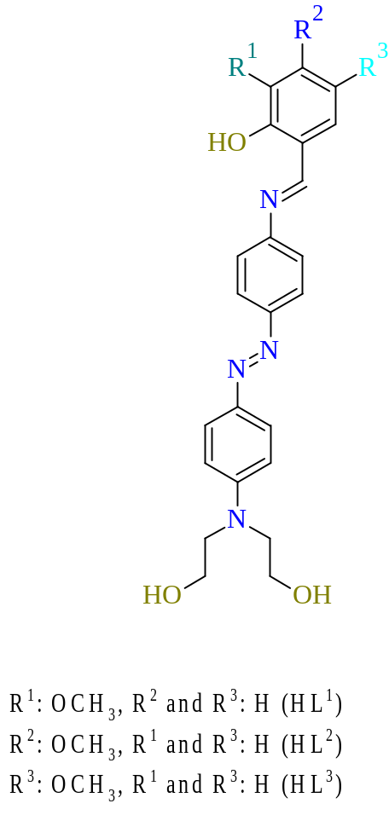
Figure S1. The proposed structures of the azo-imine ligands.

a)

b)

c)

d)
Figures S2a-d. The solid and solution UV-vis spectra of the compounds.
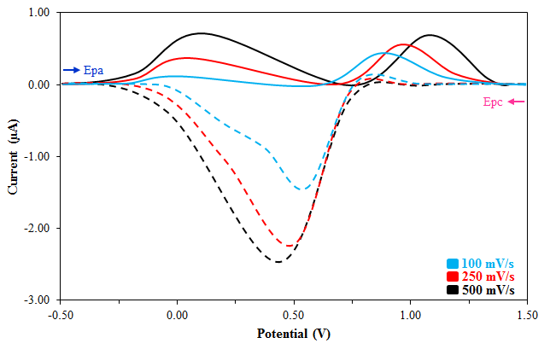
a) KL¹
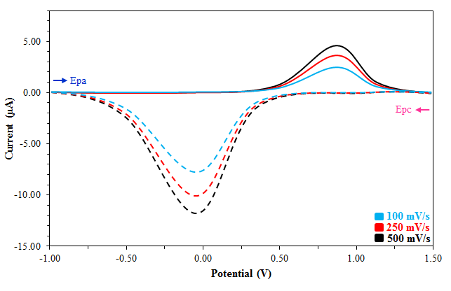
b) KL¹Cu
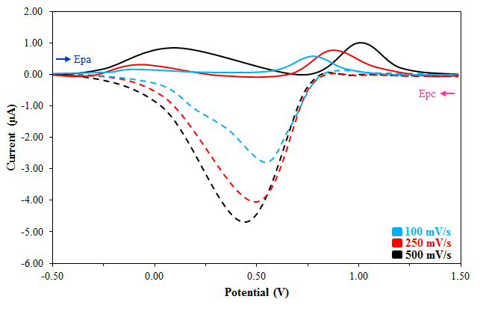
c) KL²
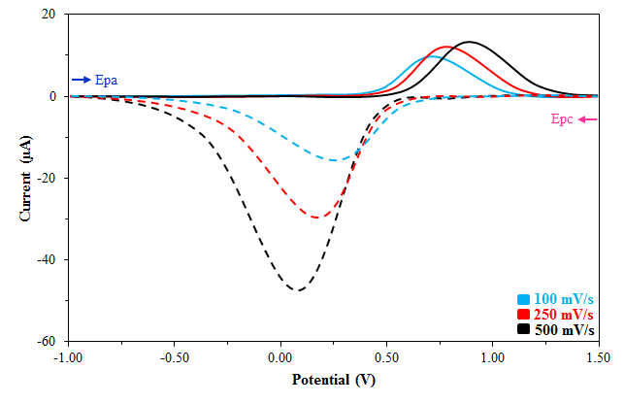
d) KL²Cu

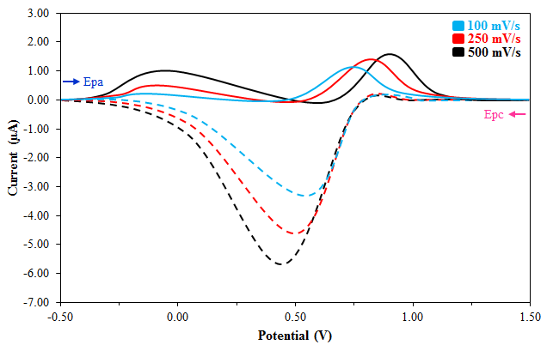
e) KL³
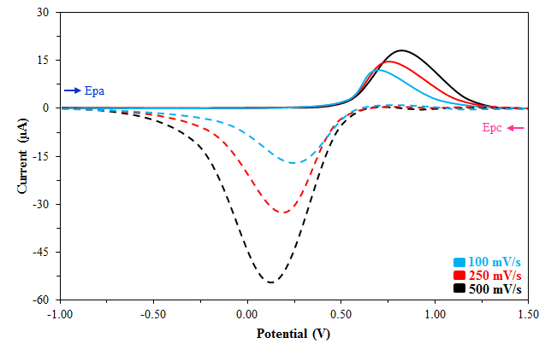
f) KL³Cu
Figures S3a-f. The cyclic voltammograms of the compounds KL¹-KL³ and their Cu²⁺ complexes.

Figures S4. Thermal curves of KL¹-KL³ and their Pt²⁺ complexes

Tablo S. Antimicrobial activity of the compounds as mean of inhibition diameter zone (mm) (100 µl disc⁻¹).
100 µl /Disc (6mm)
Sıra no | Kimyasal Madde ADI | Bacteria |  |  |  |  | Fungi |  | Negative Control (DMF)
Sıra no | Kimyasal Madde ADI | Escherichia coli K12 | Klebsiella spp. | Pseudomonas aeruginosa | Staphylococcus aureus  ATCC 6538 | Staphylococcus epidermidis  B-4268 | Penicillium spp. | Aspergillus niger | Negative Control (DMF)
1 | KL¹Cu  1000 ppm | - | - | - | - | - | 14 | 8 | 0
2 | KL¹Cu  2000 ppm | - | - | - | - | - | 21 | 10 | 0
3 | KL¹Pt  1000 ppm | - | - | - | - | - | 22 | 10 | 0
4 | KL¹Pt  2000 ppm | - | - | - | - | - | 29 | 20 | 0
5 | KL²Cu  1000 ppm | - | - | - | - | - | 10 | 8 | 0
6 | KL²Cu  2000 ppm | - | - | - | 10 | - | 16 | 8 | 0
7 | KL²Pt  1000 ppm | - | - | - | - | - | 14 | - | 0
8 | KL²Pt  2000 ppm | - | - | - | - | - | 18 | - | 0
9 | KL³Cu  1000 ppm | - | - | - | - | - | 14 | - | 0
10 | KL³Cu  2000 ppm | - | - | - | - | - | 20 | 9 | 0
11 | KL³Pt  1000 ppm | - | - | - | - | - | 14 | - | 0
12 | KL³Pt  2000 ppm | - | - | - | - | - | 20 | - | 0

( - ) Not inhibited

References
1. C. Rocchiccioli-Deltcheff, M. Fournier, R. Franck, and R. Thouvenot, Inorg. Chem. 22, 207 (1983).
2. M. X. Yang, S. Lin, L. J. Chen, X. H. Chen, X. H. Yang, and J. Guo, Polyhedron 87, 329 (2015).
3. S. Razmavar, M. A. Abdulla, S. B. Ismail, and P. Hassandarvish, Biomed Res. Int. 2014, (2014).
4. S. Toroglu, J. Environ. Biol. 28, 551 (2007).
5. M. Tümer, E. Akgün, S. Toroǧlu, A. Kayraldiz, and L. Dönbak, J. Coord. Chem. 61, 2935 (2008).

