Additional file 4. Neighbor-Joining tree of P. ovale subspecies (A) and P. vivax (B) samples (Red) in comparison to NCBI sequences based on 18S rRNA gene sequences (Black)

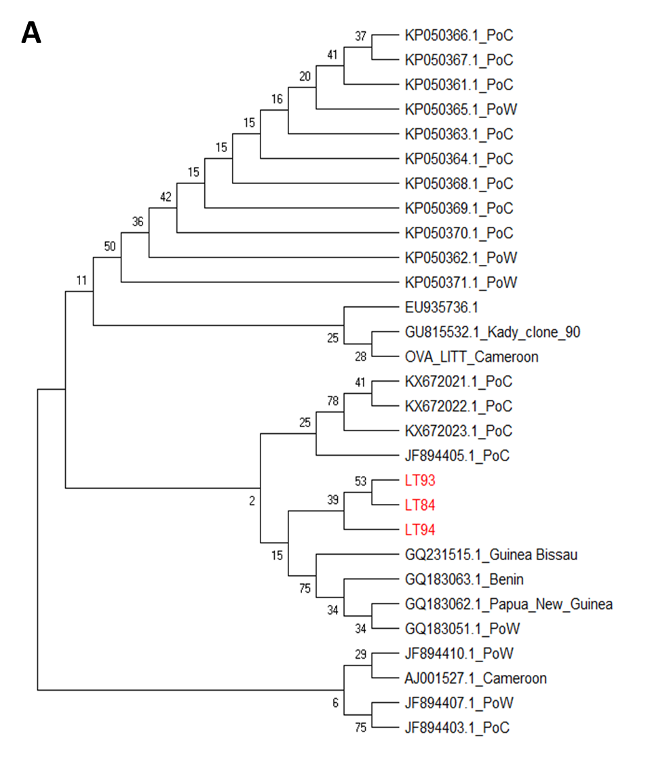
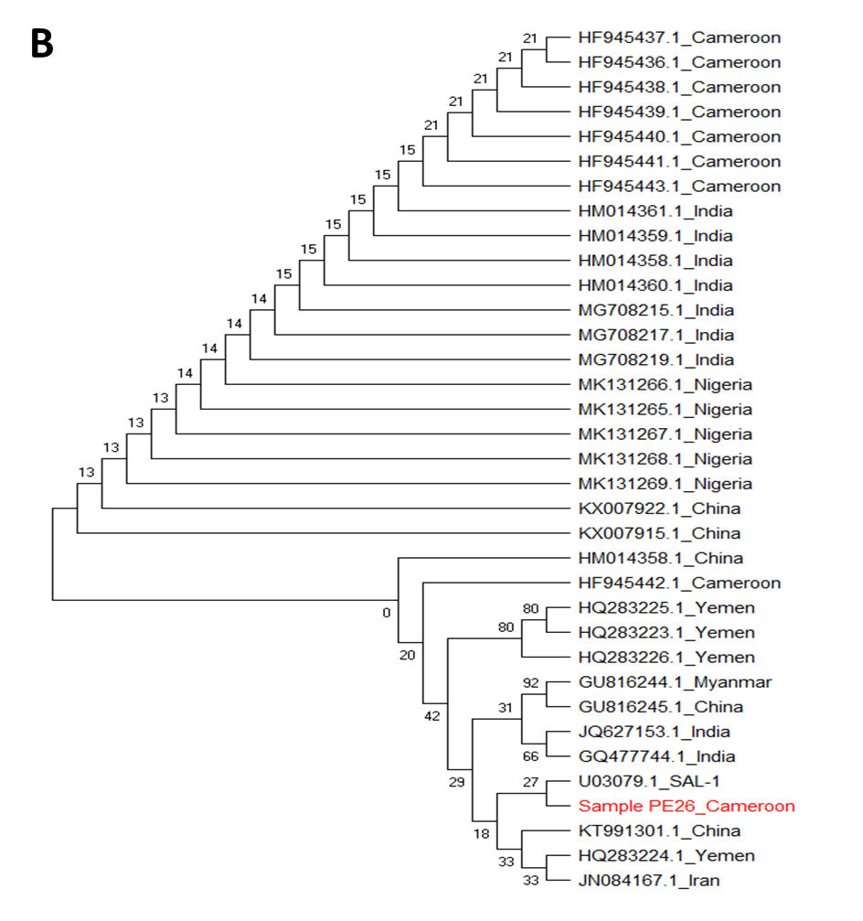
Nodal values represent bootstrap probabilities based on 1000 replicates. PoC: P. ovale curtisi, PoW: P. ovale wallikeri

