Supporting Information

Synthesis of Orange-Red Emissive Au-SG and AuAg-SG Nanoclusters and Their Turn-OFF vs. Turn-ON Metal Ion Sensing

Sagar Bowmik^{1,2} • Shashikana Paria¹ • Ishika Tater¹ • Prasenjit Maity^{1,2}
¹ School of Engineering and Technology, National Forensic Sciences University - Gandhinagar, Sector-09, Gandhinagar –382007, India
² School of Forensic Science, National Forensic Sciences University - Tripura, Radhanagar, Agartala–799001, India
E-mail: prasenjit.maity@nfsu.ac.in (P. Maity); orcid.org/0000−0003−2319−7435

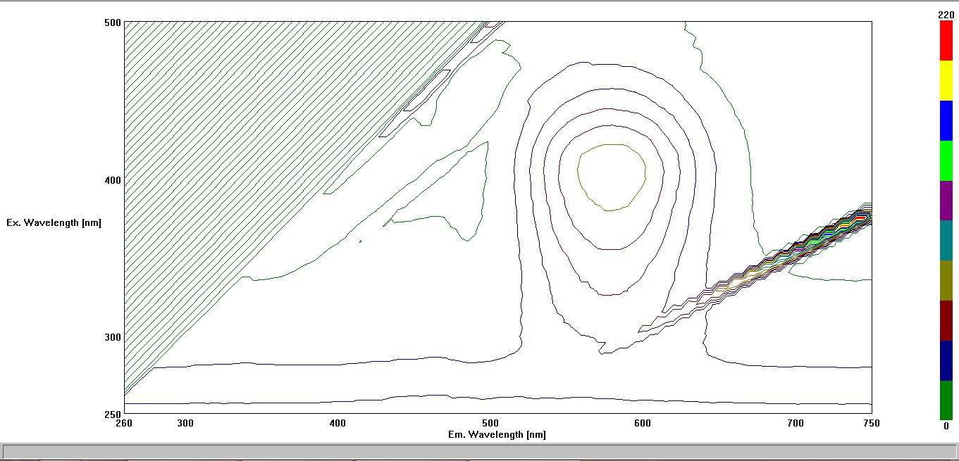
Fig. S1. 3D excitation vs. emission vs. intensity profile of Au-SG cluster.

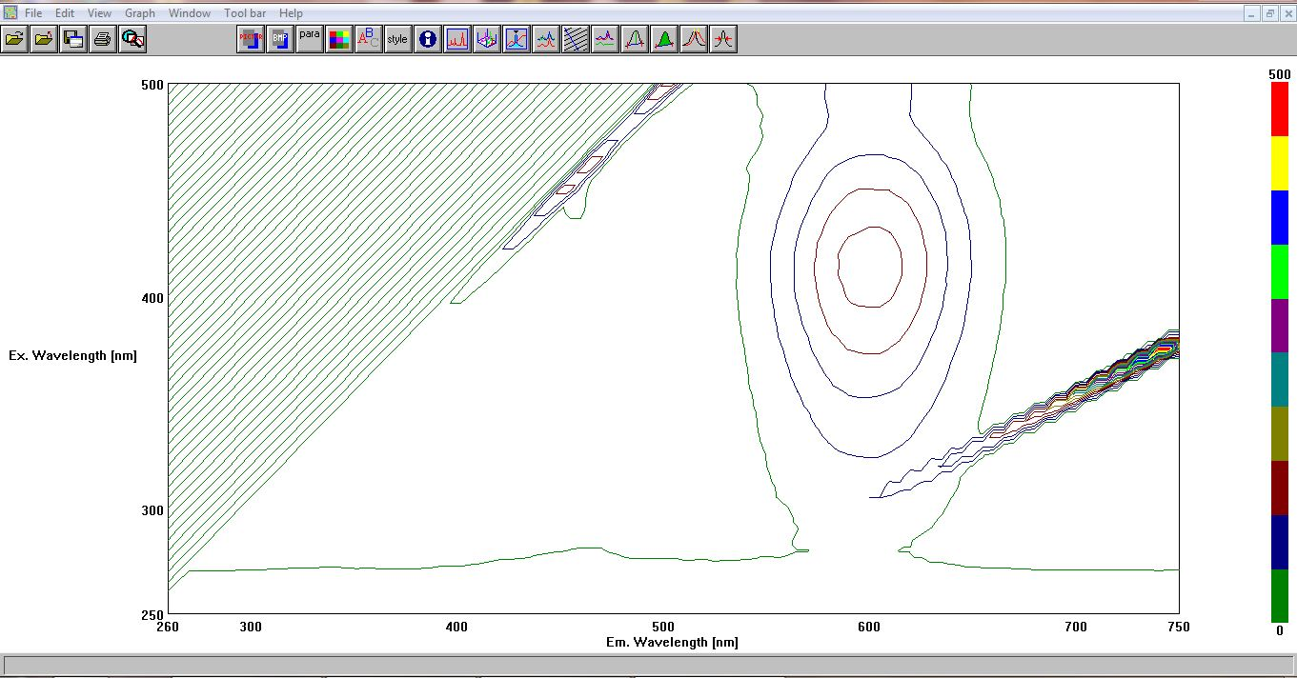
Fig. S2. 3D excitation vs. emission vs. intensity profile of AuAg-SG cluster.
Fig. S3. Luminescence decay profiles and excited state lifetime values of Au-SG cluster during gradual addition of Fe³⁺ ion.

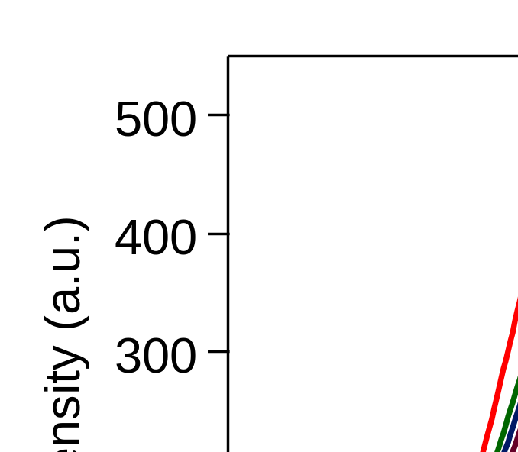
Fig. S4. Emission spectra of AuAg-SG cluster under argon gas purging and Oxygen gas purging conditions.

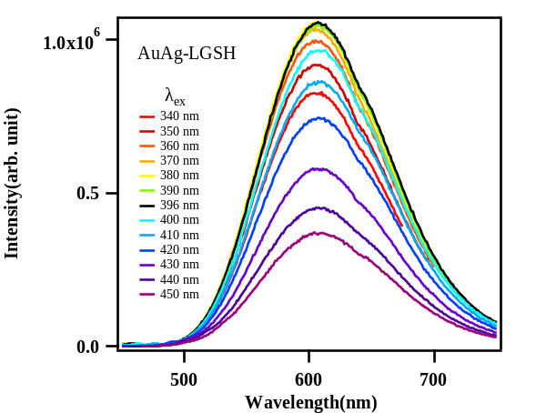
Fig. S5. Excitation wavelength dependent emission spectra of AuAg-SG cluster.

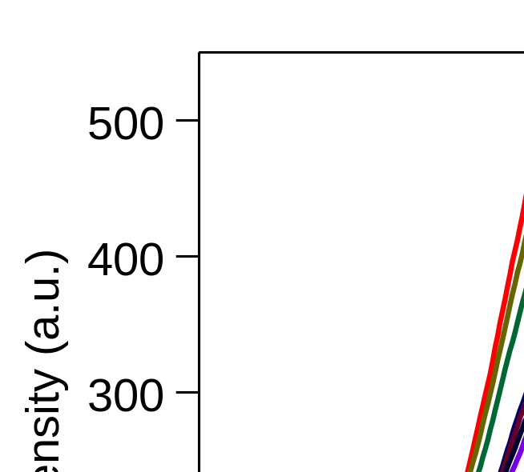
Fig. S6. Emission spectra of AuAg-SG cluster under varying pH conditions.
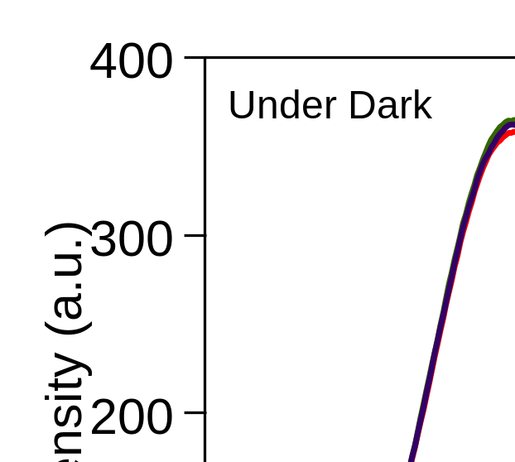
Fig. S7. Stability study of emission spectra of AuAg-SG under dark conditions.

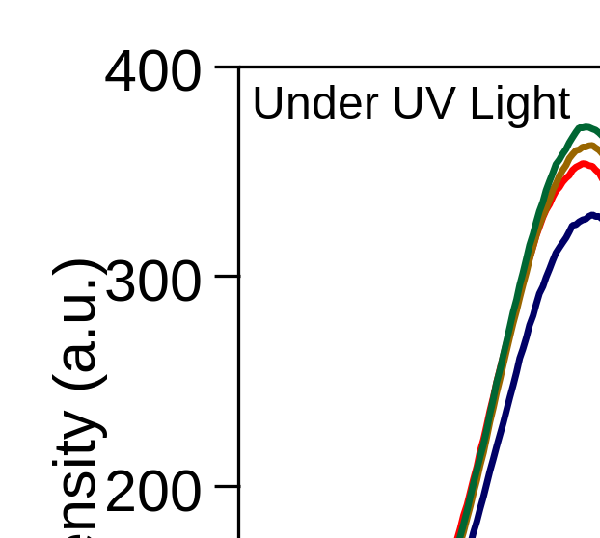
Fig. S8. Stability study of emission spectra of AuAg-SG under UV light conditions.

Fig. S9. Luminescence spectroscopic titration of Au-SG cluster with incremental addition (0 μM to 113.2 μM) of (a) Fe³⁺, (b) Hg²⁺ in water at 298 K under neutral pH of 7.5; (c) Stern-Volmer plots obtained for these two metal ions from the above spectral intensities.

Fig S10. I0/I values of pristine Au-SG and AuAg-SG clusters (value 1) and in presence of 113.2 mM of various salts.
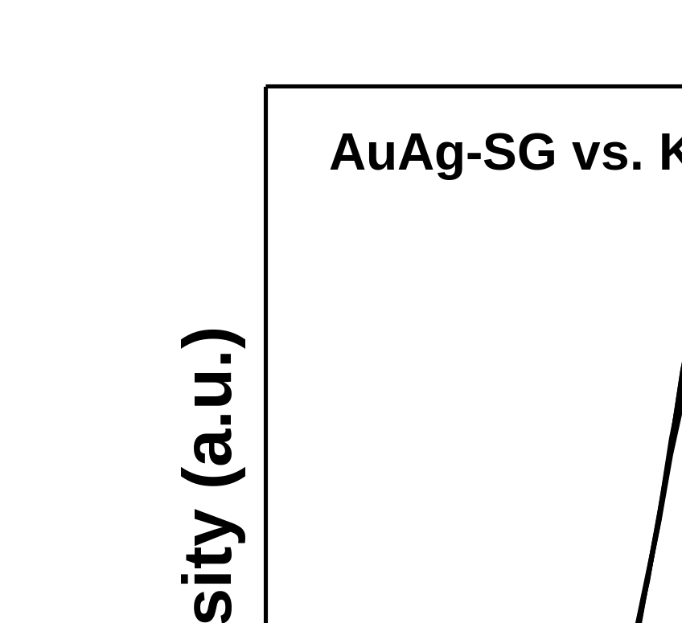
Fig. 11. Luminescence spectroscopic titration of AuAg-SG cluster with incremental addition (0 μM to 113.2 μM) of KBr
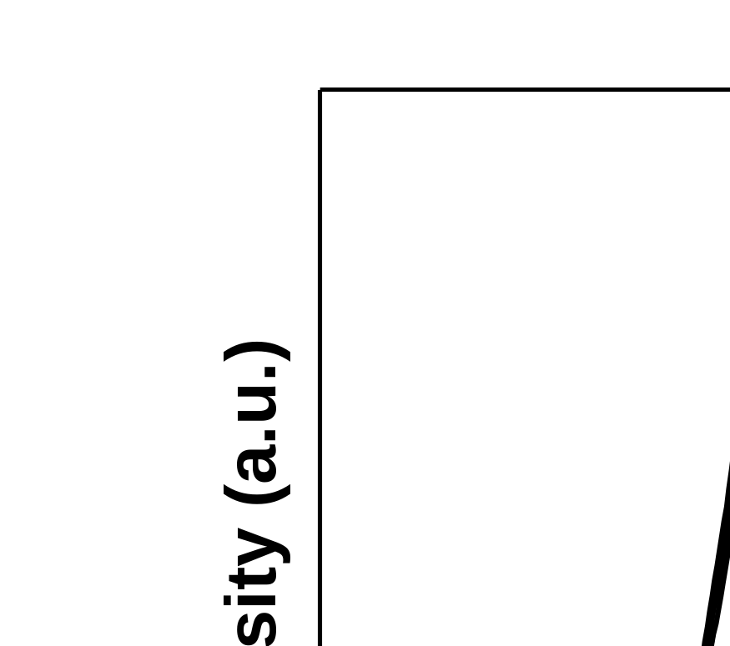

Fig. S12. Luminescence spectroscopic titration of AuAg-SG cluster with incremental addition (0 μM to 113.2 μM) of PbCl₂

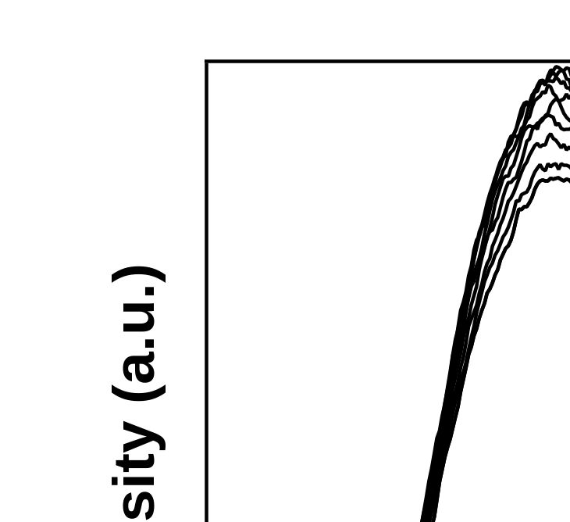
Fig. S13. Luminescence spectroscopic titration of AuAg-SG cluster with incremental addition (0 μM to 113.2 μM) of As₂O_{3.}
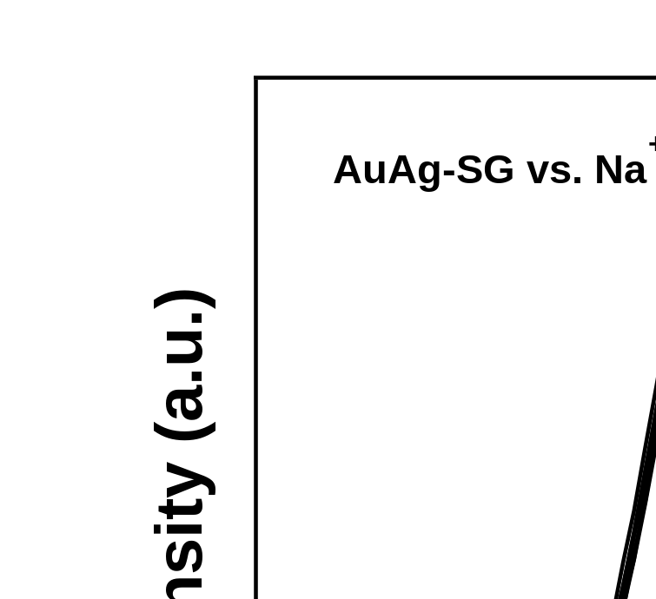
Fig. S14. Luminescence spectroscopic titration of AuAg-SG cluster with incremental addition (0 μM to 113.2 μM) of NaCl
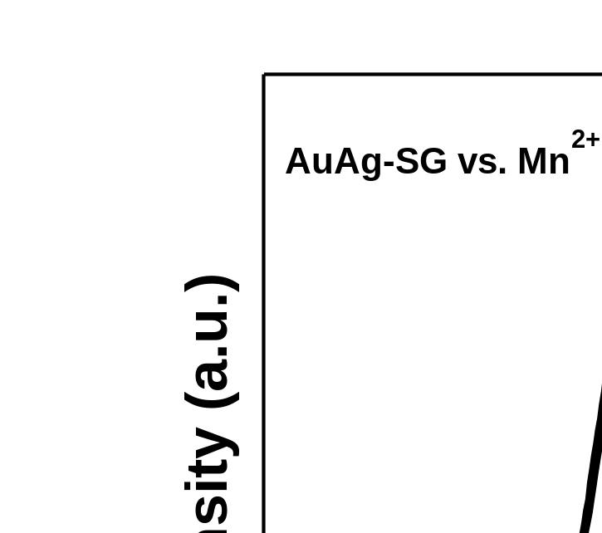
Fig. S15. Luminescence spectroscopic titration of AuAg-SG cluster with incremental addition (0 μM to 113.2 μM) of MnCl₂
Fig. S16. Hydrodynamic diameter of aqueous solution of Au-SG cluster during gradual addition of FeCl_{3.}

