Supporting information
One step dual template facile synthesis of Micro-Mesoporous ZSM-5 Composite and its application in 5-(ethoxymethyl)furfural (biofuel additive) synthesis
Prajakta N. Manal, P. S. Niphadkar, SachinNandanwar, V.V. Bokade*
Catalysis & Inorganic Chemistry Division, CSIR-National Chemical Laboratory,Dr.HomiBhabha Road, Pashan, Pune 411008, INDIA

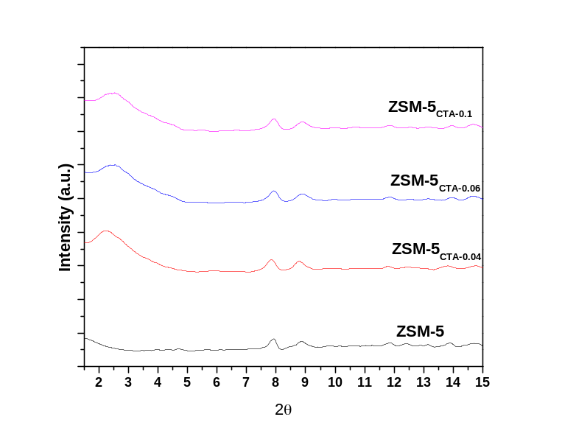
Fig. S1- Low angle Powder X-ray diffraction pattern of ZSM-5 & Mesoporous ZSM-5

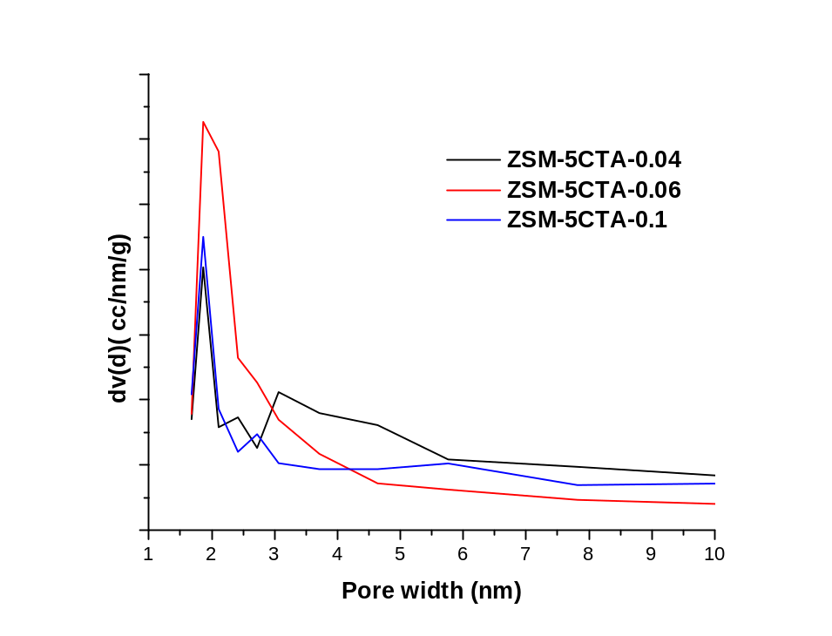
Fig. S2. Pore size distribution of Isotherm of N₂ adsorption and desorption of ZSM-5_{CTA-0.04 ,} ZSM-5_{CTA-0.06 ,} and ZSM-5_{CTA-.0.1}

