Supporting Information

Record-High Gain Unipolar Barrier Solar Blind Avalanche Photodetector via Deliberate Lattice and Band Engineering

Qingyi Zhang,¹ Ning Li,¹ Tao Zhang,¹ Dianmeng Dong,¹ Yongtao Yang,¹ Yuehui Wang,¹ Zhengang Dong,¹ Jiaying Shen,¹ Tianhong Zhou,² Yuanlin Liang,² Weihua Tang,¹ Yang Zhang,^{2, a)} Zhenping Wu,^{1, a)} Jianhua Hao^{3, a)}

¹ State Key Laboratory of Information Photonics and Optical Communications & School of Science, Beijing University of Posts and Telecommunications, Beijing 100876, P. R. China

² Institute of Modern Optics & Tianjin Key Laboratory of Micro-Scale Optical Information Science and Technology, Nankai University, Tianjin 300071, P. R. China

³ Department of Applied Physics, The Hong Kong Polytechnic University, Hung Hom, Hong Kong, P. R. China

^{a)} Corresponding author. Emails: yangzhang@nankai.edu.cn, zhenpingwu@bupt.edu.cn, and jh.hao@polyu.edu.hk.

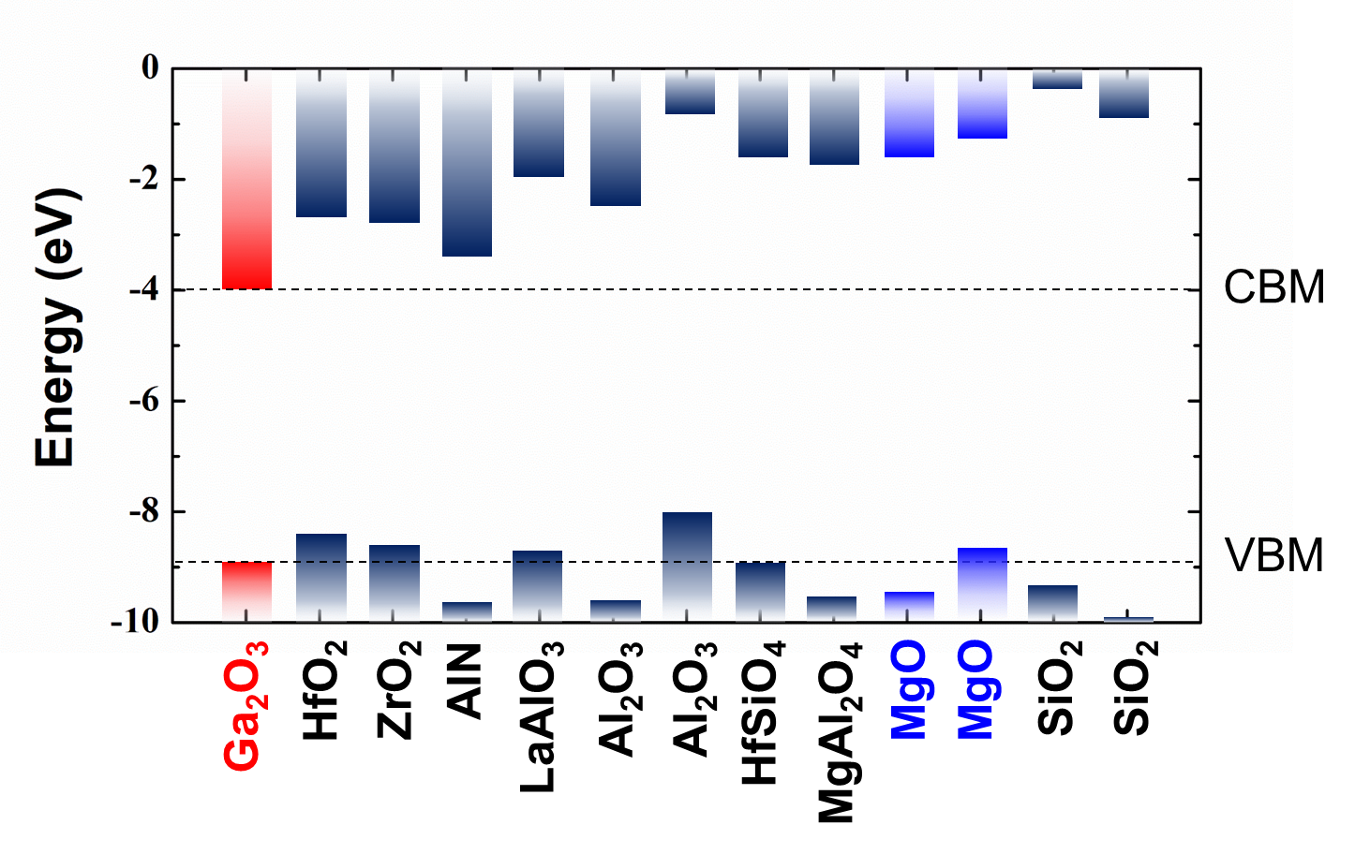
Fig. S1. Schematic band diagram of Ga₂O₃ with other wide bandgap dielectrics.

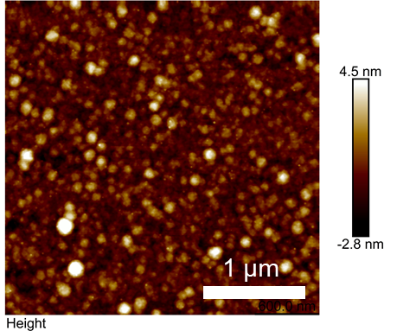

Fig. S2. Surface topography acquired by atomic force microscopy (AFM).

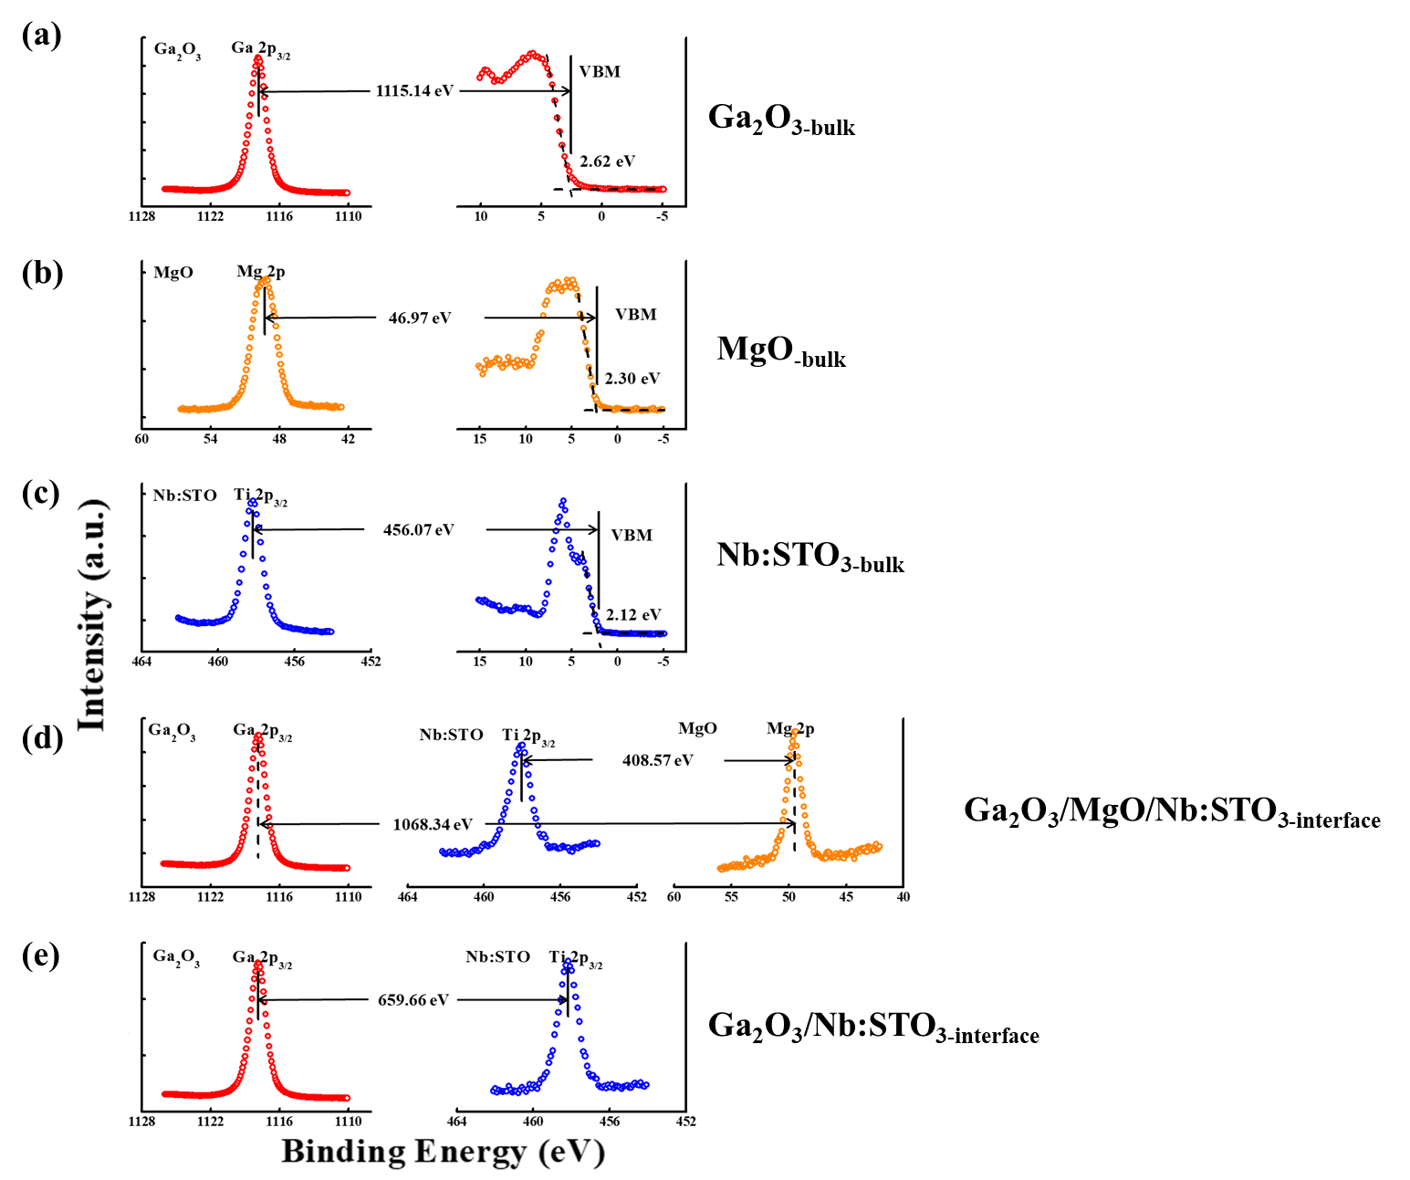
Fig. S3. XPS measurements of Ga₂O₃/MgO/Nb:STO and Ga₂O₃/Nb:STO heterostructures. (a) Ga 2p core level and valence band spectra of Ga₂O₃ bulk. (b) Mg 2p core level and valence band spectra of MgO bulk. (c) Ti 2p core level and valence band spectra of Nb:STO bulk. (d) Ga 2p, Mg 2p, and Ti 2p core-level spectra of the ultrathin Ga₂O₃ (3 nm)/MgO (2 nm)/Nb:STO. (e) Ga 2p and Ti 2p core-level spectra of the ultrathin Ga₂O₃ (3 nm)/Nb:STO.

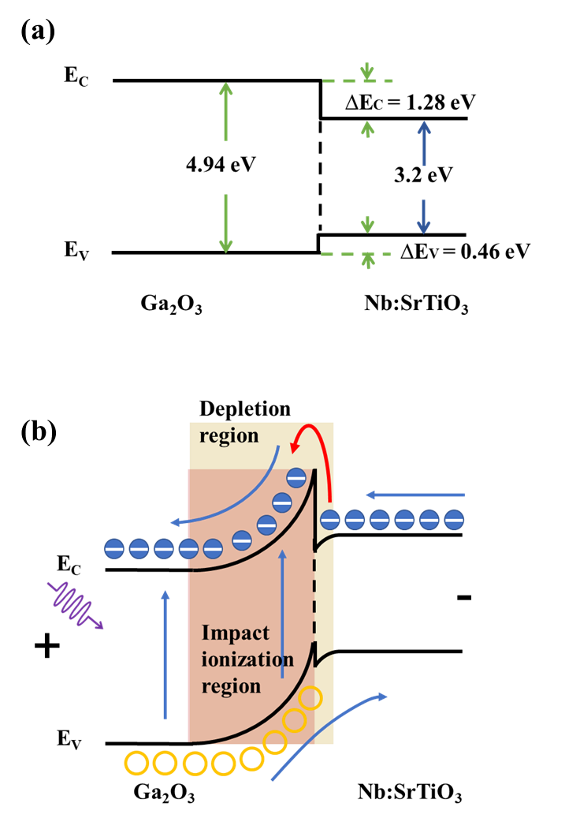
Fig. S4. Band diagram of Ga₂O₃/ Nb:STO heterostructure in equilibrium conditions (a) and in avalanche condition (b)

Fig. S5. Avalanche threshold voltage as a function of temperatures in dark.

Fig. S6. Reverse I-V characteristics of the isotype Ga₂O₃/Nb:STO APD in the dark and under various intensity 254 nm light illumination.

Fig. S7. The responsivity as functions of light intensities and applied bias of the isotype Ga₂O₃/Nb:STO APD.

Fig. S8. The detectivity as functions of light intensities and applied bias of the isotype Ga₂O₃/Nb:STO APD.

Supplementary Table 1. Comparison of the figure-of-merits among reported Ga₂O₃ APD, AlGaN APD and PMT.

Device  structures | Modes | Gain  (a.u.) | R  (A/W) | D*  (Jones) | Bias  (V) | Response speed | ref
ZnO−Ga₂O₃ Core−Shell | n-n | 2.92×10⁴ | 15.18×10³ | 9.91×10¹⁴ | -10 | 20 μs/42 μs | ^{[1]}
β-Ga₂O₃/SnO₂ | n-n | 2.5×10⁵ | 6.3×10³ | 1.7×10¹⁵ | -10 | 48 μs/102 μs | ^{[2]}
ITO/Ga₂O₃ | n-n | 6.8×10⁴ | 5.9×10⁴ | 1.8×10¹⁴ | -40 | - | ^{[3]}
α-Ga₂O₃/ZnO | n-n | 5224 | 1.1×10⁴ | 2.3×10¹⁵ | -40 | 238 μs/3.04 ms | ^{[4]}
Ga₂O₃ | Schottky | 1.7×10⁴ | 1.2×10⁵ | 2×10¹⁶ | -40 | -/90 ms | ^{[5]}
AlGaN | p–i–n | 2×10⁴ | 2.55×10⁵ | 6.31×10¹⁴ | -140 | - | ^{[6]}
AlGaN | p–i–n | 2500 | 2.128 | 3.33×10¹⁰ | -62 | - | ^{[7]}
AlGaN | Schottky | 1560 | 666.67 | 1.4×10¹⁴ | -68 | - | ^{[8]}
AlGaN | Schottky | 4000 | 29.4 | 1.54×10¹² | -177 | - | ^{[9]}
PMT | - | >5×10⁵ | >1.4×10⁴ | >5×10¹⁶ | -1500 | 4 ns/30 ns | ^{[10]}
Ga₂O₃/MgO/Nb:STO | nBn | 5.86×10⁵ | 4.46×10⁵ | 3.28×10¹⁷ | -78.1 | 12.4 ns/41.7 μs | This work

Supplementary References
1 Zhao, B. et al. Solar-blind avalanche photodetector based on single ZnO-Ga₂O₃ core-shell microwire. Nano Lett 15, 3988-3993, (2015).
2 Mahmoud, W. E. Solar blind avalanche photodetector based on the cation exchange growth of β-Ga₂O₃/SnO₂ bilayer heterostructure thin film. Sol. Energy Mater. Sol. Cells 152, 65-72, (2016).
3 Wang, Y. et al. Ultrahigh gain solar blind avalanche photodetector using an amorphous Ga₂O₃-based heterojunction. ACS Nano 15, 16654-16663, (2021).
4 Chen, X. et al. Solar-blind photodetector with high avalanche gains and bias-tunable detecting functionality based on metastable phase α-Ga₂O₃/ZnO isotype heterostructures. ACS Appl. Mater. Interfaces 9, 36997-37005, (2017).
5 Li, Z. et al. High-performance β-Ga₂O₃ solar-blind schottky barrier photodiode with record detectivity and ultrahigh gain via carrier multiplication process. IEEE Electron Device Lett. 41, 1794-1797, (2020).
6 Wu, H. et al. All AlGaN epitaxial structure solar-blind avalanche photodiodes with high efficiency and high gain. Appl. Phys. Express 9, 052103, (2016).
7 Sun, L., Chen, J., Li, J. & Jiang, H. AlGaN solar-blind avalanche photodiodes with high multiplication gain. Appl. Phys. Lett. 97, 191103, (2010).
8 Tut, T., Gokkavas, M., Inal, A. & Ozbay, E. Al_{x}Ga_{1−x}N-based avalanche photodiodes with high reproducible avalanche gain. Appl. Phys. Lett. 90, 163506, (2007).
9 Huang, Z., Li, J., Zhang, W. & Jiang, H. AlGaN solar-blind avalanche photodiodes with enhanced multiplication gain using back-illuminated structure. Appl. Phys. Express 6, 054101, (2013).
10 Photomultiplier tube products from Hamamatsu Photonics, <www.hamamatsu.com/us/en/product/optical-sensors/pmt/pmt_tube-alone/head-on-type.html> (2022).

