Supporting Information
Contactless Manipulation of Mixed Phase Fluids in Liquid Crystal Polymer Microtubes Assisted with Light-Driven Vortex

Yao Lu,^{1,5} Lang Qin,^{1,5} Quan Liu,¹ Zichuan Li,³ Weijia Zhang,² Chongyu Zhu,¹* and Yanlei Yu,^{1,4}*
¹Department of Materials Science & State Key Laboratory of Molecular Engineering of Polymers, Fudan University, 220 Handan Road, Shanghai 200433, P. R. China.
²Institutes of Biomedical Sciences & State Key Laboratory of Molecular Engineering of Polymers, Fudan University, 220 Handan Road, Shanghai 200433, P. R. China.
³Academy for Engineering and Technology, Fudan University, 220 Handan Road, Shanghai 200433, P. R. China.
⁴Yiwu Research Institute of Fudan University, Chengbei Road, Yiwu City, Zhejiang 322000, P. R. China.
⁵These authors contributed equally: Yao Lu, Lang Qin.
*E-mail: ylyu@fudan.edu.cn; cy_zhu@fudan.edu.cn

1. Synthesis of the linear liquid crystal polymer (LLCP)
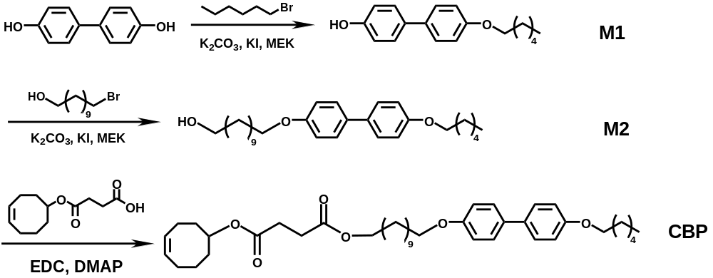
Figure 1. Synthesis route of the homopolymer CBP.

Synthesis of 4'-(hexyloxy)-[1,1'-biphenyl]-4-ol (M1):
4,4'-Dihydroxybiphenyl (7.44 g, 40 mmol), 1-bromohexane (3.28 g, 20 mmol) and potassium carbonate (11.00 g, 80 mmol) were added into 500 mL flask and dissolved by 250 mL methyl ethyl ketone (MEK). The mixture was heated at 80 °C for 12 h and concentrated under vacuum. The crude product was purified by column chromatography (petroleum ether/dichloromethane, 80/20) on silica gel to give a white solid M1 (4.35 g, 81%).
Synthesis of 11-((4'-(hexyloxy)-[1,1'-biphenyl]-4-yl)oxy)undecan-1-ol (M2):
M1 (2.70 g, 10 mmol), 11-bromoundecan-1-ol (2.50 g, 10 mmol) and sodium potassium carbonate (5.50 g, 40 mmol) were added into 500 mL flask and dissolved by 250 mL MEK. The mixture was heated at 80 °C for 12 h and concentrated under vacuum. The crude product was purified by column chromatography with dichloromethane on silica gel to give a white solid M2 (3.99 g, 90%).
Synthesisofcyclooct-4-en-1-yl(11-((4'-(hexyloxy)-[1,1'-biphenyl]-4-yl)oxy) undecyl)succinate (CBP):
M2 (3.54 g, 8 mmol), 4-(cyclooct-4-en-1-yloxy)-4-oxobutanoic acid (1.80 g, 8 mmol) and 4-dimethylaminopyridine (DMAP, 0.96 g, 0.8 mmol) were added into 500 mL flask and dissolved by 200 mL dichloromethane. Then, dicyclohexylcarbodiimide (DCC, 4.52 g, 20 mmol) in 80 mL dichloromethane was added dropwise into the mixture. After stirring at room temperature for 12 h, the mixture was filtrated to remove the precipitates. The white solid BP was obtained by column chromatography with silica gel using dichloromethane (4.45 g, 86%).
Synthesis of the CAB:
The monomer CAB was obtained according to the published work. ^{[1]}
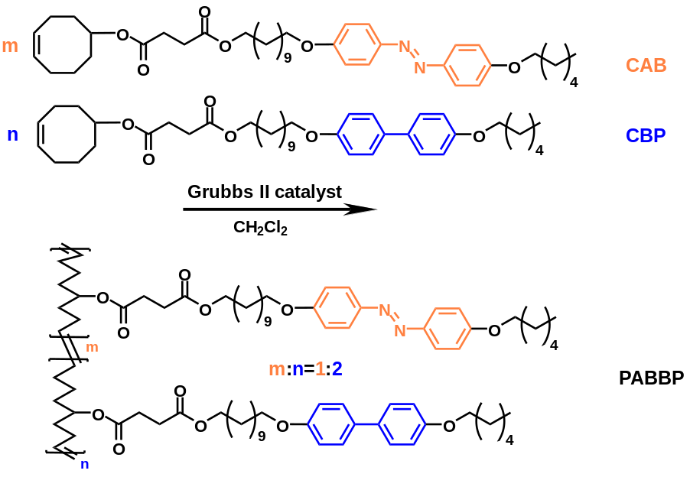
Figure 2. Synthesis route of the LLCP (feed ratio = 1:2).

Synthesis of the LLCP:
The LLCP was obtained according to the published work.^{[2]} The polymerization was performed using standard Schlenk techniques under a nitrogen atmosphere. CAB (0.13 g, 0.2 mmol) and CBP (0.26 g, 0.4 mmol) were added into a Schlenk flask. Then, 0.02 mol second-generation Grubbs catalyst with 3 mL anhydrous dichloromethane was added to the mixture. After stirring for 6 h at 45 °C, the yellow solid polymer was precipitated from methanol (0.37 g, 96%).

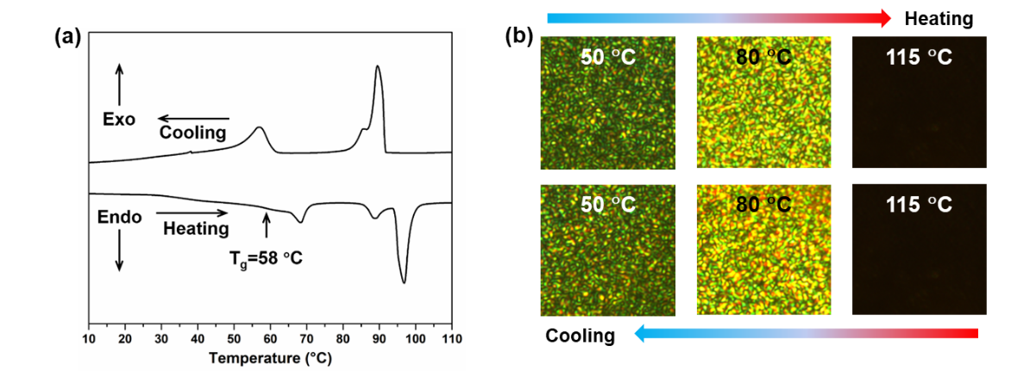
Figure 3. (a) DSC curves of the LLCP upon the second heating and cooling processes. The heating and cooling rate is 10 °C min⁻¹. The DSC curves show that the LLCP exhibits two liquid crystal phases before turning into isotropic phase at about 98 °C. The phase transition temperature between the two liquid crystal phases is about 68 °C. The glass transition temperature is 58 °C. (b) Polarizing optical microscope images of the LLCP at various temperatures.

2. Preparation and photodeformation of the photo/magnet-controlled microtube (PTMs)
The filtered the LLCP dichloromethane solution (3 wt%) was filled into ethylene-vinyl acetate (EVA) microtubes. After the removal of dichloromethane at 40 °C and the annealing process at 60 °C for 1 h, the LLCP was coated uniformly on the inner surface of the EVA microtube substrates to obtain a bilayer microtube. Then, bovine serum albumin (BSA) buffer solution (5 wt%) was filled into the bilayer microtube and incubated in constant temperature refrigerator at 5 °C for 12 h.

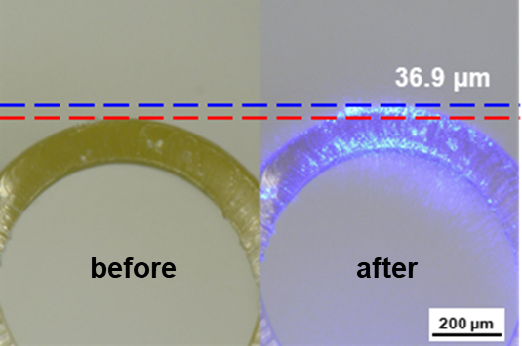
Figure 4. Photographs of local radial expansion of the PTM cross section before and after the irradiation of 470 nm light (80 mW cm⁻²).

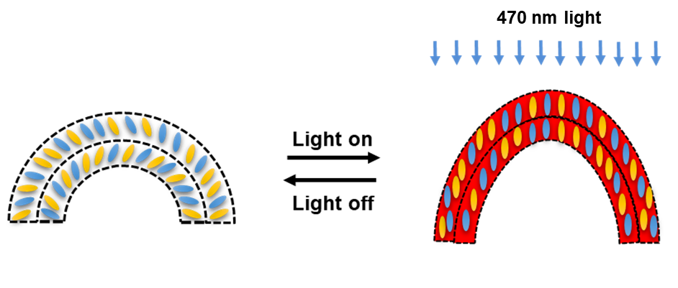
Figure 5. Schematic diagram to show the mechanism of the LLCP layer deformation upon 470 nm light. The mechanism of the deformation is attributed to the ‘Weigert effect’, i.e., the aligned azobenzene mesogens in the LLCP reorient along the propagation direction of the light by trans-cis-trans isomerization cycles, leading to a local radial expansion of the PTM cross section upon the 470 nm light.

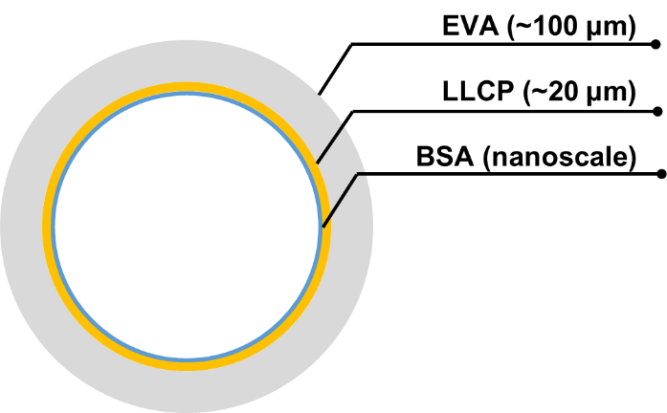
Figure 6. Schematic representation showing the relative thickness of each layers of the PTM.

Figure 7. A plot to show the moving speeds of a 5 μL PBS droplet and magnetic nanoparticle (MNP) suspension in the PTM at different light intensities. Moving speed here is the average speed of droplet within a distance of 50 mm driven by the light.

3. BSA modification and measurement of nonspecific adsorption of the PTMs
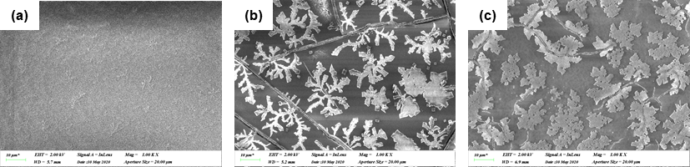
Figure 8. Scanning electron microscopy photographs of the PTM inner wall before (a) and after (b) BSA modification. BSA formed dendritic crystal microstructures on the PTM inner layer. (c) Scanning electron microscopy photographs of the PTM inner wall after finishing the protein analysis processes. The dendritic crystal microstructures of BSA are remained.

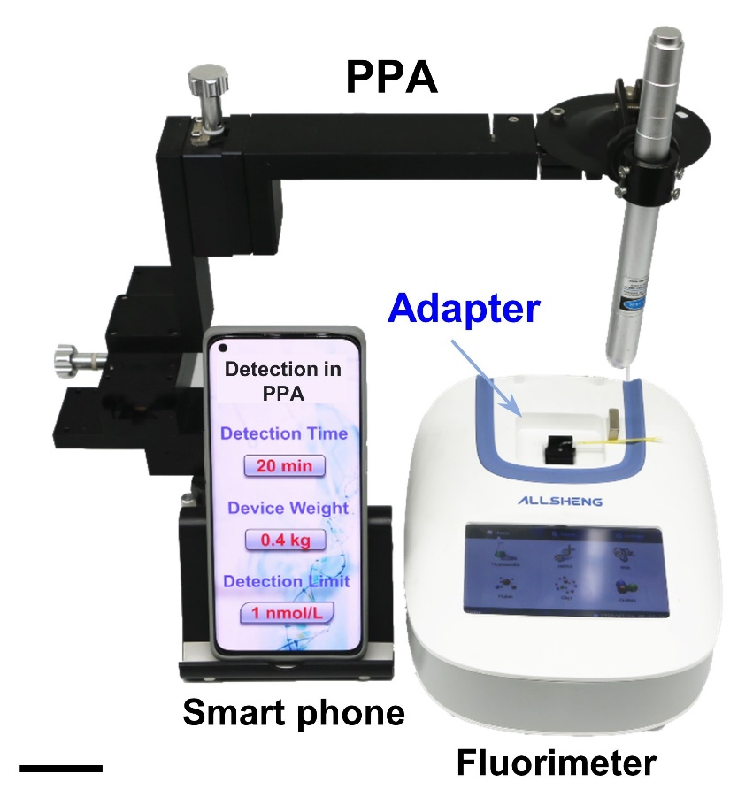
Figure 9. A photograph showing the construction of the portable protein analyzer (PPA). A PTM is connected with an adapter inserted into a mini-fluorimeter, which is used to detect the fluorescent signal. The detection results are recorded by a smart phone. Scar bar: 5 cm.

4. Synthesis of the biotin-MNPs
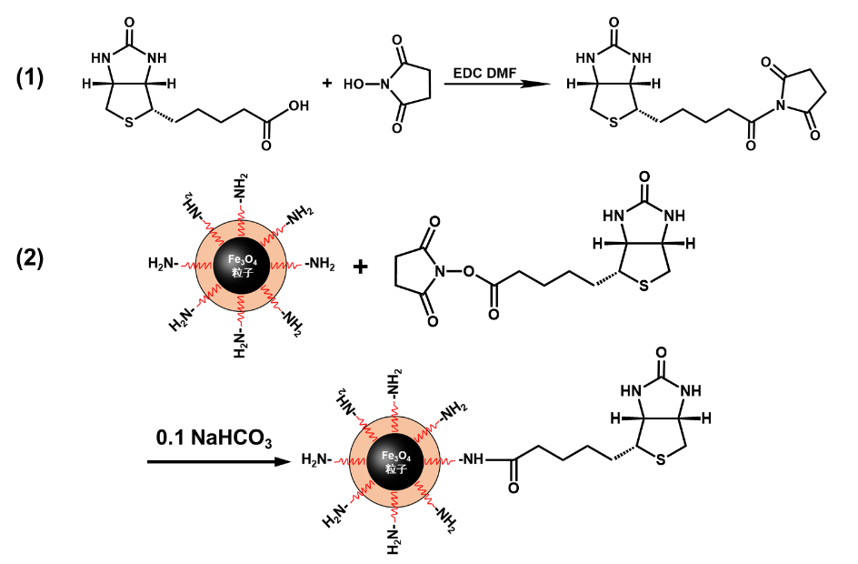
Figure 10. Synthesis route of the biotin-MNPs.

Synthesis of biotinyl-N-hydroxysuccinimide ester (biotin-NHS)
Biotin was treated with N-Hydroxysuccinimide (NHS) and 3-(3-Dimethylaminopropyl)-1-Ethylcarbodiimide Hydrochloride in a molar ratio of 1:1:1.2 in dry N, N’-dimethylformamide under nitrogen atmosphere at room temperature for 24 h to give a white precipitate. The reaction mixture was filtered, and the filtrate was evaporated and triturated with ether. The white precipitate was filtered and washed with diethyl ether to afford a white powder.

Conjugation of biotin-NHS to MNPs-NH₂
MNPs modified with -NH₂ (MNPs-NH₂) with a diameter of 100-200 nm were purchase from BaseLine® limited company, Tianjin, China. 108 mg of biotin-NHS was dissolved in 5 mL of dimethylsulphoxide and then 12 mg of MNPs-NH₂ were added to the solution and kept mechanical stirring for 24 h. the resulting biotinylated MNPs was then centrifuged at 1000 rpm at 4-5 °C for 10 min to afford the biotin-MNPs, which were then washed with PBS buffer and were dried in a vacuum at 40 °C for 12 h.

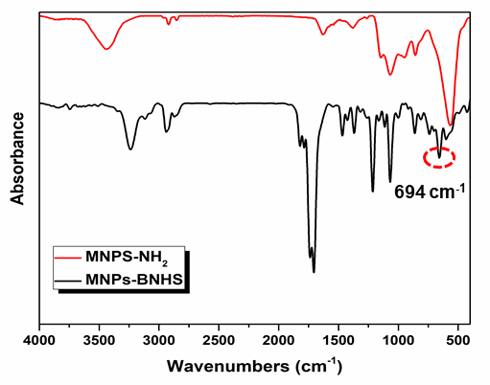
Figure 11. FT-IR spectra of MNPs-NH₂ before and after biotin modification. The characteristic peak at 694 cm⁻¹ is the absorption of thiophene ring of biotin, which indicates that biotin molecules are successfully modified on the MNPs.

Figure 12. The particle size distribution curve of the MNPs.

5. Protein extraction and detection by the PTM
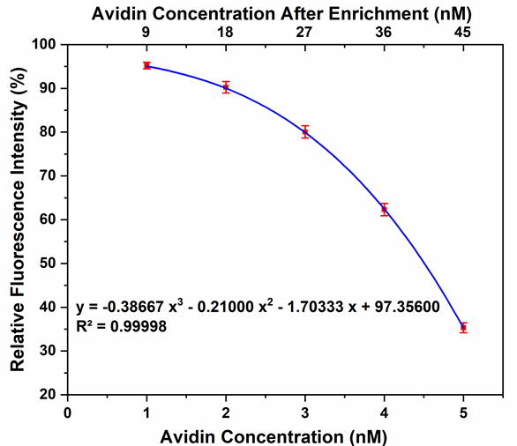
Figure 13. A plot to show the standard detection curve of avidin protein samples with low concentration. The low concentration avidin samples are enriched in the PTM for 9 times and then detected. The detection limit reaches 1 nom L⁻¹ (pmol mL⁻¹) after enrichment. The fitting function is y = -0.38667x³ - 0.21x² -1.7033x + 97.356, fitting constant R² = 0.99998.

The prerequisite for protein analysis in the PTM is to ensure that the target protein cannot be nonspecific adsorbed by the inner wall. Droplets of 5 μL avidin solution with concentration of 0.5 mg/mL were preloaded and incubated in the PTMs before and after BSA modification. The droplet was then exported at intervals to detect the decrease of avidin protein content in the supernate, which was nonspecifically absorbed by the PTM inner wall. The content of avidin in supernate was determined by standard enzyme-linked immunoassay (ELISA).
ELISA kits for chicken avidin was purchased from Ruixin Biotech Ltd. The detailed operation processes are listed below.
- Sample preparation. Add PBS into the supernatant and dilute it to 50 μL.
- Determine wells for diluted standard, blank and sample. Prepare 5 wells for standard points, 1 well for blank. Add 50 µL each of dilutions of standard, blank and samples into the appropriate wells, respectively. And then add 50 µL of Detection Reagent A to each well immediately. Shake the plate gently by using a microplate shaker. Cover with a Plate sealer. Incubate for 1 hour at 37 °C.
- Aspirate the solution and wash with 350 µL of 1X Wash Solution to each well using a squirt bottle, multi-channel pipette, manifold dispenser or auto washer, and let it sit for 1-2 minutes. Remove the remaining liquid from all wells completely by snapping the plate onto absorbent paper. Repeat 3 times. After the last wash, remove any remaining Wash Buffer by aspirating or decanting. Invert the plate and blot it against absorbent paper.
- Add 100µL of Detection Reagent B working solution to each well. Incubate for 30 minutes at 37 °C after covering it with the Plate sealer.
- Repeat the aspiration/wash process for total 5 times as conducted in step 3.
- Add 90 µL of Substrate Solution to each well. Cover with a new Plate sealer. Incubate for 10-20 minutes at 37 °C. Protect from light. The liquid turns blue by the addition of Substrate Solution.
- Add 50 µL of Stop Solution to each well. The liquid turns yellow by the addition of Stop solution. Mix the liquid by tapping the side of the plate.
- Remove any drop of water and fingerprint on the bottom of the plate and confirm there is no bubble on the surface of the liquid. Then, run the microplate reader and conduct measurement at 450 nm immediately.
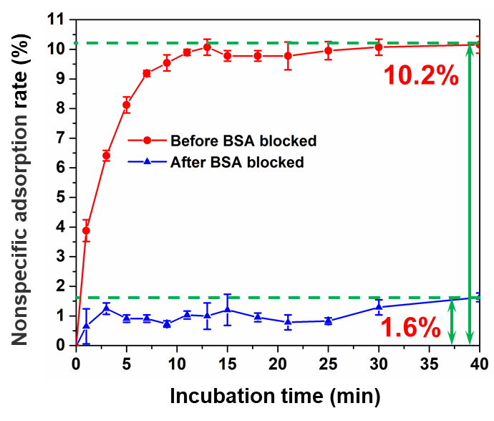
Figure 14. Non-specific adsorption rate of target avidin protein and incubation time in the PTM before and after BSA blocking modification. The results show that the non-specific adsorption of the PTM to target avidin protein decreases from 10.2 % to 1.6% after BSA modification.

6. Protein enrichment in the PPA
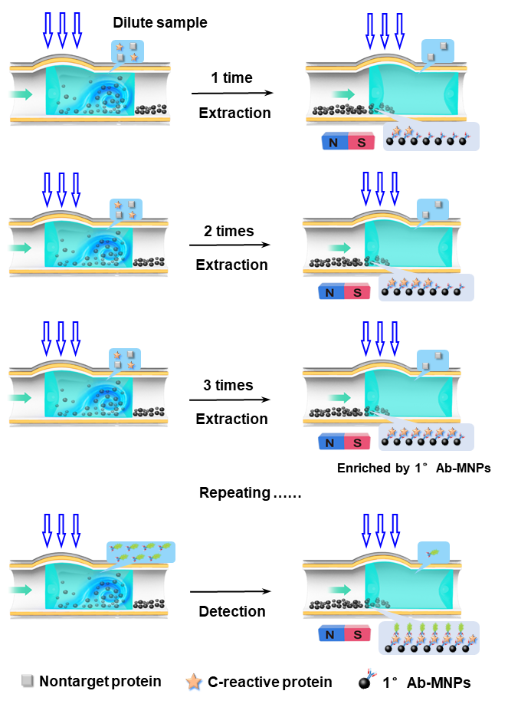
Figure 15. Schematic representation of the protein enrichment by repeating the extraction step.

7. References
[1] J. Lv, Y. Liu, J. Wei, E. Chen, L. Qin, Y. Yu, Nature 2016, 537, 179.
[2] B. Xu, C. Zhu, L. Qin, J. Wei, Y. Yu, Small 2019, 15, 1901847.

8. NMR spectra
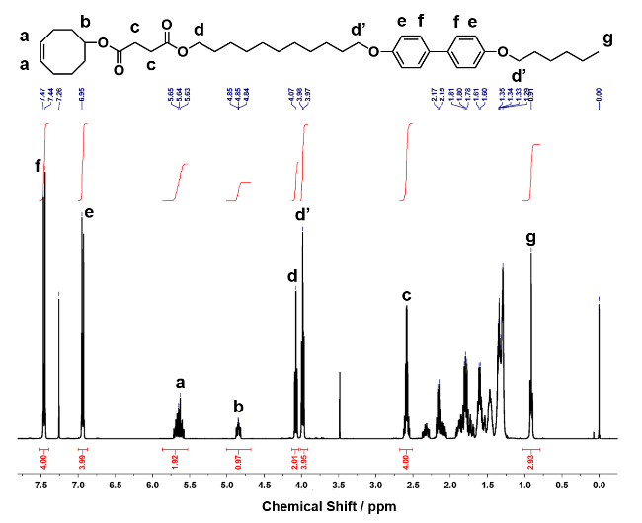
The ¹H NMR spectra of the monomer AB was reported in the previous literature
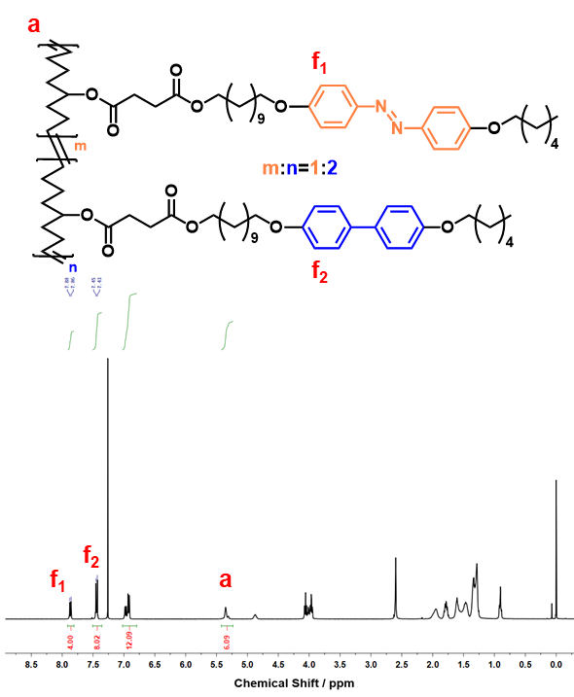
The ¹H NMR spectra of the LLCP. After polymerization, the double bond peaks originally at 5.7 ppm (peak a in Figure S1) is displaced to 5.4 ppm (peak a), indicating that the polymerization is complete. The integration ratio of the peak area of f₁ and f₂ is about 1:2, indicating that the relative ratio of the two monomers conformed to the design of 1:2.

9. Supplementary movie descriptions
Video 1
The detailed operation processes, including suspending, depositing, and separating of liquid/solid mixed phases in the PTM under photo/magnet-combined control. The movie was shot with an optical filter between the target PTM and the camera lens to filter light below 530 nm, which effectively eliminates the dazzle of 470 nm light.

