Supporting Information

Construction of an Escherichia coli cell factory to synthesize taxadien-5α-ol, the key precursor of anti-cancer drug paclitaxel
Qing-Yang Wu, Zheng-Yu Huang, Jin-Yi Wang and Hui-Lei Yu* and Jian-He Xu
ª State Key Laboratory of Bioreactor Engineering, Shanghai Collaborative Innovation Centre for Biomanufacturing, College of Biotechnology, East China University of Science and Technology, Shanghai 200237, P. R. China.

* Corresponding author:
Prof. Hui-Lei Yu, email: huileiyu@ecust.edu.cn

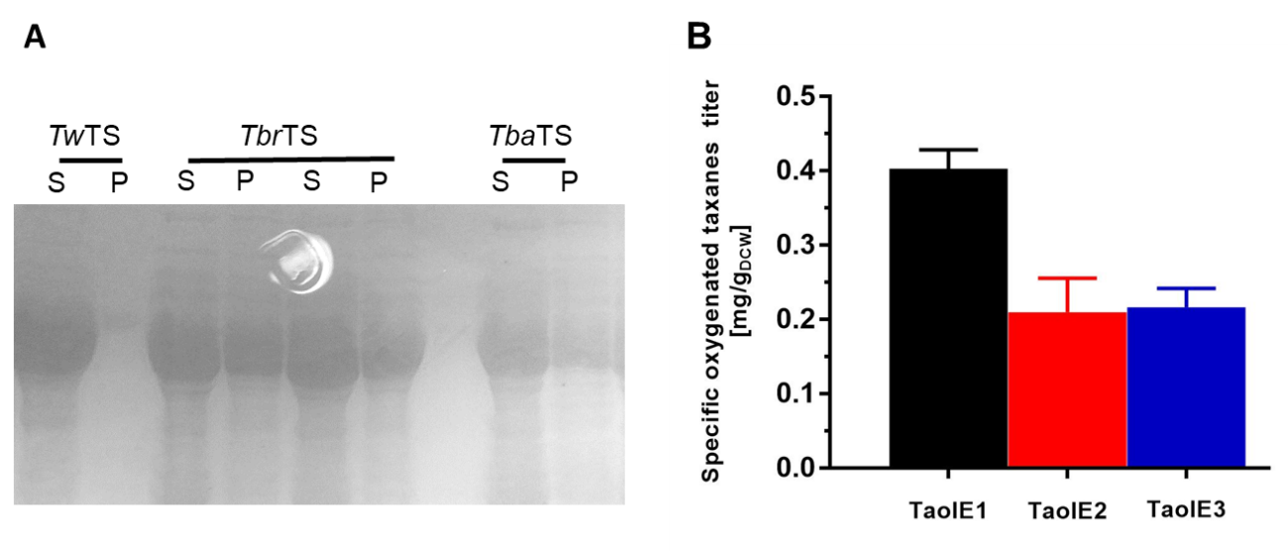
Fig. S1 Comparison of taxadiene synthases from different sources. (A) SDS-PAGE gel of different TSs in E. coli. S: Supernatant; P: Precipitate. (B) Comparison of the specific oxygenated taxanes titer of TaolE1-3 strains.

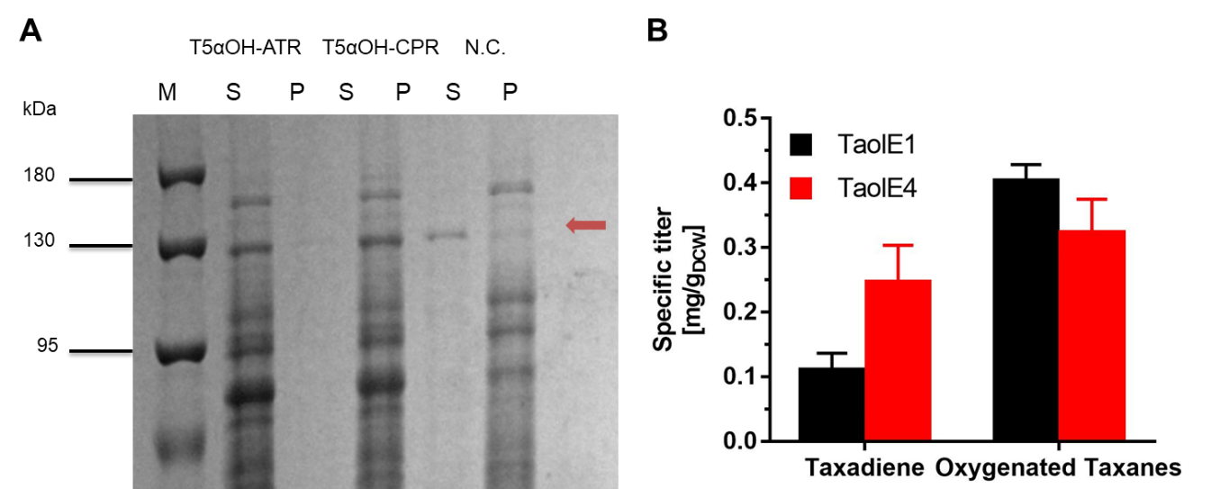
Fig. S2 Comparison of cytochrome P450 reductase from different sources. (A) SDS-PAGE gel of T5αOH-ATR/CPR in E. coli. M: Protein marker; S: Supernatant; P: Precipitate. N.C.: Negative control. (B) The comparison of specific titer of TaolE1 and TaolE4 strains.

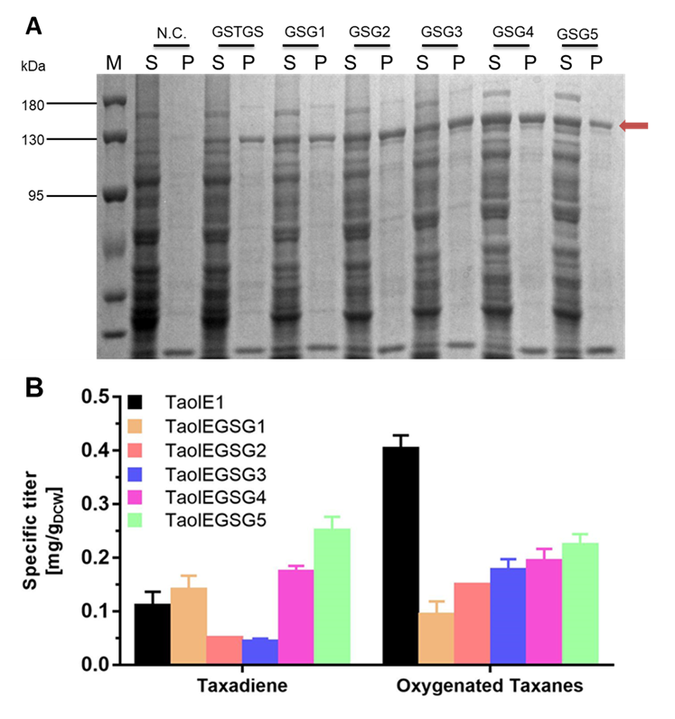
Fig. S3 Comparison of different linkers of T5αOH-CPR fusions. (A) SDS-PAGE gel of (GSG)n, n=1-5 linker in E. coli. M: Protein marker; N.C.: Negative control. S: Supernatant; P: Precipitate. (B) The comparison of specific titer of TaolE1 and TaolEGSGn strains.

Fig. S4 MS spectrum of product iso-OCT. Retation time of GC is 14.80 min.
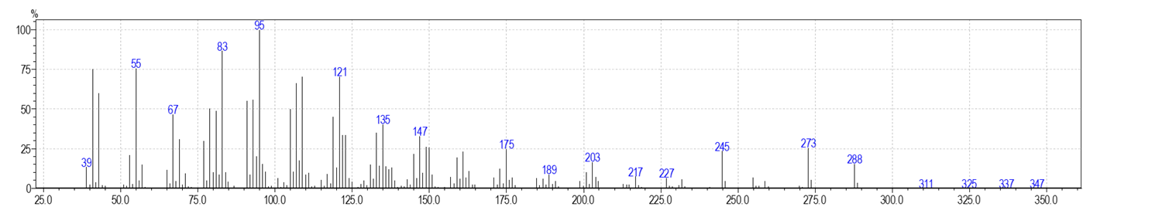
Fig. S5 MS spectrum of product diterpenoid1. Retation time of GC is 15.20 min.
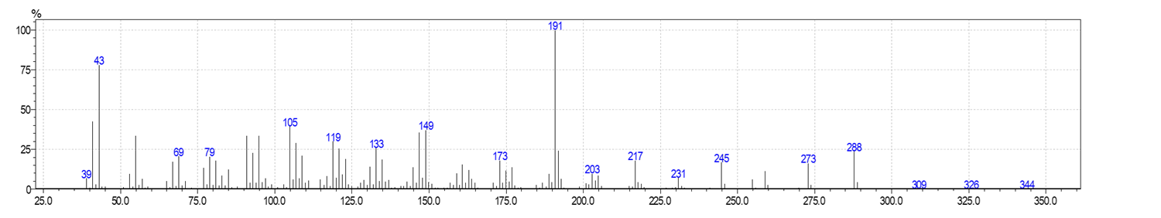
Fig. S6 MS spectrum of product OCT. Retation time of GC is 15.65 min.
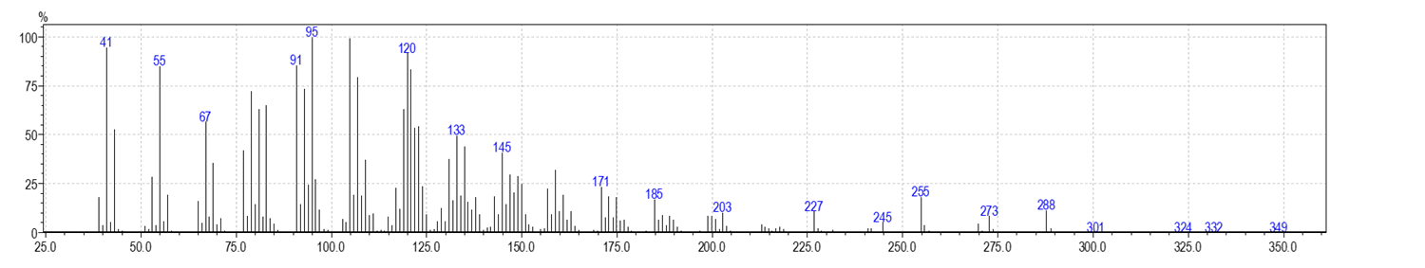
Fig. S7 MS spectrum of product taxadien-5α-ol. Retation time of GC is 16.02 min.

Table S1 The engineered strains constructed in this study and products titers (48 h).
Strains | Pathway engineering | Plasmid combinations | Total oxygenated taxanes titer  (mg L⁻¹) | Taxadien-5α-ol titer (mg L⁻¹) | Specific oxygenated taxanes titer  (mg g_{dcw}⁻¹)
TaolE1 |  | p40T7-dxs-idi,  pRSFDuet-1-TbrTS-GGPPS, pACYCDuet-1-T5αOH-CPR | 2.3 ª | 0.31 | 0.40
TaolE2 |  | p40T7-dxs-idi,  pRSFDuet-1-TbaTS-GGPPS, pACYCDuet-1-T5αOH-CPR | 0.95 | 0.18 | 0.21
TaolE3 |  | p40T7-dxs-idi,  pRSFDuet-1-TwTS-GGPPS, pACYCDuet-1-T5αOH-CPR | 2.1 | 0.40 | 0.22
TaolE4 |  | p40T7-dxs-idi,  pRSFDuet-1-TbrTS-GGPPS, pACYCDuet-1-T5αOH-ATR | 1.8 | 0.10 | 0.32
TaolEGSG1 | / | p40T7-dxs-idi,  pRSFDuet-1-TbrTS-GGPPS, pACYCDuet-1-T5αOH-(GSG)1-CPR | 0.77 | 0.27 | 0.090
TaolEGSG2 | / | p40T7-dxs-idi,  pRSFDuet-1-TbrTS-GGPPS, pACYCDuet-1-T5αOH-(GSG)2-CPR | 0.77 | 0.25 | 0.15
TaolEGSG3 | / | p40T7-dxs-idi,  pRSFDuet-1-TbrTS-GGPPS, pACYCDuet-1-T5αOH-(GSG)3-CPR | 0.96 | 0.31 | 0.18
TaolEGSG4 | / | p40T7-dxs-idi,  pRSFDuet-1-TbrTS-GGPPS, pACYCDuet-1-T5αOH-(GSG)4-CPR | 1.0 | 0.30 | 0.19
TaolEGSG5 | / | p40T7-dxs-idi,  pRSFDuet-1-TbrTS-GGPPS, pACYCDuet-1-T5αOH-(GSG)5-CPR | 1.4 | 0.39 | 0.22
TaolED1 |  | p40T7-dxs-idi,  pACYC-ED1 | 5.0 | 1.5 | 0.59
TaolED2 |  | p40T7-dxs-idi,  pACYC-ED2 | 2.0 | 0.59 | 0.25
TaolED3 |  | p40T7-dxs-idi,  pACYC-ED3 | 8.2 | 2.2 | 0.96
TaolED4 |  | p40T7-dxs-idi,  pACYC-ED4 | 12 | 3.1 | 1.3
TaolED5 |  | p40T7-dxs-idi,  pACYC-ED5 | 11 | 2.9 | 1.3
TaolED6 |  | p40T7-dxs-idi,  pACYC-ED6 | 1.4 | 0.40 | 0.18
TaolV1 | 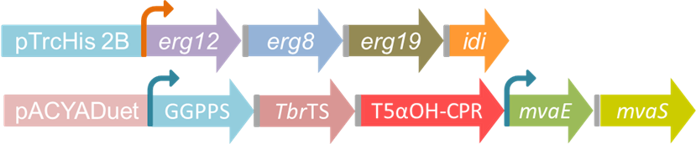 | TrcE,  AES4 | 14 ^{b} | 3.8 ^{b} | 1.3 ^{b}
TaolV2 | 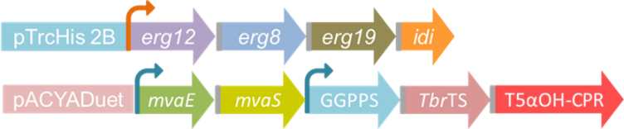 | TrcE,  AES5 | 3.5 | 0.62 | 0.57
TaolV3 | 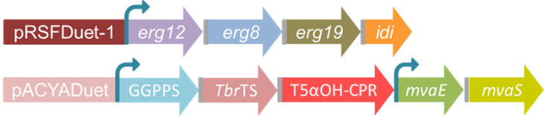 | T7E1,  AES4 | 5.9 | 1.7 | 0.67
TaolV4 | 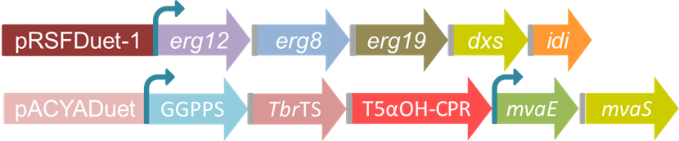 | T7E2,  AES4 | 9.1 | 2.2 | 1.1
TaolV5 |  | TrcE1,  AES4 | 5.1 | 1.7 | 0.80
ª: All experiments were performed for triplicate, with error bars showing the standard deviations; ^{b}: None of the data in the table has been optimized for culture conditions.
Table S2 The primers used in this study.
Name | Sequence (5’ to 3’)
TG-MF | CTTTAATAAGGAGATATACCATGAGCAGCAGCACCGGCAC
TG-MR | GTGGCAGCAGCCTAGGTTAATCACAACTGACGAAACGCAA
TG-ZF | GTGCCGGTGCTGCTGCTCATGGTATATCTCCTTATTAAAG
TG-ZR | TTGCGTTTCGTCAGTTGTGATTAACCTAGGCTGCTGCCAC
T5-MF | TTAATAAGGAGATATACCATGGCGCTGCTGCTGGCGGTTTTCTTTAGCATTGCGCTGAGCGCGATTGCTG
T5-MR | CTGGGTATCGGAACCGCCGCGACGGGATCCGGTGCTACCCGGACGCGGAAACAGCTTGATGCT
CPR-MF | AGCATCAAGCTGTTTCCGCGTCCGGGTAGCACCGGATCCCGTCGCGGCGGTTCCGATACCCAG
CPR-MR | GCCATATGTATATCTCCTTCTTTTACCAGATGTCACGCAGGT
TC-ZF | CAGCAATCGCGCTCAGCGCAATGCTAAAGAAAACCGCCAGCAGCAGCGCCATGGTATATCTCCTTATTAA
TC-ZR | ACCTGCGTGACATCTGGTAAAAGAAGGAGATATACATATGGC
Tba-MF | GTTTAACTTTAATAAGGAGATATACCATGGCAATGAGCAGCAGCAGCAC
Tba-MR | CCGAGCTCGAATTCGGATCCTTACACCTGAATCGGGTCGA
Tba-ZF | GTGCTGCTGCTCATTGCCATGGTATATCTCCTTATTAAAGTTAAAC
Tba-ZR | TCGACCCGATTCAGGTGTAAGGATCCGAATTCGAGCTCGG
Tw-MF | GTTTAACTTTAATAAGGAGATATACCATGGCAATGAGCAGCAGCAC
Tw-MR | CCGAGCTCGAATTCGGATCCTTAAACCTGAATCGGGTCGA
Tw-ZF | GTGCTGCTCATTGCCATGGTATATCTCCTTATTAAAGTTAAAC
Tw-ZR | TCGACCCGATTCAGGTTTAAGGATCCGAATTCGAGCTCGG
ATR-MF | TTTAACTTTAATAAGGAGATATACCATGGCGCTGCTGCTGGCGGTTTTCTTTAGCATTGCGCTGAGCGCG
ATR-MR | ATATGTATATCTCCTTCTTTTACCATACATCTCTAAGATAT
ATR-ZF | CGCGCTCAGCGCAATGCTAAAGAAAACCGCCAGCAGCAGCGCCATGGTATATCTCCTTATTAAAGTTAAA
ATR-ZR | ATATCTTAGAGATGTATGGTAAAAGAAGGAGATATACATAT
G1-MF | TCAAGCTGTTTCCGCGTCCGGGATCCGGACGTCGCGGCGGTTCCGATAC
Gn-MR | TGACAATCGGGGTGGTGCTGTCCGCCGGCA
G1-ZF | GTATCGGAACCGCCGCGACGTCCGGATCCCGGACGCGGAAACAGCTTG
Gn-ZR | TGCCGGCGGACAGCACCACCCCGATTGTCA
G2-MF | TCAAGCTGTTTCCGCGTCCGGGATCCGGAGGATCCGGACGTCGCGGCGGTTCCGATAC
G2-ZF | GTATCGGAACCGCCGCGACGTCCGGATCCTCCGGATCCCGGACGCGGAAACAGCTTGA
G3-MF | TCAAGCTGTTTCCGCGTCCGGGATCCGGAGGATCCGGAGGATCCGGACGTCGCGGCGGTTCCGATAC
G3-ZF | GTATCGGAACCGCCGCGACGTCCGGATCCTCCGGATCCTCCGGATCCCGGACGCGGAAACAGCTTGA
G4-MF | TCAAGCTGTTTCCGCGTCCGGGATCCGGAGGATCCGGAGGATCCGGAGGATCCGGACGTCGCGGCGGTTCCGATAC
G4-ZF | GTATCGGAACCGCCGCGACGTCCGGATCCTCCGGATCCTCCGGATCCTCCGGATCCCGGACGCGGAAACAGCTTGA
G5-MF | TCAAGCTGTTTCCGCGTCCGGGATCCGGAGGATCCGGAGGATCCGGAGGATCCGGAGGATCCGGACGTCGCGGCGGTTCCGATAC
G5-ZF | GTATCGGAACCGCCGCGACGTCCGGATCCTCCGGATCCTCCGGATCCTCCGGATCCTCCGGATCCCGGACGCGGAAACAGCTTGA
1-G-MF | ACCTGCGTGACATCTGGTAATTTAATAAGGAGATATACCATGTTTGATTTCAATGAATA
1-G-MR | GTGCCGGTGCTGCTGCTCATGGTATATCTCCTTATTAAATCACAACTGACGAAACGCAA
1-TS-MF | TTGCGTTTCGTCAGTTGTGATTTAATAAGGAGATATACCATGAGCAGCAGCACCGGCAC
1-TS-MR | AAGCTGCGCTAGTAGACGAGTCCATTTAAACCTGAATCGGATCGA
1-ZF | TTACCAGATGTCACGCAGGT
1-ZR | ATGGACTCGTCTACTAGCGCAGCTT
2-G-MF | ACCTGCGTGACATCTGGTAATTTAATAAGGAGATATACCATGAGCAGCAGCACCGGCAC
2-G-MR | TATTCATTGAAATCAAACATGGTATATCTCCTTATTAAATTAAACCTGAATCGGATCGA
2-TS-MF | TCGATCCGATTCAGGTTTAATTTAATAAGGAGATATACCATGTTTGATTTCAATGAATA
2-TS-MR | AAGCTGCGCTAGTAGACGAGTCCATTCACAACTGACGAAACGCAA
2-ZF | TTACCAGATGTCACGCAGGT
2-ZR | ATGGACTCGTCTACTAGCGCAGCTT
3-G-MF | TCGATCCGATTCAGGTTTAATTTAATAAGGAGATATACCATGTTTGATTTCAATGAATA
3-G-MR | AGCAGCGCCATGGTATATCTCCTTATTAAATCACAACTGACGAAACGCAATGTAATCGGC
3-TS-MF | TAACAATTCCCCTGTAGAAATTTAATAAGGAGATATACCATGAGCAGCAGCACCGGCACCAGCAAGGTG
3-TS-MR | TATTCATTGAAATCAAACATGGTATATCTCCTTATTAAATTAAACCTGAATCGGATCGA
3-ZF | TACAGGGGAATTGTTATCCG
3-ZR | TTTAATAAGGAGATATACCATGGCGCTGCTGCT
4-T5-MF | TCGATCCGATTCAGGTTTAATTTAATAAGGAGATATACCATGGCGCTGCTGCTGGCGGT
4-T5-MR | TATTCATTGAAATCAAACATGGTATATCTCCTTATTAAATTACCAGATGTCACGCAGGT
4-G-MF | ACCTGCGTGACATCTGGTAATTTAATAAGGAGATATACCATGTTTGATTTCAATGAATA
4-G-MR | AGCCTAGGTTAATTAAGCTGTCACAACTGACGAAACGCAA
4-ZF | TTAAACCTGAATCGGATCGA
4-ZR | CAGCTTAATTAACCTAGGCT
5-T5-MF | TCGATCCGATTCAGGTTTAATTTAATAAGGAGATATACCATGGCGCTGCTGCTGGCGGT
5-T5-MR | TATTCATTGAAATCAAACATGGTATATCTCCTTATTAAATTACCAGATGTCACGCAGGT
5-G-MF | ACCTGCGTGACATCTGGTAATTTAATAAGGAGATATACCATGTTTGATTTCAATGAATA
5-G-MR | AGCCTAGGTTAATTAAGCTGTCACAACTGACGAAACGCAA
5-ZF | TTAAACCTGAATCGGATCGA
5-ZR | CAGCTTAATTAACCTAGGCT
6-T5-MF | TTGCGTTTCGTCAGTTGTGATTTAATAAGGAGATATACCATGGCGCTGCTGCTGGCGGT
6-T5-MR | GTGCCGGTGCTGCTGCTCATGGTATATCTCCTTATTAAATTACCAGATGTCACGCAGGT
6-G-MF | CTTTAATAAGGAGATATACCATGTTTGATTTCAATGAATA
6-G-MR | ACCGCCAGCAGCAGCGCCATGGTATATCTCCTTATTAAATCACAACTGACGAAACGCAA
6-TS-MF | ACCTGCGTGACATCTGGTAATTTAATAAGGAGATATACCATGAGCAGCAGCACCGGCAC
6-TS-MR | CGATTACTTTCTGTTCGACTTTAAACCTGAATCGGATCGA
6-ZF | GGTATATCTCCTTATTAAAGTTAAACAAAATTATTT
6-ZR | AGTCGAACAGAAAGTAATCGTATTGTACACGGCCGCA
E12-MF | GTATCGATTAAATAAGGAGGAATAAACCATGAGTCTACCATTTTTAACATCAGCTCCC
E12-MR | TTAGCTGGTCACGGCAG
E8-MF | CTGCCGTGGACCAGCTAAGTATAAGAGGAGGTAAAAAAACATGTCAGAACTAAGGGCATTTAGTGC
E8-MR | CGCTCGCCTTGTAAACGATCTTATTTGTCCAGATACGTTTCCGGGTC
MVA1-ZF | GGTTTATTCCTCCTTATTTAATCGATACATTAATATATACC
MVA1-ZR | GATCGTTTACAAGGCGAGCG
E19-MF | GACCCGGAAACGTATCTGGACAAATAAGTATAAGAGGAGGTAAAAAAACATGGCAATGACAGTTTATACGGC
E19-MR | TTACTCTTTCGGCAGACCGG
I-MF | CCGGTCTGCCGAAAGAGTAAGTATAAGAGGAGGTAAAAAAACATGACAGCTGATAATAACTCAATGCCC
I-MR | CCGTTTAAACTCAATGATGATGATGATGATGTTACAGCATACGATGAATCTGACGATCG
MVA2-ZF | CATCATCATCATCATCATTGAGTTTAAACGG
MVA2-ZR | TTATTTGTCCAGATACGTTTCCGGGTC
E-MF | CTTTAATAAGGAGATATACCATGAAAACAGTTGTAATAATTGATGCTCTA
E-MR | TTACTGTTTGCGCAGGTCGTTC
S-MF | GAACGACCTGCGCAAACAGTAAGTATAAGAGGAGGTAAAAAAACATGACAATTGGAATAGATAAAATATCATTTTTCG
S-MR | GCGCCGAGCTCGAATTCGGATCCTTAATTGCGGTAGCTACGAACGG
AES-ZF | GGTATATCTCCTTATTAAAGTTAAACAAAATTATTTCTACAGGGG
AES-ZR | GGATCCGAATTCGAGCTCGGCGCGCCTGCA
4-MF | GATATACATATGGCAGATCTATGAAAACAGTTGTAATAAT
4-MR | CCAGACTCGAGGGTACCGACTTAATTGCGGTAGCTACGAA
AES4-ZF | ATTATTACAACTGTTTTCATAGATCTGCCATATGTATATC
AES4-ZR | TTCGTAGCTACCGCAATTAAGTCGGTACCCTCGAGTCTGG
5-MF | TAGTTAAGTATAAGAAGGAGATATACATATGTTTGATTTCAATGAATA
5-MR | CGGTTTCTTTACCAGACTCGAGTTACCAGATGTCACGCAGGT
AES5-ZF | TATTCATTGAAATCAAACATATGTATATCTCCTTCTTATACTTAACTA
AES5-ZR | ACCTGCGTGACATCTGGTAACTCGAGTCTGGTAAAGAAACCG
ET7-MF | CTTTAATAAGGAGATATACCATGAGTCTACCATTTTTAAC
ET7-MR | TTATGCGGCCGCAAGCTTGTTTACAGCATACGATGAATCT
ET7-ZF | GTTAAAAATGGTAGACTCATGGTATATCTCCTTATTAAAG
ET7-ZR | AGATTCATCGTATGCTGTAAACAAGCTTGCGGCCGCATAA
D4-MF | CCGGTCTGCCGAAAGAGTAAGTATAAGAGGAGGTAAAAAAACATGAGTTTTGATATTGCCAA
D4-MR | GAGTTATTATCAGCTGTCATATGTATATCTCCTTCTTATGCCAGCCAGGCCTTGAT
D4-ZF | TTGGCAATATCAAAACTCATGTTTTTTTACCTCCTCTTATACTTACTCTTTCGGCAGACCGG
D4-ZR | ATCAAGGCCTGGCTGGCATAAGAAGGAGATATACATATGACAGCTGATAATAACTC
D5-MF | GGTCTGCCGAAAGAGTAAGTATAAGAGGAGGTAAAAAAACATGAGTTTTGATATTGCCAAATACCCGACC
D5-MR | TTGAGTTATTATCAGCTGTCATGTTTTTTTACCTCCTCTTATACCTTATGCCAGCCAGGCCTTGATTTTG
D5-ZF | CTCCTCTTATACTTACTCTTTCGGCAGACC
D5-ZR | ATGACAGCTGATAATAACTCAATGCCCCACGGTGC

