Supplementary Materials for
Nucleophilic Attack Enables Chemical Suture of Crystalline Silicon at Room Temperature
Xuebiao Deng,¹ Tao Zeng,² Jun Li,³ Guoying Yao,¹ Huai Chen,¹ Liangpang Xu,⁴ Linfeng Wei,¹ Mohsen Shakouri,⁵ Jimmy C. Yu,⁴ Ying Wang,⁴ and Zhenyu Yang¹*

- MOE Laboratory of Bioinorganic and Synthetic Chemistry, Lehn Institute of Functional Materials, School of Chemistry, Sun Yat-sen University, Guangzhou, Guangdong, 510275, China
- Department of Chemistry, York University, Toronto, Ontario, M3J 1P3, Canada
- Frontiers Science Center for Transformative Molecules, Shanghai Jiao Tong University, Shanghai, 200240, China
- Department of Chemistry, Chinese University of Hong Kong, Hong Kong SAR, China
- Canadian Light Source, Inc. (CLSI), Saskatoon, Saskatchewan, S7H 0X4, Canada

Corresponding E-mail: yangzhy63@mail.sysu.edu.cn

KEYWORDS: nucleophilic attack, crystalline silicon, silicane, solid-state synthesis, surface chemistry, density functional theory calculations
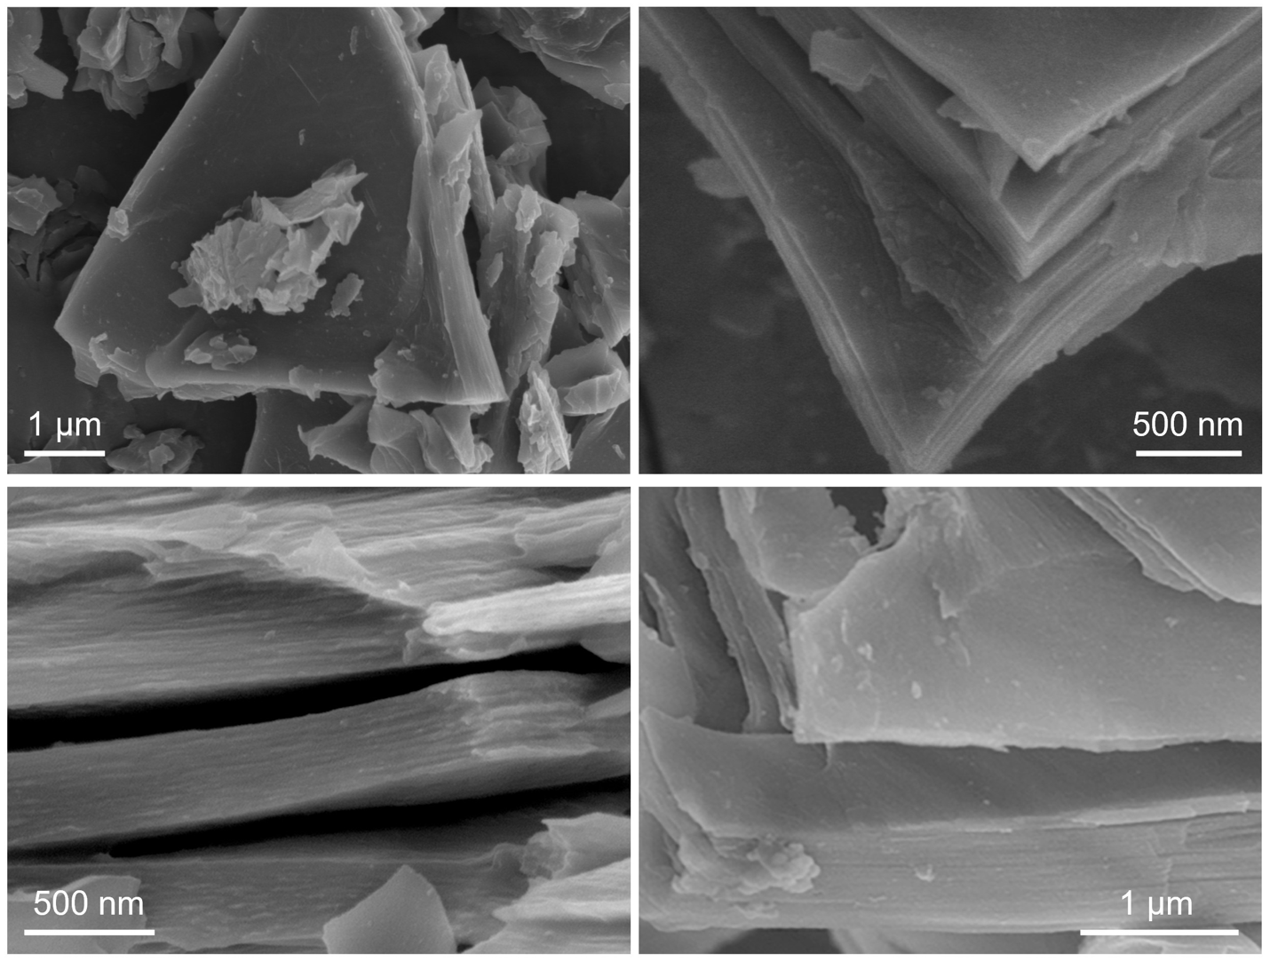
Supplementary Figure 1 | Additional SEM images of the freshly-etched HSi sample.

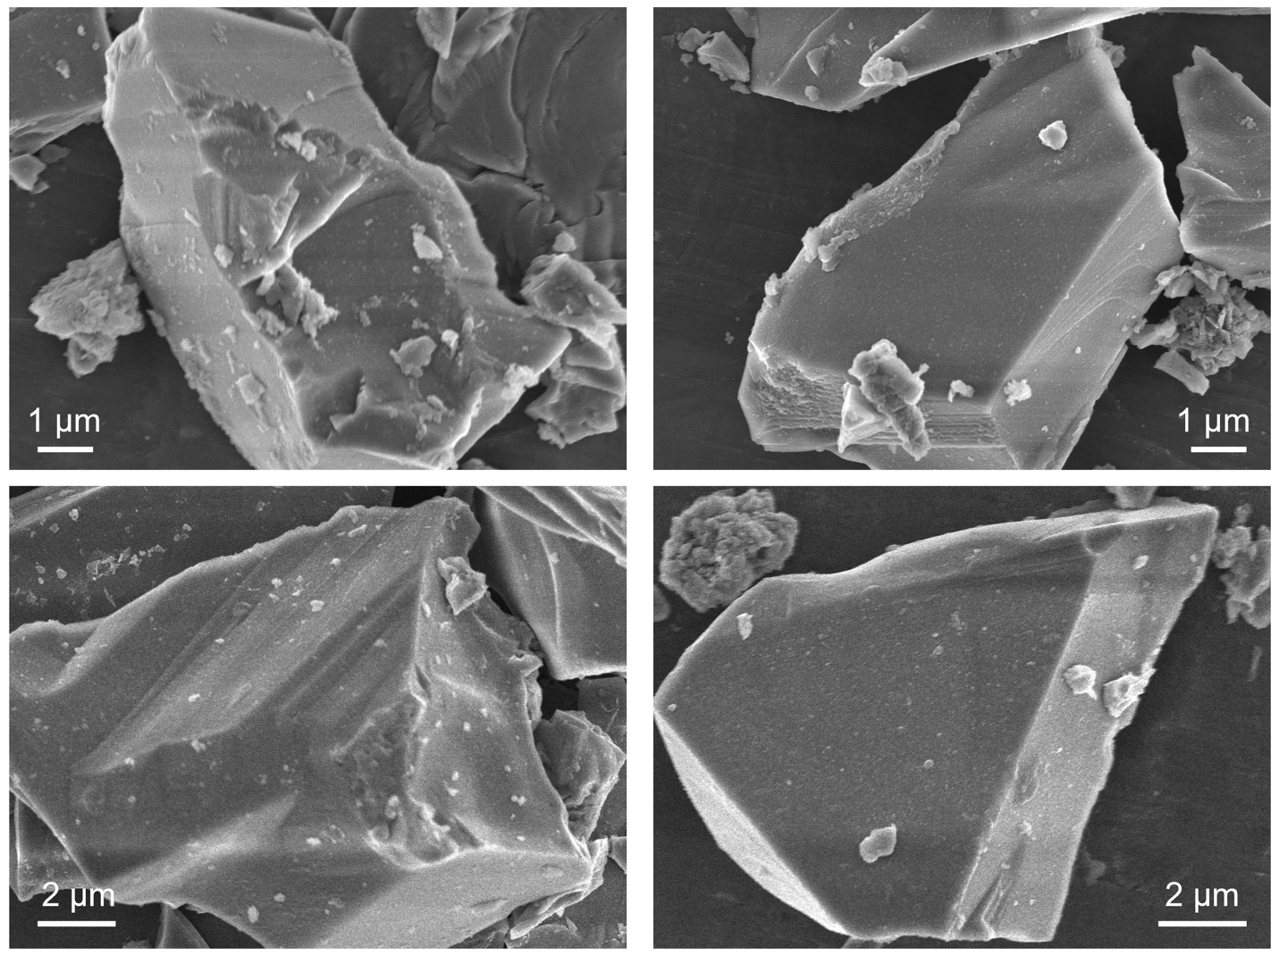
Supplementary Figure 2 | Additional SEM images of the c-Si sample formed from the DMSO treatment on HSi.

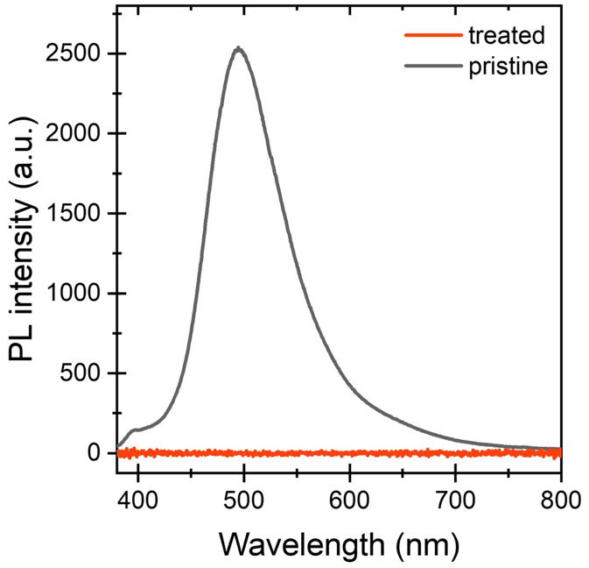
Supplementary Figure 3 | Comparison of the PL intensity of HSi samples before and after the treatment with DMSO.

Supplementary Figure 4 | The total electron yield (TEY) X-ray absorption near-edge structure (XANES) spectra at the Si K-edge of HSi before and after the treatment and the standard materials (i.e., Si and amorphous SiO₂).
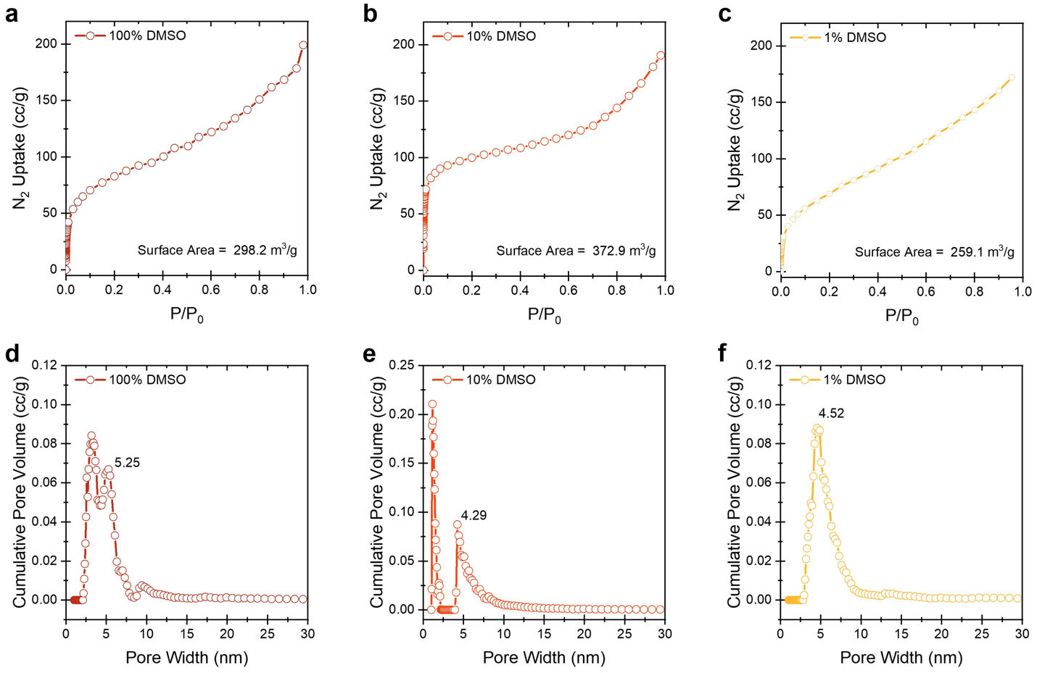
Supplementary Figure 5 | BET isotherm results of c-Si samples. (a-c) Low-temperature (77 K) N₂ adsorption/desorption isotherms and (d-f) the corresponding pore size distributions of c-Si samples after the treatment with DMSO with various concentrations. The calculations were based on the Barrett-Joyner-Halenda (BJH) method of N₂ absorption curves shown in Figures a-c.

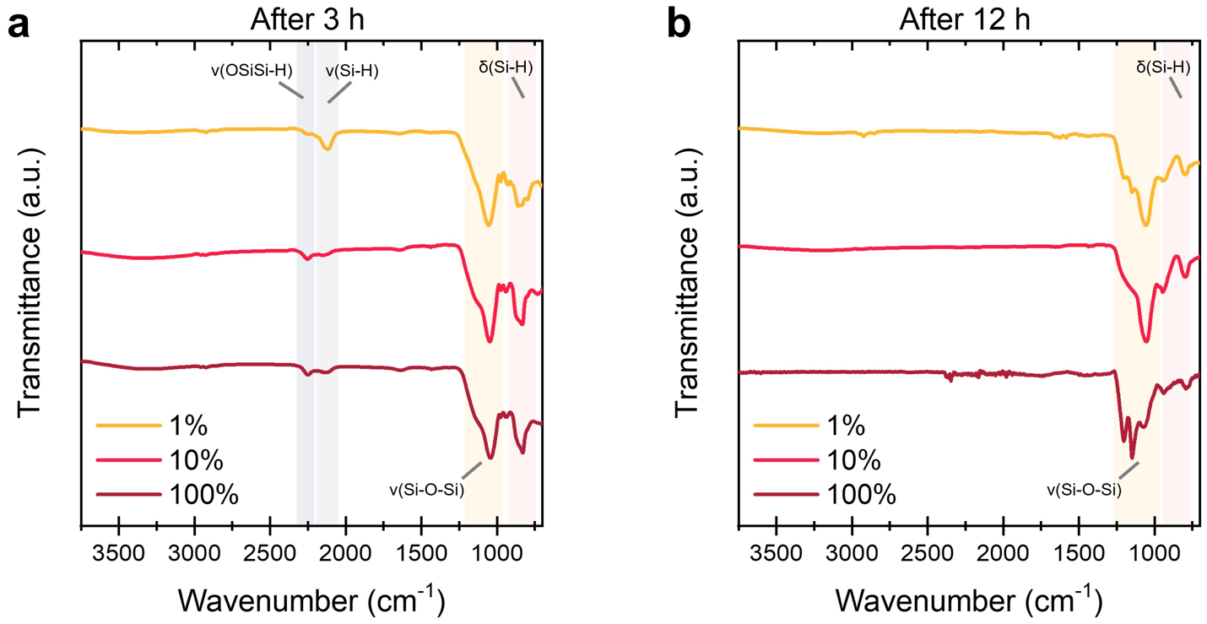
Supplementary Figure 6 | FT-IR spectra of HSi samples treated by DMSO solution with various concentrations. Sample are extracted from the solution after (a) 3 h and (b) 12 h, and purified by multiple washing steps (see Methods) before the FT-IR measurements.
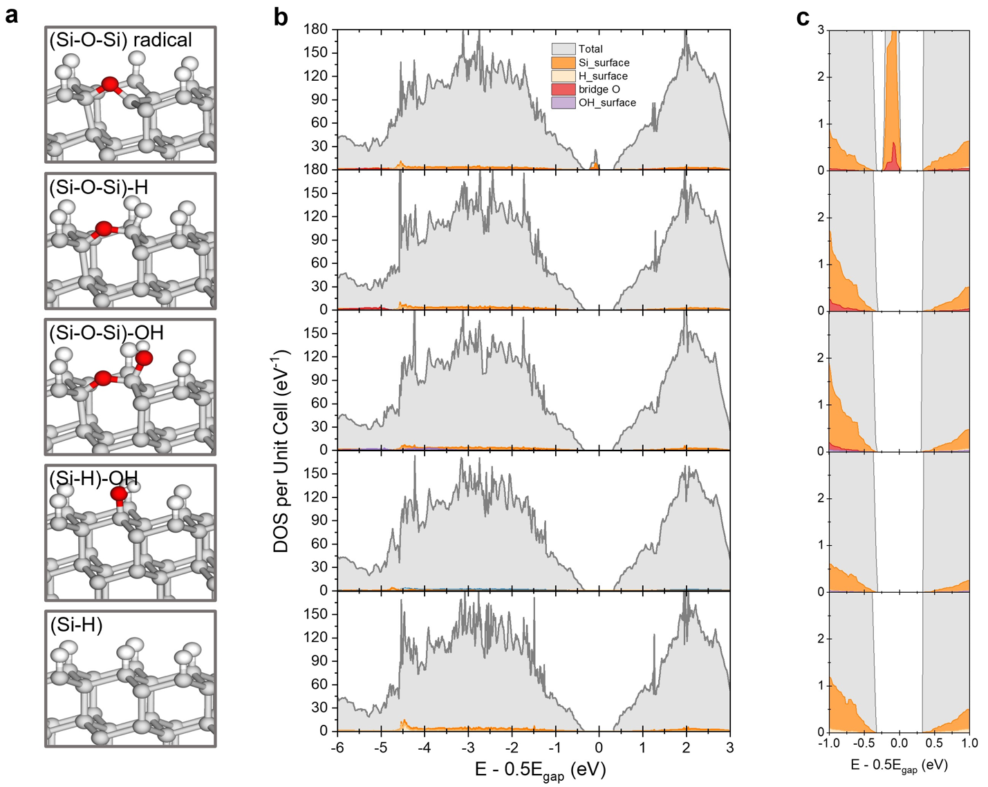
Supplementary Figure 7 | Computational studies of the surface state influence on the bandedge structure of c-Si. (a) Five possible surface models and (b) the corresponding simulated bandedge structures. (c) Zoom-in near-bandedge regions (-1 to 1 eV) corresponding to (b).

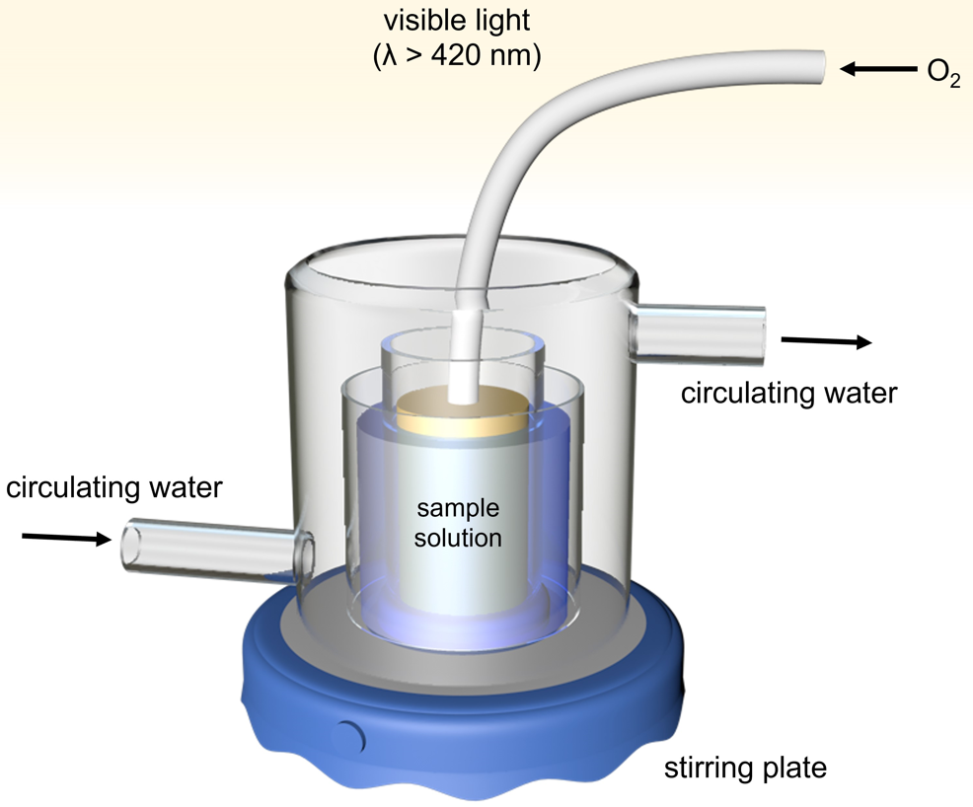
Supplementary Figure 8 | Instrumental setup of the c-Si-based photocatalytic production of H₂O₂.
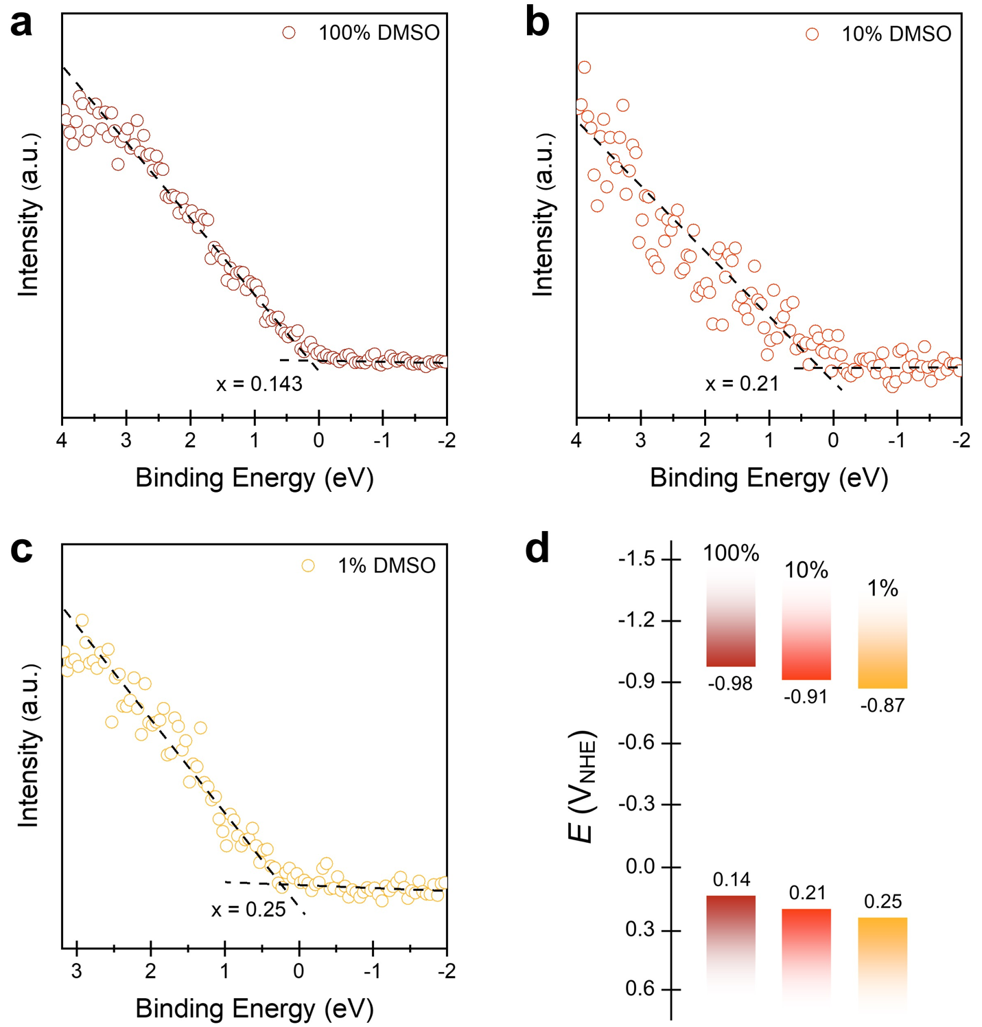
Supplementary Figure 9 | X-ray Photoelectron spectra (XPS) and band structures of c-Si. (a-c) zoom-in XPS results (binding energy -2 – 3.2 eV) and (d) the corresponding band alignment of c-Si after the treatment with DMSO with various concentrations.
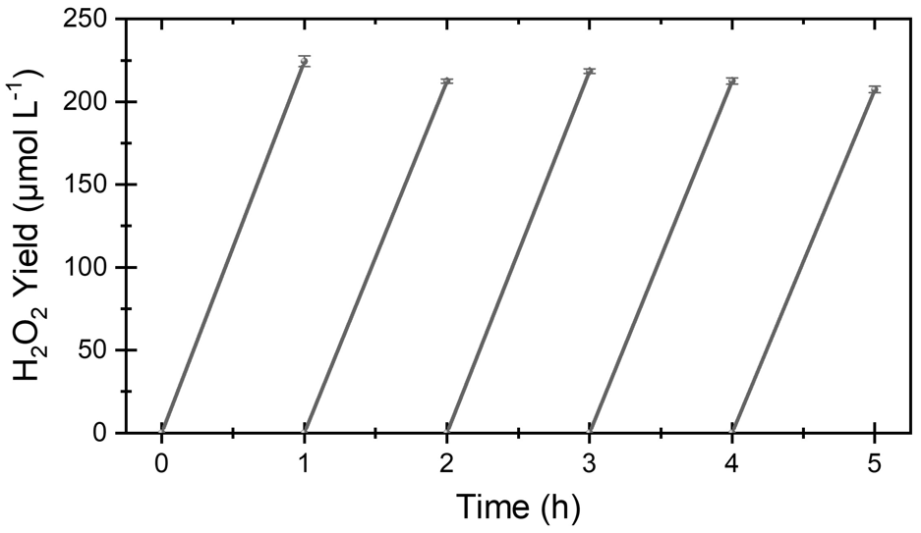
Supplementary Figure 10 | Stability test of the c-Si under visible light irradiation in ambient conditions for the production of H₂O₂.

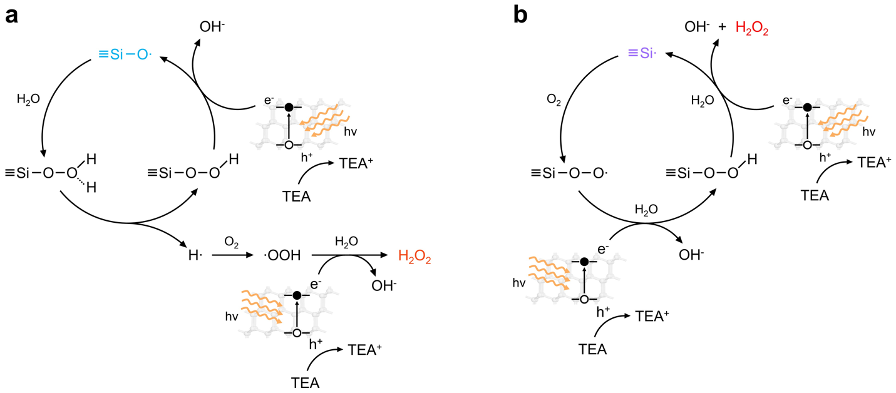
Supplementary Figure 11 | Proposed mechanism of the H₂O₂ production promoted by the surface (a) siloxyl (≡Si-O•) and (b) silyl (≡Si•) radicals under visible light irradiation.

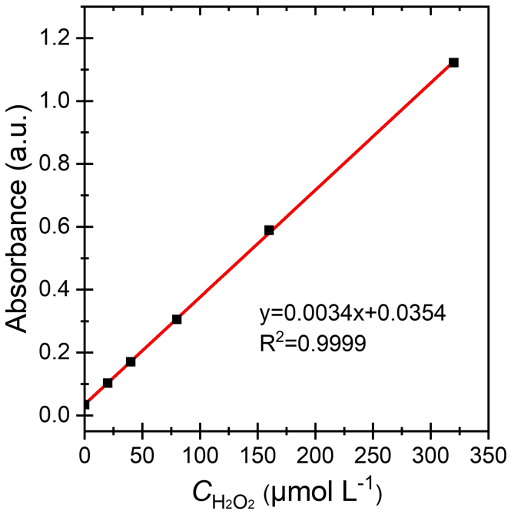
Supplementary Figure 12 | Calibration file of H₂O₂ concentration analyzed by analyzed by I₃⁻ method.

Supplementary Note 1 | More Details of DFT Calculations:
We are interested in the dehydrogenation process that stitch up 2D HSi flakes to c-Si. This dehydrogenation process is considered to be a localized reaction. It is reasonable to use the (SiH₃)₃SiH molecule as a simplified model to represent the Si-H fragment that participates in the reaction. The central Si in the model is connected to three Si atoms, just as any Si atoms in HSi. For all species other than H₂, we corrected their electronic energies by Gibbs free energies arising only from molecular vibrations. This is because these species remain in solution in the course of reactions, and they do not freely translate and rotate like in gas phase. This is especially so for the Si compounds that model silicanes, disconnected and connected. H₂ is released into gas phase in our experiment. Therefore, we include Gibbs free energy corrections arising from translation and rotation of H₂. All energies shown below in reaction energy profiles were obtained in this way.

Supplementary Note 2 | Computational Results of the Uncatalyzed Suture of HSi Flakes:
The dehydrogenation reaction is thermodynamically favored by $∆G$ = -15.7 kcal/mol. Without the translational and rotational Gibbs energy corrections to H₂, the favourability is reduced to -8.5 kcal/mol. The reaction does not release a large amount of heat. The 67.2 kcal/mol formidably high barrier shown in Supplementary Figure 13a prevents the reaction from occurring without facilitation by catalyst. The transition state (TS) structure shown in Supplementary Figure 13b reflects the difficulty of reaching this maximum of the reaction pathway. The two central Si-H bonds are stretched to 1.74 and 1.82 Å, suggesting partial breaking of the two bonds. However, the 1.24 Å long H-H distance means that the H-H bond has not been formed yet. The -0.27, -0.01, and -0.13 natural atomic charges of the colinear two H atoms and Si atom suggest the formation of a 3-center-4-electron (3c4e) bond. The Si atom with +0.12 natural charge can be viewed as a cationic center that has lost its electron to form the 3c4e bonds. A typical 3c4e bond has two electronegative termini and an electropositive central atom. With an electropositive Si as a terminus and the two H atoms as the central atom and the other terminus, respectively, such an atypical 3c4e bond provides limited stabilization for the TS structure.
The 3c4e interaction was confirmed by the NBO second order perturbation theory analysis. The interaction is shown in Supplementary Figure 14. The summation of the occupancies of the orbitals there is 0.55 + 1.01 + 0.52 + 1.63 + 0.25 = 3.96 $≈$ 4. The large 2nd order perturbation theory interaction energies in Supplementary Figures 13a and 13b indicate the instability, rather than stability, of the TS structure. The central H orbital is not stable enough to accommodate an electron pair and has a strong tendency to share the pairs with the termini (Supplementary Figure 14a) and the cationic Si (Supplementary Figure 14b). The antisymmetric combination of the terminal orbital lobes is also not capable of accommodating an electron pair, and needs to share the pair with the $σ_{SiSi}^{*}$ orbital in Supplementary Figure 14c. All these electron donations from the 3c4e moiety to its neighbors reflect the low electronegativities of the H, H, and Si 3 centers. It is necessary to emphasize the qualitative nature of the perturbation theory analysis, and the interaction energies shown in Supplementary Figure 14 are overestimations.
It is not a surprise that NBO analysis finds 3c4e interaction for TS structures obtained using closed-shell DFT calculations. Many chemical processes can be viewed as having a A…B…C type TS, where the AB bond is partially broken, and the BC bond is partially formed. One such example is the S_{N}2 reaction in organic chemistry. The process of breaking an AB bond and forming a BC bond can be viewed as: (1) the C lone pair orbital overlaps with the AB antibonding orbital and evolves to the BC bonding orbital; (2) simultaneously, the AB bonding orbital evolves to the A lone pair orbital. In the whole process, the closed-shell electronic structure of the reaction complex is maintained. For a reaction involving breaking two bonds and forming two bonds, e.g., the breaking of the two Si-H bonds and the formation of H-H and Si-Si bonds here, a heterolytic cleavage of one bond proceeds to prepare the long pair containing fragment (e.g., Fragment C shown in Supplementary Figure 14). We tried using symmetry-breaking unrestricted open-shell DFT calculation to locate the TS for the reaction in Supplementary Figure 13a. The barrier was found to be higher than 80 kcal/mol. The closed-shell electronic structure maintain throughout the reaction. The 3c4e NBO description for the TS comes from mapping the closed-shell wave function to a well-defined Lewis structure. It is of qualitative nature, yet it is very useful in terms of explaining the electronic structure using language that is familiar to chemists. Similar 3c4e descriptions apply to the other TS structures below. Their qualitative nature will not be re-emphasized.
Supplementary Figure 13 | (a) Reaction energy profile of the dehydrogenation and formation of Si-Si bond between two (SiH₃)₃SiH model molecules. (b) Key structural parameters and natural atomic charges (highlighted in yellow) of the TS structure in Figure (a). The energies in (a) are given in kcal/mol. The red arrows in the transition state structure in (a) indicate the normal mode with the only imaginary frequency.

Supplementary Figure 14 | Key results of the NBO second order perturbation theory analysis for the TS structure in Supplementary Figure 13. (a) The bonding interaction between the symmetric combination of the terminal H and Si lobes and the central H lobe. (b) The bonding interaction between the central H lobe and the vacant orbital of the Si⁺ center. (c) The bonding interaction between the antisymmetric combination of the terminal H and Si lobes and a $σ_{SiSi}^{*}$ orbital. The red-blue and yellow-green lobe pairs indicate the two orbitals that interact in each panel. Each pair of colored numbers that are separated by a semi-colon indicate the occupancy (the first) and the energy (in E_{H}) of the orbital in the same colors. The 2nd order perturbation theory interaction energy between the red-blue and green-yellow orbitals is given in kcal/mol in each panel.

Supplementary Note 3 | Computational Results of the DMSO Catalyzed Suture of HSi Flakes:
With the presence of a DMSO solvent molecule, the reaction barrier is significantly reduced to 28.7 kcal/mol, as shown in Supplementary Figure 15. This barrier is high yet surmountable, consistent with the observation of slow release of H₂ bubbles. The TS structure and natural atomic charges in Supplementary Figure 15b show that the DMSO activates one Si into a siliconium center, with the +0.39 charge, and a trigonal bipyramidal configuration with the O from DMSO and the leaving H⁻ (with -0.19 charge) at the axial positions. Since Si in silicane adopts a +0.10 positive charge, it is ready to be attacked by the negatively charged O (Supplementary Figure 15c) and reach an S_{N}2-type TS. In this attack, the S-O bond length increases from 1.49 to 1.55 Å, reflecting the shifting of the $π_{SO}$ bond pair to the O center and become a lone pair, enriching the O’s capability to attack the Si center. Note that the -1.05 and -1.04 similar charges of O before and after the attack are not in contrast to the shifting of the original $π_{SO}$ bond pair onto the O center, since the extra negative charge on O is relayed to the siliconium center and then to the leaving H⁻ in the attack. The leaving H⁻ abstracts a protonic H from another silicane, leaving the original H-Si bond pair electron to a silicide center with a -0.44 charge. The hydridic and protonic H atoms form the effusive H₂ and the leftover siliconium and silicide centers form an Si-Si bond, releasing the DMSO back to the solvent. Given the good availability of the DMSO solvent catalyst, such a catalytic cycle occurs continuously at different pairs of Si centers from different silicane sheets and enables the conversion from HSi to c-Si. DMSO is the key solvent catalyst to stitch up the HSi to c-Si.
The NBO perturbation theory analysis indicates a 5-center-6-electron (5c6e) interaction in the O-Si⁺-H⁻-H⁺-Si⁻ moiety. The 0.91 Å short H-H distance indicates that the bond formation between the hydridic and protonic H atoms is almost completed. This is consistent with the 1.80 e population of the $σ_{HH}$ orbital in the NBO analysis shown in Supplementary Figure 16a. The H₂ accepts electron from the silicide center through its $σ_{HH}^{*}$ orbital (Supplementary Figure 16b), resulting in a 3c4e interaction, with the total 3.62 e in the three orbitals. At the same time, the siliconium takes the central position of another 3c4e interaction, with the O and the H₂ as the termini. The $σ_{HH}$ and the O lone pair orbital together donate 0.41 e to the siliconium lone pair orbital (Supplementary Figures 15a and 15c). The total occupancy of the three orbitals is 1.80 + 1.79 + 0.41 = 4.00 e, consistent with the 3c4e description. The two 3c4e interactions share the two H atoms and their electrons, and overall, they add up to a 5c6e interaction.
Supplementary Figure 15 | (a) Reaction energy profile of the dehydrogenation and formation of Si-Si bond between two (SiH₃)₃SiH model molecules, facilitated by a DMSO solvent molecule; (b) and (c) key structural parameters and natural atomic charges (highlighted in yellow) of the TS structure in Figure (a) and DMSO. The energies in Figure (a) are given in kcal/mol. The red arrows in the transition state structure in Figure (a) indicate the normal mode with the only imaginary frequency.

Supplementary Figure 16 | Key results of the NBO second order perturbation theory analysis for the TS structure in Figure Supplementary Figure 16a. (a) The bonding interaction between $σ_{HH}$ and the siliconium vacant orbital. (b) The bonding interaction between $σ_{HH}^{*}$ and the silicide lone orbital. (c) The bonding interaction between the O lone pair orbital and the siliconium vacant orbital. The red-blue and yellow-green lobe pairs indicate the two orbitals that interact in each panel. Each pair of colored numbers that are separated by a semi-colon indicate the occupancy (the first) and the energy (in E_{H}) of the orbital in the same colors. The 2nd order perturbation theory interaction energy between the red-blue and green-yellow orbitals is given in kcal/mol in each panel.

Supplementary Note 4 | Computational Results of the Possible Insertion of O from DMSO to Si-H bond of Silicane:
If DMSO can catalyze the conversion from HSi to c-Si, why cannot it directly interact with the HSi and insert the O into the Si-H bond to form Si-OH? The Si-O and O-H bond enthalpies are known to be large (108 and 109 kcal/mol, respectively) and the product dimethylsulfide (DMS) is a kinetically persistent species. These facts suggest thermodynamical favourability for the formation of Si-OH. Indeed, our calculation showed that this reaction has a $∆G$ = -43.1 kcal/mol (Supplementary Figure 17a). However, it comes with a 39.1 kcal/mol high barrier, which prevents this reaction from occurring. The TS structure in Supplementary Figure 17b exhibits a 1.96 Å S-O bond length. The 1.55 Å S-O bond in Supplementary Figure 15b can be considered as a S-O single bond, since the $π_{SO}$ bond pair has been shifted to become the O lone pair. The elongation of the S-O single bond to 1.96 Å in the TS structure (Supplementary Figure 17b) costs energy, which contributes to the barrier. The Si-O bond is almost formed in the TS structure, as the 1.74 Å bond length is not substantially larger than the typical Si-O bond (1.60 Å). The ionic nature of the Si-O bond is reflected by the +0.43 and -1.03 charges of the Si and O. The H atom is dangling, in the middle of migrating from Si to O.
The NBO perturbation theory analysis points to a 3c4e interaction among S, O, and the H atom that migrates from Si to O. The analysis shows that the Si-O bond has been formed and the S-O bond is not broken yet. The $σ_{SO}$ orbital is shown in Supplementary Figure 18a. The corresponding $σ_{SO}^{*}$ orbital accepts the donation from the 1s orbital of the migrating hydridic center (Supplementary Figure 18b). Since the H atom is not electronegative enough to accommodate a pair of electrons, this donation is significant, with 0.56 electron transfer and -681.3 kcal/mol interaction energy (again, a qualitative and overestimated value). The hydridic orbital is so unstable that its electrons are also smeared into the $σ_{SiO}^{*}$ and $σ_{SiSi}^{*}$ orbitals shown in Supplementary Figures 18c and 18d. Such an atypical 3c4e interaction with electropositive termini (S and H) and electronegative central atom explains the 39.1 kcal/mol high barrier and the incapability of DMSO to oxidize HSi. Overall, this oxidation is a thermodynamically favorable but kinetically unfavored process. As mentioned in the main text, no DMS was detected in our experiment. This is consistent with the high calculated barrier.
Since the surface oxidation by DMSO is unlikely to occur, the conversion from HSi to c-Si through forming Si-O-Si bonds, as a consequent step of the oxidation, is also unlikely to occur.
Supplementary Figure 17 | (a) Energy profile of the reaction between the silicane model and DMSO to form the oxidized silicane and DMS. (b) key structural parameters and natural atomic charges (highlighted in yellow) of the TS structure in (a). The energies in (a) are given in kcal/mol. The red arrows in the transition state structure in (a) indicate the normal mode with the only imaginary frequency.

Supplementary Figure 18 | (a) Key results of the NBO second order perturbation theory analysis for the TS structure in Supplementary Figure 18a. (a) $σ_{SO}$ orbital. (b) The bonding interaction between the H lone pair orbital and $σ_{SO}^{*}$ orbital. (c) the bonding interaction between the H lone pair orbital and $σ_{SiO}^{*}$ orbital. (d) the bonding interaction between the H lone pair orbital and $σ_{SiSi}^{*}$ orbital. The red-blue and yellow-green lobe pairs indicate the two orbitals that interact in each panel. Each pair of colored numbers that are separated by a semi-colon indicate the occupancy (the first) and the energy (in E_{H}) of the orbital in the same colors. The 2nd order perturbation theory interaction energy between the red-blue and green-yellow orbitals is given in kcal/mol in Figures (b)-(d).
Supplementary Note 5 | The Suture Model for Stitching up HSi flakes to c-Si:
Knowing how each Si-Si bond is formed between two HSi flakes under the catalysis of DMSO, we propose the following suture model for the formation of c-Si from individual HSi flakes. The model is illustrated in Supplementary Figure 19. Since this figure is frequently referred to in the present section, it is abbreviated as S-F19. The upper half of the figure illustrates the ideal situation. The 2-D HSi flakes are sketched as the 1-D grey curves or lines. The DMSO molecule is sketched as a red arrow, with the tip representing its O end. When two Si-H bonds of two flakes are close to each other, one of the Si-H bond is activated from its backside by a DMSO molecule, and undergoes the partial Si^{δ+}H^{δ-} heterolytic cleavage. This Si^{δ+}H^{δ-} moiety induces the Si^{δ-}H^{δ+} heterolytic cleavage of the opposite Si-H bond. The hydridic and protonic H atoms then form an effusive H₂, leaving the siliconium and silicide Si centers to form the first Si-Si bond between the two flakes. This first Si-Si bond, which we call an anchored bond, is sketched as a red line in S-F19. A red dashed line is used to highlight that the anchored bond is being formed, e.g., in S-F19a and e. The Si-H bonds that surround the anchored bond and point to the other flakes are brought to proximity by the anchored bond. Catalyzed by DMSOs from above the top flake or below the bottom flake, more Si-Si bonds are formed around the anchored bond (S-F19c). The Si-Si bonds formed subsequently to the anchored bond are sketched as blue lines, or blue dashed lines when they are being formed. Consequently, more Si-H bonds are brought to the precursor configuration for H₂ and Si-Si bond formation. Such Si-Si bond formation propagates across the two flakes until they are sutured to form a double-layered HSi₂ flake (from S-F19c to d).
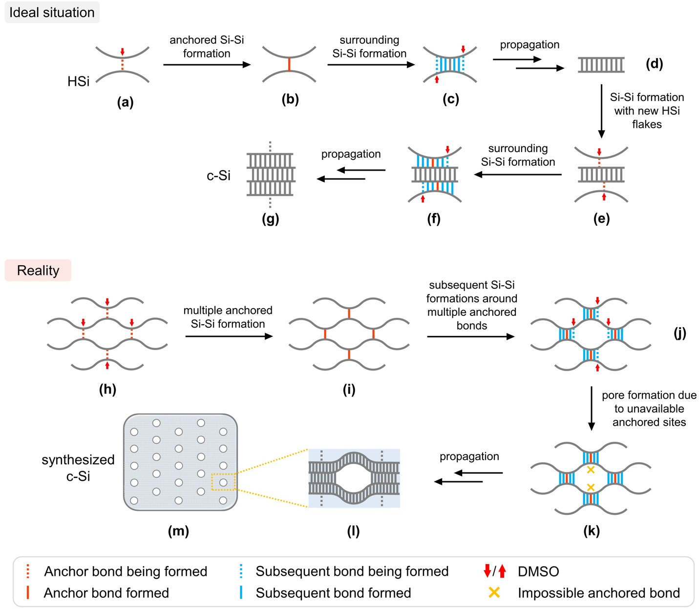
Supplementary Figure 19 | Proposed mechanism of the formation of porous c-Si from the DMSO treatment of HSi. More discussion will be available in Supplementary Note 5.

The Si-H bonds of this double-layered HSi₂ flake have their backsides enclosed between the two single layers. These backsides are inaccessible to DMSO and therefore, the Si-H bonds of the HSi₂ flake cannot undergo the Si^{δ+}H^{δ-} heterolytic cleavage. Now, two other HSi flakes approach the HSi₂ flake from above and below, not necessarily synchronously. Their sides facing the HSi₂ flake are called their front sides, and the other sides are their backsides. One frontside Si-H bond of the approaching HSi flakes is activated by a DMSO molecule on its backside and undergoes the Si^{δ+}H^{δ-} cleavage. This Si^{δ+}H^{δ-} moiety induces the Si^{δ-}H^{δ+} cleavage of a nearby Si-H bond on the HSi₂ flake, and then an anchored Si-Si bond is formed between the approaching HSi flake and the HSi₂ flake (S-F19e). The new anchored Si-Si bond can be formed independently above and below the HSi₂ flake. The anchored bonds bring more Si-H bonds of the two approaching HSi flakes to those of the HSi₂ flake. DMSO continuously activates those frontside Si-H bonds of the approaching HSi flakes and the formation of Si-Si bonds between the HSi flake and the HSi₂ flake propagates, until the two HSi flakes are complete sutured to the two sides of the HSi₂ flake (from S-F19f to g), resulting in a quadruple-layered HSi₄ flake. Through the same process, more and more HSi flakes are sutured to the two sides of the central HSi_{n} flake, and n increases. Gradually, the thicker and thicker HSi_{n} flake becomes the c-Si crystalline.
With such an adiabatic (in thermodynamics sense), bond by bond, layer by layer suture, the resultant c-Si shall be a perfect crystalline without enclosed cavities or surface pores. However, in reality, the suture proceeds as the lower half in S-F19. Given the large size (over 5 μm as verified by SEM, Supplementary Figure 1) and the large number of the HSi flakes, the entropy effect determines that multiple anchored bonds must be formed between more than two HSi flakes (S-F19h and i). Several suturing processes propagate independently and simultaneously around the multiple anchor centers, and leave some fragments of the flakes, whose backsides have been sutured to other flakes (S-F19j). These fragments cannot be sutured, as indicated by the yellow cross marks in S-F19k, and hence leave some empty spaces in the synthesized c-Si (S-F19l and m).
When the DMSO concentration is high, there are more simultaneous anchor centers, and consequently, the synthesized c-Si has more empty spaces within itself. However, the 2D sketches in S-F19 are simplifications. In reality, the suture propagates in 3D, and most of the empty spaces shall well be enclosed in the actual 3-D structure. These enclosed cavities, or more pictorially, bubbles, are inaccessible to the N₂ gas in the isotherm experiment. This explains the lack of correlation between surface area of the synthesized c-Si and the DMSO concentration in Figure 4d in the main text. However, the enclosed cavities can form Si• and O=Si• radicals in their inner surfaces, which are detectable in EPR. This explains the most intensive EPR absorptions at g = 2.0039 and 2.0111 for the c-Si sample obtained in 100% DMSO solution. In Supplementary Note 6, we used DFT calculations to show that when the Si• radicals in the inner surfaces of the enclosed cavities are not too many layers away from the outer surface of the c-Si crystalline, they facilitate adsorption of radical species onto the outer surface and stabilize them. These radical species are important intermediates in the photocatalysis oxidation of H₂O. This explains the correlation between the H₂O₂ yield and DMSO concentration in the preparation of c-Si catalyst in Figure 4g in the main text.

Supplementary Note 6 | Influence of Inner Surface Si Radicals on Catalytic Performance of c-Si:
The c-Si products have similar specific surface areas, regardless of the DMSO concentration in their syntheses (Figure 4d and Supplementary Figure 6). This phenomenon contrasts with the expectation that a higher DMSO concentration results in more porous c-Si samples, and consequently a higher specific surface area. The unexpectation is explained by that the suture occurs in all three directions and therefore, the little bubbles in Supplementary Figure 19m represent enclosed cavities, instead of hollow pores. They are not accessible to the N₂ adsorbate in the specific area measurement. Therefore, despite the larger amount of the cavities induced by the higher DMSO concentration, the specific area is not larger.
On the other hand, we notice the better catalysis performance of the c-Si product synthesized using a higher concentration of DMSO (see Figure 4g in the main text). So, the enclosed cavities do play some role in the photo-oxidation of H₂O to H₂O₂, despite their inaccessibility to any of the reactants. The Si radicals on the inner surface of the enclosed cavities must somehow participate in the reaction. To prove this idea, we constructed a trilayer model with two Si (111) surfaces and used it to investigate surface-capturing of incoming radicals using DFT calculations. The radical capturing is important since radical intermediates are involved in both H₂O oxidation mechanism proposed in Supplementary Figure 11. Therefore, capturing and stabilization of the radical species facilitate the oxidation. The Si(111) model in Supplementary Figure 20a is three layers thick and its surface is fully saturated by H. In Supplementary Figure 20b, we added a H atom, which simulates an incoming radical, on the upper surface and the optimized structure (Si(111)_H_{ext}) indicates the adsorption of the H atom to a surface Si atom that is 4-coordinated by four Si atoms. This atom is labeled as Si2 in the figure. The 5-coordinated Si2 adopts a trigonal bipyramidal-like structure, and an obvious elongation of the axial Si2-Si3 bond from 2.36 to 2.65 Å. The Si2-H_{ext} bond is slightly longer than the conventional surface Si-H bond (1.59 vs 1.50 Å). The Hirschfeld(I) atomic charges relevant to the adsorption are summarized in Supplementary Table 1. The Si2 and Si3 charges remain largely invariant in the adsorption, and the H_{ext} charge is close to zero. Overall, the H_{ext}-Si2-Si3 axial moiety does not gain/lose electron from/to the rest of the system. They form a 3-center-3-electron (3c3e) bond, which gives a -0.456 eV adsorption energy in our calculation.
We removed the saturating H atom from the surface Si1 atom and constructed a surface radical model in Supplementary Figure 20c. The upper surface of this model simulates an inner surface of an enclosed cavity, which is three layers away from the lower surface, which simulates the outer surface that is accessible to reactants. We added a H atom to the outer (lower) surface and optimized the structure, which is shown in Supplementary Figure 20d, with the setting of two unpaired electrons. What such parallel spins, the inner surface Si1 radical turned out to be a spectator of the adsorption. The H_{ext} is adsorbed onto Si4, forming the H_{ext}-Si4-Si6 3c3e bond. A similar calculated adsorption energy of -0.440 eV was obtained, and the atomic charges relevant to the adsorption are similar to the above case in Supplementary Figure 20b, when the inner surface Si radical is absent. Another evidence of the spectator role of the inner surface radical is the invariant atomic charge of the radical Si1 in the adsorption (0.199 vs 0.198). This spectator role under the setting of two unpaired electrons is not unexpected. There are simply two radical centers, one at the 3c3e moiety and the other at the inner surface Si radical.
The situation is completely different when we set the number of unpaired electrons to be zero, that we paired up the electron of the Si1 radical and that brought by H_{ext}. The optimized structure is shown in Supplementary Figure 20e. H_{ext} bridges Si4 and Si5, instead of being adsorbed on one 4-coordinated Si. The adsorption energy was calculated to be -0.876 eV, almost twice of the adsorption energy with the H-Si-Si 3c3e bond formation. The Si4-H_{ext}-Si5 moiety gains in total 0.681 positive charge in the adsorption, indicating a formation of a 3-center-2-electron (3c2e) bond, with the more electronegative H_{ext} at the desired central position. Formally one electron is transferred from the three centers to the rest of the structure. The atomic charge of Si1 changes from 0.199 to -0.067 in this adsorption, indicating the accumulation of the transferred electron around Si1. The original inner surface Si radical has now become a formal surface anion. We emphasize the formal nature of this anion because of the -0.067 slightly negative charge of Si1. The -0.266 change of the Si1 charge is a piece of undeniable evidence for the electron accumulation. Correspondingly, the Si1 structure becomes more pyramidal after the adsorption, with the summation of the three surrounding Si-Si-Si bond angles being 300 degrees, compared to 334 degrees prior to the adsorption.
So, the Si radicals on the inner surfaces of enclosed cavities are not spectator for adsorption of radical species on the outer surface, as long as the cavities are not far away from the outer surface. How far is far? We do not have a conclusive answer, other than knowing that the distance of three layers is not far. The inner surface Si radicals can accommodate the electron transferred from the moiety of the adsorbed radical species and the two outer surface Si atoms that it bridges, resulting in the formation of a 3c2e bond. This electron transfer from outer to inner surface through the layers between them is facilitated by semi-conductor nature of silicon. Although we did not consider incoming radical species other than H atom, the conclusion shall be generalizable, since it is the easiness of transferring one electron from outer surface to an inner surface radical site that matters. While a more systematic study will be left for a future work, we believe that we have reconciled the apparent contradiction between the independence of surface area of the c-Si product on the DMSO concentration and the dependence of catalytic performance on the concentration.
Supplementary Figure 20 | The models of trilayer Si (111). (a) Trilayer Si both surfaces being fully saturated, (b) with one H atom adsorbed on the upper surface, (c) one Si radical on the upper surface, (d) with one H adsorbed on the lower surface of the model in (c) and with two unpaired electrons, and (e) the same as (d) but with no unpaired electron. the Hirshfrld(I) for marked Si (red number) and H (bule number) atoms are summarized in Supplementary Table 1.

Supplementary Table | The Hirshfrld(I) of Si and H atoms in the trilayer models shown in Panels (a)-(e) in Supplementary Figure 21.

Atom | (a) | (b) | (c) | (d) | (e)
Si1 | 0.441 | 0.478 | 0.199 | 0.198 | -0.067
Si2 | -0.350 | -0.341 | -0.297 | -0.291 | -0.207
Si3 | 0.060 | 0.098 | 0.056 | 0.035 | 0.050
Si4 | -0.344 | -0.333 | -0.337 | -0.343 | 0.292
Si5 | 0.436 | 0.430 | 0.429 | 0.499 | 0.802
H_{ext} | - | -0.075 | - | -0.073 | -0.293

