One-pot preparation of magnetic nitrogen-doped porous carbon from lignin for efficient and selective adsorption of organic pollutants
Yuxin Tianª, Yanbo Yinª, Zuoyu Jiaª, Hongming Lou^{b}, Haifeng Zhouª*
ª Key Laboratory of Low Carbon Energy and Chemical Engineering, College of Chemical and Biological Engineering, Shandong University of Science and Technology, Qingdao, 266590, China
^{b} Guangdong Provincial Key Lab of Green Chemical Product Technology, South China University of Technology, Guangzhou, 510641, China
*Corresponding author: Haifeng Zhou
Phone: +86-532-86057766
E-mail: zhou_hf@sdust.edu.cn

3.2.1 Effect of adsorbent type (SI)
Fig. S1 compares the MB and TC adsorption capacity of activated carbons prepared by different methods under the same experimental parameters. Obviously, the adsorption performance of M-PLAC prepared by one-step method is much better than that of M@PL-AC prepared by two-step method. The q_{e} and removal rate of MB by M-PLAC are 438.80 mg/g and 86.76%, respectively, while M@PL-AC is only 254.29 mg/g and 50.86% (Fig. 4a). And in MB solution with a concentration of 300 mg/ L, it only takes 20 min to reach the adsorption equilibrium of M-PLAC, which shows the excellent adsorption performance of M-PLAC for MB. Not only that, the adsorption of TC also showed similar situation. The above results all indicate that the preparation of M-PLAC by one-step method is not only far superior to the two-step method in terms of adsorption performance, but also more convenient and less energy consumption than the two-step method. Therefore, we choose one-step method to prepare M-PLAC and carried out the following adsorption experiments.
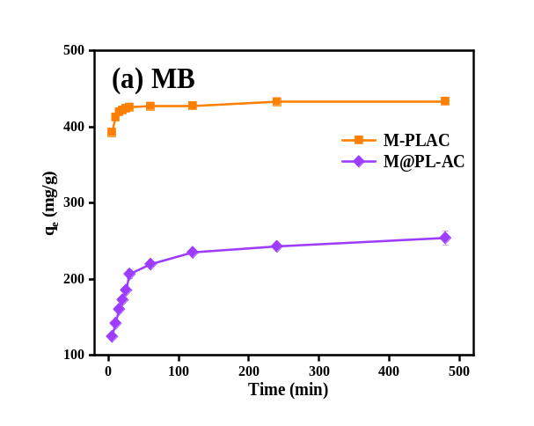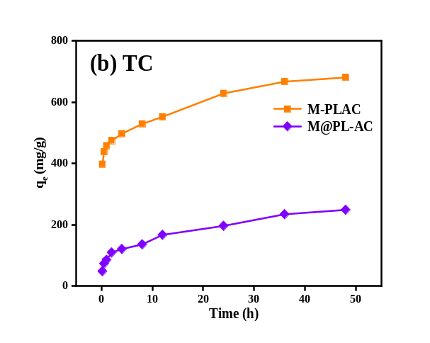
Fig. S1. The adsorption capacity of (a) MB and (b) TC by M-PLAC and M@PLAC.

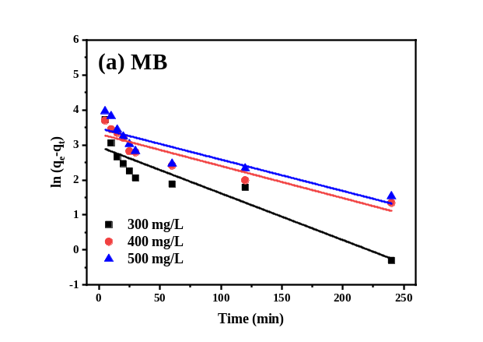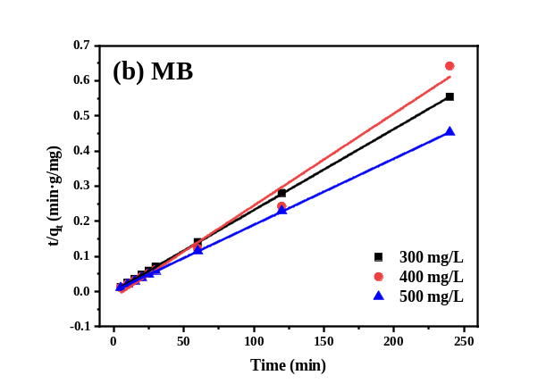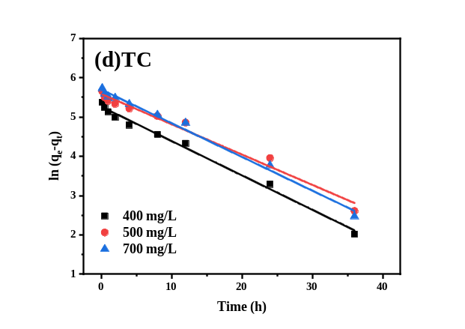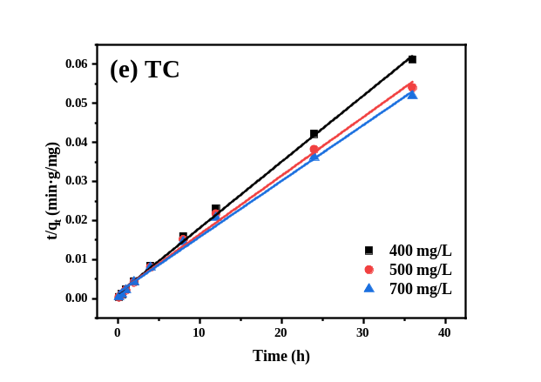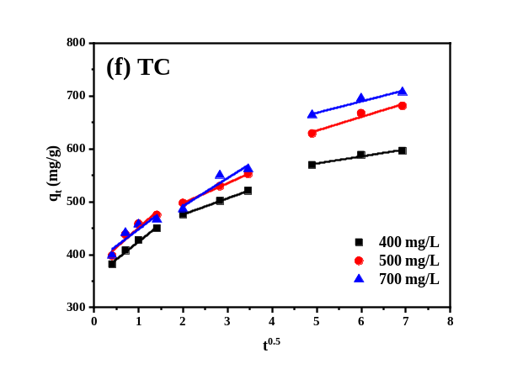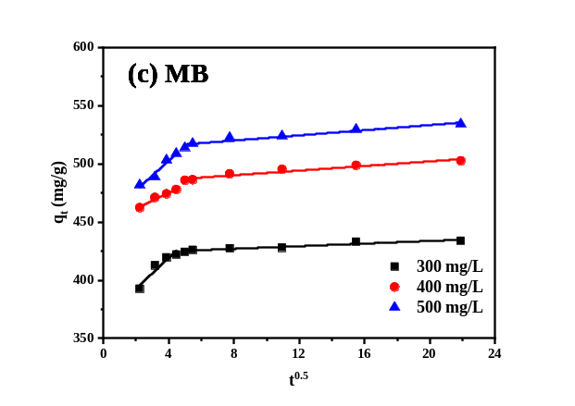
Fig. S2. Adsorption kinetics curves of MB and TC onto M-PLAC: (a) and (d) pseudo-first-order; (b) and (e) pseudo-second-order; (c) and (f) intraparticle diffusion model.

Table S1. Element normalization scale of M-PLAC.
Element | Atomicity | Mass [%] | Normalized mass [%] | Atom [%] | abs. error [%]  (1 sigma)
C | 6 | 51.49 | 65.12 | 78.13 | 5.59
O | 8 | 8.78 | 11.10 | 10.00 | 1.14
Fe | 26 | 12.92 | 16.34 | 4.22 | 0.64
N | 7 | 5.88 | 7.44 | 7.65 | 0.91
- | - | 79.07 | 100.00 | 100.00 | -

