Preparation and optimization of photocatalytic polyacrylic acid/guar gum/TiO₂ hydrogels for absorption and removing of methylene blue under Visible and UV irradiation
Seyyed Masud Naserzadeª, Mohsen Shahrousvandª*, Jamshid Mohammadi-Rovshandehª*, Hojjat Basatiª
ª Caspian Faculty of Engineering, College of Engineering, University of Tehran, P.O. Box 43841-119, Guilan, Rezvanshar, Iran
masud.naserzade@ut.ac.ir
m.shahrousvand@ut.ac.ir
roshandeh@ut.ac.ir
hojjat.basati@ut.ac.ir

Corresponding authors:
Mohsen Shahrousvanda, Caspian Faculty of Engineering, College of Engineering, University of Tehran, P.O. Box 43841-119, Guilan, Rezvanshar, Iran, Email: m.shahrousvand@ut.ac.ir
Jamshid Mohammadi-Rovshandeh, Caspian Faculty of Engineering, College of Engineering, University of Tehran, P.O. Box 43841-119, Guilan, Rezvanshar, Iran, Email: roshandeh@ut.ac.ir

Table 1S. Summary of full factorial design with four factors
Variables | Units | Coded variables
Variables | Units | -α | -1 | 0 | 1 | α
$X_{1}$(BDOD) | % | 2 | 4 | 6 | 8 | 10
$X_{2}$ (GG) | % | 0.5 | 1 | 1.5 | 2 | 2.5
$X_{3}$ (TiO₂) | % | 0 | 5 | 10 | 15 | 20
$X_{4}$ (pH) |  | 5 | 6 | 7 | 8 | 9

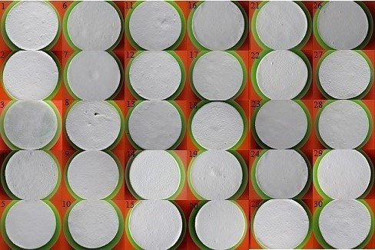
Fig. 1S. Images of synthesized hydrogels based on run number
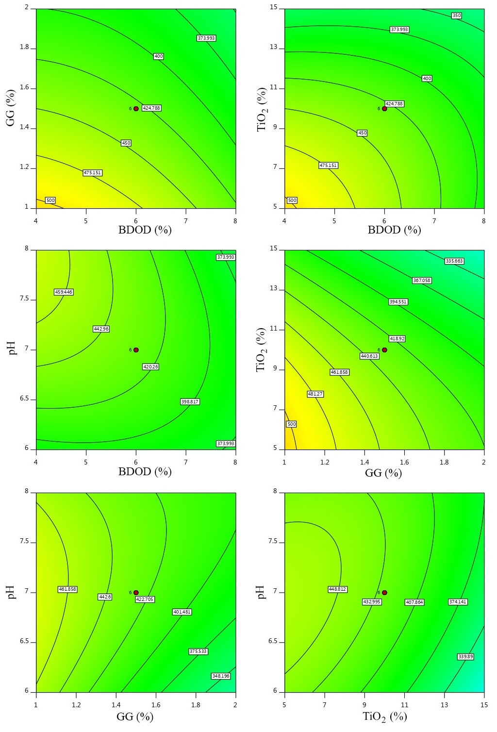
Fig. 2S. Evaluation of swelling factors by design expert program
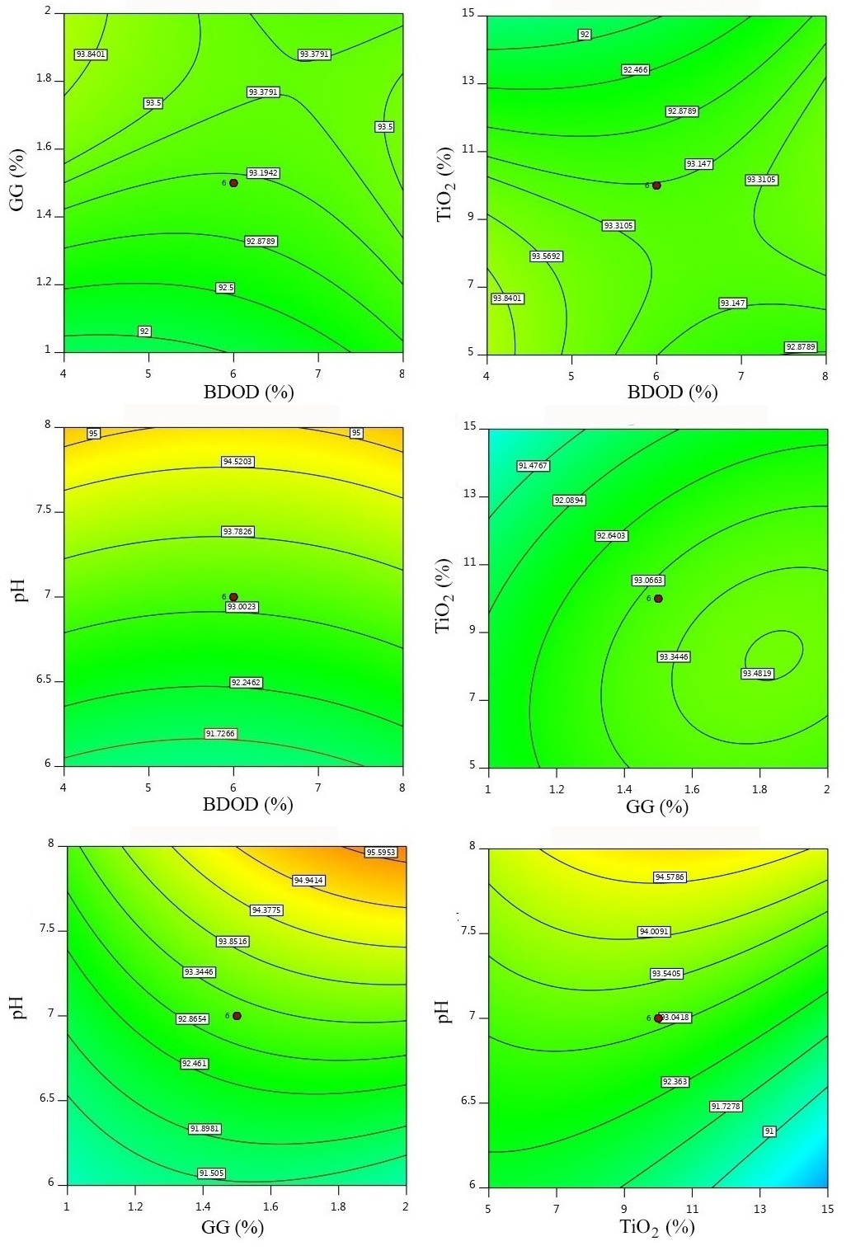
Fig. 3S. Evaluation of adsorption without UV (in visible light), factors by design expert program
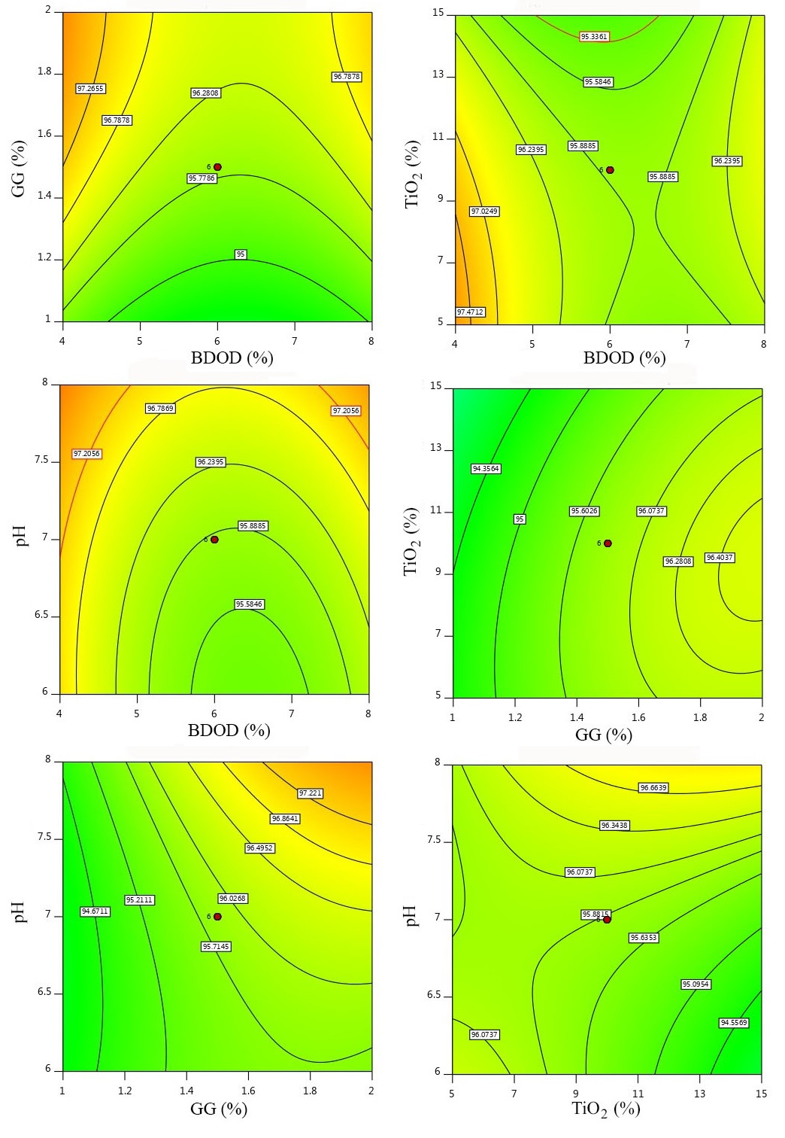
Fig. 4S. Evaluation of adsorption with UV, factors by design expert program

Table 2S. Evaluation of swelling response by experimental design program
Source | Sum of Squares | df | Mean Square | F-value | p-value
Model | 1.99E+05 | 14 | 14201.61 | 4.62 | 0.0035
A-BDOD | 18014.4 | 1 | 18014.4 | 5.86 | 0.0296
B-GG | 50508.38 | 1 | 50508.38 | 16.44 | 0.0012
C-TiO₂ | 66045.04 | 1 | 66045.04 | 21.5 | 0.0004
D-pH | 7957.04 | 1 | 7957.04 | 2.59 | 0.1298
AB | 689.06 | 1 | 689.06 | 0.2243 | 0.6431
AC | 8695.56 | 1 | 8695.56 | 2.83 | 0.1146
AD | 7612.56 | 1 | 7612.56 | 2.48 | 0.1378
BC | 115.56 | 1 | 115.56 | 0.0376 | 0.849
BD | 5439.06 | 1 | 5439.06 | 1.77 | 0.2046
CD | 6683.06 | 1 | 6683.06 | 2.18 | 0.1624
A² | 2055.11 | 1 | 2055.11 | 0.669 | 0.4271
B² | 217.23 | 1 | 217.23 | 0.0707 | 0.7942
C² | 12639.18 | 1 | 12639.18 | 4.11 | 0.062
D² | 9775.01 | 1 | 9775.01 | 3.18 | 0.0961
Residual | 43006.65 | 14 | 3071.9
Lack of Fit | 43006.65 | 9 | 4778.52
Pure Error | 0 | 5 | 0
Cor Total | 2.42E+05 | 28

Table 3S. Evaluation of the adsorption response in Without UV (visible light) by Design Expert program
Source | Sum of Squares | df | Mean Square | F-value | p-value
Model | 134.08 | 14 | 9.58 | 5.26 | 0.0019
A-BDOD | 0.0791 | 1 | 0.0791 | 0.0434 | 0.8379
B-GG | 11.65 | 1 | 11.65 | 6.4 | 0.0241
C-TiO₂ | 8.28 | 1 | 8.28 | 4.54 | 0.0513
D-pH | 72.79 | 1 | 72.79 | 39.95 | < 0.0001
AB | 2.96 | 1 | 2.96 | 1.63 | 0.223
AC | 6.79 | 1 | 6.79 | 3.73 | 0.074
AD | 0.0309 | 1 | 0.0309 | 0.017 | 0.8982
BC | 1.21 | 1 | 1.21 | 0.6667 | 0.4279
BD | 6.2 | 1 | 6.2 | 3.4 | 0.0864
CD | 7.87 | 1 | 7.87 | 4.32 | 0.0565
A² | 1.32 | 1 | 1.32 | 0.7271 | 0.4082
B² | 5.22 | 1 | 5.22 | 2.87 | 0.1125
C² | 9.41 | 1 | 9.41 | 5.17 | 0.0393
D² | 0.0692 | 1 | 0.0692 | 0.038 | 0.8483
Residual | 25.51 | 14 | 1.82
Lack of Fit | 25.51 | 9 | 2.83 | 1.79E+10 | < 0.0001
Pure Error | 7.92E-10 | 5 | 1.58E-10
Cor Total | 159.59 | 28

Table 4S. Evaluation of adsorption with UV response by Design Expert program
Source | Sum of Squares | df | Mean Square | F-value | p-value
Model | 1.99E+05 | 14 | 14201.61 | 4.62 | 0.0035
A-BDOD | 18014.4 | 1 | 18014.4 | 5.86 | 0.0296
B-GG | 50508.38 | 1 | 50508.38 | 16.44 | 0.0012
C-TiO₂ | 66045.04 | 1 | 66045.04 | 21.5 | 0.0004
D-pH | 7957.04 | 1 | 7957.04 | 2.59 | 0.1298
AB | 689.06 | 1 | 689.06 | 0.2243 | 0.6431
AC | 8695.56 | 1 | 8695.56 | 2.83 | 0.1146
AD | 7612.56 | 1 | 7612.56 | 2.48 | 0.1378
BC | 115.56 | 1 | 115.56 | 0.0376 | 0.849
BD | 5439.06 | 1 | 5439.06 | 1.77 | 0.2046
CD | 6683.06 | 1 | 6683.06 | 2.18 | 0.1624
A² | 2055.11 | 1 | 2055.11 | 0.669 | 0.4271
B² | 217.23 | 1 | 217.23 | 0.0707 | 0.7942
C² | 12639.18 | 1 | 12639.18 | 4.11 | 0.062
D² | 9775.01 | 1 | 9775.01 | 3.18 | 0.0961
Residual | 43006.65 | 14 | 3071.9
Lack of Fit | 29.95 | 9 | 3.33 | 126.01 | < 0.0001
Pure Error | 0 | 5 | 0
Cor Total | 2.42E+05 | 28

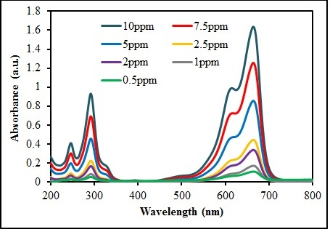
Fig. 5S. MB calibration curve from 200 to 800 nm

