Supplementary Information

Crystal structure thermal evolution and novel orthorhombic phase of methylammonium lead bromide, CH₃NH₃PbBr₃

Carmen Abia,^{1,3} Carlos A. López,^{1,2*}, Laura Canadillas-Delgado³, María T. Fernández-Diaz³ and José A. Alonso¹*

¹ Instituto de Ciencia de Materiales de Madrid, CSIC, Cantoblanco 28049 Madrid, Spain.
² INTEQUI, (UNSL-CONICET) and Facultad de Química, Bioquímica y Farmacia, UNSL, Almirante Brown 1455, 5700, San Luis, Argentina.
³Institut Laue Langevin. 38042 Grenoble Cedex, France.

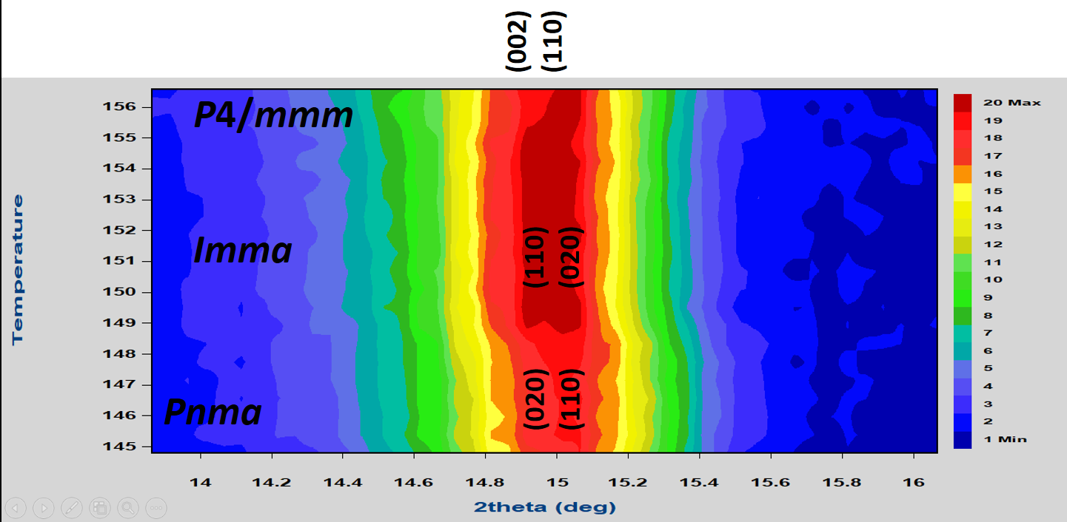
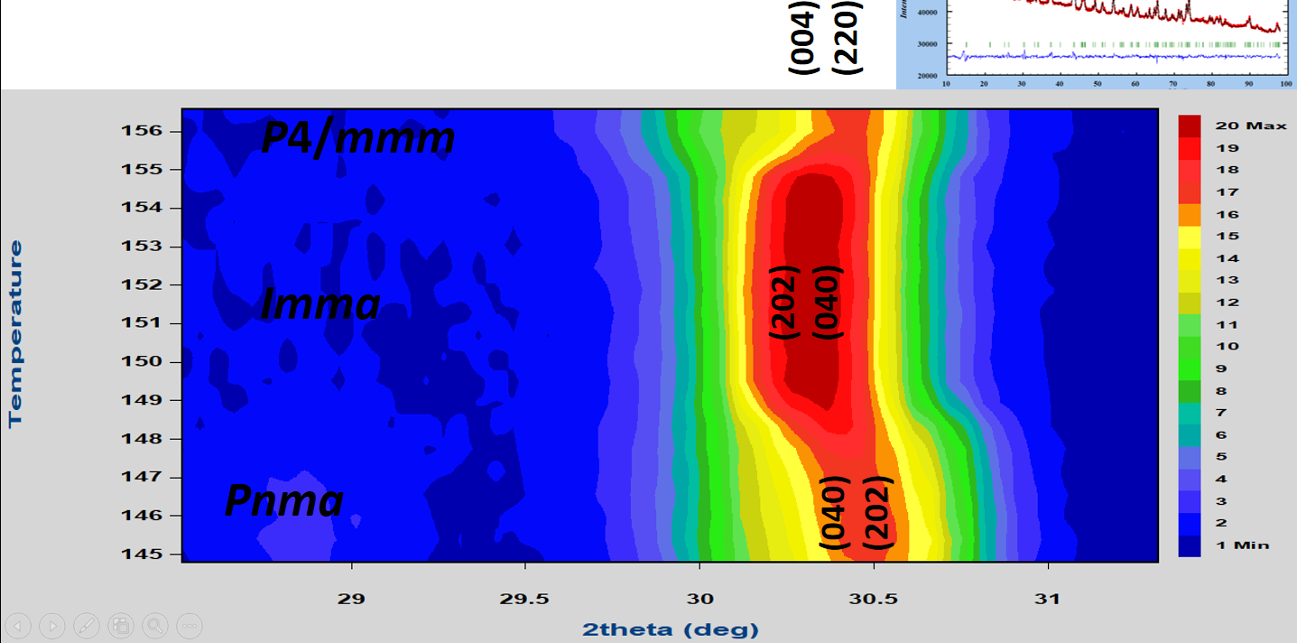
Figure S1: Neutron powder diffraction 2D maps of two selected angular regions of the MAPbBr₃, illustrating the Pnma-Imma-P4/mmm phase transitions.
Table S1: Crystallographic data for MAPbBr₃ phase in Imma orthorhombic system from NPD at 150.5 K.
a = 8.4494(11) Å, b = 11.6942(14) Å, c = 8.2103(10) Å and V = 811.25(17) Å³
 | x | y | z | U_{iso} | f_{occ}
Pb1 | 0 | 0 | 0 | 0.0012(7) | 0.226(1)
Br1 | 0 | 0.25 | 0.9550(18) | 0.061(3) | 0.25
Br2 | 0.25 | 0.0251(9) | 0.25 | 0.061(3) | 0.5
C1 | 0 | 0.31874 | 0.5 | 0.062(4) | 0.062(4)
N1 | 0 | 0.19389 | 0.5 | 0.062(4)
  0.062(4)
H1a | 0.07657 | 0.16634 | 0.42120 | 0.10132 | 0.062(4)
H2a | -0.0766 | 0.34629 | 0.57880 | 0.10132 | 0.062(4)
H3a | 0.02803 | 0.16634 | 0.60764 | 0.10132 | 0.062(4)
H4a | -0.1046 | 0.16634 | 0.47116 | 0.10132 | 0.062(4)
H5a | 0.10459 | 0.34629 | 0.52884 | 0.10132 | 0.062(4)
H6a | -0.0280 | 0.34629 | 0.39236 | 0.10132 | 0.062(4)
C2 | 0.11238 | 0.25 | 0.46802 | 0.062(4) | 0.188(4)
N2 | -0.0576 | 0.25 | 0.5 | 0.062(4) | 0.188(4)
H1b | -0.0756 | 0.25 | 0.61668 | 0.10132 | 0.188(4)
H2b | 0.13042 | 0.25 | 0.35134 | 0.10132 | 0.188(4)
H3b | -0.1048 | 0.31776 | 0.45225 | 0.10132 | 0.377(9)
H4b | 0.15963 | 0.18224 | 0.51577 | 0.10132 | 0.377(9)
R_{p} = 0.869 %, R_{wp} = 1.16 %, χ² = 5.77, R_{Bragg} = 8.19%

%%%%%%%%%%%%%Comparacion
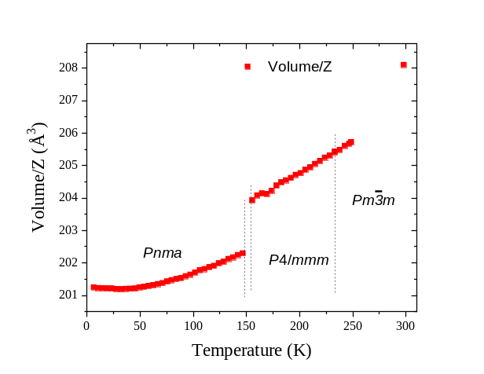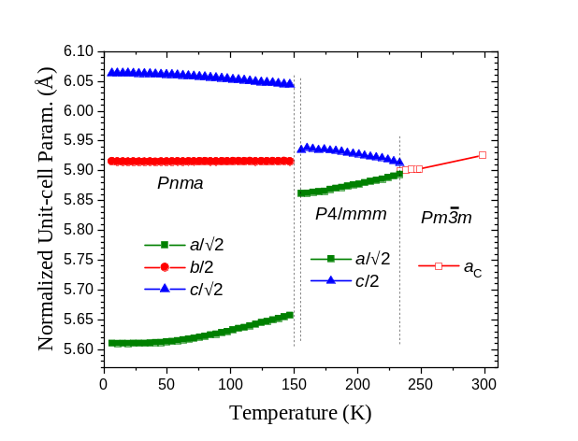
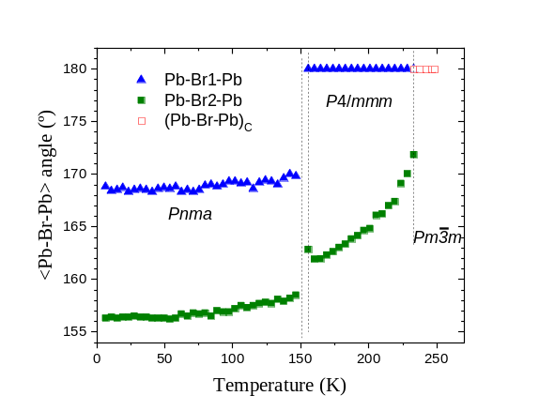

Table S2: Comparison of the crystallographic data, angles and distances, for MAPbBr₃ orthorhombic phase in the Pnma system.
 | 2 K |  | Varadwaj  (Theory) | Yang et al.  95 K |  | Swainson et al.  1 K Duterated sample
 | Dist | Angle | Dist | Dist | Angle | Dist | Angle
NH11∙∙∙Br1 | 2.47(2) | 157.6(7) | 2.501 | 2.519(17) | 157.5(9) | 2.50(1) | 156.9(5)
NH11∙∙∙Br2 | 3.24(1) | 106.2(4) |  | 3.246(15) | 107.0(4) | 3.234(7) | 106.6(3)
NH12∙∙∙Br1 | 3.25(1) | 105.5(4) |  | 3.222(17) | 107.4(5) | 3.227(8) | 109.1(4)
NH12∙∙∙Br2 | 2.52(1) | 152.4(6) | 2.446 | 2.506(16) | 154.6(6) | 2.525(8) | 151.2(5)
CH21∙∙∙Br1 | 3.04(2) | 170.1(7) | 3.005 | 3.029(12) | 175.6(9) | 2.988(17) | 177.6(6)
CH21∙∙∙Br2 | 3.96(1) | 107.5(3) |  | 4.004(14) | 104.8(4) | 4.040(10) | 101.6(3)
CH22∙∙∙Br1 | 3.24(1) | 101.3(5) |  | 3.175(18) | 104.7(5) | 3.226(12) | 100.7(4)
CH22∙∙∙Br2 | 2.93(9) | 164.8(6) | 2.916 | 2.95(2) | 158.0(7) | 2.916(12) | 165.0(5)
Pb–Br1–Pb (°) | 169.1(2) |  |  | 168.80(16) |  | 168.39(17)
Pb–Br2–Pb (°) | 156.6(1) |  |  | 157.06(13) |  | 157.29(13)

