Supplementary Materials

Isolation, characterization, and comparative genomic analysis of vB_BviS-A10Y, a novel bacteriophage from mangrove sediments

Tianyou Zhang¹, Menghui Zhang¹,Yuan Chen¹, Meishun Yu¹, Runying Zeng^{1,2*}, Min Jin^{1,2*}

¹State Key Laboratory Breeding Base of Marine Genetic Resource, Third Institute of Oceanography, Ministry of Natural Resources, Xiamen, China
²Southern Marine Science and Engineering Guangdong Laboratory, Zhuhai, China

*Corresponding author (Min Jin):
E-mail address: jinmin@tio.org.cn
Address: Third Institute of Oceanography, Ministry of Natural Resources, Xiamen 361005, China

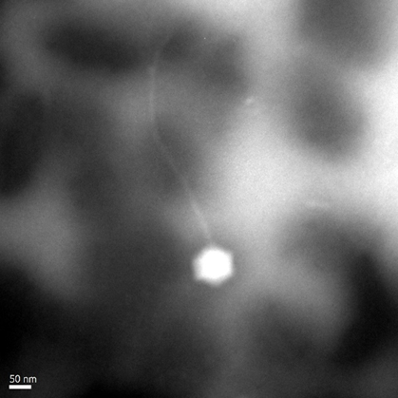

Fig.S1 Morphology of vB_BviS-A10Y. Purified phage particles were negatively stained with 2% uranyl acetate on carbon-coated copper grids and observed using a JEM-1230 TEM at an accelerating voltage of 120 kV.

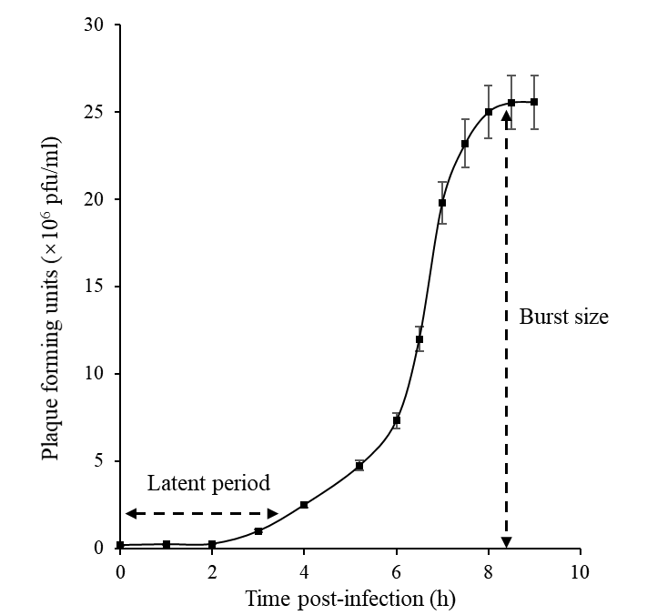

Fig.S2 One-step growth curve of phage vB_BviS-A10Y. Each data point is shown as the mean ± SD of three independent replicates.

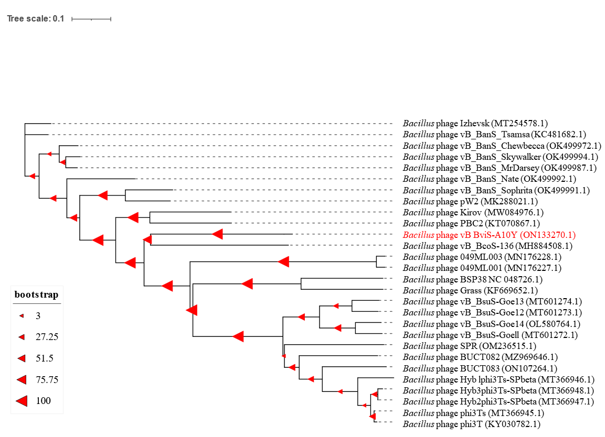

Fig.S3 Neighbor-joining phylogenetic tree based on the whole genome of phage vB_BviS-A10Y and other related phages. The GenBank accession number is shown along with the species name. The genome of vB_BviS-A10Y is marked in red.

