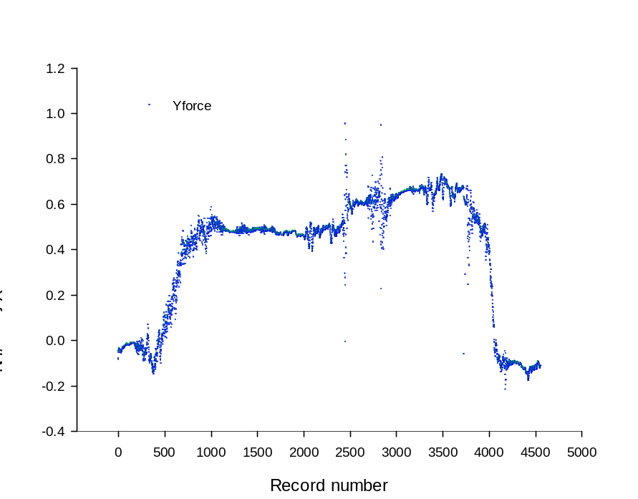
Appendix D Tension of standing trees of C033 families of Eucalyptus camaldulensis during tree pulling test

