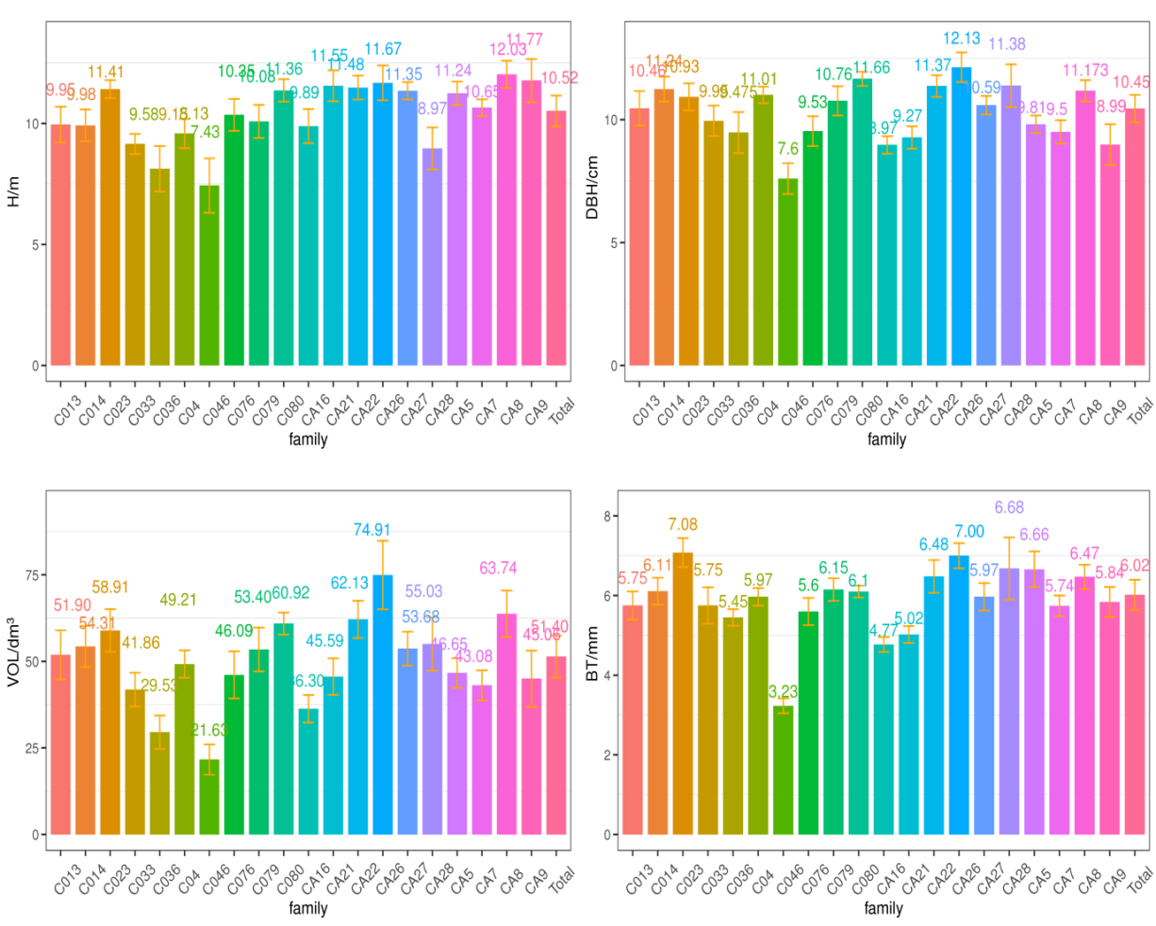
a: Growth traits of 20 Eucalyptus camaldulensis families

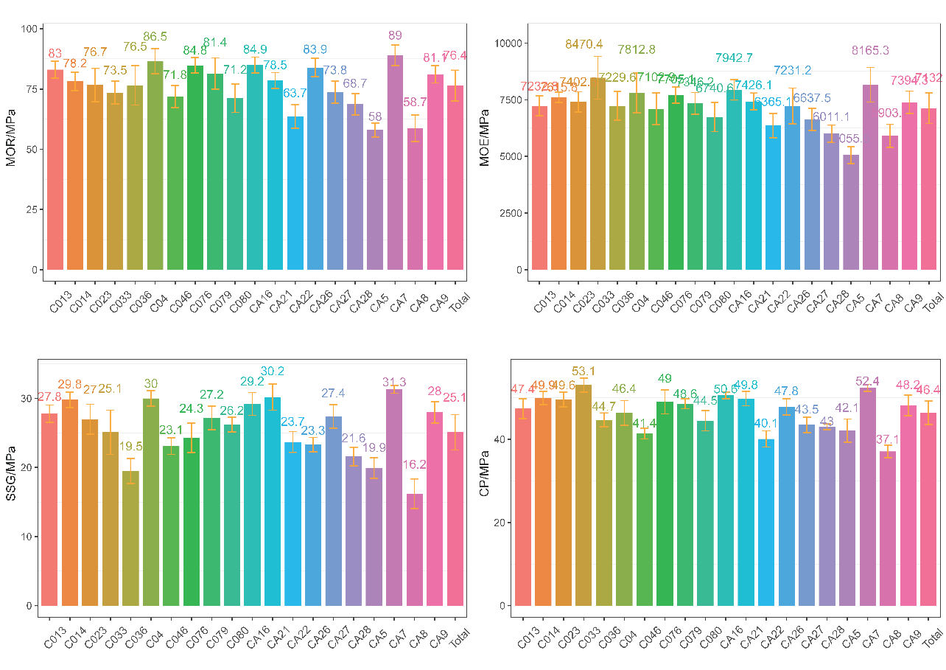
b: Wood properties of standing trees of 20 Eucalyptus camaldulensis families

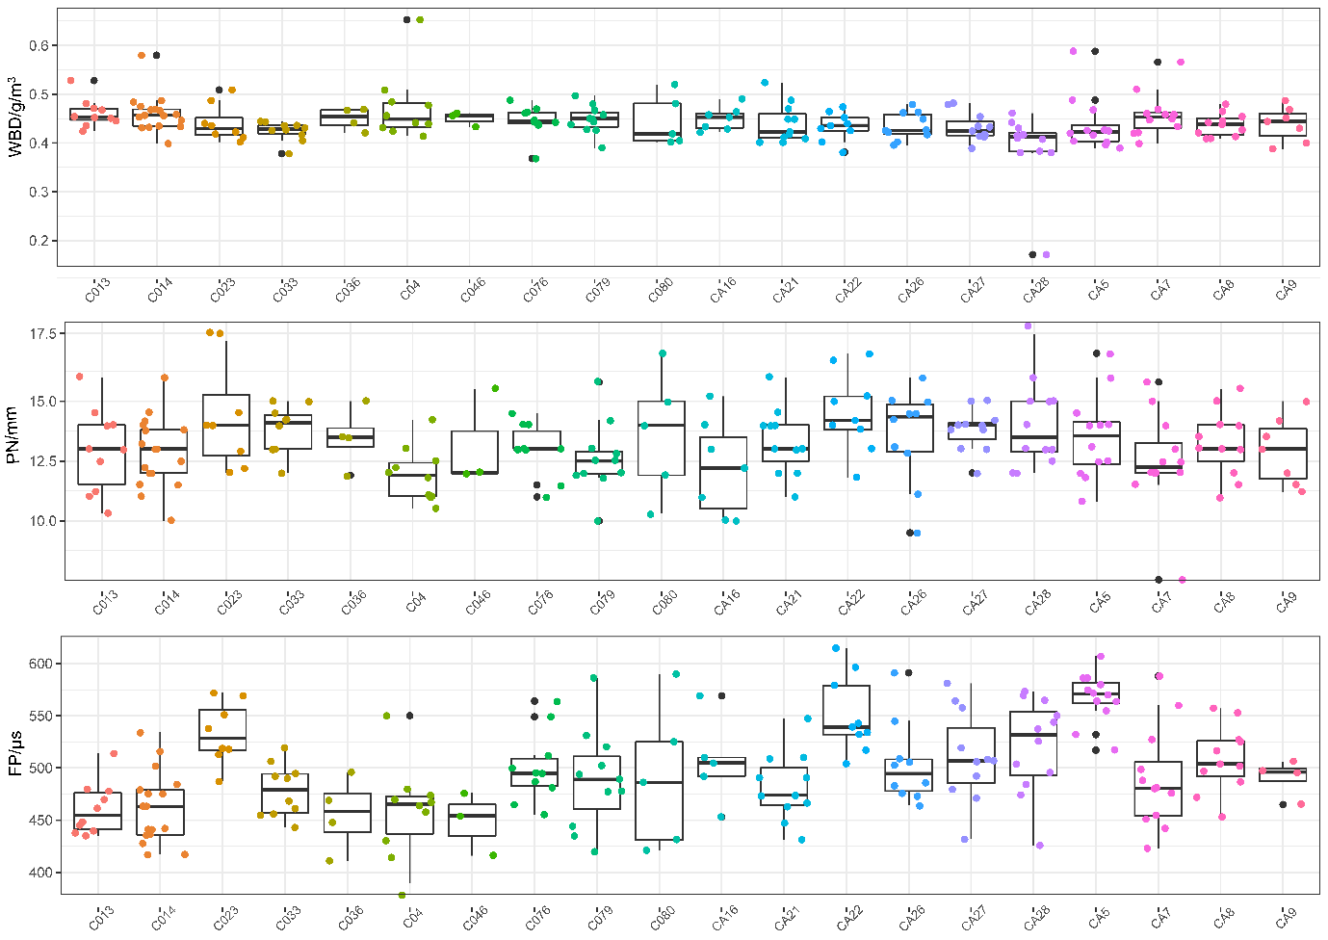
c: Box diagram of physical properties of standing trees of 20 Eucalyptus camaldulensis families

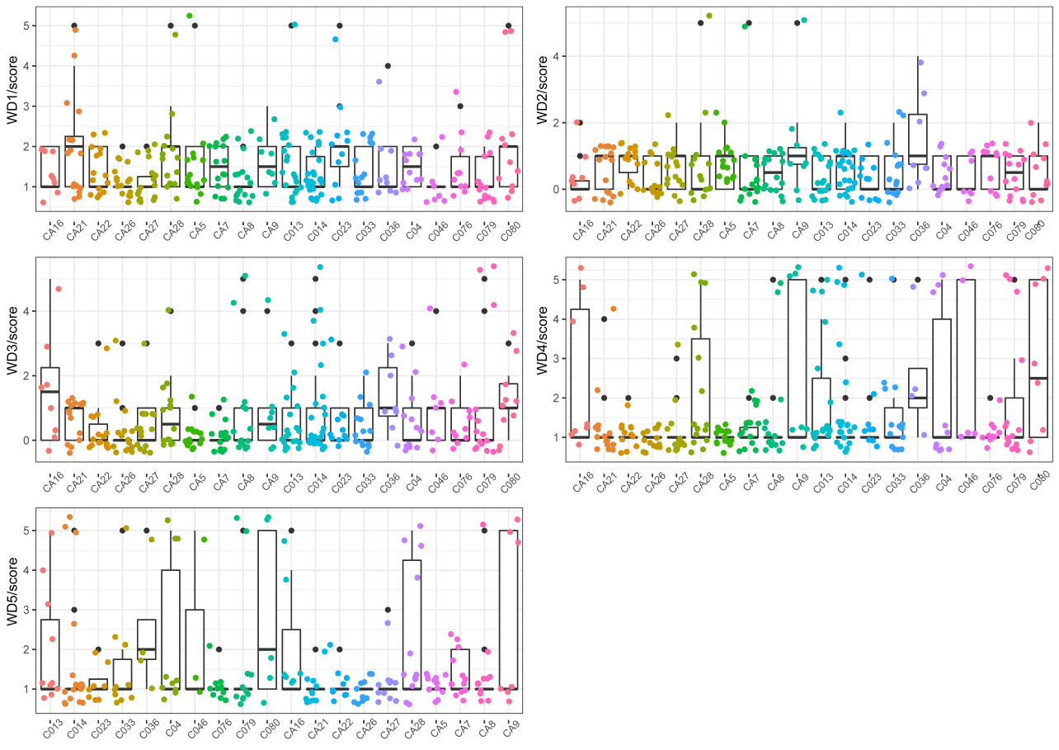
d: WD1-WD5 box map of 20 Eucalyptus camaldulensis families
Appendix C Different characters of 20 Eucalyptus camaldulensis families

