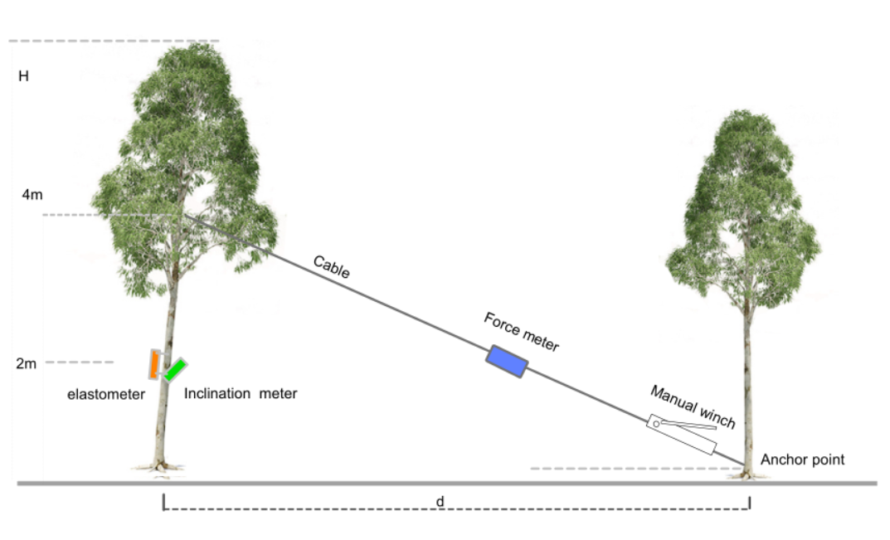
Appendix B Schematic diagram of wind damage test for tree simulation

