Supplementary Figures
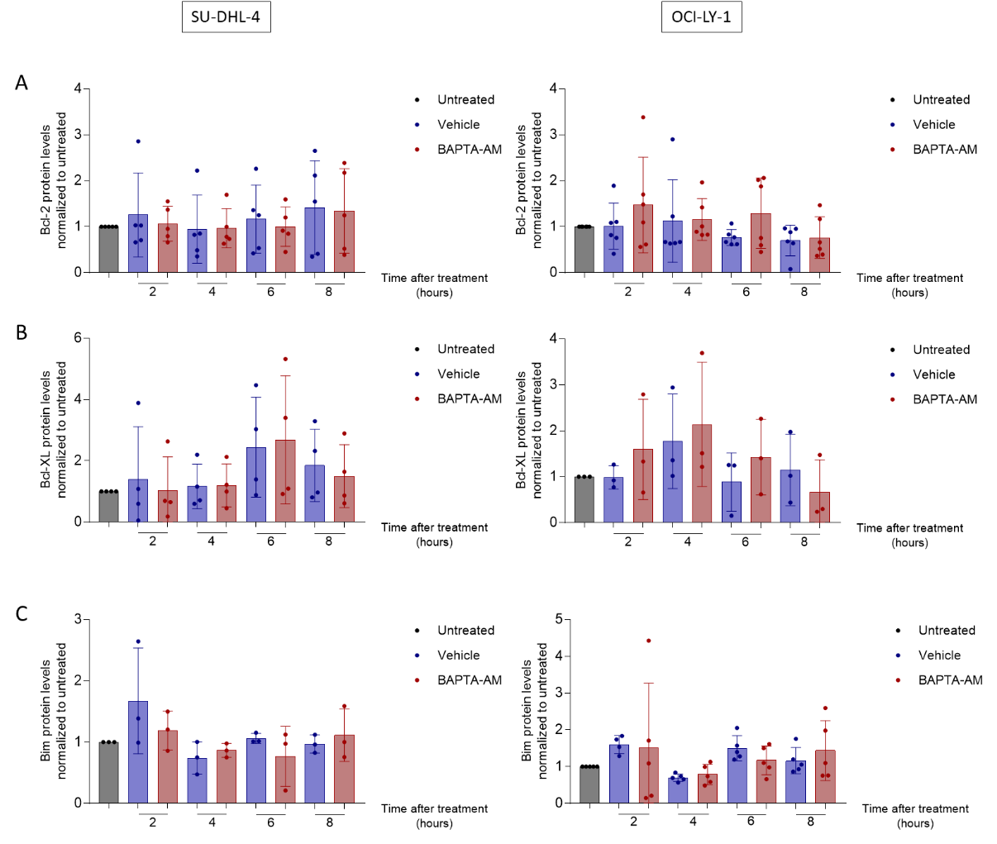

Supplementary figure 1
Representative western blot and statistical analysis of Bcl-2 (A), Bcl-XL (B) Bim (C) levels normalized to untreated in response to vehicle (dark blue) and 10 µM of BAPTA-AM (red) after 2, 4, 6, 8, and 24 hours. Vinculin was included as a loading control. Data are represented as the average ± S.D. Statistical significant differences were determined with a paired two-tailed Student’s t-test. Differences were considered significant when p < 0.05. (** p < 0.01; *** p < 0.001).

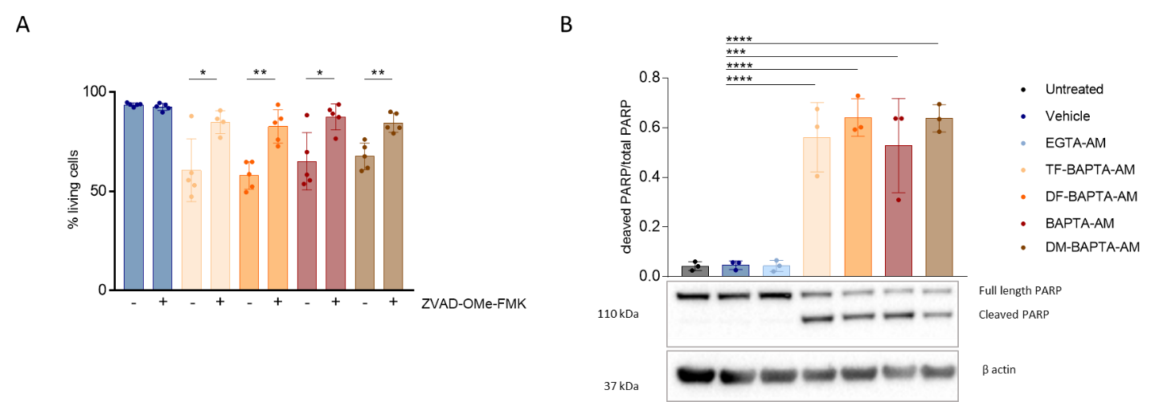
Supplementary figure 2
(A) Quantitative analysis of apoptosis in OCI-LY-1 in response to 6 h treatment with vehicle (dark blue), 10 µM of TF-BAPTA-AM (yellow), DF-BAPTA-AM (orange), BAPTA-AM (red) and DM-BAPTA-AM (brown) and co-treatment for 6 h with 10 µM ZVAD-OMe-FMK. Cells were stained with annexin V-FITC and 7-AAD and the apoptotic fraction was identified as annexin V positive cells. Data are represented as the average ± S.D.; N = 5. Statistically significant differences were determined with a paired two-tailed Student’s t-test. Differences were considered significant when p < 0.05. (** p < 0.01; *** p < 0.001). (B) Statistical analysis of PARP cleavage/total PARP protein levels normalized to untreated in response to vehicle (dark blue), 10 µM of EGTA-AM (light blue), TF-BAPTA-AM (yellow), DF-BAPTA-AM (orange), BAPTA-AM (red) and DM-BAPTA-AM (brown). Β actin was used as a loading control. Data are represented as the average ± S.D.; N = 3. Statistically significant differences were determined with a one-way ANOVA. Differences were considered significant when p < 0.05. (** p < 0.01; *** p < 0.001).

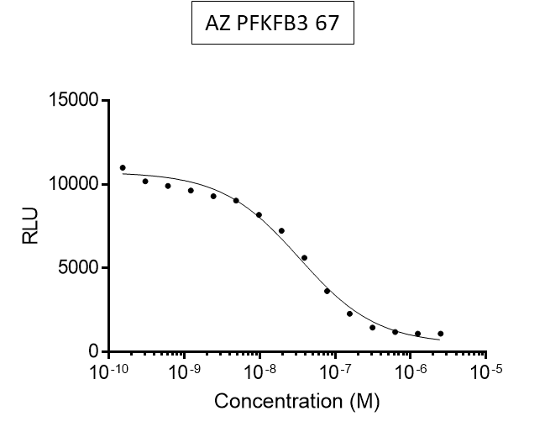

Supplementary figure 3
In vitro measurement of PFKFB3 activity in the presence of increasing concentrations of AZ PFKFB3 67.

