Appendix
Peak demand calculation

Equation 5. Peak capacity per cell
$${Peak max}_{ xy year}(capacity unit)= max⁡(\frac{{SpecifiedAnnualDemand}_{xy, year}∙{SpecifiedDemandProfile}_{ts, year}}{CapacitytoActivity∙{YearSplit}_{ts, year}})$$
Equation 6. Peakdemand per cell-km
$${Peakdemand}_{xy, year} (capacity unit/km)=\frac{{Peak max}_{ xy, year}}{{Distributionlosses}_{xy}∙{Estimatedkm}_{xy}}$$
Distribution lines additions to OSeMOSYS

Parameters and variables
param Peakdemand {r in REGION, t in TECHNOLOGY, y in YEAR};
param MaxKmPerTech {r in REGION, t in TECHNOLOGY, y in YEAR};
param CapitalCostkmkW {r in REGION, t in TECHNOLOGY, y in YEAR};

var km {r in REGION, t in TECHNOLOGY, y in YEAR}>=0;
var CapitalCostnetwork{r in REGION, t in TECHNOLOGY, y in YEAR}>= 0;

Objective function
minimize cost: sum{r in REGION, t in TECHNOLOGY, y in YEAR}
(((((sum{yy in YEAR: y-yy < OperationalLife[r,t] && y-yy>=0}
NewCapacity[r,t,yy])+ ResidualCapacity[r,t,y])*FixedCost[r,t,y] +
sum{m in MODEperTECHNOLOGY[t], l in TIMESLICE}
RateOfActivity[r,l,t,m,y]*YearSplit[l,y]*VariableCost[r,t,m,y]) / DiscountFactorMid[r,y] +
(CapitalCost[r,t,y] * NewCapacity[r,t,y] +CapitalCostnetwork[r,t,y]) * CapitalRecoveryFactor[r,t] * PvAnnuity[r,t] / DiscountFactor[r,y] +
DiscountedTechnologyEmissionsPenalty[r,t,y] - DiscountedSalvageValue[r,t,y]));

Added network functions
s.t. CAa6_NewCapacityDistribution{r in REGION, t in TECHNOLOGY, y in YEAR}: Peakdemand[r,t,y] * (sum{yy in YEAR: y-yy>=0} km[r,t,yy]) >= TotalCapacityAnnual[r,t,y];

s.t. CAa7_DistributionkmLimit{r in REGION, t in TECHNOLOGY, y in YEAR}: (sum{yy in YEAR: y-yy>=0} km[r,t,yy]) <= MaxKmPerTech[r,t,y];

s.t. NetworkCostPerCapacitykm{r in REGION, t in TECHNOLOGY, y in YEAR}: km[r,t,y] * CapitalCostkmkW[r,t,y] = CapitalCostnetwork[r,t,y];

Modified costing equations
s.t. CC1_UndiscountedCapitalInvestment{r in REGION, t in TECHNOLOGY, y in YEAR}: CapitalCost[r,t,y] * NewCapacity[r,t,y] + CapitalCostnetwork[r,t,y] = CapitalInvestment[r,t,y];

s.t. SV1_SalvageValueAtEndOfPeriod1{r in REGION, t in TECHNOLOGY, y in YEAR: (y + OperationalLife[r,t]-1) > (max{yy in YEAR} max(yy)) && DiscountRate[r]>0}: SalvageValue[r,t,y] = (CapitalCost[r,t,y] * NewCapacity[r,t,y] + CapitalCostnetwork[r,t,y])* CapitalRecoveryFactor[r,t] * PvAnnuity[r,t] * (1-(((1+DiscountRate[r])^(max{yy in YEAR} max(yy) - y+1)-1)/((1+DiscountRate[r])^OperationalLife[r,t]-1)));

s.t. SV2_SalvageValueAtEndOfPeriod2{r in REGION, t in TECHNOLOGY, y in YEAR: (y + OperationalLife[r,t]-1) > (max{yy in YEAR} max(yy)) && DiscountRate[r]=0}: SalvageValue[r,t,y] = (CapitalCost[r,t,y] * NewCapacity[r,t,y] + CapitalCostnetwork[r,t,y]) * CapitalRecoveryFactor[r,t] * PvAnnuity[r,t] * (1-(max{yy in YEAR} max(yy) - y+1)/OperationalLife[r,t]);

s.t. TDC1_TotalDiscountedCostByTechnology{r in REGION, t in TECHNOLOGY, y in YEAR}: ((((sum{yy in YEAR: y-yy < OperationalLife[r,t] && y-yy>=0} NewCapacity[r,t,yy])+ ResidualCapacity[r,t,y])*FixedCost[r,t,y] + sum{m in MODEperTECHNOLOGY[t], l in TIMESLICE} RateOfActivity[r,l,t,m,y]*YearSplit[l,y]*VariableCost[r,t,m,y])/DiscountFactorMid[r,y]+(CapitalCost[r,t,y] * NewCapacity[r,t,y]+CapitalCostnetwork[r,t,y])/DiscountFactor[r,y] +DiscountedTechnologyEmissionsPenalty[r,t,y]-DiscountedSalvageValue[r,t,y]) = TotalDiscountedCostByTechnology[r,t,y];

Table 3. GIS Datasets
Name | Resolution | Reference
Nighttime light (VIIRS) (Nighttimelight data average masked, 2020) | 15 arc second | (Elvidge et al., 2021)
GDP PPP (GDP_PPP_2015_WGS_84) | 300 arc second | (Kummu et al., 2019)
Population (HRSL_Kenya) | 1 arc second | (Facebook, 2021b)
Administrative boundaries (ADM: gadm36_KEN_shp) | - | (GADM, 2021)
Road network (Roads) | - | (Jordan et al., 2021)
Low voltage distribution network (11kV transmission Kenya) | - | (KPLC, 2020a)
Low voltage distribution network (33kV transmission Kenya.zip) | - | (KPLC, 2020a)
Medium voltage distribution network (66kV transmission Kenya) | - | (KPLC, 2020a)
High voltage transmission network (132kV transmission Kenya) | - | (KPLC, 2020a)
High voltage transmission network (220kV transmission Kenya) | - | (KPLC, 2020a)
Existing mini-grid locations (mini-grid-exisitng.zip) | - | (Jordan et al., 2020)
Under development mini-grid locations (minigrid-under-development) | - | (Jordan et al., 2020)
Transformers (transformersKenya) | - | (KPLC, 2017)
Transmission stations (transmissionstationsKenya) | - | (KPLC, 2020a)
Substations (primary-substationsKenya) | - | (KPLC, 2020b)

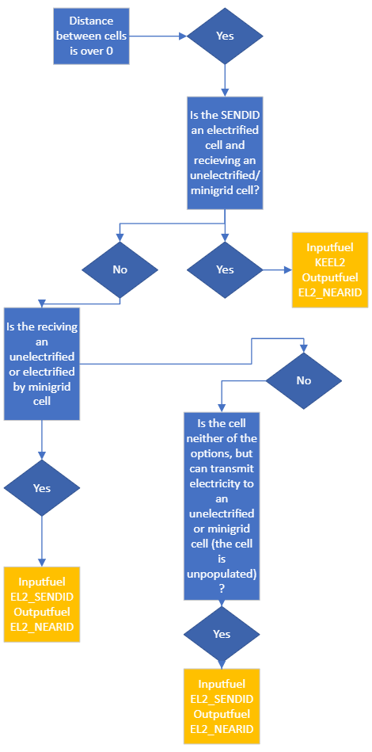

Figure 14 Decision flowchart of the transmission lines
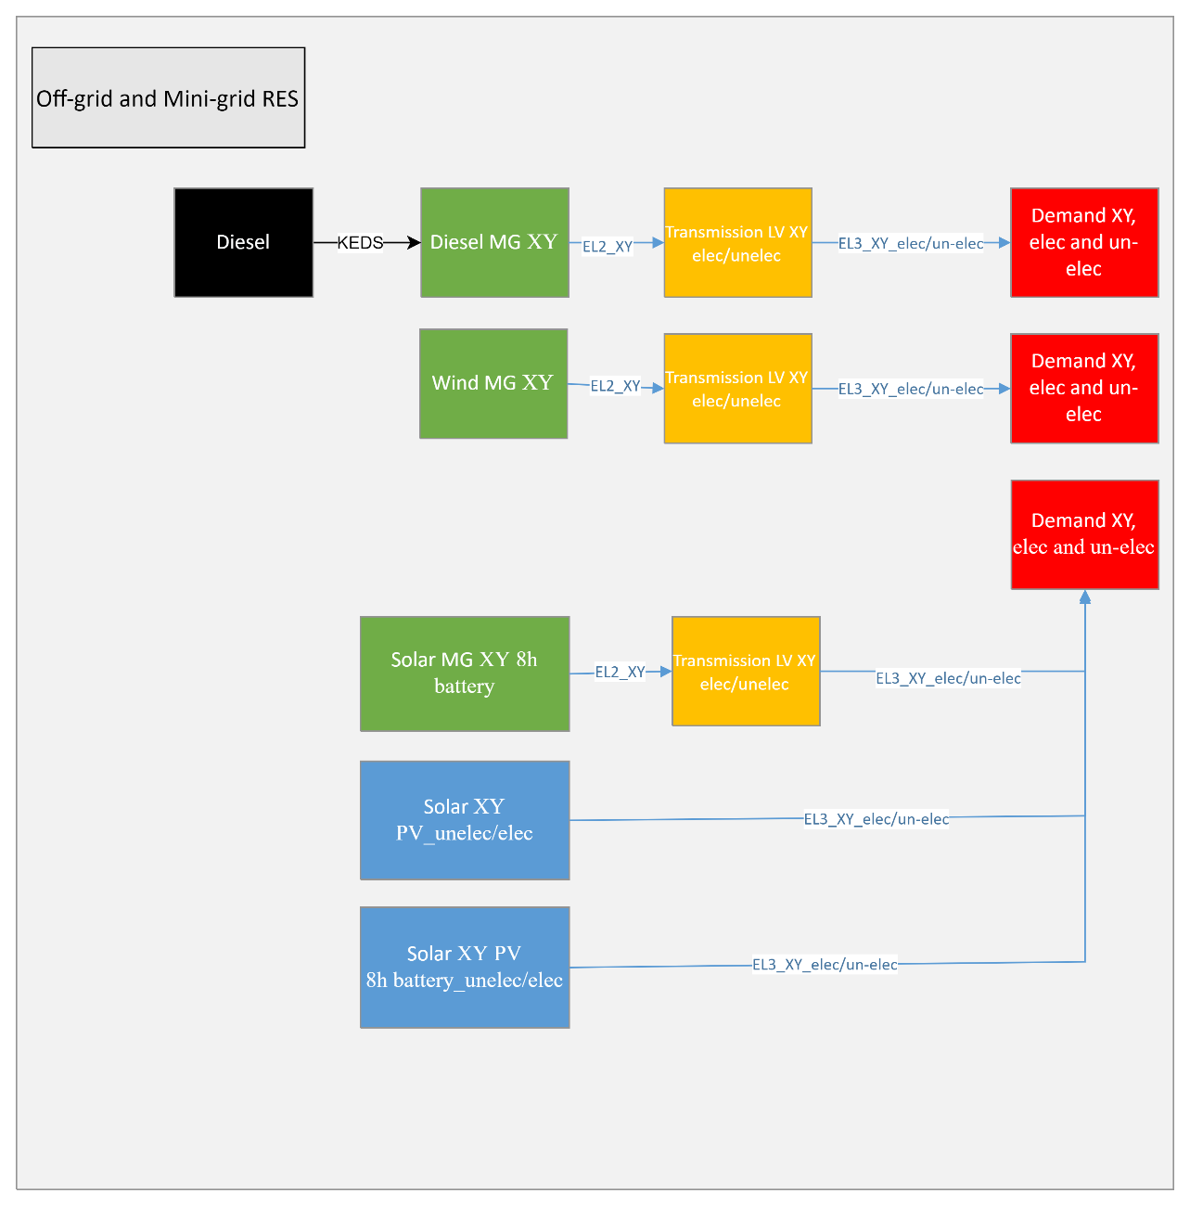
Figure 15. Off-grid reference energy system

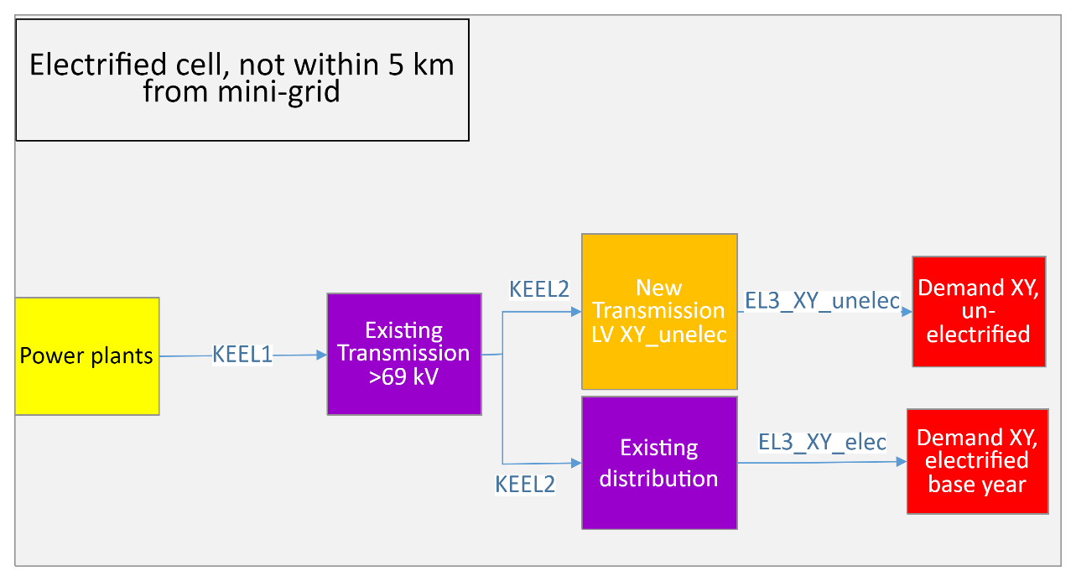
Figure 16. Central power plant reference energy system

Table 4. Battery techno-economic data (NREL (National Renewable Energy Laboratory), 2021a) adjusted to Kenyan wages (International Labour Organization, 2020)
Type | Capital cost | 2019 | 2025 | 2030 | 2035 | 2040
Residential | 1 kW / 4 kWh Battery Storage - Advanced | 4589 | 2806 | 2043 | 1843 | 1643
Residential | 1 kW / 4 kWh Battery Storage - Moderate | 4589 | 3270 | 2845 | 2668 | 2490

Table 5. Techno-economic data
Technology | Capital cost (USD/kW) | Variable cost  (USD/GJ) | Fixed cost (USD/kW) | Operational life (years) | Efficiency/  Capacity factor | Availability factor | Annual max capacity
Residential PV  NREL (National Renewable Energy Laboratory), 2021) | 2020: 2710 2030:1004 | - | 18 | 30  (NREL (National Renewable Energy Laboratory), 2021b) | Location specific (Pfenninger and Staffell, 2016) | -
Wind mini-grid (NREL (National Renewable Energy Laboratory), 2021a) | 2020: 1375 2030:910 | - | 39 | 20  (NREL (National Renewable Energy Laboratory), 2021b) | Location specific (Staffell and Pfenninger, 2016) | -
Transmission and distribution | HV/MV: 3.3 USD/kW-km (location specific)(IEA, 2014)  LV: 10000 USD/km (location specific)  (Korkovelos et al., 2019)  Increasing capacity for existing transmission lines is assumed to 365 USD/kW and 80 USD/kW for distribution. | - | 2.5 % of capital cost (location specific)  (Ministry of Energy Kenya, 2018) | 60 (outside of the modelling period) | HV lines: 95.5%  Distribution: 83%  (Energy and Petroleum Regulatory Authority (EPRA)Kenya et al., 2021) | -
PV Mini-grid + battery 8h (NREL (National Renewable Energy Laboratory), 2021a) | 2020: 3613  2030: 2024 | - | 95  (13 USD/kW for PV, 82 USD/kW for battery) | 30  (NREL (National Renewable Energy Laboratory), 2021b) | Location specific (Pfenninger and Staffell, 2016) + calculated battery | -
PV residential +8h battery  (NREL (National Renewable Energy Laboratory), 2021a) | 2020: 7040  2030: 3850 | - | 100  (18 USD/kW for PV + 82 USD/kW for battery) | 30 (NREL (National Renewable Energy Laboratory), 2021b) | Location specific (Pfenninger and Staffell, 2016) + calculated battery | -
Diesel generators (Gioutsos et al., 2018) | 650 | 4.2 | 15 | 15 | 25% (specific fuel consumption) (Yamegueu et al., 2011) | -
Technology | Capital cost (USD/kW) | Variable cost  (USD/GJ) | Fixed cost (USD/kW) | Operational life (years) | Efficiency/  Capacity factor | Availability factor | Annual max capacity
Import Ethiopia (200 MW, 612 km Kenya) (Ministry of Energy Kenya, 2018) | 1300(Ministry of Energy Kenya, 2018) | 19.44 USD/GJ  (7 cent per kWh) | - | 60 | - | 85%
Wind central (NREL (National Renewable Energy Laboratory), 2021a) | 2020: 1375 2030:910 | - | 40 | 25 | 38%  Seasonal variation | - | 4.6 GW (Energy and Petroleum Regulatory Authority (EPRA)Kenya et al., 2021)
Heavy fuel oil (Energy and Petroleum Regulatory Authority (EPRA)Kenya et al., 2021) | 1650 | 1.2 | 7.1 | 20 | 45% | 92%
Hydro run of river | 2902 | 1.2 | 2 | 50 | 38% | 98%
Hydro dam medium (Ministry of Energy Kenya, 2018) | 4089 | 0.16 | 18.6 | 50 |  | 90%
Hydro large (Energy and Petroleum Regulatory Authority (EPRA)Kenya et al., 2021) | 3798 | 0.14 | 15.3 | 50 | Seasonal variation, on average 58%. Based on monthly production of Turkwel and Sondu HPP | 90%
Hydropower: Masinga  Kamburu  Gitaru  Kinadruma  Kiambere  High grand Falls  (Energy and Petroleum Regulatory Authority (EPRA)Kenya et al., 2021) | High grand Falls: 3819  Start year: 2031  Remaining hydropower is not installing new capacity. | 0.14 | 15.3 | 50 | All HPP are seasonal based on their monthly production  Masinga: 43%  Kamburu:48%  Gitaru: 40%  Kinadruma: 29%  Kiambere: 60%  Mutonga: 49% (Moksnes, 2016)  High grand Falls (same as Mutonga): 49% | 90%
Geothermal (Energy and Petroleum Regulatory Authority (EPRA)Kenya et al., 2021) | 3500 | Binary: 2.9 | Binary: 22.1  Flash steam: 151.9 | 30 | Binary:80%  Flash steam: 90% | 95%
Solar utility (NREL (National Renewable Energy Laboratory), 2021a) | 2020: 136  2030: 759 |  | 2020: 22  2030: 16 | 25 | 22% (peak capacity factor in daytime, low evening and 0 night-time)
Biomass (Ministry of Energy Kenya, 2018) | 3045 | 2.5 | 152.3 | 30 | 25% | 90%
Medium Speed Diesel power plant (Energy and Petroleum Regulatory Authority (EPRA)Kenya et al., 2021) | 1650 | 1.7 | 7.1 | 25 | 45% | 92%
Technology | Capital cost (USD/kW) | Variable cost  (USD/GJ) | Fixed cost (USD/kW) | Operational life (years) | Efficiency/  Capacity factor | Availability factor | Annual max capacity
Natural gas, combined cycle (Energy and Petroleum Regulatory Authority (EPRA)Kenya et al., 2021) | 1349 | 1 | 18 | 20 | 49.5% | 90%
Coal power plant (Energy and Petroleum Regulatory Authority (EPRA)Kenya et al., 2021) | 2553  Start year: 2024 | 1.4 | 68 | 30 | 39% | 90%
Nuclear (Energy and Petroleum Regulatory Authority (EPRA)Kenya et al., 2021) | 6200  Start year: 2031 |  | 66.3 | 50 | 37% | 90%
Concentrated solar with storage (NREL (National Renewable Energy Laboratory), 2021a) | 2020: 6507 2030: 4408 | 3.5 | 66.8 | 25 | 56% (peak capacity factor Day and evening, low night-time)

Table 6. Emission factors
Technology | Emission factor ktCO2/GJ
Heavy fuel oil | 7.01 * 10⁻⁵
Diesel medium speed | 6.943 * 10⁻⁵
Natural gas, combined cycle | 5.029 * 10⁻⁵
Coal power plant | 9.05 * 10⁻⁵
Diesel generator (distributed technology) | 8.838* 10⁻⁵ (Jakhrani et al., 2012)

The fuel prices in the model are harmonized with LCDP 2020-2040 (Energy and Petroleum Regulatory Authority (EPRA)Kenya et al., 2021) until 2021 and thereafter the WEO 2020 projections are applied for stated policies and sustainable development scenario. According to the LCDP heavy fuel oil is estimated 75% of the crude oil price. Additional transport costs are accounted for (and included in the figure below) with 7 USD/ton coal is added as well as 13% of the import price to diesel and heavy fuel oil (Figure 17).

Figure 17. Fuel price development (Energy and Petroleum Regulatory Authority (EPRA)Kenya et al., 2021; IEA, 2019)
Table 7. Quality of GIS data
GIS-data | Compared to literature
Transmission lines:  11kV: 35,699km  33kV: 28,319km  66kV: 850 km  132kV: 2,558 km  220kV: 1,526 km  (KPLC, 2020a, 2020c) | 2019/20:  11kV: 40,616 km  33kV: 35,703 km  66kV: 1,187 km  132kV: 3,372 km  220kV: 1,686 km  415/240V: 158,527 km  (Energy and Petroleum Regulatory Authority (EPRA)Kenya et al., 2021)
Population (2020):  53,646,681 people  (Facebook, 2021a) | Population (2020):  53,771,300 people  (World Bank, 2020)

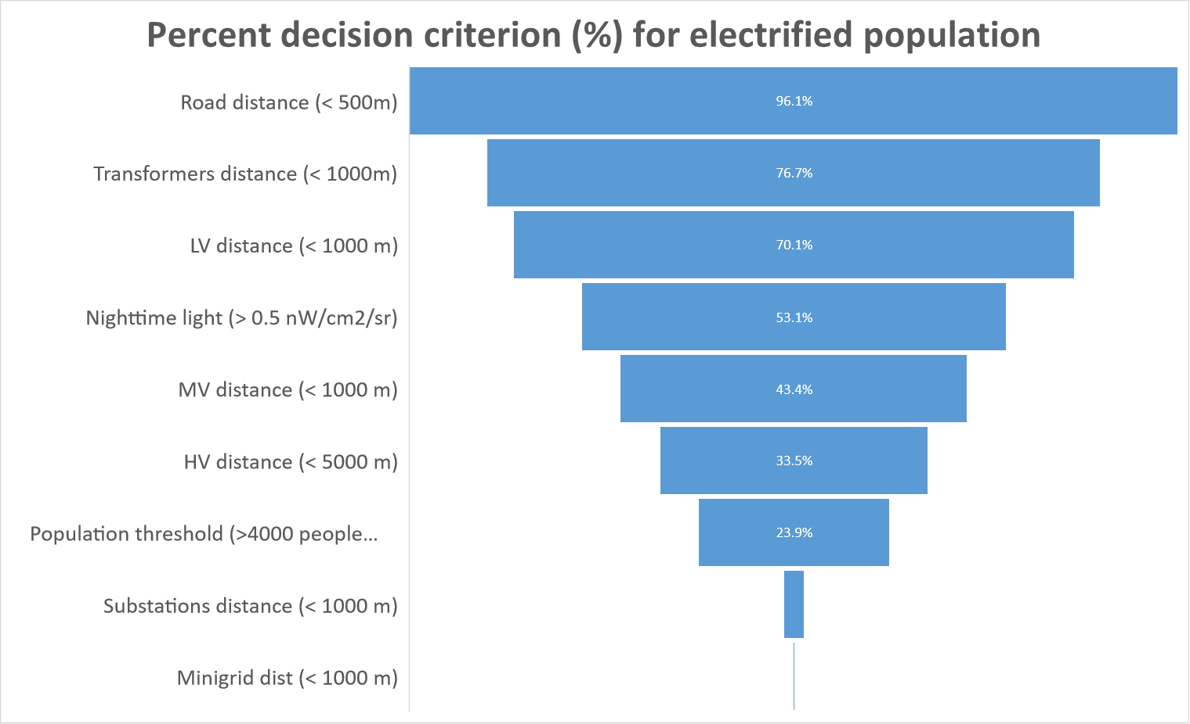
Figure 18. Electrification algorithm results

Equation 7 Low Voltage length calculation adapted from (van Ruijven et al., 2012)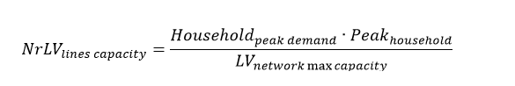
Equation 8. LV line minimum length
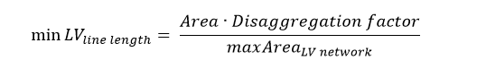
Equation 9. LV networks per MV line

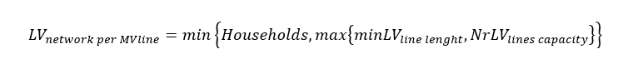
Equation 10. Number of households per LV line
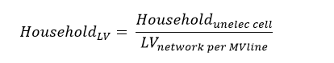
Equation 11. Length of LV network
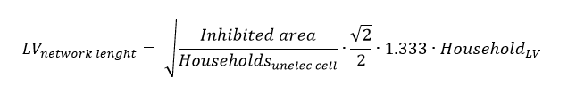
Equation 12. Length of all LV network (km)

