ARRIVE form complete for the use of mice as experimental animals in the Study: CD3Ɛ IMMUNE RESTORATIVE ABILITY INDUCED BY MAITAKE PRO4X IN IMMUNOSUPRESSED BALBC MICE.
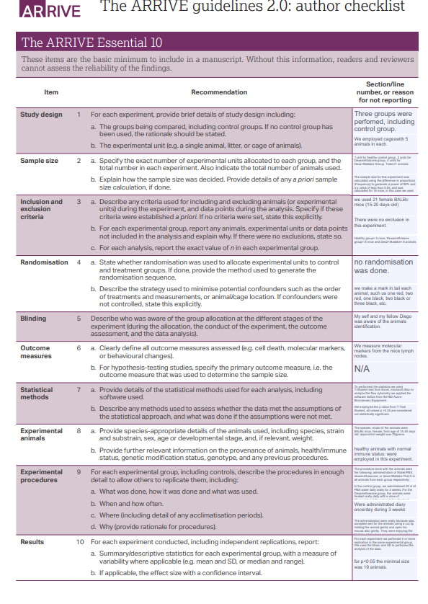
Answers:
Study Design
Paragraph 1A. Three groups were performed, including control group: Control group, Dexamethasone group and Dexa+Maitake Group.
Paragraph 1B: We employed cages with 5 animals in each.
Sample Size:
Paragraph 2A: 1 unit for healthy control group, 2 units for Dexamethasone group, 2 units for Dexa+Maitake Group. Total 21 animal
Paragraph 2B: The sample size for this experiment was calculated using the difference in proportions (Frequency) to generate a power of 95% and a p value less than 0.05, the size was calculated as 19 mice, and we employed 21 BALBc mice to achieve the statistical power as was previously indicated.
Inclusion and exclusion criteria:
Paragraph 3A: We used 21 female BALBc mice (15-20 days old).
Paragraph 3B: There were no exclusion in this experiment.
Paragraph 3C: Healthy group= 5 mice, Dexamethasone group= 8 mice and Dexa+Maitake= 8 animals
Randomization:
Paragraph 4A: no randomization was done, cages were placed control group first and then Dexa group cages and followed by Dexa+Maitake group cages, keeping this order from the beginning to the end of the experiment.
As you can observed in this picture the cages are all placed in a structural rack providing conditioning air, controlled atmosphere, filtrated air (HEPA) and regulated the ambient temperature to 22ºC.
Maintenance of the experimental model. Albino mice of the BALB/c strain used in the experimental protocols were kept in plastic boxes of controlled atmosphere and HEPA filtered air in the BIOMED-UCA-CONICET (CABA) animal facility.
Water and food were administrated ad libitum.

Paragraph 4B: We make a mark in tail each animal, such us one red, two red, one black, two black or three black, etc.
As you can observed in this picture (orange arrow) this animal was marked with only one black line:

Blinding
Paragraph 5: Myself and my fellow’s Diego Aguilera Braico was aware of the animal’s identification, nobody else in the laboratory know about that.

Outcome measures:
Paragraph 6A: We measured immune molecular markers from mice lymph nodes and spleen tissue
Paragraph 6B: N/A

Statistical Methods
Paragraph 7A: To perform the statistics we used T-Student test from Excel, Microsoft. Also, to analyze the flow cytometry we applied the software FlowJo from the BD Accuri C6 Flow Cytometry Equipment (Shown in the below picture).
Paragraph 7B: We employed the p value from T-Test Student, all values p >0.05 are considered not statistically significant.
Experimental animals
Paragraph 8A: Murine experimental model. It was used for the in vivo tests and is represented by albino mice of the BALB/c strain. Female animals were used. The species and strain of the animals were BALBc mice, female, from age of 15-20 days old, approximate weight was 20-25 grams, acquired from the Animal Facility of the Biomedical Research Institute (BIOMED) of the UCA-CONICET. Image taken from http://www.taconic.com/images/balb-c-inbred-mouse-model.jpg.
Paragraph 8B: Only healthy animals with normal immune status were employed in this experiment.

Experimental procedure:
Paragraph 9A: The procedure done with those animals were the following: Oral Administration of Water/PBS to all the animals from the Control/Healthy group, Oral Administration of Dexamethasone to all the animals from the dexamethasone Group, and Oral Administration of Dexamethasone and Maitake Pro4X in all animals from Dexa+Maitake group respectively.

Paragraph 9B: In the control group, we administered 30 µl of PBS water daily orally for 3 weeks. For the Dexamethasone group, the animals were treated orally daily with a dose of Glucocorticoid-Decadron 0.5mg/Kg dissolved in water (30 µl was the volume administrated) for 3 weeks, and for the Dexa+Maitake group we treated the animals orally daily with Decadron 0.5mg/Kg and Maitake Pro4X 5mg/ kg (30 µl was the volume administrated for each compound) for 3 weeks. Oral administration was performed as the picture shown.

Paragraph 9C: Were administrated daily once/day for 3 weeks
Paragraph 9D: The administration was orally using a micropipette tip through the mouse as shown in the previous picture from Paragraph 9B.
Paragraph 9E: The administration was orally because was accepted well for the animals using a micropipette tip holding the animal gently and open his mouse gently introducing as maximum 30 µl/ time, in the case of the Dexa+Maitake administration, we procedure first with dexamethasone administration and after couple minutes were administrated with Maitake Pro4X 5mg/Kg with a maximum volume of 30 µl. The rationale for the drug doses employed in this study was based on previous studies that shown that this choose doses were the correct one to employed in those animals and the duration of the oral administration was also investigated in the literature and make sure that was the correct one to proof and dose-effect of such treatment.
Results
Paragraph 10A: For each experiment we performed 5 or more replication in the same experimental group. We used the Mean and SD to perform the analysis of the data. The results are shown in the main manuscript submitted to revised.
Paragraph 10B: N/A.

