SUPPLEMENTAL INFORMATION:

Sex Differences in the Lipidome of Circulating Extracellular Vesicles from Adolescents Exposed to Ethanol Intoxication

Carla Perpiñá-Clérigues ^{1,2}, José F. Català-Senent ¹, Susana Mellado ^{2,3}, Francesc Ibáñez ³, Pilar Costa ⁴, Miguel Marcos ⁵, Consuelo Guerri ³, Francisco García-García ^{1,}* and María Pascual ^{2,3,}*

¹ Bioinformatics and Biostatistics Unit, Príncipe Felipe Research Center, 46012 Valencia, Spain.
² Department of Physiology, School of Medicine and Dentistry, University of Valencia, 46010 Valencia, Spain.
³ Department of Molecular and Cellular Pathology of Alcohol, Príncipe Felipe Research Center, 46012 Valencia, Spain.
⁴ Emergency Department, University Hospital of Salamanca-IBSAL, University of Salamanca, 37007 Salamanca, Spain.
⁵ Department of Internal Medicine, University Hospital of Salamanca, University of Salamanca, Institute of Biomedical Research of Salamanca (IBSAL), 37007 Salamanca, Spain.

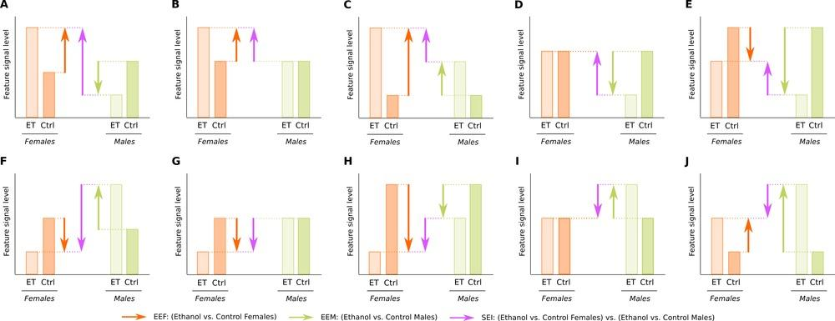

Figure S1. Bar chart representing the possible causes of a positive (A-E) or negative (F-J) LFC/LOR in the SEI comparison, depending on the EEF or EEM comparison.

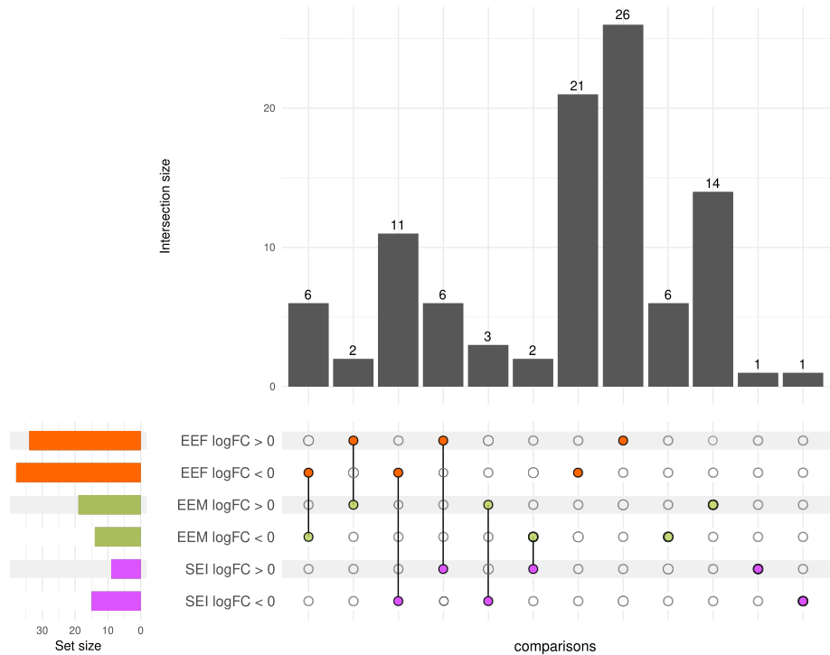

Figure S2. Upset plot of differential abundance analysis results in human samples. The results of each comparison are separated according to the LFC sign. Horizontal bars indicate the number of significant lipids in each comparison (a specific color for each comparison). Vertical bars indicate the lipids included in the intersection of the groups denoted with a colored dot underneath. A colored dot under a bar indicates the specificity of the genes to this group.

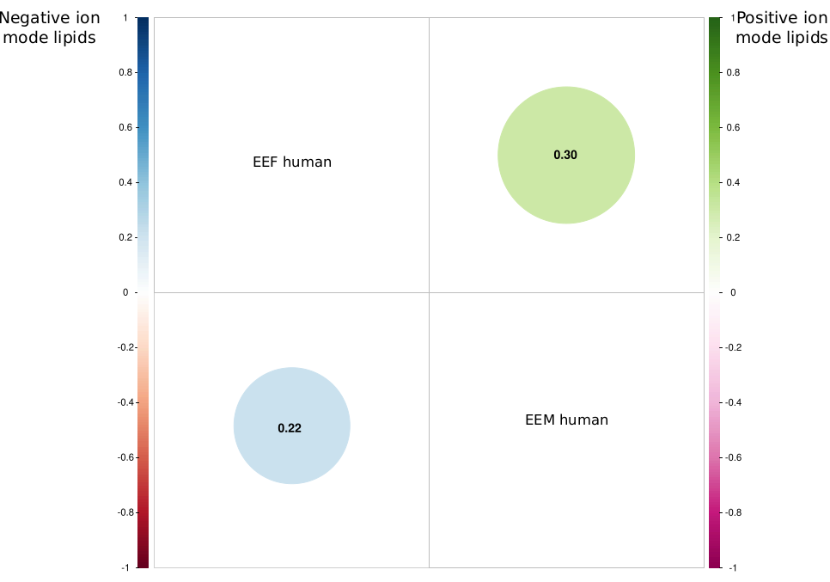
Figure S3. Pearson's correlation coefficient in the differential lipid abundance analysis between EEF and EEM in human samples.

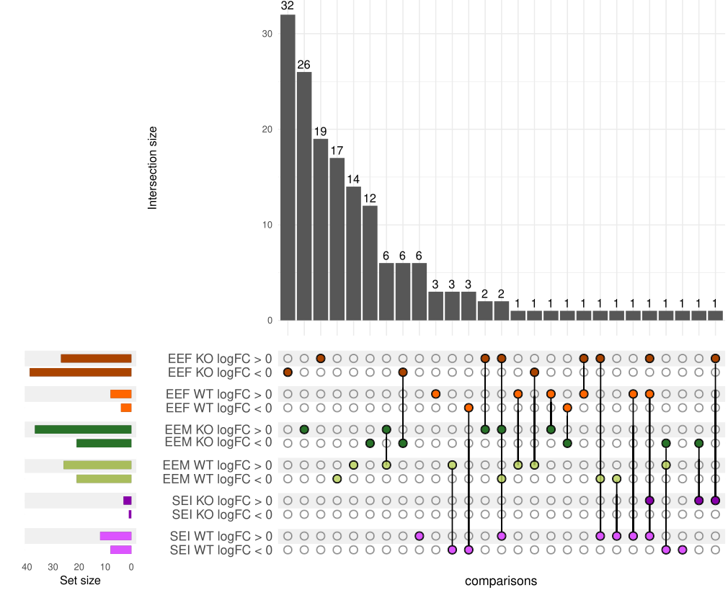
Figure S4. Upset plot of the differential abundance analysis results in WT and TLR4-KO mouse samples. The results of each comparison are separated according to the LFC sign. Horizontal bars indicate the number of significant lipids in each comparison (a specific color for each comparison). Vertical bars indicate the lipids included in the intersection of the groups denoted with a colored dot underneath. A colored dot under a bar indicates the specificity of the genes to this group.

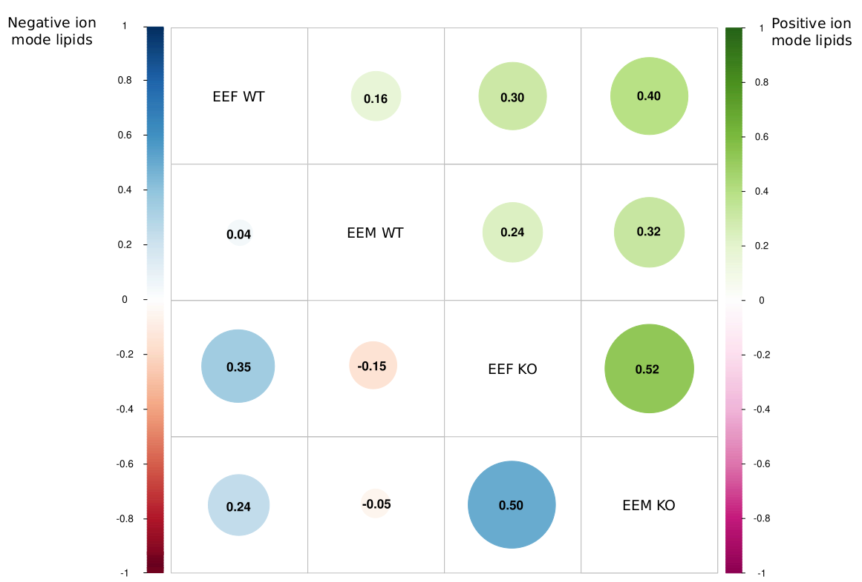

Figure S5. Pearson's correlation coefficient in the differential lipid abundance analysis between EEF and EEM in human samples

Table S1. Abbreviation of the different sub classes.

CAR | Acylcarnitine
Cer_ADS | Ceramide α-hydroxy fatty acid-dihydrosphingosine
Cer_AP | Ceramide α-hydroxy fatty acid-phytosphingosine
Cer_AS | Ceramide α-hydroxy fatty acid-sphingosine
Cer_EODS | Ceramide esterified ω-hydroxy fatty acid-dihydrosphingosine
Cer_NDS | Ceramide non-hydroxy fatty acid-dihydrosphingosine
Cer_NP | Ceramide non-hydroxy fatty acid-phytosphingosine
Cer_NS | Ceramide non-hydroxy fatty acid-sphingosine
DAG | Diacylglycerol
DGTS | Diacylglyceryl-trimethylhomoserine
FA | Fatty acid
FAHFA | Fatty acid ester of hydroxyl fatty acid
HexCer_AP | GlucosylCeramide/HexosylCeramide α-hydroxy fatty acid-phytospingosine
HexCer_NDS | GlucosylCeramide/HexosylCeramidesnon-hydroxyfatty acid-dihydrosphingosine
HexCer_NS | GlucosylCeramide/HexosylCeramidesnon-hydroxyfatty acid-sphingosine
LPC | Lyso-phosphatidylcholine
LPE | Lyso-phosphatidylethanolamine
OxPC-O | Oxidized etherphosphatidylcholine (OxEtherPC)
OxPI | Oxidized Phosphatidylinositols
PA | Phosphatidic acid
PC | Phosphatidylcholine
PC-O | Etherphosphatidylcholine (EtherPC)
PCA | Análisis de componentes principales
PE | Phosphatidylethanolamine
PE-O | Etherphosphatidylethanolamine (EtherPE)
PG | Phosphatidylglycerol
PI | Phosphatidylinositol
SHexCer | SulfoglucosylCeramide/SulfohexosylCeramide
SM | Sphingomyelin
SQDG | Sulfoquinovosyl-diacylglycerol
TAG | Triacylglycerol (TG)

Table S2. Classification by levels of all negative ion mode lipids in human samples.
- NEGATIVE ION MODE IN HUMAN LIPID SAMPLES -
SUPER CLASS | N | MAIN CLASS | N | SUB CLASS | N
Sphingolipids | 152 | Sphingomyelins | 40 | SM | 40
Sphingolipids | 152 | Glycosphingolipids | 18 | HexCer_AP | 1
 |  |  |  | HexCer_NDS | 11
 |  |  |  | HexCer_NS | 4
 |  |  |  | SHexCer | 2
Sphingolipids | 152 | Ceramides | 94 | Cer_ADS | 17
 |  |  |  | Cer_AP | 11
 |  |  |  | Cer_AS | 6
 |  |  |  | Cer_EODS | 1
 |  |  |  | Cer_NDS | 35
 |  |  |  | Cer_NP | 2
 |  |  |  | Cer_NS | 22
Fatty Acyls | 32 | Fatty acids | 21 | Unsaturated FA | 21
Fatty Acyls | 32 | Fatty esters | 11 | FAHFA | 11
Glycerophospholipids | 145 | Glycerophosphates | 1 | PA | 1
Glycerophospholipids | 145 | Glycerophosphocholines | 86 | PC | 43
 |  |  |  | PC-O | 30
 |  |  |  | LPC | 12
 |  |  |  | OxPC-O | 1
Glycerophospholipids | 145 | Glycerophosphoethanolamines | 47 | PE | 27
 |  |  |  | PE-O | 19
 |  |  |  | LPE | 1
Glycerophospholipids | 145 | Glycerophosphoinositols | 10 | PI | 9
 |  |  |  | OxPI | 1
Glycerophospholipids | 145 | Glycerophosphoglycerols | 1 | PG | 1
Glycerolipids | 1 | Glycosyldiradylglycerols | 1 | SQDG | 1
Total | 330 |  | 330 |  | 330
"N" represents the total number in each class.

Table S3. Classification by levels of all positive ion mode lipids in human samples.
- POSITIVE ION MODE IN HUMAN LIPID SAMPLES -
SUPER CLASS | N | MAIN CLASS | N | SUB CLASS | N
Sphingolipids | 57 | Ceramides | 13 | Cer_NS | 13
Sphingolipids | 57 | Glycosphingolipids | 1 | HexCer_NS | 1
Sphingolipids | 57 | Sphingomyelins | 43 | SM | 43
Fatty Acyls | 2 | Fatty esters | 2 | CAR | 2
Glycerophospholipids | 66 | Glycerophosphocholines | 61 | PC | 43
 |  |  |  | LPC | 18
Glycerophospholipids | 66 | Glycerophosphoethanolamines | 5 | PE | 5
Glycerolipids | 116 | Diradylglycerols | 8 | DAG | 8
Glycerolipids | 116 | Other Glycerolipids | 1 | SQDG | 1
Glycerolipids | 116 | Triradylglycerols | 107 | TAG | 107
Sterol Lipids | 6 | Sterol esters | 6 | Chol. esters | 6
Total | 247 |  | 247 |  | 247
"N" represents the total number in each class.

Table S4. Lipids with significant differential abundance in human samples, separated by LFC.
Negative ion mode | EEF | EEM | SEI
LFC>0 | Cer_NDS d38:1, Cer_NDS d39:1, Cer_NDS d41:2, Cer_NDS d43:1, Cer_NDS d43:2, Cer_NDS d44:1, Cer_NDS d44:2, Cer_NS d18:1_16:0, Cer_NS d18:1_18:0, Cer_NS d18:1_22:0, Cer_NS d18:1_24:0, Cer_NS d18:2_16:0, Cer_NS d18:2_25:0, EtherPC 16:0e_20:3, EtherPE 16:1e_22:6, FA 18:2, FA 19:1, FA 22:4, FAHFA 16:0_12:0, FAHFA 18:2_18:1, HexCer_NDS d42:2, LPC 20:0/0:0, LPC 20:2/0:0, PA 2:0_16:3, PC 14:0_22:6, PE 20:0_20:4 | Cer_NDS d39:1, EtherPE 18:1e_22:4, HexCer_NDS d43:1, PC 14:0_18:2, PC 16:0_16:0, PC 16:0_16:1, PE 18:0_18:1, PE 36:3, PI 34:1 | Cer_AP t42:1, Cer_AS d43:1, Cer_NDS d38:1, Cer_NDS d41:2, Cer_NDS d43:2, Cer_NDS d44:1, Cer_NDS d44:2, FA 19:1, SM d44:3
LFC<0 | Cer_ADS d42:0, Cer_AP t45:0, Cer_NDS d25:0_18:2, Cer_NDS d36:1, Cer_NDS d40:0, Cer_NDS d40:1, Cer_NDS d42:0, Cer_NDS d42:1, Cer_NS d16:1_22:0, Cer_NS d16:1_23:0, Cer_NS d18:1_25:0, Cer_NS d18:2_23:0, Cer_NS d44:1, EtherPC 16:0e_14:0, EtherPC 18:0e_22:6, EtherPC 18:1e_22:6, EtherPC 34:1e, EtherPC 44:4e, EtherPE 18:2e_18:1, HexCer_NS d20:2_22:0, PC 19:0_18:2, PE 14:0_16:0, SM d18:0_14:0, SM d33:2, SM d38:0 | Cer_AS d43:1, Cer_NP t43:1, EtherPC 18:0e_22:6, SM d44:3 | Cer_NDS d36:1, Cer_NDS d42:0, Cer_NS d16:1_22:0, Cer_NS d16:1_23:0, Cer_NS d18:2_23:0, Cer_NS d44:1, EtherPC 44:4e, EtherPE 18:2e_18:1, PC 16:0_16:1, PE 16:0_18:1, SM d18:0_14:0, SM d33:2, SM d38:0
Lipids altered in the EEF and EEM comparisons are indicated in boldface, lipids altered in the EEF and SEI comparisons are underlined, and lipids altered in the EEM and SEI comparisons are indicated in purple italics.

Table S5. Lipids with significant differential abundance in human samples, separated by LFC.

Positive ion mode | EEF | EEM | SEI
LFC>0 | LPC 20:3/0:0, PC 14:0_18:2, PC 35:3, TG 14:0_16:0_20:4, TG 15:0_16:0_18:2, TG 16:0_18:1_18:1, TG 16:0_18:1_20:3, TG 56:6 | CE 18:0, TG 12:0_15:0_16:0, TG 12:0_16:0_18:2, TG 14:0_15:0_18:2, TG 16:0_17:0_18:0, TG 16:0_18:1_20:3, TG 17:0_18:0_18:0, TG 18:1_18:1_22:0, TG 44:1, TG 53:2
LFC<0 | CE 20:4, DG 18:1_18:2, SM d38:1, SM d42:0, SM d44:1, TG 16:0_16:0_16:0, TG 16:0_18:1_22:0, TG 16:0_18:1_22:4, TG 17:1_18:0_18:2, TG 49:4, TG 51:3, TG 52:7, TG 53:0 | CE 20:4, DG 18:1_18:2, SM d33:0, SM d36:3, TG 17:1_18:1_18:2, TG 18:0_18:1_18:1, TG 49:4, TG 51:3, TG 51:4, TG 52:7 | TG 12:0_15:0_16:0, TG 53:2
Lipids altered in the EEF and EEM comparisons are indicated in boldface, lipids altered in the EEF and SEI comparisons are underlined, and lipids altered in the EEM and SEI comparisons are indicated in purple italics.

Table S6. Classification by levels of all negative ion mode lipids in WT and KO mouse samples.

- NEGATIVE ION MODE IN WT AND TLR4-KO MICE SAMPLES -
SUPER CLASS | N | MAIN CLASS | N | SUB CLASS | N
Sphingolipids | 138 | Sphingomyelins | 27 | SM | 27
Sphingolipids | 138 | Glycosphingolipids | 15 | HexCer_AP | 2
 |  |  |  | HexCer_NDS | 10
 |  |  |  | HexCer_NS | 3
Sphingolipids | 138 | Ceramides | 96 | Cer_ADS | 17
 |  |  |  | Cer_AP | 15
 |  |  |  | Cer_AS | 11
 |  |  |  | Cer_EODS | 3
 |  |  |  | Cer_EOS | 1
 |  |  |  | Cer_NDS | 32
 |  |  |  | Cer_NP | 3
 |  |  |  | Cer_NS | 14
Fatty Acyls | 34 | Fatty acids | 25 | Unsaturated FA | 25
Fatty Acyls | 34 | Fatty esters | 9 | FAHFA | 9
Glycerophospholipids | 118 | Glycerophosphates | 2 | PA | 2
Glycerophospholipids | 118 | Glycerophosphocholines | 79 | PC | 46
 |  |  |  | PC-O | 15
 |  |  |  | LPC | 16
 |  |  |  | OxPC-O | 2
Glycerophospholipids | 118 | Glycerophosphoethanolamines | 31 | PE | 21
 |  |  |  | PE-O | 7
 |  |  |  | LPE | 3
Glycerophospholipids | 118 | Glycerophosphoinositols | 5 | PI | 5
Glycerophospholipids | 118 | Glycerophosphoserines | 1 | PS | 1
Glycerolipids | 1 | Glycosyldiradylglycerols | 1 | SQDG | 1
Total | 291 |  | 291 |  | 291
"N" represents the total number in each class.

Table S7. Classification by levels of all positive ion mode lipids in WT and KO mouse samples.

- POSITIVE ION MODE IN WT AND TLR4-KO MICE SAMPLES -
SUPER CLASS | N | MAIN CLASS | N | SUB CLASS | N
Sphingolipids | 39 | Ceramides | 7 | Cer_NS | 7
Sphingolipids | 39 | Glycosphingolipids | 2 | HexCer_NS | 2
Sphingolipids | 39 | Sphingomyelins | 30 | SM | 30
Fatty Acyls | 3 | Fatty esters | 3 | CAR | 3
Glycerophospholipids | 89 | Glycerophosphocholines | 83 | PC | 49
 |  |  |  | LPC | 34
Glycerophospholipids | 89 | Glycerophosphoethanolamines | 6 | PE | 6
Glycerolipids | 127 | Diradylglycerols | 8 | DAG | 8
Glycerolipids | 127 | Other Glycerolipids | 2 | DGTS | 2
Glycerolipids | 127 | Triradylglycerols | 117 | TAG | 117
Sterol Lipids | 6 | Sterol esters | 6 | Chol. esters | 6
Total | 264 |  | 264 |  | 264
"N" represents the total number in each class.

Table S8. Lipids with significant differential abundance in WT mouse samples, separated by LFC.
Negative ion mode WT mice | EEF | EEM | SEI
LFC>0 | Cer_AS d27:1_16:0, Cer_AS d41:1, Cer_AS d42:1, HexCer_NS d40:2, SM d35:1 | Cer_AS d42:1, Cer_NDS d40:1, Cer_NS d18:1_16:0, Cer_NS d18:1_23:0, Cer_NS d18:1_24:0, EtherPC 16:0e_18:2, LPC 20:3/0:0, PC 16:0_17:1, PC 18:0_18:2, PC 18:0_22:6, PC 18:2_20:4, PC 20:4_22:6, PE 40:2, PI 40:5 | Cer_ADS d19:0_15:0, Cer_ADS d38:0, Cer_ADS d41:0, Cer_AS d27:1_16:0, Cer_AS d41:1, Cer_NDS d41:1, Cer_NDS d42:1, Cer_NS d18:1_22:0, Cer_NS d39:1, EtherPC 24:0e
LFC<0 | PC 18:1_22:6, PE 18:0_22:5 | Cer_NDS d41:1, Cer_NDS d42:1, Cer_NS d18:1_18:0, Cer_NS d18:1_22:0, Cer_NS d39:1, Cer_NS d42:3, PE 18:0_22:6 | Cer_NDS d40:1, PC 16:1_20:4, PC 18:1_22:6, PE 18:0_22:5, PI 40:5
Lipids altered in the EEF and EEM comparisons are indicated in boldface, lipids altered in the EEF and SEI comparisons are underlined, and lipids altered in the EEM and SEI comparisons are indicated in purple italics.

Table S9. Lipids with significant differential abundance in WT mouse samples, separated by LFC.
Positive ion mode WT mice | EEF | EEM | SEI
LFC>0 | PC 18:0_22:6, TG 15:0_18:2_18:3, TG 18:2_18:2_21:0 | CE 18:1, LPC 0:0/18:0, LPC 17:0/0:0, LPC 18:1/0:0, LPC 20:3/0:0, LPC 22:3/0:0, LPC 22:5/0:0, PC 40:5, PC 40:8, PC 44:4, SM d43:2, TG 18:0_18:1_20:3 | TG 49:4, TG 54:1
LFC<0 | DGTS 38:2, TG 53:6 | CE 20:5, DG 18:1_18:2, PC 16:0_20:4, PC 32:2, PE 16:0_18:2, TG 12:0_16:1_16:1, TG 14:0_16:1_18:2, TG 15:0_18:2_22:6, TG 16:0_18:2_22:6, TG 16:1_18:2_18:3, TG 18:0_20:1_20:4, TG 18:1_18:1_22:5, TG 18:1_20:4_22:6, TG 50:6 | LPC 18:1/0:0, PC 40:8, TG 53:6
Lipids altered in the EEF and EEM comparisons are indicated in boldface, lipids altered in the EEF and SEI comparisons are underlined, and lipids altered in the EEM and SEI comparisons are indicated in purple italics.

Table 10. Lipids with significant differential abundance in TLR4-KO mouse samples, separated by LFC.
Negative ion mode TLR4-KO mice | EEF | EEM | SEI
LFC>0 | Cer_AS d27:1_16:0, Cer_NDS d16:0_28:2, Cer_NDS d34:1, Cer_NDS d42:1, Cer_NDS d42:2, Cer_NS d18:1_22:0, Cer_NS d39:1, EtherPC 16:1e_18:2, EtherPC 18:0e_20:4, EtherPC 18:1e_22:6, EtherPE 16:1e_20:4, EtherPE 16:1e_22:6, HexCer_NDS d24:0_18:1, HexCer_NDS d34:1, HexCer_NDS d42:2, HexCer_NS d20:2_22:1, LPC 20:0/0:0, LPC 20:2/0:0, LPC 22:0/0:0, PC 18:0_22:4, PC 38:2, PE 16:0_18:0, PE 20:0_20:3, SM d35:1, SM d38:1 | Cer_ADS d40:0, Cer_NDS d41:2, Cer_NDS d42:1, Cer_NS d18:1_22:0, EtherPC 16:0e_18:2, HexCer_AP t18:0_16:0, LPC 18:0/0:0, LPC 19:0/0:0, LPC 20:3/0:0, PC 17:0_18:2, PC 18:0_22:6, PC 19:0_20:4, PE 20:0_20:3, SM d38:1, SM d41:1 | Cer_AS d27:1_16:0
LFC<0 | Cer_ADS d44:0, Cer_ADS d45:0, Cer_ADS d46:0, Cer_ADS d46:1, Cer_ADS d47:0, Cer_ADS d48:0, Cer_AP t22:0_25:0, Cer_AP t41:0, Cer_AP t42:1, Cer_AP t46:1, Cer_AS d44:1, Cer_AS d48:1, Cer_EODS d57:0, Cer_NDS d18:0_23:0, Cer_NDS d21:0_24:0, Cer_NDS d24:0_24:0, Cer_NDS d26:0_24:0, Cer_NDS d43:0, Cer_NDS d44:0, Cer_NDS d47:0, Cer_NS d18:1_24:0, Cer_NS d18:1_24:1, EtherPC 18:0e_22:6, EtherPC 42:6e, EtherPE 18:0e_18:2, FA 18:2, FAHFA 18:1_18:0, FAHFA 20:4_20:3, HexCer_AP t18:0_23:0, LPC 14:0/0:0, LPC 20:4/0:0, LPE 16:0, PC 18:1_20:4, PC 19:0_22:6, PC 22:0_18:2, PE 16:0_20:4, PE 18:0_18:2, PE 19:0_18:2 | Cer_ADS d47:0, Cer_AP t22:0_24:0, Cer_AS d48:1, Cer_NDS d40:1, Cer_NDS d44:0, LPC 14:0/0:0, LPE 16:0
Lipids altered in the EEF and EEM comparisons are indicated in boldface, lipids altered in the EEF and SEI comparisons are underlined, and lipids altered in the EEM and SEI comparisons are indicated in purple italics.

Table S11. Lipids with significant differential abundance in TLR4-KO mouse samples, separated by LFC.
Positive ion mode TLR4-KO mice | EEF | EEM | SEI
LFC>0 | SM d31:1, TG 18:2_18:2_18:3 | LPC 0:0/18:0, LPC 0:0/18:2, LPC 19:0/0:0, LPC 20:1/0:0, LPC 20:3/0:0, LPC 22:1/0:0, LPC 22:5/0:0, PC 18:0_22:6, PC 34:1, PC 39:7, PC 40:10, PC 40:7, PC 42:5, SM d18:1_18:0, SM d32:2, SM d34:0, SM d35:1, SM d39:1, TG 52:7, TG 55:6, TG 57:7, TG 57:8 | TG 18:2_18:2_18:3, TG 46:0
LFC<0 | TG 45:2 | DGTS 38:2, LPC 16:0/0:0, PC 18:1_20:4, TG 16:0_16:0_18:1, TG 16:0_16:1_16:1, TG 16:0_18:0_18:1, TG 16:0_18:1_18:1, TG 45:2, TG 46:0, TG 47:2, TG 48:1, TG 53:0, TG 54:0, TG 57:2
Lipids altered in the EEF and EEM comparisons are indicated in boldface, lipids altered in the EEF and SEI comparisons are underlined, and lipids altered in the EEM and SEI comparisons are indicated in purple italics.

