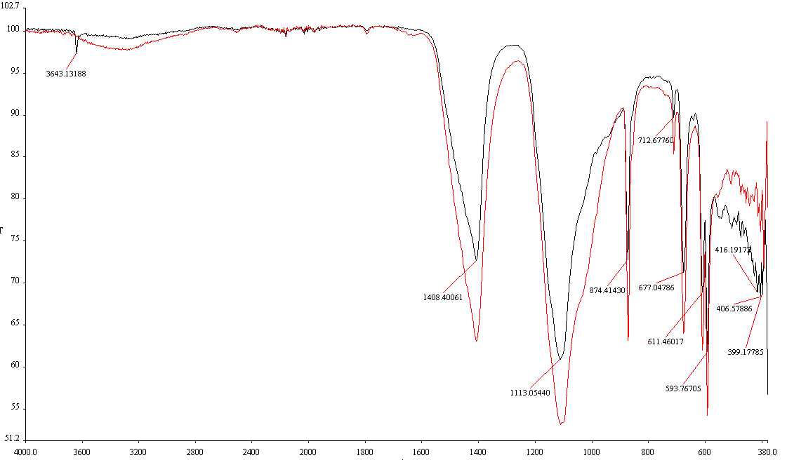
Transmittance [%]
Wave number [cm⁻¹]
Slag
Slag + Cu(II)

Fig SM7 FT-IR plot of slag before and after Cu(II) ions adsorption

