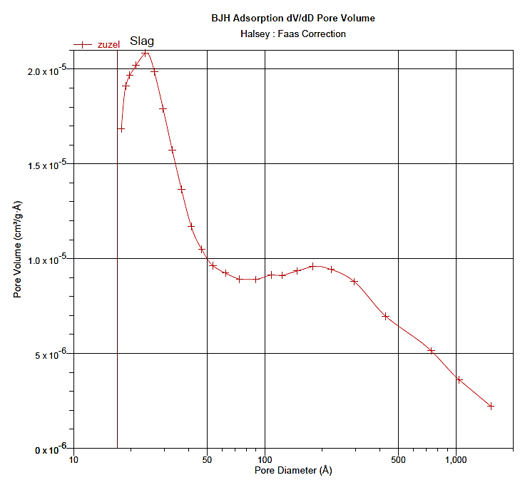
Fig. SM5. The BJH adsorption isotherm of CFBC slag.

