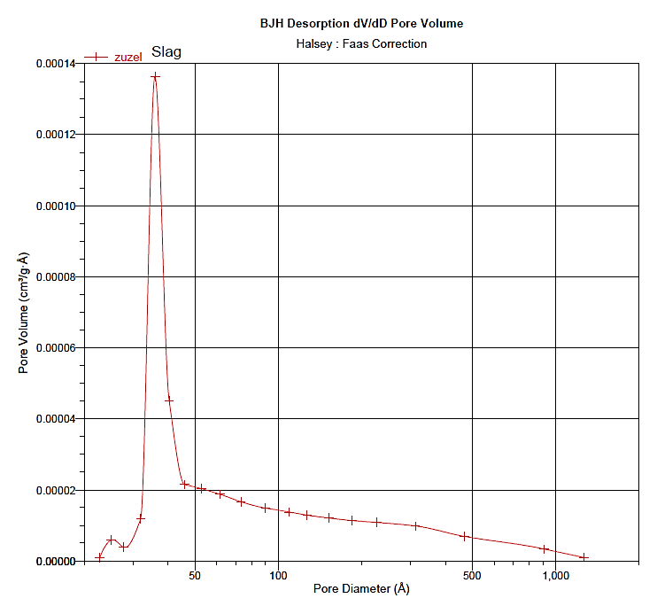
Fig. SM6. The BJH desorption isotherm of CFBC slag.

