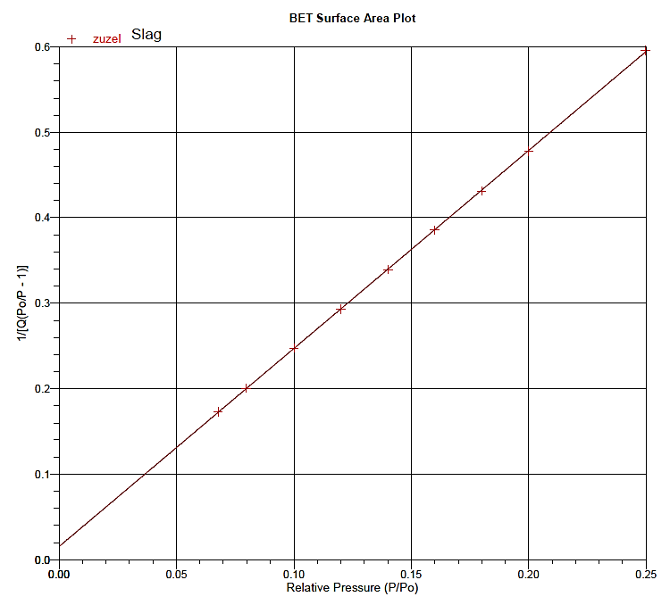
Fig. SM4. The linear BET isotherm of CFBC slag

