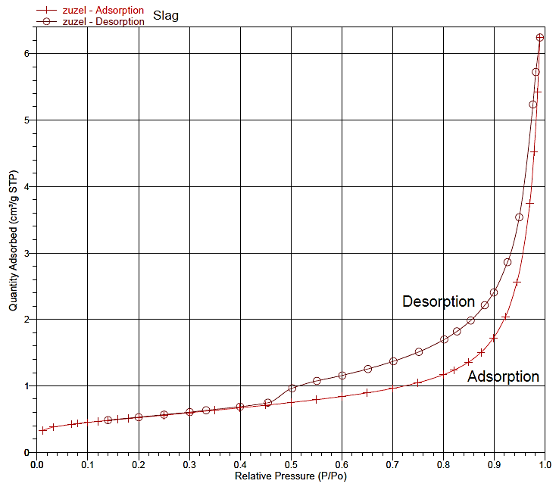
Fig. SM3. The low temperature BET adsorption and desorption isotherms of CFBC slag

