Table S1: List of primers used in qRT-PCR analysis of chickpea CIPK genes.

Purpose | Primer | Sequence
 | CaEF1α F | 5' TCCACCACTTGGTCGTTTTG 3'
  qRT-PCR
qRT-PCR | CaEF1α R | 5' CTTAATGACACCGACAGCAACAG 3'
qRT-PCR | CaCIPK2 F | 5' CCGGTTGTGCCTGTGAGTAT 3'
qRT-PCR | CaCIPK2 R | 5' AGCAATCTCTTCCAGCCTCG 3'
qRT-PCR | CaCIPK11 F | 5' TGTCTCCACGAAGTTCTCGC 3'
qRT-PCR | CaCIPK11 R | 5' AACCGACCCTTTGCGATCTT 3'
qRT-PCR | CaCIPK12 F | 5' GATGATTGACGCCGCCTTT 3'
qRT-PCR | CaCIPK12 R | 5' AATCGTGAGGGCCAAGAAGA 3'
qRT-PCR | CaCIPK16 F | 5' TCACACAACCAACATTCCTTCAC 3'
qRT-PCR | CaCIPK16 R | 5' GGAATTTTGGAAGGTTGTTGAGA 3'
qRT-PCR | CaCIPK17 F | 5' CCAGGATAACGATGACGGGG 3'
qRT-PCR | CaCIPK17 R | 5' ATACGGATTGGCGATCCTGG 3'
qRT-PCR | CaCIPK21 F | 5' AGAAAACTTGCTCCTTGACAGC 3'
qRT-PCR | CaCIPK21 R | 5' GGAGCCACATAGCACGGGGAAC 3'

Table S2: Sequence logo of different motifs identified through MEME.

Logo | E-value | Sites | Width
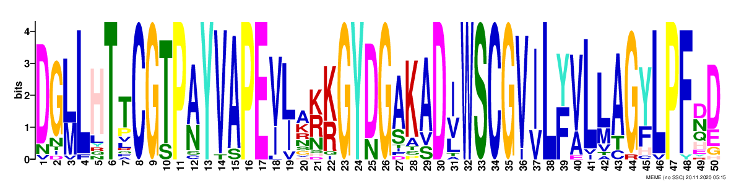 | 1.1e-797 | 22 | 50
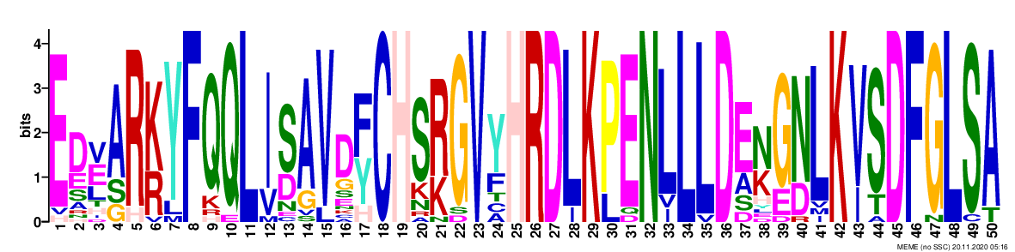 | 5.1e-768 | 22 | 50
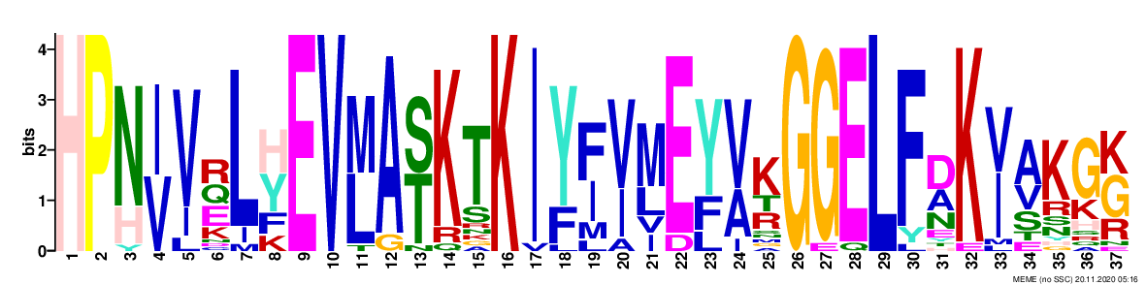 | 2.0e-441 | 22 | 37
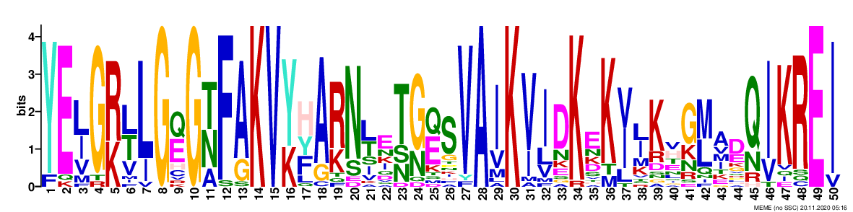 | 3.1e-502 | 22 | 50
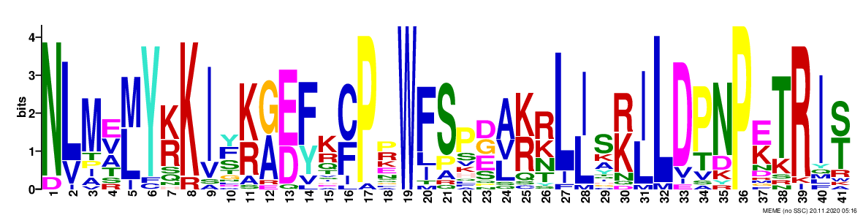 | 5.7e-409 | 22 | 41
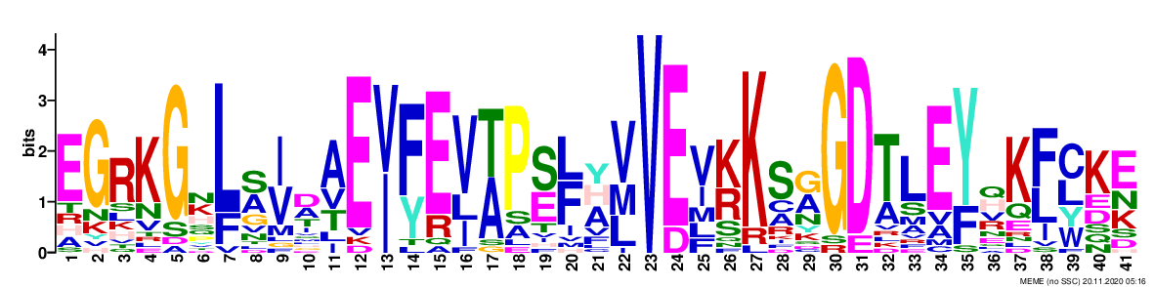 | 2.7e-254 | 21 | 41
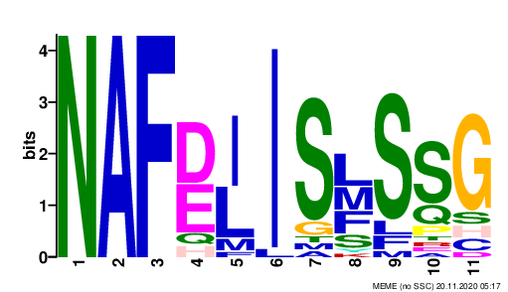 | 4.4e-097 | 22 | 11
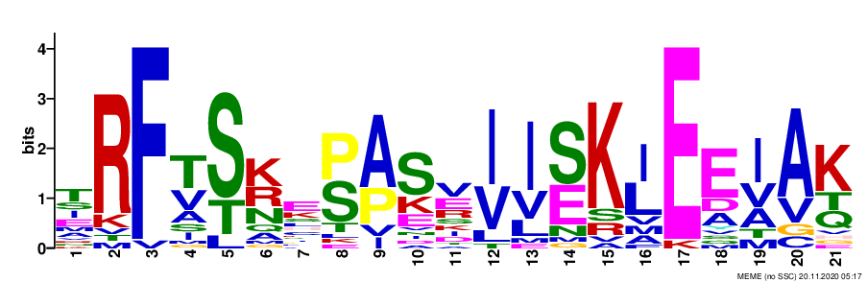 | 2.7e-092 | 22 | 21
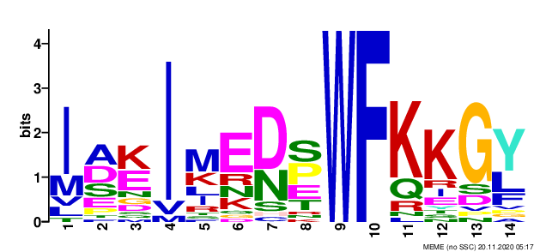 | 7.1e-084 | 22 | 14
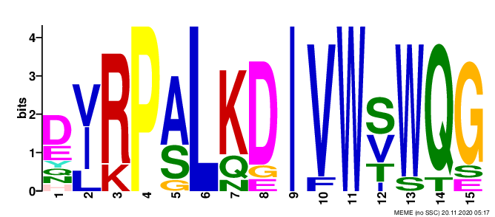 | 3.1e-065 | 10 | 15

Table S3: List of segmentally duplicated gene pairs.

Collinear gene pair
Gene name | Gene name | Ka | Ks | Ka/Ks
CaCIPK7 | CaCIPK5 | 0.1373 | 1.7532 | 0.0783
CaCIPK1 | CaCIPK17 | 0.1356 | 0.8096 | 0.1675
CaCIPK2 | CaCIPK18 | 0.2566 | 5.4846 | 0.0468
CaCIPK14 | CaCIPK22 | 0.3502 | 2.2212 | 0.1577
CaCIPK2 | CaCIPK10 | 0.1562 | 1.1211 | 0.1394
CaCIPK14 | CaCIPK11 | 0.1903 | 2.101 | 0.0906
CaCIPK18 | CaCIPK10 | 0.2768 | 2.8293 | 0.0978
CaCIPK22 | CaCIPK11 | 0.3208 | 47.4983 | 0.0068
CaCIPK18 | CaCIPK15 | 0.1194 | 0.9769 | 0.1222

Table S4: List of cis-regulatory elements identified in the promoter regions of CaCIPK genes.

 | CaCIPK1 | CaCIPK2 | CaCIPK3 | CaCIPK4 | CaCIPK5 | CaCIPK6 | CaCIPK7 | CaCIPK8 | CaCIPK9 | CaCIPK10 | CaCIPK11 | CaCIPK12 | CaCIPK13 | CaCIPK14 | CaCIPK15 | CaCIPK16 | CaCIPK17 | CaCIPK18 | CaCIPK19 | CaCIPK20 | CaCIPK21 | CaCIPK22
LTR |  | 1 |  |  |  |  |  |  |  | 1 |  |  |  |  |  |  |  |  | 1 |  | 1
ABRE | 1 | 10 | 1 | 3 | 2 | 2 | 1 | 3 |  | 3 | 1 |  |  | 2 |  |  | 1 | 1 | 1 |  |  | 1
ERE | 5 | 3 | 4 | 2 | 2 | 2 | 3 | 1 | 2 | 1 | 3 | 4 | 6 | 3 | 1 | 4 | 3 | 3 | 1 | 2 | 3 | 6
W box | 1 | 1 | 1 |  | 1 | 1 |  |  |  | 1 |  | 1 |  |  |  |  |  |  |  | 1 | 1 | 1
WUN-motif | 2 | 1 |  |  | 1 | 3 | 5 |  |  |  | 2 | 1 |  | 2 |  |  | 1 |  | 2 | 1 | 1 | 3
ARE | 2 | 4 | 1 | 2 |  | 2 | 1 | 2 |  | 3 | 3 | 3 | 2 | 4 | 1 | 2 | 2 | 2 | 1 | 1 | 1 | 2
LAMP-element | 1 |  |  |  |  |  |  |  |  |  |  |  |  |  | 1 |  |  |  |  |  | 1
Box 4 | 8 | 1 | 9 | 7 | 4 |  | 8 | 2 | 1 | 12 | 1 | 3 | 3 | 4 | 5 | 5 | 9 | 5 | 6 |  | 8 | 5
MYB | 2 | 3 | 6 | 3 | 1 | 5 | 6 |  | 2 | 6 | 3 | 6 | 3 | 5 | 1 | 3 | 1 | 4 | 2 | 5 | 6 | 1
GT1-motif | 4 | 5 | 1 |  | 1 | 1 | 2 |  |  | 1 |  | 1 |  | 1 |  |  |  | 2 | 2 |  | 2
AE-box | 1 |  |  | 1 |  |  |  |  |  | 1 | 1 | 1 |  |  | 1 | 1
MYB recognition site |  | 1 |  |  |  |  |  |  |  |  |  | 1 | 1 |  |  |  |  |  |  |  | 1
O2-site |  | 1 |  |  | 3 |  |  |  |  |  |  |  | 1 |  |  | 1 |  |  | 1 | 1
AuxRR-core |  |  | 1 |  |  |  |  |  |  |  |  | 1 |  |  |  | 1 |  | 1
TCA-element |  | 1 |  | 1 |  |  | 1 |  |  | 1 |  |  | 1 | 1 |  | 1 | 2 | 1 | 1 |  | 1
TC-rich repeats |  | 1 | 1 |  | 1 |  | 2 |  |  |  | 2 |  |  | 1 | 1 |  | 1 | 1 | 1 | 1 |  | 1

Table S5: The confidence, coverage and sequence identities of the homologous relationship of the CaCIPKs.

 |  |  | Model based on the template
Protein | Percentage confidence | Percentage coverage | Template id | Percentage identity with template | Percentage identity with c4czuC_
CaCIPK1 | 100 | 92 | c6c9dB_ | 30 | 61
CaCIPK2 | 100 | 91 | c6c9dB_ | 29 | 59
CaCIPK3 | 100 | 93 | c6c9dB_ | 33 | 75
CaCIPK4 | 100 | 59 | c5ebzF_ | 25 | 54
CaCIPK5 | 100 | 93 | c6c9dB_ | 31 | 56
CaCIPK6 | 100 | 57 | c5ebzF_ | 27 | 65
CaCIPK7 | 100 | 92 | c6c9dB_ | 29 | 57
CaCIPK8 | 100 | 54 | c5ebzF_ | 29 | 66
CaCIPK9 | 100 | 90 | c6c9dB_ | 29 | 85
CaCIPK10 | 100 | 54 | c5ebzF_ | 29 | 60
CaCIPK11 | 100 | 57 | c5ebzF_ | 28 | 58
CaCIPK12 | 100 | 50 | c5ebzF_ | 31 | 66
CaCIPK13 | 100 | 91 | c6c9dB_ | 31 | 59
CaCIPK14 | 100 | 58 | c5ebzF_ | 26 | 59
CaCIPK15 | 100 | 54 | c5ebzF_ | 27 | 65
CaCIPK16 | 100 | 95 | c6c9dB_ | 30 | 61
CaCIPK17 | 100 | 93 | c6c9dB_ | 29 | 59
CaCIPK18 | 100 | 54 | c5ebzF_ | 28 | 63
CaCIPK19 | 100 | 93 | c6c9dB_ | 31 | 63
CaCIPK20 | 100 | 56 | c5ebzF_ | 27 | 62
CaCIPK21 | 100 | 57 | c5ebzF_ | 28 | 61
CaCIPK22 | 100 | 58 | c5ebzF_ | 23 | 52

Table S6: Type and strength of interactions between CBL and CIPK proteins in chickpea

Node1 | Node2 | Node1_string_id | Node2_string_id | coexpression | experimentally_determined_interaction | database_annotated | automated_textmining | combined_score
CaCBL1 | CaCIPK7 | XP_004508968.1 | XP_004486613.1 | 0.044 | 0.2 | 0.047 | 0.282 | 0.406
CaCBL1 | CaCIPK1 | XP_004508968.1 | XP_004488187.1 | 0.044 | 0.847 | 0.047 | 0.602 | 0.937
CaCBL1 | CaCIPK9 | XP_004508968.1 | XP_004488520.1 | 0.044 | 0.843 | 0.047 | 0.696 | 0.95
CaCBL1 | CaCIPK2 | XP_004508968.1 | XP_004490705.1 | 0.044 | 0.395 | 0.047 | 0.289 | 0.555
CaCBL1 | CaCIPK14 | XP_004508968.1 | XP_004490706.1 | 0.044 | 0.777 | 0.047 | 0.576 | 0.902
CaCBL1 | CaCIPK3 | XP_004508968.1 | XP_004491202.1 | 0.044 | 0.282 | 0.047 | 0.623 | 0.72
CaCBL1 | CaCIPK18 | XP_004508968.1 | XP_004492544.1 | 0.044 | 0.395 | 0.047 | 0.289 | 0.555
CaCBL1 | CaCIPK22 | XP_004508968.1 | XP_004492546.1 | 0.044 | 0.777 | 0.047 | 0.564 | 0.899
CaCBL1 | CaCIPK4 | XP_004508968.1 | XP_004498005.1 | 0.044 | 0.445 | 0.047 | 0.474 | 0.698
CaCBL1 | CaCIPK16 | XP_004508968.1 | XP_004498818.1 | 0.044 | 0.2 | 0.047 | 0.282 | 0.406
CaCBL1 | CaCIPK10 | XP_004508968.1 | XP_004500345.1 | 0.044 | 0.395 | 0.047 | 0.289 | 0.555
CaCBL1 | CaCIPK13 | XP_004508968.1 | XP_004500544.1 | 0.044 | 0.395 | 0.047 | 0.289 | 0.555
CaCBL1 | CaCIPK15 | XP_004508968.1 | XP_004506437.1 | 0.044 | 0.395 | 0.047 | 0.289 | 0.555
CaCBL1 | CaCIPK5 | XP_004508968.1 | XP_004507079.1 | 0.044 | 0.2 | 0.047 | 0.282 | 0.406
CaCBL1 | CaCIPK6 | XP_004508968.1 | XP_004507724.1 | 0.044 | 0.485 | 0.047 | 0.681 | 0.83
CaCBL1 | CaCIPK21 | XP_004508968.1 | XP_004507818.1 | 0.044 | 0.355 | 0.047 | 0.543 | 0.695
CaCBL2 | CaCIPK1 | XP_004499340.1 | XP_004488187.1 | 0.044 | 0.678 | 0.047 | 0.521 | 0.84
CaCBL2 | CaCIPK9 | XP_004499340.1 | XP_004488520.1 | 0.044 | 0.838 | 0.047 | 0.696 | 0.949
CaCBL2 | CaCIPK2 | XP_004499340.1 | XP_004490705.1 | 0.044 | 0.197 | 0.047 | 0.29 | 0.411
CaCBL2 | CaCIPK14 | XP_004499340.1 | XP_004490706.1 | 0.044 | 0.291 | 0.047 | 0.326 | 0.506
CaCBL2 | CaCIPK3 | XP_004499340.1 | XP_004491202.1 | 0.044 | 0.449 | 0.047 | 0.519 | 0.726
CaCBL2 | CaCIPK18 | XP_004499340.1 | XP_004492544.1 | 0.044 | 0.197 | 0.047 | 0.29 | 0.411
CaCBL2 | CaCIPK22 | XP_004499340.1 | XP_004492546.1 | 0.044 | 0.64 | 0.047 | 0.478 | 0.805
CaCBL2 | CaCIPK13 | XP_004499340.1 | XP_004500544.1 | 0.044 | 0.197 | 0.047 | 0.29 | 0.411
CaCBL2 | CaCIPK15 | XP_004499340.1 | XP_004506437.1 | 0.044 | 0.197 | 0.047 | 0.29 | 0.411
CaCBL2 | CaCIPK10 | XP_004499340.1 | XP_004500345.1 | 0.044 | 0.197 | 0.047 | 0.29 | 0.411
CaCBL2 | CaCIPK21 | XP_004499340.1 | XP_004507818.1 | 0.044 | 0.199 | 0.047 | 0.488 | 0.576
CaCBL2 | CaCIPK6 | XP_004499340.1 | XP_004507724.1 | 0.044 | 0.756 | 0.047 | 0.621 | 0.904
CaCBL3 | CaCIPK7 | XP_004500149.1 | XP_004486613.1 | 0.044 | 0.168 | 0.047 | 0.404 | 0.487
CaCBL3 | CaCIPK1 | XP_004500149.1 | XP_004488187.1 | 0.044 | 0.678 | 0.047 | 0.521 | 0.84
CaCBL3 | CaCIPK9 | XP_004500149.1 | XP_004488520.1 | 0.044 | 0.838 | 0.047 | 0.696 | 0.949
CaCBL3 | CaCIPK2 | XP_004500149.1 | XP_004490705.1 | 0.044 | 0.197 | 0.047 | 0.623 | 0.687
CaCBL3 | CaCIPK14 | XP_004500149.1 | XP_004490706.1 | 0.044 | 0.291 | 0.047 | 0.62 | 0.721
CaCBL3 | CaCIPK3 | XP_004500149.1 | XP_004491202.1 | 0.044 | 0.449 | 0.047 | 0.521 | 0.727
CaCBL3 | CaCIPK18 | XP_004500149.1 | XP_004492544.1 | 0.044 | 0.197 | 0.047 | 0.29 | 0.411
CaCBL3 | CaCIPK22 | XP_004500149.1 | XP_004492546.1 | 0.044 | 0.64 | 0.047 | 0.478 | 0.805
CaCBL3 | CaCIPK16 | XP_004500149.1 | XP_004498818.1 | 0.044 | 0.168 | 0.047 | 0.404 | 0.487
CaCBL3 | CaCIPK15 | XP_004500149.1 | XP_004506437.1 | 0.044 | 0.197 | 0.047 | 0.29 | 0.411
CaCBL3 | CaCIPK13 | XP_004500149.1 | XP_004500544.1 | 0.044 | 0.197 | 0.047 | 0.29 | 0.411
CaCBL3 | CaCIPK21 | XP_004500149.1 | XP_004507818.1 | 0.044 | 0.199 | 0.047 | 0.521 | 0.603
CaCBL3 | CaCIPK10 | XP_004500149.1 | XP_004500345.1 | 0.044 | 0.197 | 0.047 | 0.623 | 0.687
CaCBL3 | CaCIPK6 | XP_004500149.1 | XP_004507724.1 | 0.044 | 0.756 | 0.047 | 0.621 | 0.904
CaCBL4 | CaCIPK7 | XP_004502645.1 | XP_004486613.1 | 0.044 | 0.2 | 0.047 | 0.294 | 0.416
CaCBL4 | CaCIPK1 | XP_004502645.1 | XP_004488187.1 | 0.044 | 0.847 | 0.047 | 0.602 | 0.937
CaCBL4 | CaCIPK9 | XP_004502645.1 | XP_004488520.1 | 0.044 | 0.843 | 0.047 | 0.696 | 0.95
CaCBL4 | CaCIPK2 | XP_004502645.1 | XP_004490705.1 | 0.044 | 0.395 | 0.047 | 0.546 | 0.716
CaCBL4 | CaCIPK14 | XP_004502645.1 | XP_004490706.1 | 0.044 | 0.777 | 0.047 | 0.559 | 0.898
CaCBL4 | CaCIPK3 | XP_004502645.1 | XP_004491202.1 | 0.044 | 0.282 | 0.047 | 0.587 | 0.693
CaCBL4 | CaCIPK18 | XP_004502645.1 | XP_004492544.1 | 0.044 | 0.395 | 0.047 | 0.289 | 0.555
CaCBL4 | CaCIPK22 | XP_004502645.1 | XP_004492546.1 | 0.044 | 0.777 | 0.047 | 0.564 | 0.899
CaCBL4 | CaCIPK4 | XP_004502645.1 | XP_004498005.1 | 0.044 | 0.445 | 0.047 | 0.474 | 0.698
CaCBL4 | CaCIPK16 | XP_004502645.1 | XP_004498818.1 | 0.044 | 0.2 | 0.047 | 0.294 | 0.416
CaCBL4 | CaCIPK10 | XP_004502645.1 | XP_004500345.1 | 0.044 | 0.395 | 0.047 | 0.546 | 0.716
CaCBL4 | CaCIPK13 | XP_004502645.1 | XP_004500544.1 | 0.044 | 0.395 | 0.047 | 0.289 | 0.555
CaCBL4 | CaCIPK5 | XP_004502645.1 | XP_004507079.1 | 0.044 | 0.2 | 0.047 | 0.282 | 0.406
CaCBL4 | CaCIPK15 | XP_004502645.1 | XP_004506437.1 | 0.044 | 0.395 | 0.047 | 0.289 | 0.555
CaCBL4 | CaCIPK21 | XP_004502645.1 | XP_004507818.1 | 0.044 | 0.355 | 0.047 | 0.543 | 0.695
CaCBL4 | CaCIPK6 | XP_004502645.1 | XP_004507724.1 | 0.044 | 0.485 | 0.047 | 0.681 | 0.83
CaCBL5 | CaCIPK7 | XP_004503610.1 | XP_004486613.1 | 0.044 | 0.168 | 0.047 | 0.503 | 0.572
CaCBL5 | CaCIPK1 | XP_004503610.1 | XP_004488187.1 | 0.044 | 0.198 | 0.047 | 0.327 | 0.442
CaCBL5 | CaCIPK9 | XP_004503610.1 | XP_004488520.1 | 0.044 | 0.201 | 0.047 | 0.644 | 0.706
CaCBL5 | CaCIPK2 | XP_004503610.1 | XP_004490705.1 | 0.044 | 0.168 | 0.047 | 0.62 | 0.673
CaCBL5 | CaCIPK14 | XP_004503610.1 | XP_004490706.1 | 0.044 | 0.198 | 0.047 | 0.698 | 0.749
CaCBL5 | CaCIPK3 | XP_004503610.1 | XP_004491202.1 | 0.044 | 0.168 | 0.047 | 0.335 | 0.428
CaCBL5 | CaCIPK18 | XP_004503610.1 | XP_004492544.1 | 0.044 | 0.168 | 0.047 | 0.478 | 0.551
CaCBL5 | CaCIPK22 | XP_004503610.1 | XP_004492546.1 | 0.044 | 0.198 | 0.047 | 0.519 | 0.601
CaCBL5 | CaCIPK16 | XP_004503610.1 | XP_004498818.1 | 0.044 | 0.168 | 0.047 | 0.503 | 0.572
CaCBL5 | CaCIPK10 | XP_004503610.1 | XP_004500345.1 | 0.044 | 0.168 | 0.047 | 0.62 | 0.673
CaCBL5 | CaCIPK13 | XP_004503610.1 | XP_004500544.1 | 0.044 | 0.168 | 0.047 | 0.478 | 0.551
CaCBL5 | CaCIPK15 | XP_004503610.1 | XP_004506437.1 | 0.044 | 0.168 | 0.047 | 0.478 | 0.551
CaCBL5 | CaCIPK5 | XP_004503610.1 | XP_004507079.1 | 0.044 | 0.168 | 0.047 | 0.503 | 0.572
CaCBL5 | CaCIPK21 | XP_004503610.1 | XP_004507818.1 | 0.044 | 0.168 | 0.047 | 0.581 | 0.639
CaCBL5 | CaCIPK6 | XP_004503610.1 | XP_004507724.1 | 0.044 | 0.168 | 0.047 | 0.622 | 0.675
CaCBL6 | CaCIPK10 | XP_004486376.1 | XP_004500345.1 | 0.044 | 0.197 | 0.047 | 0.29 | 0.411
CaCBL6 | CaCIPK18 | XP_004486376.1 | XP_004492544.1 | 0.044 | 0.197 | 0.047 | 0.29 | 0.411
CaCBL6 | CaCIPK15 | XP_004486376.1 | XP_004506437.1 | 0.044 | 0.197 | 0.047 | 0.29 | 0.411
CaCBL6 | CaCIPK2 | XP_004486376.1 | XP_004490705.1 | 0.044 | 0.197 | 0.047 | 0.29 | 0.411
CaCBL6 | CaCIPK13 | XP_004486376.1 | XP_004500544.1 | 0.044 | 0.197 | 0.047 | 0.29 | 0.411
CaCBL6 | CaCIPK14 | XP_004486376.1 | XP_004490706.1 | 0.044 | 0.291 | 0.047 | 0.326 | 0.506
CaCBL6 | CaCIPK21 | XP_004486376.1 | XP_004507818.1 | 0.044 | 0.199 | 0.047 | 0.488 | 0.576
CaCBL6 | CaCIPK3 | XP_004486376.1 | XP_004491202.1 | 0.044 | 0.449 | 0.047 | 0.519 | 0.726
CaCBL6 | CaCIPK22 | XP_004486376.1 | XP_004492546.1 | 0.044 | 0.64 | 0.047 | 0.478 | 0.805
CaCBL6 | CaCIPK1 | XP_004486376.1 | XP_004488187.1 | 0.044 | 0.678 | 0.047 | 0.521 | 0.84
CaCBL6 | CaCIPK6 | XP_004486376.1 | XP_004507724.1 | 0.044 | 0.756 | 0.047 | 0.621 | 0.904
CaCBL6 | CaCIPK9 | XP_004486376.1 | XP_004488520.1 | 0.044 | 0.838 | 0.047 | 0.696 | 0.949
CaCBL8 | CaCIPK7 | XP_004503608.1 | XP_004486613.1 | 0.044 | 0.168 | 0.047 | 0.541 | 0.605
CaCBL8 | CaCIPK9 | XP_004503608.1 | XP_004488520.1 | 0.044 | 0.201 | 0.047 | 0.645 | 0.706
CaCBL8 | CaCIPK14 | XP_004503608.1 | XP_004490706.1 | 0.044 | 0.168 | 0.047 | 0.482 | 0.554
CaCBL8 | CaCIPK3 | XP_004503608.1 | XP_004491202.1 | 0.044 | 0.168 | 0.047 | 0.327 | 0.421
CaCBL8 | CaCIPK22 | XP_004503608.1 | XP_004492546.1 | 0.044 | 0.197 | 0.047 | 0.7 | 0.751
CaCBL8 | CaCIPK16 | XP_004503608.1 | XP_004498818.1 | 0.044 | 0.168 | 0.047 | 0.541 | 0.605
CaCBL8 | CaCIPK6 | XP_004503608.1 | XP_004507724.1 | 0.044 | 0.168 | 0.047 | 0.48 | 0.553
CaCBL8 | CaCIPK5 | XP_004503608.1 | XP_004507079.1 | 0.044 | 0.168 | 0.047 | 0.541 | 0.605
CaCBL8 | CaCIPK21 | XP_004503608.1 | XP_004507818.1 | 0.044 | 0.168 | 0.047 | 0.581 | 0.639
CaCBL9 | CaCIPK7 | XP_004510366.1 | XP_004486613.1 | 0.044 | 0.168 | 0.047 | 0.351 | 0.442
CaCBL9 | CaCIPK1 | XP_004510366.1 | XP_004488187.1 | 0.044 | 0.168 | 0.047 | 0.578 | 0.637
CaCBL9 | CaCIPK9 | XP_004510366.1 | XP_004488520.1 | 0.044 | 0.168 | 0.047 | 0.797 | 0.825
CaCBL9 | CaCIPK2 | XP_004510366.1 | XP_004490705.1 | 0.044 | 0.168 | 0.047 | 0.313 | 0.409
CaCBL9 | CaCIPK14 | XP_004510366.1 | XP_004490706.1 | 0.044 | 0.198 | 0.047 | 0.591 | 0.661
CaCBL9 | CaCIPK3 | XP_004510366.1 | XP_004491202.1 | 0.044 | 0.168 | 0.047 | 0.62 | 0.673
CaCBL9 | CaCIPK18 | XP_004510366.1 | XP_004492544.1 | 0.044 | 0.168 | 0.047 | 0.313 | 0.409
CaCBL9 | CaCIPK22 | XP_004510366.1 | XP_004492546.1 | 0.044 | 0.173 | 0.047 | 0.552 | 0.617
CaCBL9 | CaCIPK4 | XP_004510366.1 | XP_004498005.1 | 0.044 | 0.168 | 0.047 | 0.35 | 0.441
CaCBL9 | CaCIPK16 | XP_004510366.1 | XP_004498818.1 | 0.044 | 0.168 | 0.047 | 0.351 | 0.442
CaCBL9 | CaCIPK10 | XP_004510366.1 | XP_004500345.1 | 0.044 | 0.168 | 0.047 | 0.313 | 0.409
CaCBL9 | CaCIPK13 | XP_004510366.1 | XP_004500544.1 | 0.044 | 0.168 | 0.047 | 0.313 | 0.409
CaCBL9 | CaCIPK15 | XP_004510366.1 | XP_004506437.1 | 0.044 | 0.168 | 0.047 | 0.313 | 0.409
CaCBL9 | CaCIPK5 | XP_004510366.1 | XP_004507079.1 | 0.044 | 0.168 | 0.047 | 0.351 | 0.442
CaCBL9 | CaCIPK6 | XP_004510366.1 | XP_004507724.1 | 0.044 | 0.168 | 0.047 | 0.862 | 0.881
CaCBL9 | CaCIPK21 | XP_004510366.1 | XP_004507818.1 | 0.044 | 0.168 | 0.047 | 0.576 | 0.635
CaCBL10 | CaCIPK7 | XP_004498906.1 | XP_004486613.1 | 0.044 | 0.168 | 0.047 | 0.446 | 0.523
CaCBL10 | CaCIPK1 | XP_004498906.1 | XP_004488187.1 | 0.044 | 0.168 | 0.047 | 0.578 | 0.637
CaCBL10 | CaCIPK9 | XP_004498906.1 | XP_004488520.1 | 0.044 | 0.168 | 0.047 | 0.797 | 0.825
CaCBL10 | CaCIPK2 | XP_004498906.1 | XP_004490705.1 | 0.044 | 0.168 | 0.047 | 0.446 | 0.523
CaCBL10 | CaCIPK14 | XP_004498906.1 | XP_004490706.1 | 0.044 | 0.198 | 0.047 | 0.573 | 0.646
CaCBL10 | CaCIPK3 | XP_004498906.1 | XP_004491202.1 | 0.044 | 0.168 | 0.047 | 0.621 | 0.674
CaCBL10 | CaCIPK18 | XP_004498906.1 | XP_004492544.1 | 0.044 | 0.168 | 0.047 | 0.313 | 0.409
CaCBL10 | CaCIPK22 | XP_004498906.1 | XP_004492546.1 | 0.044 | 0.173 | 0.047 | 0.552 | 0.617
CaCBL10 | CaCIPK4 | XP_004498906.1 | XP_004498005.1 | 0.044 | 0.168 | 0.047 | 0.35 | 0.441
CaCBL10 | CaCIPK16 | XP_004498906.1 | XP_004498818.1 | 0.044 | 0.168 | 0.047 | 0.446 | 0.523
CaCBL10 | CaCIPK15 | XP_004498906.1 | XP_004506437.1 | 0.044 | 0.168 | 0.047 | 0.313 | 0.409
CaCBL10 | CaCIPK13 | XP_004498906.1 | XP_004500544.1 | 0.044 | 0.168 | 0.047 | 0.313 | 0.409
CaCBL10 | CaCIPK5 | XP_004498906.1 | XP_004507079.1 | 0.044 | 0.168 | 0.047 | 0.351 | 0.442
CaCBL10 | CaCIPK10 | XP_004498906.1 | XP_004500345.1 | 0.044 | 0.168 | 0.047 | 0.446 | 0.523
CaCBL10 | CaCIPK21 | XP_004498906.1 | XP_004507818.1 | 0.044 | 0.168 | 0.047 | 0.576 | 0.635
CaCBL10 | CaCIPK6 | XP_004498906.1 | XP_004507724.1 | 0.044 | 0.168 | 0.047 | 0.862 | 0.881

Table S7: Log2FPKM values of different tissues belonging to different developmental stages.

 | Germination |  |  | Seedling |  | Vegetative |  |  |  | Reproductive |  |  |  |  |  |  |  |  | Senescence
Gene | Radicle | Plumule | Embryo | Epicotyl | Primary Root | Root | Petiole | Stem | Leaf | Petiole | Stem | Nodules | Root | Flowers | Buds | Pods | Immature Seeds | Leaf |  | Leaf | Leaf Yellow | Immature Seeds | Mature Seeds | Seed Coat | Stem | Petiole | Root | Nodules
CaCIPK1 | 1.774 | -1.490 | 0.852 | 1.826 | 2.665 | 2.642 | 0.458 | 1.110 | 0.090 | 1.444 | 1.674 | 2.572 | 4.090 | 2.789 | 2.340 | 0.853 | 1.103 | 0.338 |  | 1.022 | -0.157 | 0.425 | 0.014 | 0.589 | 2.106 | 0.139 | 2.882 | 1.927
CaCIPK2 | -2.335 | -1.788 | -1.297 | 1.637 | -3.686 | -0.624 | -3.235 | -2.493 | -2.310 | -1.002 | -1.040 | -4.632 | 0.096 | 0.929 | -0.319 | -0.205 | -0.017 | 1.240 |  | -0.835 | -1.627 | -0.685 | 2.475 | -0.104 | -0.733 | -2.896 | -1.232 | -2.833
CaCIPK3 | 5.066 | 4.230 | 4.853 | 4.678 | 4.042 | 5.303 | 4.862 | 4.639 | 5.373 | 4.149 | 2.681 | 3.724 | 4.355 | 4.392 | 4.841 | 3.804 | 3.546 | 5.432 |  | 4.359 | 4.343 | 2.738 | 3.179 | 2.693 | 3.258 | 3.561 | 3.667 | 3.621
CaCIPK4 | 3.878 | 3.817 | 3.366 | 5.266 | 5.292 | 7.585 | 5.762 | 5.757 | 3.698 | 5.065 | 6.681 | 5.816 | 6.526 | 3.988 | 3.839 | 4.355 | 4.065 | 3.022 |  | 5.198 | 5.201 | 2.021 | 2.061 | 2.156 | 6.164 | 5.549 | 5.946 | 5.839
CaCIPK5 | 3.947 | 2.683 | 3.606 | 2.036 | 4.170 | 2.892 | 4.007 | 1.972 | 2.677 | 1.950 | 2.105 | 3.274 | 3.830 | 2.404 | 1.382 | 1.216 | 2.131 | -0.202 |  | 2.239 | 2.351 | 0.733 | -0.597 | 1.271 | 3.206 | 1.870 | 1.806 | 3.732
CaCIPK6 | 6.992 | 7.575 | 7.778 | 7.239 | 6.096 | 5.563 | 6.453 | 5.318 | 6.826 | 5.864 | 5.730 | 5.475 | 5.982 | 7.195 | 7.204 | 7.056 | 7.044 | 7.828 |  | 5.808 | 5.787 | 4.633 | 3.447 | 4.923 | 6.176 | 6.625 | 6.308 | 5.919
CaCIPK7 | 7.897 | 7.191 | 8.194 | 6.904 | 7.135 | 7.136 | 7.270 | 7.992 | 6.297 | 8.493 | 8.565 | 7.882 | 8.223 | 6.821 | 6.805 | 6.428 | 6.081 | 6.044 |  | 6.608 | 6.630 | 2.815 | 4.524 | 3.266 | 6.721 | 7.380 | 7.280 | 7.242
CaCIPK8 | 0.000 | 0.000 | 0.000 | 0.000 | -7.760 | 0.000 | 0.000 | 0.000 | -5.032 | 0.000 | 0.000 | -1.516 | -5.053 | -5.963 | 0.000 | 0.000 | -4.978 | 0.000 |  | 0.000 | 0.000 | 0.000 | 0.000 | -5.855 | -9.172 | -5.371 | -5.668 | -2.107
CaCIPK9 | 3.695 | 2.336 | 3.123 | 2.115 | 2.890 | 2.337 | 0.972 | 1.869 | 1.050 | 2.189 | 2.120 | 1.399 | 3.522 | 0.618 | 1.949 | 2.579 | 0.754 | 2.418 |  | 1.675 | 1.844 | -0.383 | 0.049 | 0.895 | 3.618 | 1.219 | 3.336 | 2.669
CaCIPK10 | 3.074 | 2.092 | 1.367 | 2.590 | 2.212 | 1.805 | 1.641 | 1.644 | 1.347 | 1.578 | 2.287 | 1.485 | 0.000 | 2.724 | 1.925 | 0.881 | 0.243 | 1.784 |  | 2.210 | 1.808 | 0.690 | 1.479 | 0.422 | 2.664 | 2.421 | 2.011 | 1.838
CaCIPK11 | 2.616 | 2.863 | 1.614 | 1.846 | -0.604 | 0.212 | 1.076 | 2.492 | 0.952 | 2.829 | 2.002 | 0.388 | -0.280 | 6.064 | 4.213 | 3.750 | 4.218 | 0.489 |  | 0.985 | 0.923 | 0.786 | 1.800 | 0.366 | 1.471 | 2.277 | 0.451 | 0.353
CaCIPK12 | 4.745 | 3.602 | 3.287 | 3.506 | 2.476 | 3.304 | 3.456 | 3.393 | 2.619 | 3.215 | 4.568 | 2.867 | 3.969 | 3.556 | 3.287 | 1.981 | 0.794 | 2.891 |  | 3.381 | 3.281 | -0.179 | -2.243 | -0.855 | 4.654 | 3.597 | 4.968 | 3.051
CaCIPK13 | -0.416 | -0.716 | 0.996 | 0.320 | -0.739 | -1.337 | -0.445 | -0.251 | -2.449 | -2.659 | -1.244 | -1.698 | -0.167 | -3.610 | -0.054 | -0.704 | 1.391 | -1.517 |  | -1.425 | -1.232 | -1.325 | 0.000 | -1.814 | -1.056 | -1.167 | 3.210 | -2.099
CaCIPK14 | 5.413 | 5.324 | 4.661 | 5.514 | 5.938 | 6.673 | 4.796 | 5.683 | 4.133 | 5.803 | 6.506 | 4.154 | 5.783 | 5.244 | 5.374 | 6.350 | 5.396 | 4.589 |  | 5.093 | 5.206 | 3.457 | 3.172 | 3.627 | 5.603 | 5.906 | 5.449 | 4.166
CaCIPK15 | 7.382 | 6.870 | 5.273 | 5.529 | 4.491 | 4.562 | 4.436 | 5.931 | 3.869 | 6.520 | 5.885 | 4.737 | 5.327 | 5.967 | 3.613 | 4.501 | 2.938 | 4.007 |  | 6.307 | 6.306 | 1.031 | 2.172 | 1.437 | 4.752 | 6.273 | 4.608 | 3.958
CaCIPK16 | 5.289 | 4.346 | 4.780 | 5.416 | 5.144 | 4.500 | 5.139 | 3.562 | 4.569 | 5.182 | 4.287 | 3.795 | 5.407 | 5.836 | 4.084 | 5.719 | 6.278 | 5.257 |  | 5.803 | 5.845 | 3.336 | -0.243 | 3.519 | 6.175 | 5.487 | 6.619 | 4.760
CaCIPK17 | 0.832 | 0.864 | -1.258 | 1.670 | 0.458 | 2.579 | 2.053 | 1.149 | 1.411 | 1.758 | 3.129 | 0.000 | 2.207 | 0.753 | 0.955 | 0.425 | -1.657 | 1.751 |  | 2.593 | 2.859 | -3.925 | -2.926 | -3.351 | 1.842 | 1.506 | 2.342 | -1.153
CaCIPK18 | 4.530 | 4.333 | 4.410 | 5.983 | 4.135 | 5.339 | 4.101 | 5.169 | 4.734 | 5.991 | 5.375 | 4.704 | 5.418 | 5.887 | 5.219 | 6.185 | 5.403 | 6.119 |  | 4.643 | 4.706 | 2.470 | 1.072 | 2.721 | 5.149 | 5.234 | 4.311 | 4.649
CaCIPK19 | 0.000 | -0.465 | 0.000 | 0.000 | 0.000 | 0.000 | 0.000 | 0.000 | 0.000 | 0.000 | 0.000 | 0.000 | 0.000 | -1.733 | 0.000 | -0.490 | 0.000 | 0.000 |  | 0.000 | 0.000 | -2.036 | 0.992 | 0.000 | 0.000 | 0.000 | 0.000 | 0.000
CaCIPK20 | -3.837 | 0.000 | 0.000 | 0.000 | 0.000 | 0.000 | -5.020 | -5.280 | 0.000 | 0.000 | 0.000 | 0.000 | -4.056 | 8.005 | 1.921 | -3.367 | -2.552 | -1.044 |  | -5.223 | -4.399 | 0.000 | 0.000 | -4.313 | 0.000 | 0.000 | -1.773 | 0.000
CaCIPK21 | 0.000 | -1.251 | 0.000 | -9.715 | 0.000 | 0.000 | -3.111 | -1.751 | -1.289 | -1.537 | -2.977 | 0.000 | 0.000 | -0.274 | -5.108 | 0.000 | -0.852 | -3.550 |  | -2.263 | 0.000 | -1.476 | 0.000 | -2.271 | -7.441 | 0.000 | -2.465 | -5.051
CaCIPK22 | 2.839 | 2.961 | 3.032 | 5.030 | 3.207 | 4.748 | 5.426 | 4.591 | 4.765 | 5.717 | 5.567 | 3.912 | 4.373 | 5.461 | 4.919 | 4.950 | 4.802 | 5.179 |  | 5.659 | 5.549 | 0.159 | 1.438 | 0.130 | 5.140 | 5.325 | 3.857 | 4.665

Table S8: Log2 Fold Change values of CaCIPKs in various stages of seed development.

 | SEED STAGE 1 |  | SEED STAGE 2 |  | SEED STAGE 3 |  | SEED STAGE 4 |  | SEED STAGE 5 |  | SEED STAGE 6 |  | SEED STAGE 7
GENE | JGK3 | HIMCHANA1 | JGK3 | HIMCHANA1 | JGK3 | HIMCHANA1 | JGK3 | HIMCHANA1 | JGK3 | HIMCHANA1 | JGK3 | HIMCHANA1 | JGK3 | HIMCHANA1
CaCIPK1 | -2.648 | -1.964 | -0.522 | -0.097 | -0.817 | 0.398 | -0.086 | 0.464 | -0.213 | -1.114 | -3.006 | -2.411 | -2.977 | -2.135
CaCIPK2 | 2.360 | 2.453 | 1.789 | 1.847 | 1.637 | 1.372 | 2.677 | 3.548 | 3.234 | 1.404 | 5.204 | 3.481 | 5.040 | 1.961
CaCIPK3 | -0.625 | -0.196 | -0.051 | 0.329 | -0.289 | -1.064 | -1.041 | -0.555 | -0.163 | -0.496 | -0.924 | -0.660 | -0.225 | -0.257
CaCIPK4 | 0.101 | 0.961 | 0.743 | 1.292 | -0.785 | 1.087 | 0.085 | 1.810 | -1.383 | -0.479 | -2.655 | -0.403 | -2.410 | -0.036
CaCIPK5 | -1.347 | -1.082 | -0.855 | -0.633 | -1.069 | -0.397 | -0.271 | -0.786 | -2.796 | -3.618 | -0.502 | 0.094 | -0.542 | 1.113
CaCIPK6 | -0.515 | -0.297 | 0.768 | 0.809 | -0.732 | -0.208 | -0.605 | -0.246 | -2.152 | -3.680 | -3.514 | -3.354 | -3.779 | -3.545
CaCIPK7 | -0.281 | -0.860 | 0.467 | -0.265 | -1.211 | -1.376 | -0.475 | -0.716 | -1.827 | -0.864 | -1.171 | -0.778 | -2.002 | -0.297
CaCIPK9 | -0.274 | -0.433 | -0.127 | -0.698 | -0.546 | -2.460 | -0.794 | -0.550 | -0.502 | -4.233 | -4.151 | -2.852 | -2.044 | -2.064
CaCIPK10 | -2.533 | -2.511 | -1.263 | -1.931 | -2.458 | -2.577 | -0.035 | -0.033 | 0.516 | 0.154 | -0.610 | -2.098 | -1.306 | -2.892
CaCIPK11 | 6.421 | 5.647 | 7.195 | 6.910 | 5.883 | 6.104 | 6.508 | 6.238 | 4.177 | 4.020 | 4.010 | 2.766 | 5.752 | 2.005
CaCIPK12 | -3.112 | -3.016 | -2.559 | -2.069 | -2.309 | -2.183 | -2.347 | -2.564 | -2.915 | -4.507 | -3.905 | -4.191 | -3.134 | -4.191
CaCIPK13 | 5.183 | 4.290 | 5.909 | 4.723 | 5.497 | 4.100 | 4.719 | 3.202 | 4.819 | 3.722 | 0.131 | -0.446 | 0.000 | -1.257
CaCIPK14 | 0.671 | 0.601 | 1.410 | 1.169 | 0.543 | 0.853 | 0.720 | 0.696 | -0.702 | -0.963 | -1.623 | -0.202 | -0.947 | 0.421
CaCIPK15 | -0.962 | -1.278 | -0.466 | -0.094 | -1.383 | -2.016 | -0.839 | -1.005 | -2.734 | -1.112 | -1.081 | -1.078 | -1.682 | 0.124
CaCIPK16 | -1.114 | -0.284 | 0.340 | 0.804 | -0.677 | -0.127 | -0.888 | -0.099 | -2.347 | -3.791 | -4.804 | -4.249 | -5.235 | -4.463
CaCIPK17 | -6.550 | -5.754 | -4.590 | -3.573 | -7.096 | -5.911 | -5.892 | -6.034 | -5.460 | -6.153 | -6.638 | -7.327 | -6.587 | -8.327
CaCIPK18 | 1.553 | 1.106 | 2.255 | 1.330 | 1.223 | 1.353 | 2.119 | 2.093 | 1.086 | -0.174 | -1.920 | -2.629 | -1.749 | -2.466
CaCIPK21 | 0.000 | 3.769 | 0.000 | 3.007 | 0.000 | 3.470 | 0.000 | 1.018 | 0.000 | 2.108 | 0.000 | 0.000 | 0.000 | -1.327
CaCIPK22 | -1.973 | -1.904 | -1.989 | -1.329 | -3.666 | -2.125 | -2.863 | -2.272 | -6.082 | -5.465 | -6.213 | -5.952 | -6.288 | -6.648

Table S9: qPCR expression data of CaCIPKs under drought, salt and ABA treatments in chickpea.

Root
Drought
 |  | 1hr |  |  | 3hr |  |  | 6hr
Gene | Gene ID | Fold Change | Regulation | P value | Fold Change | Regulation | P value | Fold Change | Regulation | P value
CaCIPK2 | LOC101488582 | 3.3 | UP | 0.04 | 2.05 | UP | 0.23 | 6.59 | UP | 0.0002
CaCIPK11 | LOC101499591 | 4.3 | UP | 0.03 | 7.87 | UP | 0.02 | 1.48 | UP | 0.3
CaCIPK12 | LOC101506657 | 20.6 | UP | 0.003 | 2.9 | UP | 0.04 | 71 | UP | 0.01
CaCIPK16 | LOC101510050 | 0.2 | DOWN | 0.03 | 5.18 | UP | 0.02 | 0.07 | DOWN | 0.01
CaCIPK17 | LOC101510187 | 7.64 | UP | 0.14 | 5.18 | UP | 0.018 | 7.64 | UP | 0.0009
CaCIPK21 | LOC101512343 | 6.9 | UP | 0.007 | 1.53 | UP | 0.025 | 2.2 | UP | 0.24
Shoot
Drought
 |  | 1hr |  |  | 3hr |  |  | 6hr
Gene | Gene ID | Fold Change | Regulation | P value | Fold Change | Regulation | P value | Fold Change | Regulation | P value
CaCIPK2 | LOC101488582 | 4.17 | UP | 0.03 | 18 | UP | 0.001 | 9.33 | UP | 0.003
CaCIPK11 | LOC101499591 | 2.3 | UP | 0.0009 | 6 | UP | 0.002 | 5.3 | UP | 0.02
CaCIPK12 | LOC101506657 | 0.2 | DOWN | 0.03 | 15 | UP | 0.004 | 3.07 | UP | 0.1
CaCIPK16 | LOC101510050 | 0.84 | DOWN | 0.59 | 3.2 | UP | 0.04 | 5.4 | UP | 0.04
CaCIPK17 | LOC101510187 | 0.56 | DOWN | 0.31 | 1.3 | UP | 0.03 | 1.5 | UP | 0.23
CaCIPK21 | LOC101512343 | 1.5 | UP | 0.21 | 1.13 | UP | 0.23 | 0.92 | DOWN | 0.11

Figure S1: Percentage of identity and similarity between CaCIPKs.
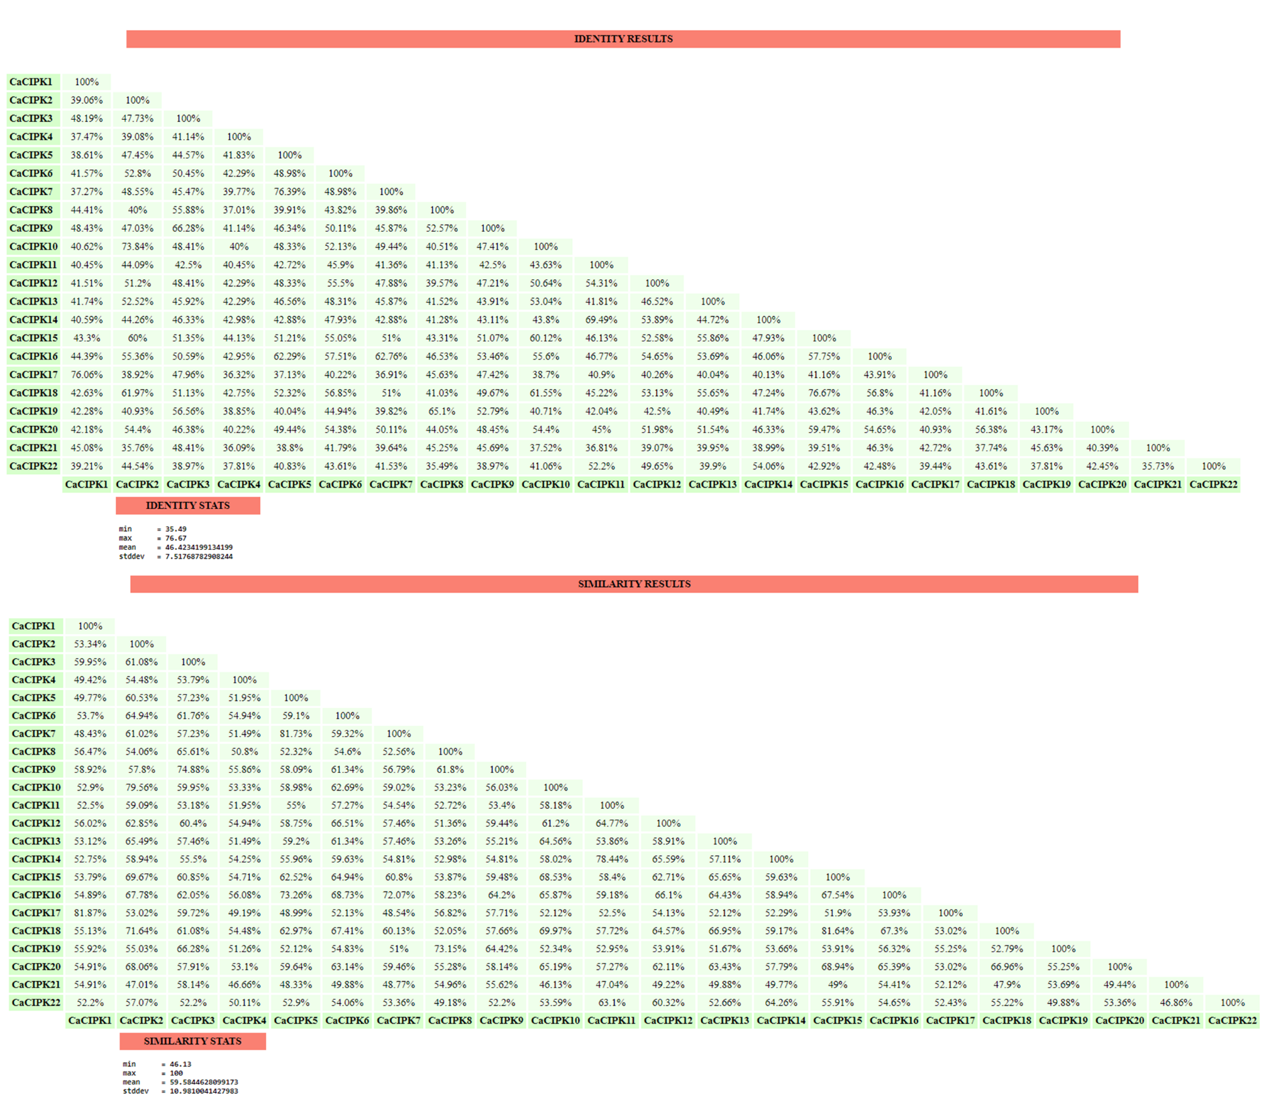
Figure S2: Alignment of 22 CaCIPKs for domain identification.
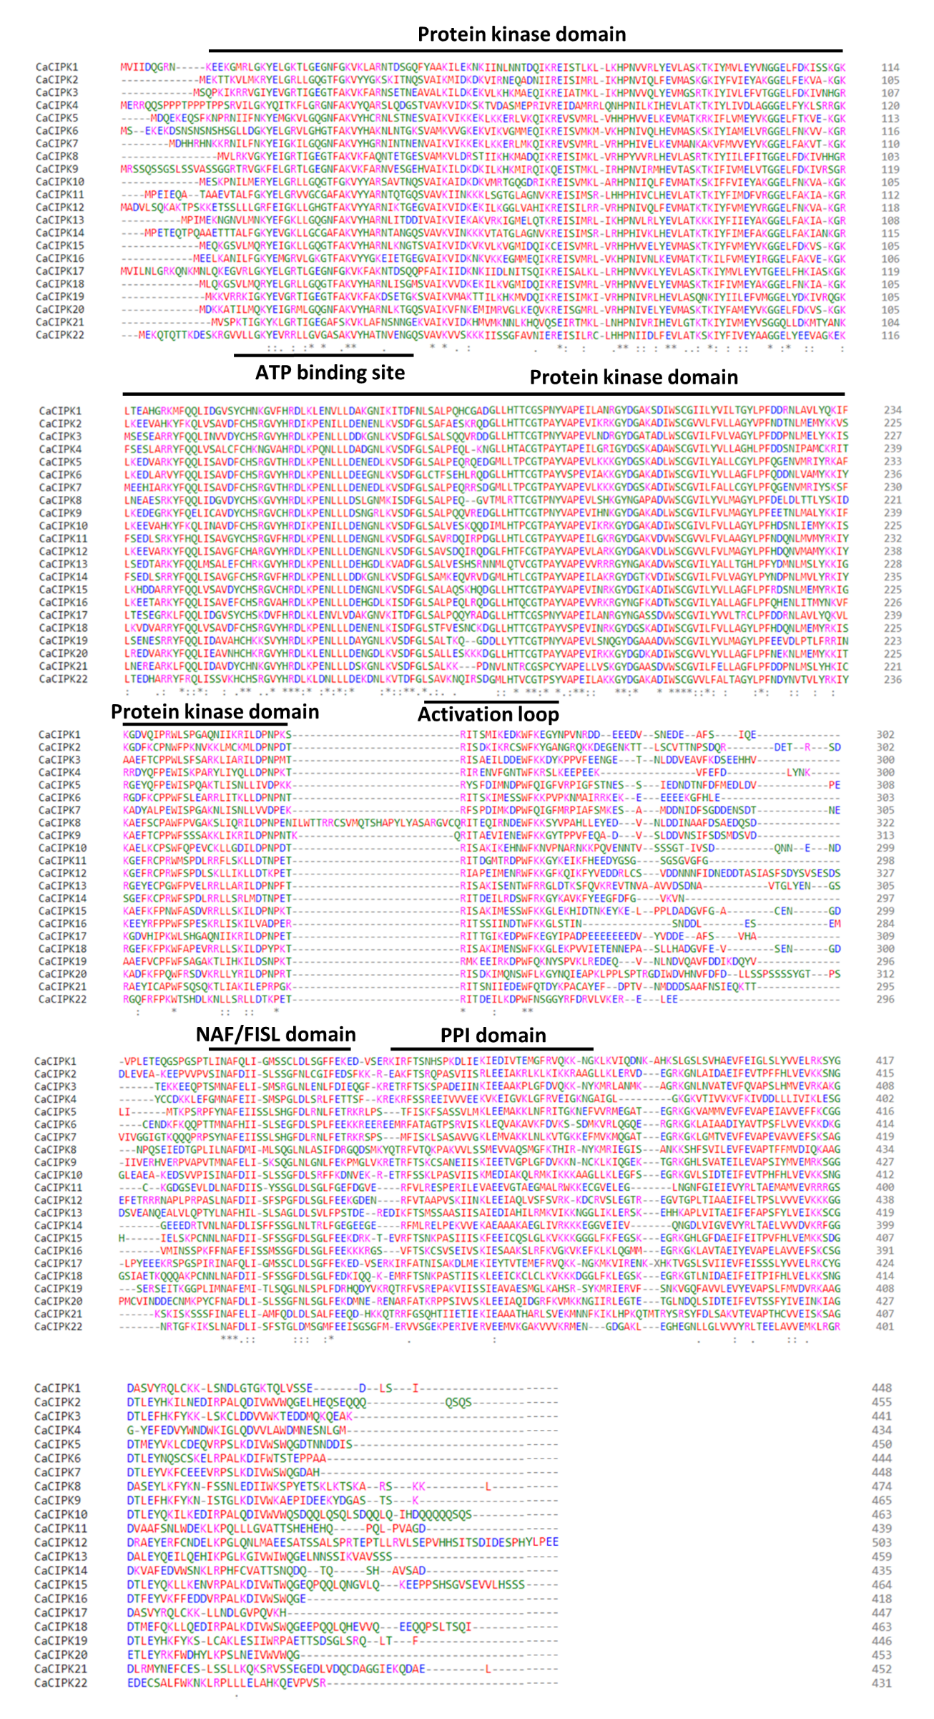

Figure S3: Identification of motifs through MEME.
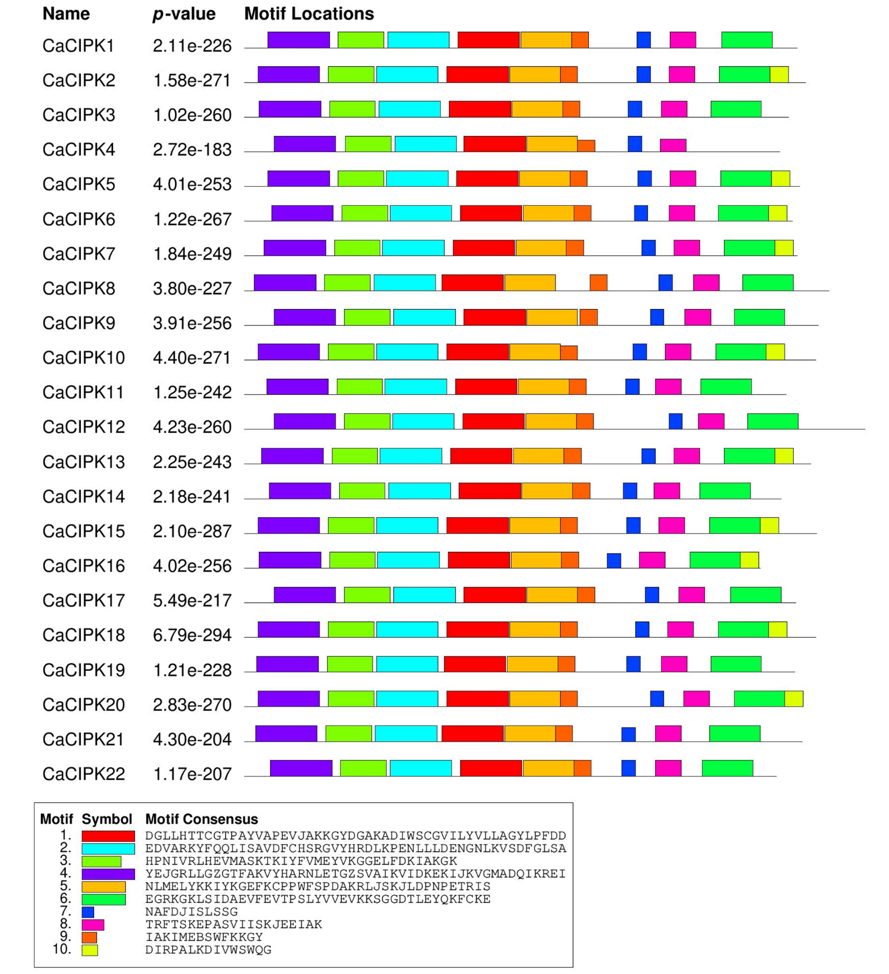

Figure S4: Duplication of chickpea CIPK genes performed by MCScanX is shown via Circos plot.
