(Supplementary Information)

Geometric-phase intraocular lenses with multifocality

Seungmin Lee¹, Gayeon Park¹, Sunho Kim¹, Yeonghwa Ryu¹, Jae Woong Yoon¹,
Ho Sik Hwang², In Seok Song³, Chang Sun Lee⁴ and Seok Ho Song^{1,5 *}

¹Department of Physics, Hanyang University, Seoul 04763, Republic of Korea
²Department of Ophthalmology, Catholic University of Korea, Seoul 07345, Republic of Korea
³Seoul Ophthalmic Clinic, Goyang 10463, Republic of Korea
⁴Koryoeyetech, Inc., Seoul 06093, Republic of Korea
⁵Tigernics, Inc., Seoul 04763, Republic of Korea
* e-mail: shsong@hanyang.ac.kr

Fig. S1. Laser interference lithography system.
Fig. S2. Badal imaging system.
Fig. S3. Visibility measurement of GP IOLs.
Table. S1. Specifications of the laser interference lithography system.
Movie-1. Wavefronts of the transmitted Ex components for circularly polarized incident
Movie-2. Defocus imaging (Movie) of the bifocal and trifocal GP IOLs.

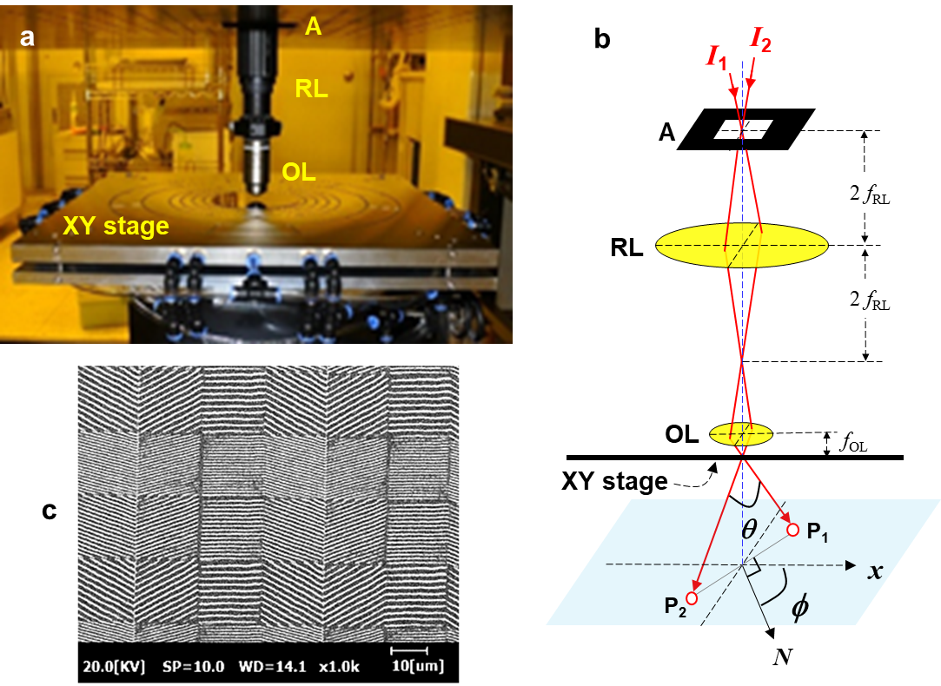

Fig. S1. Laser interference lithography system. a,b, Photograph and schematic of the laser interference lithography system used for the fabrication of microtextured grating pixels. The system consists of a square aperture (A), relay lens (RL), objective lens (OL), and motorized linear stage (XY stage). The two coherent beams (I₁ and I₂) incident to A with 1 mm² area make an interference pattern on the surface of the XY stage via RL and OL. By changing the angles of θ and φ the period (Λ) and orientation (φ) of the square gratings can be precisely defined. c, SEM image of a typical array of square gratings fabricated by the lithography system, where the Λ and φ are randomly arranged from 0.3 μm ~ 1 μm and 0º ~ 180º, respectively.

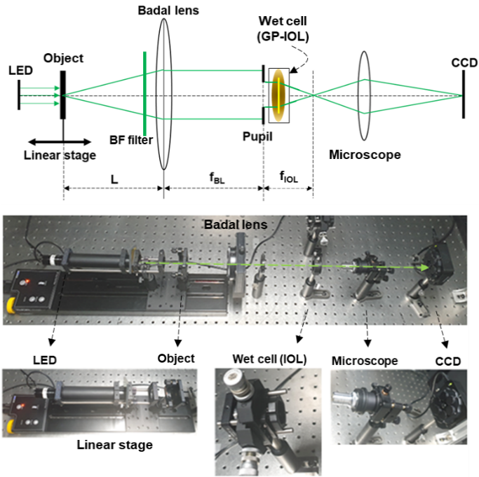

Fig. S2. Badal imaging system. Schematic and photograph of the defocus imaging setup. A white LED lamp and a bandpass (BF) filter illuminates the system at 546 nm. A test object is mounted on a linear motorized translation stage (travel range 300 mm) and placed at the front focal plane of the achromatic Badal lens with 160 mm focal length (f_{BL}). The GP IOL to be tested is immersed in a wet cell with saline solution with pupil sizes ranging from 2 mm to 6 mm. A 12-bit CCD beam profiler (BC106N-VIS, Thorlabs) with an image sensor having 1360 x 1024 pixels (pixel pitch of 6.45 μm); attached to a 5x microscope is used to capture the image formed by the MIOL under test. To assess the MTF, the object (a cross-hair slit with 25 μm width) plane is axially displaced to generate the different eye vergences ranging from -5 D to +5 D. The United States Air Force (USAF) 1951 Resolution Target is used in the imaging test.

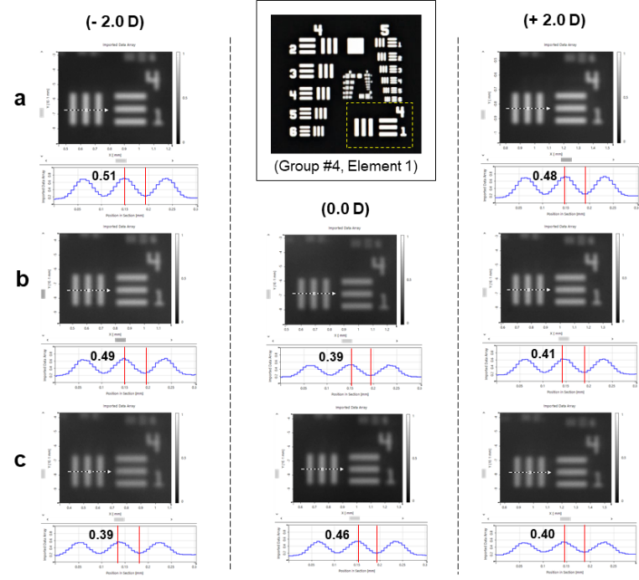
Fig. S3. Visibility measurement of GP IOLs. Magnified images of the 16 lines/mm bar patterns (Group #4, Element 1 of the resolution target as shown in the inset) at the best defocus planes of -2.0 D, 0 D, and +2 D. a, bifocal (λ/2), b, trifocal, (λ/3), and c, trifocal (λ/4) GP IOLs. The line profiles are the intensity (I) distributions along the dashed arrows in the magnified images, where the vertical red lines indicate the positions of I_{min} and I_{max}. The measured visibility (contrast), defined as the ratio of (I_{max} - I_{min})/(I_{max}+ I_{min}), is presented in each panel of the line profile.

Table. S1. Specifications of the laser interference lithography system.

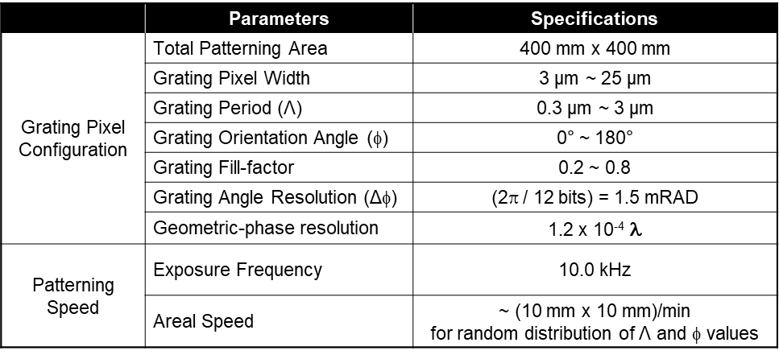

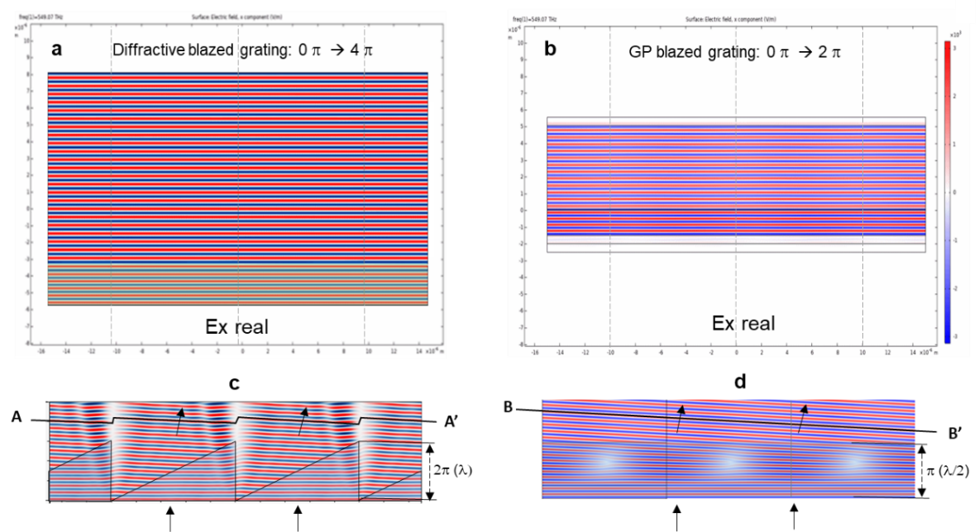
Movie-1. Wavefronts of the transmitted Ex components for circularly polarized incident. a, (Movie) Diffractive blazed grating as the height continues to increase from 0 to 2λ. b, (Movie) GP blazed grating as the GP phase increases from 0 to 2π. c, For a diffractive blazed height of λ (2π) the wavefront is stepwise along the line A-A’. d, For a GP blazed grating of 2π the wavefront is flat along the line B-B’.

Please see the attached file, “Movie-1. Wavefronts of the transmitted Ex components for circularly polarized incident.mp4”.

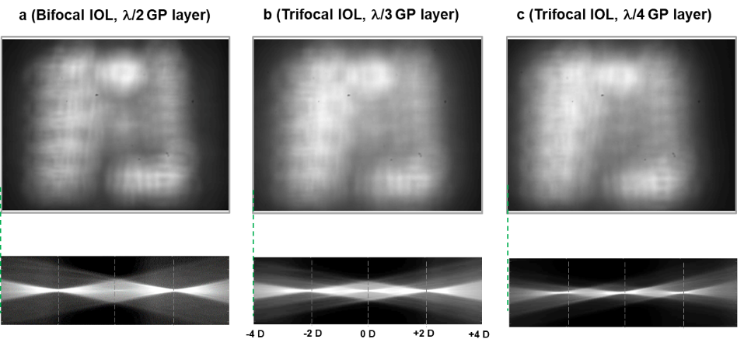

Movie-2. Defocus imaging (Movie) of a, bifocal GP IOL, b,c, trifocal GP IOLs.

Please see the attached file of “Movie-2. Defocus imaging (Movie) of the bifocal and trifocal GP IOLs.mp4”.

