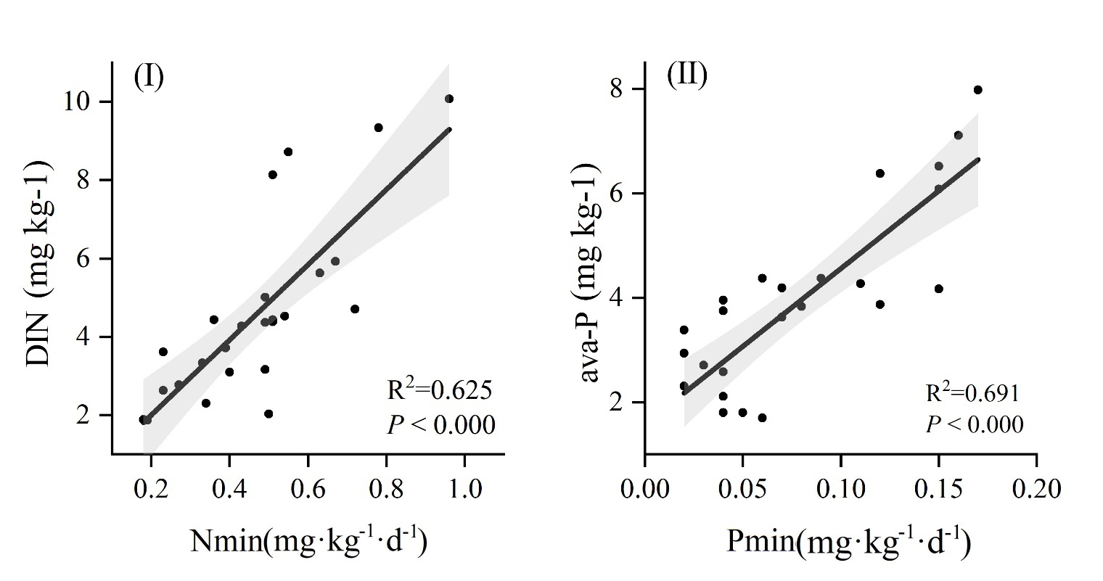

Fig.S1. relationship between soil nutrient and mineralization rate. DIN: dissolve inorganic nitrogen content; ava-P: available phosphorus; Nmin: nitrogen mineralization rate; Pmin: phosphorus mineralization rate.

Fig.S2. Partial correlations between soil characteristics and N mineralization rate. SWC: soil water content; SBD: soil bulk density; Pro: protease; NAG: β-1,4-N-acetylglucosaminidase; LAP: L-leucine aminopeptidase; MBC: microbial biomass carbon; MBN: microbial biomass nitrogen; MBP: microbial biomass phosphorus; “*” means P<0.05; “**” means P<0.01.

Fig.S3. Partial correlations between soil characteristics and N mineralization rate. SWC: soil water content; SBD: soil bulk density; ALP: alkaline phosphatase; MBC: microbial biomass carbon; MBN: microbial biomass nitrogen; MBP: microbial biomass phosphorus; “*” means P<0.05; “**” means P<0.01.
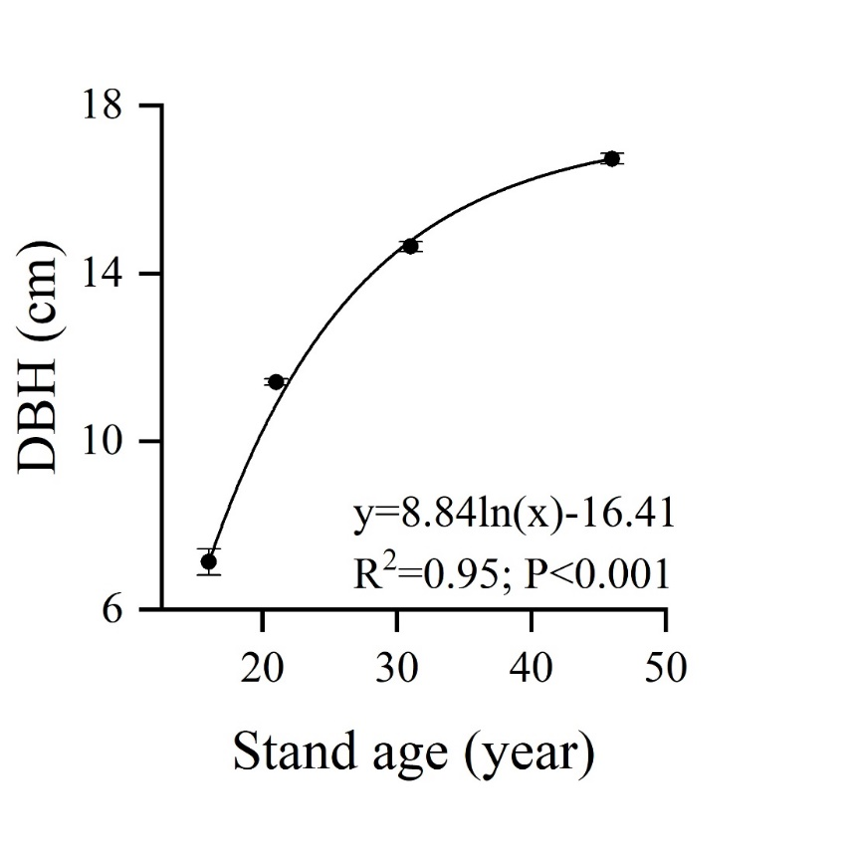
Fig.S4. changes in DBH of Robinia pseudoacacia along with the stand age. DBH: diameter at breast height.

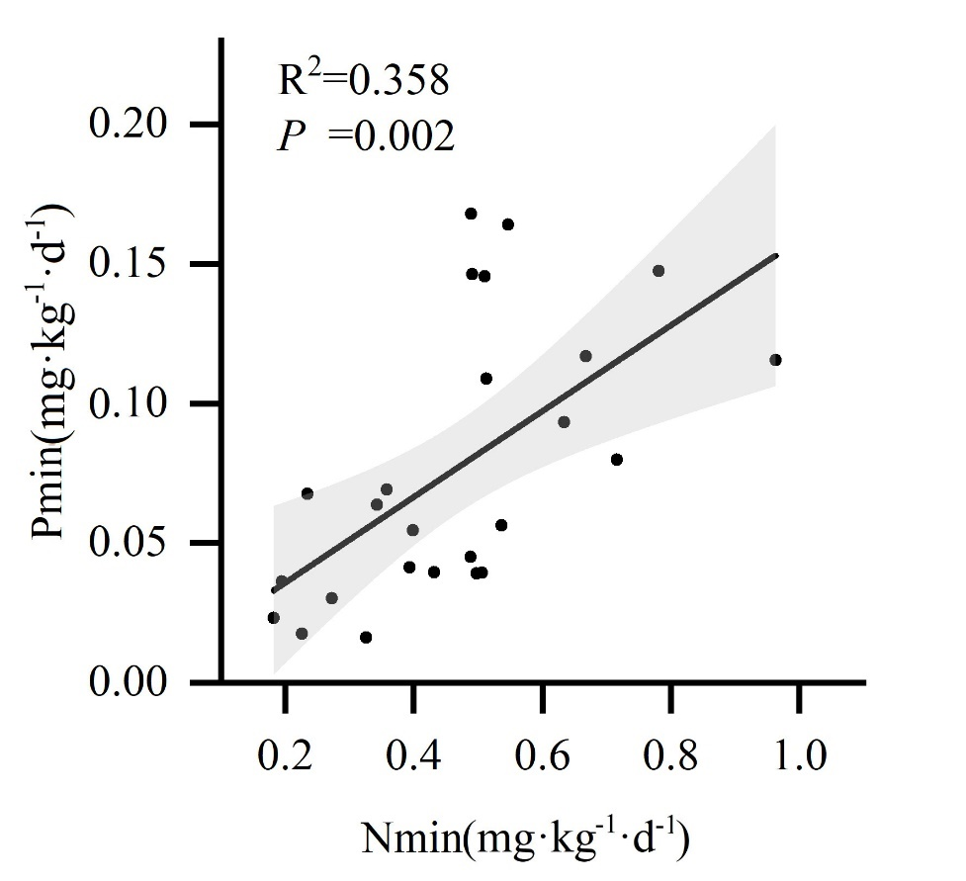

Fig.S5. relationship between N mineralization and P mineralization. Nmin: nitrogen mineralization rate; Pmin: phosphorus mineralization rate.

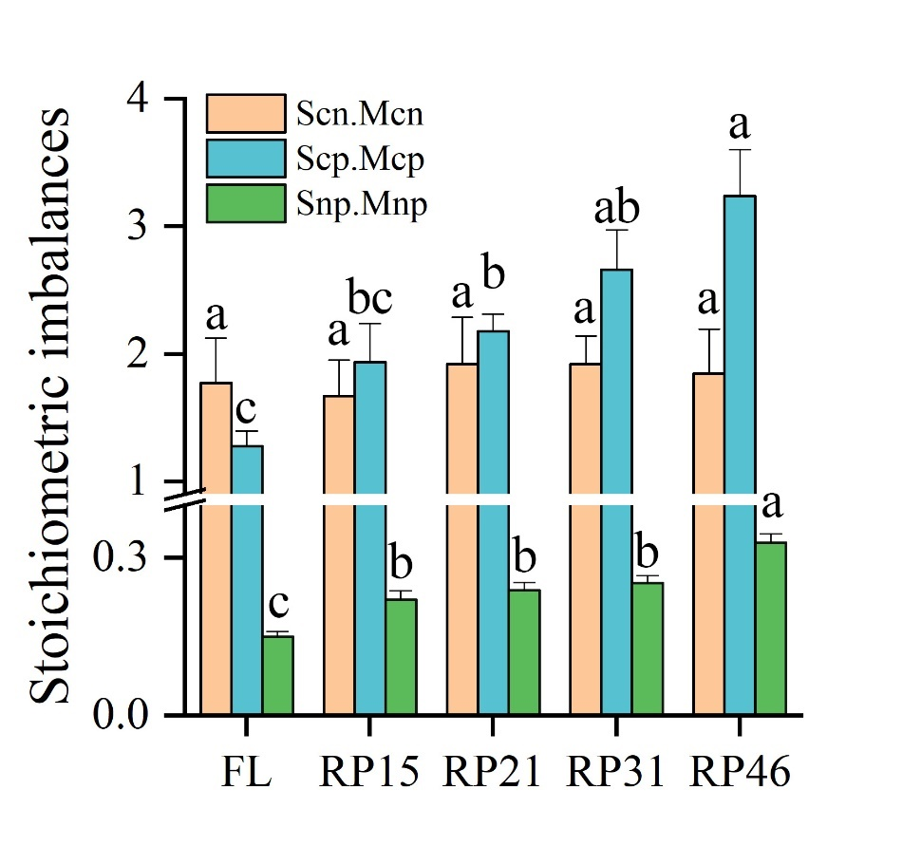

Fig.S6. Changes in stoichiometric imbalance along with afforestation age. Scn, Scp, and Snp mean SOC:STN, or SOC:STP and STN:STP, respectively; and Mcn, Mcp, and Mnp mean MBC:MBN, MBC:MBP and MBN:MBP, respectively. Different lowercase letters indicate significant differences between different afforestation ages (P<0.05).

Table S1: The information for the studied soil enzyme
Enzyme name | Abbreviation | EC number | Substrate | Standard
β-1,4-glucosidase | BG | EC 3.2.1.21 | 4-MUB-β-D-glucopyranoside | 4-MUB
β-1,4-N-acetylglucosaminidase | NAG | EC 3.2.1.14 | 4-MUB-Nacetyl-β-D-glucosaminide | 4-MUB
L-leucine aminopeptidase | LAP | EC 3.4.11.1 | L-leucine-7-amino-4-methylcoumarin | 7-AMC
Alkaline phosphatase | ALP | EC 3.1.3.1 | 4-MUB-phosphate | 4-MUB
Protease | Pro | EC 3.4 | Casein or benzoyl-L- arginine amide
Urease | Urea | EC 3.5.1.5 | Urea
Note: EC denotes enzyme commission number; 4-MUB denotes 4-methylumbelliferone; AMC denotes 7-amino-4-methylcoumarin.

Table S2: The RP biomass of different organs in 2017 and 2020 in different stand site.
 | leaf biomass  (t·hm⁻²) |  | breach biomass  (t·hm⁻²) |  | stem biomass  (t·hm⁻²) |  | root biomass  (t·hm⁻²) |  | increment biomass  (t·hm⁻²·yr⁻¹)
 | 2017 | 2020 | 2017 | 2020 | 2017 | 2020 | 2017 | 2020 | breach | stem | root
RP15 | 0.73 | 0.98 | 5.34 | 6.04 | 12.86 | 14.61 | 13.38 | 14.58 | 0.23 | 0.58 | 0.40
RP21 | 1.70 | 2.01 | 16.26 | 17.68 | 41.73 | 44.83 | 35.97 | 37.73 | 0.47 | 1.03 | 0.59
RP31 | 2.67 | 3.02 | 30.33 | 32.06 | 79.34 | 83.37 | 61.23 | 64.09 | 0.58 | 1.34 | 0.95
RP46 | 2.91 | 3.59 | 39.17 | 42.15 | 105.77 | 111.13 | 76.52 | 81.38 | 0.99 | 1.79 | 1.62

Table S3: The changes of nutrient contents in different organs after afforestation.
 |  | RP15 | RP21 | RP31 | RP45
TN  (g·kg⁻¹) | leaf | 28.29±1.49b | 29.88±0.63ab | 32.68±1.41a | 33.16±1.4a
TN  (g·kg⁻¹) | branch | 11.38±0.25a | 10.13±0.48b | 11.79±0.43a | 11.95±0.42a
TN  (g·kg⁻¹) | stem | 5.86±0.35b | 6.89±0.14b | 7.06±0.68b | 9.33±0.83a
TN  (g·kg⁻¹) | root | 15.79±0.73c | 17.13±0.75bc | 20.8±1.22ab | 21.61±2.04a
TN  (g·kg⁻¹) | litter | 15.01±0.8b | 16.51±0.29ab | 18.75±0.52a | 19.54±1.67a
TP  (g·kg⁻¹) | leaf | 1.23±0.06a | 1.28±0.03a | 1.29±0.07a | 1.31±0.08a
TP  (g·kg⁻¹) | branch | 0.6±0.06b | 0.58±0.04b | 0.98±0.17a | 0.82±0.06ab
TP  (g·kg⁻¹) | stem | 0.23±0.02b | 0.21±0.02b | 0.18±0.04b | 0.33±0.02a
TP  (g·kg⁻¹) | root | 0.65±0.06a | 0.65±0.04a | 0.73±0.05a | 0.68±0.04a
TP  (g·kg⁻¹) | litter | 0.50±0.03c | 0.61±0.04b | 0.66±0.03ab | 0.72±0.03a
Note: Different lowercase letters indicate significant differences among afforestation stages (One-way ANOVA, P < 0.05).
Table S4: The change of soil microbial biomass and extracellular enzyme after afforestation.
 | FL | RP15 | RP21 | RP31 | RP46
MBC (mg·kg⁻¹) | 121.77±25.81c | 172.12±19.22bc | 205.89±36.47bc | 258.45±28.04b | 425.14±56.02a
MBN (mg·kg⁻¹) | 21.67±1.17e | 31.48±0.64d | 37.26±1.74c | 45.92±2.31b | 73.46±2.01a
MBP (mg·kg⁻¹) | 4.96±0.13d | 8.00±0.35c | 9.24±0.17c | 10.86±0.40b | 14.45±0.82a
MBC:MBN | 5.70±1.31a | 5.43±0.51a | 5.59±1.09a | 5.72±0.72a | 5.87±0.92a
MBC:MBP | 24.29±4.66a | 22.07±3.40a | 22.23±3.84a | 24.10±3.03a | 30.34±5.30a
MBN:MBP | 4.37±0.22b | 3.97±0.25b | 4.04±0.23b | 4.23±0.14b | 5.12±0.17a
BG (nmol⋅g⁻¹⋅h⁻¹) | 23.34±2.64b | 26.97±1.24b | 30.64±2.42b | 39.17±3.70a | 45.24±0.74a
NAG (nmol⋅g⁻¹⋅h⁻¹) | 2.41±0.63b | 3.51±0.66b | 3.66±0.60b | 4.16±1.01b | 6.85±0.98a
LAP (nmol⋅g⁻¹⋅h⁻¹) | 47.59±2.79c | 55.37±4.01c | 60.38±4.71bc | 73.46±4.65ab | 80.91±8.91a
Pro (umol⋅g⁻¹⋅min⁻¹) | 1.15±0.04c | 1.17±0.02c | 1.34±0.05b | 1.45±0.01a | 1.49±0.02a
Urease (umol⋅g⁻¹⋅min⁻¹) | 0.65±0.23a | 0.72±0.26a | 0.75±0.17a | 0.86±0.15a | 1.13±0.16a
ALP (nmol⋅g⁻¹⋅h⁻¹) | 36.68±2.09e | 56.47±0.82d | 72.88±1.54c | 125.84±6.30b | 184.84±7.15a
ln(BG):ln(NAG+LAP) | 0.80±0.03a | 0.81±0.02a | 0.82±0.02a | 0.84±0.03a | 0.86±0.02a
ln(BG):ln(ALP) | 0.87±0.03a | 0.82±0.01ab | 0.80±0.02bc | 0.76±0.03bc | 0.73±0.01c
ln(NAG+LAP):ln(ALP) | 1.09±0.03a | 1.01±0.02b | 0.97±0.02b | 0.9±0.00c | 0.86±0.02c
Length | 1.18±0.04a | 1.15±0.02a | 1.14±0.02a | 1.13±0.04a | 1.13±0.01a
Angle (°) | 42.62±0.79c | 44.8±0.5b | 45.96±0.49b | 48.03±0.13a | 49.51±0.73a
Note: MBC: soil microbial biomass carbon; MBN: soil microbial biomass nitrogen; MBP: soil microbial phosphorus; The BG, NAG, LAP, Pro and ALP means β-1,4-glucosidase, β-1,4-N-acetylglucosaminidase, leucine aminopeptidase, protease, and alkaline phosphatase, respectively.

