Supplementary material “Bacteroidetes to Firmicutes - how captivity changes the gut microbiome composition and diversity in a social subterranean rodent”

Table S1. Summary linear mixed model (LMM) testing differences in library size wild and captive samples.
 | NbReads
Predictors | Estimates | p
(Intercept) | 64667.40  (43864.76 – 85470.05) | < 0.001
Population [Wild] | 29594.58  (16089.41 – 43099.75) | < 0.001
Random Effects
σ² | 1247482815.08
τ₀₀ _{Plate_No} | 258687339.04
ICC | 0.17
N _{Plate_No} | 3
Observations | 109
Marginal R² / Conditional R² | 0.128 / 0.278

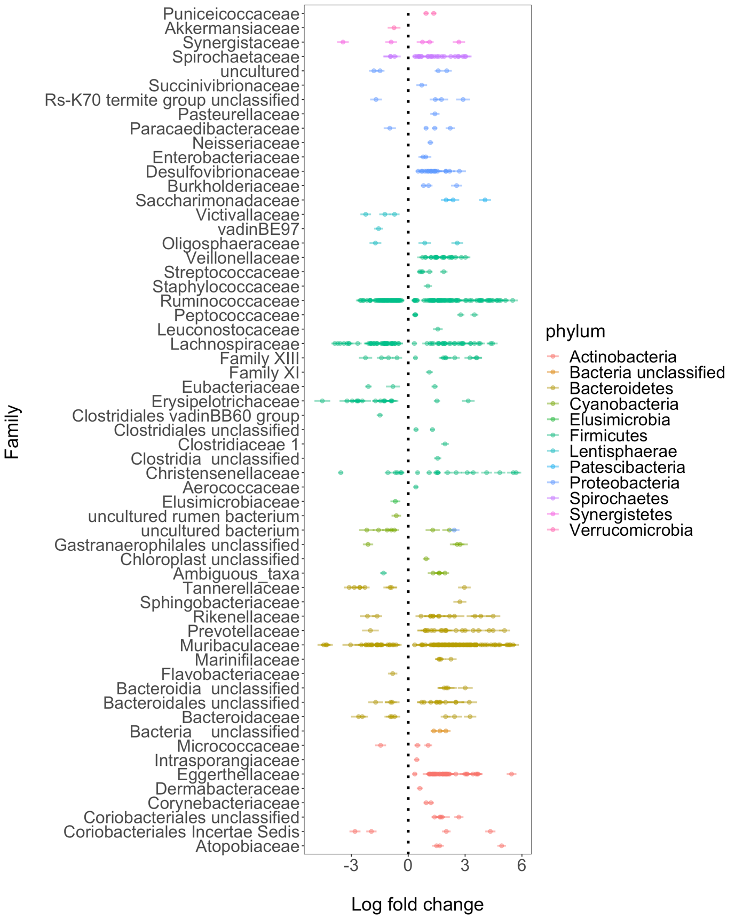
Figure S1. Differently abundant ASVs in the gut microbiome of captive and wild Damaraland mole-rats grouped by family on y-axis. Points and bars represent the log-fold change (effect size) of the 680 unique ASVs with p_{adj} < 0.05 and the 95% confidence intervals derived from the ANCOMBC model, with negative values indicating higher abundance in captive samples and positive values indicating higher abundance in wild samples. Points are coloured and sorted according to phylum, described in the legend in the figure.
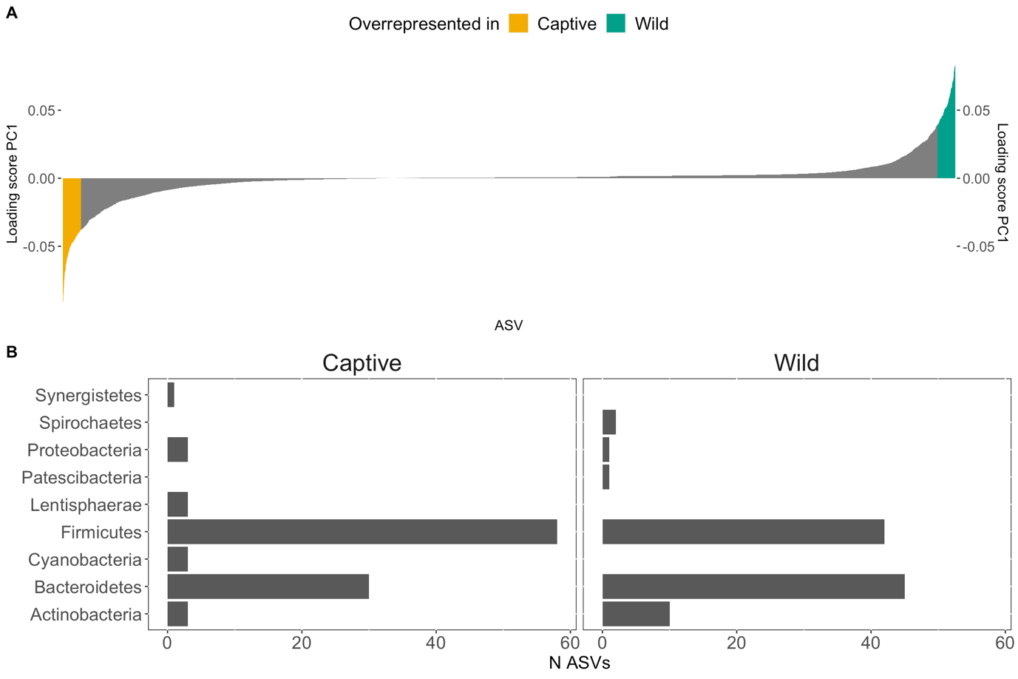Figure S2. Taxa separation of samples along the PC1 axis. A) Loading scores of PC1 (Fig. 1) sorted for all ASVs on x-axis. ASVs with the top 2% loading scores (N = 101 ASVs) are filled in blue-green and correspond to ASVs characterising wild gut microbiota and ASVs filled in yellow correspond to ASVs with the 2% with the lowest loading scores (101 ASVs) characterising captive gut microbiota of Damaraland mole-rats. B) Sum of unique ASVs belonging to each phylum as either associated with “captive" or "wild" in plot A.

Table S2. ﻿Amplicon sequencing variants (ASVs) significantly differentially abundant (p-adj < 0.05) in the gut microbiomes of wild and captive Damaraland mole-rats.
Added as separate supplementary table: TableS2.tsv
Table S3. Relative abundances Firmicutes/Bacteroidetes (F/B-ratio) ratio Liner Mixed Model results.
 | log(F/B-ratio)
Predictors | Estimates | std. Error | CI | p
(Intercept) | -0.19 | 0.12 | -0.42 – 0.04 |  | 0.104
Population [Wild] | -0.98 | 0.16 | -1.30 – -0.67 |  | <0.001
Random Effects
σ² | 0.67
τ₀₀ _{Plate_No} | 0.00
ICC | 0.00
N _{Plate_No} | 3
Observations | 109
Marginal R² / Conditional R² | 0.267 / 0.270

Table S4. Model summary betta-random estimated richness with the breakaway package [1]. The intercept corresponds to mean richness for samples from captive animals.
 | Estimates | Standard Errors | p-value
Intercept | 430.9377 | 7.316445 | 0
Population Wild | -129.6338 | 10.180837 | 0

Table S5. Results Wilcoxon sum test to differences in the number of unique ASVs per phylum between wild and captive animals. Mean and sd number of unique ASVs per population (wild or captive) provided. p-adjust are p-values adjusted with Bonferroni adjustment for multiple testing.
phylum | Mean Captive | Mean Wild | Sd Captive | Sd Wild | p-value | p-adjust
Bacteroidetes | 111.5 | 114.7 | 17.6 | 14.3 | 0.776 | 1
Firmicutes | 245.3 | 106.5 | 66.1 | 32.8 | <0.001 | <0.001
Cyanobacteria | 13.6 | 6.7 | 4.2 | 1.9 | <0.001 | <0.001
Actinobacteria | 14.9 | 30.4 | 7.8 | 15.3 | <0.001 | <0.001
Proteobacteria | 20.8 | 21.3 | 8.7 | 9.5 | 0.75 | 1
Spirochaetes | 13.8 | 14 | 7.2 | 9.9 | 0.631 | 1
Synergistetes | 4.4 | 2.7 | 1.8 | 1.3 | <0.001 | <0.001
Other phyla | 11.2 | 7.6 | 4.1 | 3.8 | <0.001 | <0.001

Method calculating body mass index
We calculated body mass index using standardised major axis regression, a widely adopted method to calculate body mass index/body condition on mammals which was proposed by Peig & Green [2]. Standardised major axis regression of ln body mass against the natural log of tooth width (which is well correlated with body length) was calculated using the smatr package [3], described in detail in Thorley et al. [4]. One captive animal was removed from body mass index analysis because of missing data on tooth width.
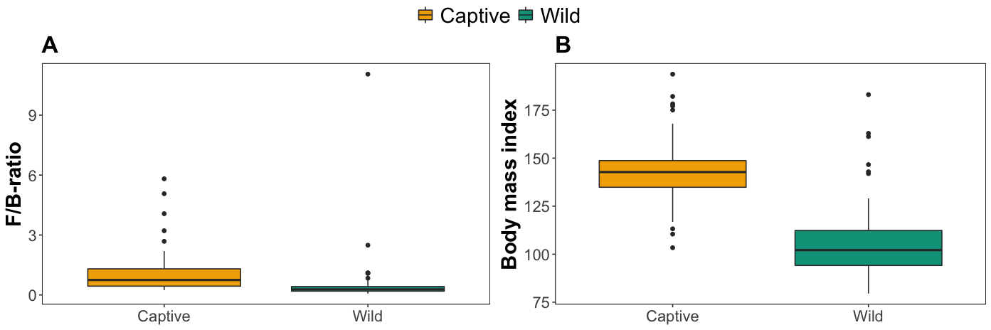
Figure S3. Differences in the ratio of relative abundances of Firmicutes/ Bacteroidetes and body mass index between captive and wild Damaraland mole-rats. A) Boxplot of ratio of relative abundances of Firmicutes/Bacteroidetes (F/B-ratio). One outlier from wild animal removed for visualization. B) Boxplot of body mass index (LM p < 0.001). Yellow boxes represent samples from captive individuals and blue-green boxes samples from wild individuals.

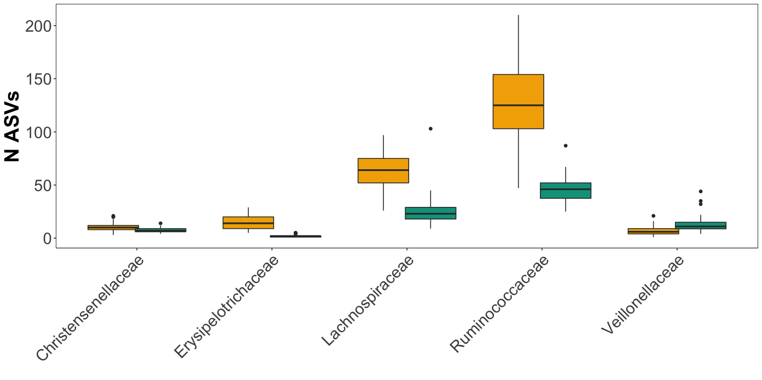
Figure S4. Boxplots of ASV richness of the five families within Firmicutes with the highest richness (mean richness > 10 ASVs) to explore what families explain increased richness of captive animals compared to wild.
Table S6. Meta-data for samples used in this study including BioSample numbers which can be found at short read archive (SRA) project PRJNA781121.
sample | Asample | SampleDate | Population | massindex | Plate_No | BioSample
383 | A_383 | 2019-09-07 | Captive | 123.7 | 1 | SAMN23246719
382 | A_382 | 2019-09-07 | Captive | 148.23 | 2 | SAMN23246815
386 | A_386 | 2019-09-07 | Captive | NA | 3 | SAMN23246992
381 | A_381 | 2019-09-07 | Captive | 140.91 | 1 | SAMN23246735
380 | A_380 | 2019-09-07 | Captive | 145.55 | 1 | SAMN23246753
390 | A_390 | 2019-09-08 | Captive | 142.89 | 1 | SAMN23246722
391 | A_391 | 2019-09-08 | Captive | 142.65 | 1 | SAMN23246739
398 | A_398 | 2019-09-09 | Captive | 129.28 | 2 | SAMN23246813
399 | A_399 | 2019-09-09 | Captive | 138.26 | 1 | SAMN23246805
419 | A_419 | 2019-09-11 | Captive | 145.55 | 3 | SAMN23246975
426 | A_426 | 2019-09-11 | Captive | 137.68 | 2 | SAMN23246824
422 | A_422 | 2019-09-11 | Captive | 124.95 | 1 | SAMN23246800
424 | A_424 | 2019-09-11 | Captive | 178.3 | 3 | SAMN23246945
429 | A_429 | 2019-09-12 | Captive | 138.02 | 1 | SAMN23246749
432 | A_432 | 2019-09-13 | Captive | 175.06 | 2 | SAMN23246871
431 | A_431 | 2019-09-13 | Captive | 142.92 | 2 | SAMN23246851
430 | A_430 | 2019-09-13 | Captive | 133.95 | 3 | SAMN23246916
454 | A_454 | 2019-09-18 | Captive | 147.24 | 2 | SAMN23246864
459 | A_459 | 2019-09-20 | Captive | 141.68 | 2 | SAMN23246818
462 | A_462 | 2019-09-23 | Captive | 167.97 | 2 | SAMN23246810
474 | A_474 | 2019-09-24 | Captive | 177.15 | 3 | SAMN23246910
472 | A_472 | 2019-09-24 | Captive | 182.15 | 2 | SAMN23246855
480 | A_480 | 2019-09-25 | Captive | 137.27 | 1 | SAMN23246762
489 | A_489 | 2019-09-27 | Captive | 145.98 | 2 | SAMN23246892
492 | A_492 | 2019-09-29 | Captive | 167.77 | 3 | SAMN23246979
501 | A_501 | 2019-10-01 | Captive | 120.16 | 2 | SAMN23246840
511 | A_511 | 2019-10-03 | Captive | 139.81 | 2 | SAMN23246834
547 | A_547 | 2019-10-08 | Captive | 119.56 | 3 | SAMN23246928
555 | A_555 | 2019-10-09 | Captive | 135.15 | 2 | SAMN23246884
563 | A_563 | 2019-10-10 | Captive | 151.11 | 2 | SAMN23246860
565 | A_565 | 2019-10-15 | Captive | 127.7 | 2 | SAMN23246837
574 | A_574 | 2019-10-15 | Captive | 156.53 | 2 | SAMN23246842
576 | A_576 | 2019-10-15 | Captive | 133.67 | 2 | SAMN23246898
575 | A_575 | 2019-10-15 | Captive | 150.25 | 3 | SAMN23246977
588 | A_588 | 2019-10-16 | Captive | 145.29 | 2 | SAMN23246817
587 | A_587 | 2019-10-16 | Captive | 193.73 | 3 | SAMN23246932
613 | A_613 | 2019-10-19 | Captive | 120.21 | 3 | SAMN23246953
615 | A_615 | 2019-10-21 | Captive | 146.58 | 3 | SAMN23246961
617 | A_617 | 2019-10-23 | Captive | 145.64 | 2 | SAMN23246889
623 | A_623 | 2019-10-26 | Captive | 116.86 | 3 | SAMN23246966
664 | A_664 | 2019-11-05 | Captive | 113.21 | 3 | SAMN23246987
650 | A_650 | 2019-11-05 | Captive | 143.96 | 1 | SAMN23246760
653 | A_653 | 2019-11-05 | Captive | 163.87 | 2 | SAMN23246862
654 | A_654 | 2019-11-05 | Captive | 139.65 | 3 | SAMN23246941
652 | A_652 | 2019-11-05 | Captive | 135.52 | 1 | SAMN23246751
651 | A_651 | 2019-11-05 | Captive | 144.45 | 3 | SAMN23246988
655 | A_655 | 2019-11-05 | Captive | 110.46 | 2 | SAMN23246883
677 | A_677 | 2019-11-07 | Captive | 164 | 3 | SAMN23246912
676 | A_676 | 2019-11-07 | Captive | 142.38 | 1 | SAMN23246764
673 | A_673 | 2019-11-07 | Captive | 161.95 | 1 | SAMN23246754
672 | A_672 | 2019-11-07 | Captive | 135.25 | 1 | SAMN23246779
685 | A_685 | 2019-11-09 | Captive | 145.69 | 1 | SAMN23246720
686 | A_686 | 2019-11-09 | Captive | 103.38 | 2 | SAMN23246812
394 | A_394 | 2019-09-09 | Wild | 162.92 | 1 | SAMN23246713
549 | A_549 | 2019-10-08 | Wild | 104.32 | 1 | SAMN23246718
446 | A_446 | 2019-09-17 | Wild | 92.61 | 1 | SAMN23246724
442 | A_442 | 2019-09-17 | Wild | 93.64 | 1 | SAMN23246729
533 | A_533 | 2019-10-07 | Wild | 86.58 | 1 | SAMN23246731
428 | A_428 | 2019-09-12 | Wild | 94.08 | 1 | SAMN23246733
527 | A_527 | 2019-10-06 | Wild | 113.37 | 1 | SAMN23246744
495 | A_495 | 2019-09-30 | Wild | 118.8 | 1 | SAMN23246765
435 | A_435 | 2019-09-16 | Wild | 97.49 | 1 | SAMN23246770
598 | A_598 | 2019-10-17 | Wild | 112.05 | 1 | SAMN23246771
496 | A_496 | 2019-09-30 | Wild | 116.13 | 1 | SAMN23246776
456 | A_456 | 2019-09-19 | Wild | 91.41 | 1 | SAMN23246781
559 | A_559 | 2019-10-09 | Wild | 142.91 | 1 | SAMN23246786
580 | A_580 | 2019-10-15 | Wild | 146.65 | 1 | SAMN23246787
464 | A_464 | 2019-09-23 | Wild | 104.2 | 1 | SAMN23246788
449 | A_449 | 2019-09-17 | Wild | 94.64 | 1 | SAMN23246790
532 | A_532 | 2019-10-07 | Wild | 161.22 | 1 | SAMN23246791
498 | A_498 | 2019-10-01 | Wild | 99.36 | 1 | SAMN23246796
558 | A_558 | 2019-10-09 | Wild | 108.34 | 1 | SAMN23246799
393 | A_393 | 2019-09-09 | Wild | 94.84 | 1 | SAMN23246804
583 | A_583 | 2019-10-16 | Wild | 129.04 | 2 | SAMN23246809
450 | A_450 | 2019-09-17 | Wild | 121.4 | 2 | SAMN23246811
479 | A_479 | 2019-09-25 | Wild | 99.13 | 2 | SAMN23246814
522 | A_522 | 2019-10-06 | Wild | 86.01 | 2 | SAMN23246820
581 | A_581 | 2019-10-15 | Wild | 104.14 | 2 | SAMN23246831
461 | A_461 | 2019-09-23 | Wild | 104.23 | 2 | SAMN23246832
397 | A_397 | 2019-09-09 | Wild | 93.07 | 2 | SAMN23246833
516 | A_516 | 2019-10-06 | Wild | 98.25 | 2 | SAMN23246846
491 | A_491 | 2019-09-28 | Wild | 105.44 | 2 | SAMN23246859
395 | A_395 | 2019-09-09 | Wild | 110.86 | 2 | SAMN23246866
526 | A_526 | 2019-10-06 | Wild | 100.13 | 2 | SAMN23246868
405 | A_405 | 2019-09-10 | Wild | 99.71 | 2 | SAMN23246877
509 | A_509 | 2019-10-02 | Wild | 96.35 | 2 | SAMN23246880
556 | A_556 | 2019-10-09 | Wild | 84.31 | 2 | SAMN23246881
562 | A_562 | 2019-10-10 | Wild | 106.32 | 2 | SAMN23246885
542 | A_542 | 2019-10-07 | Wild | 183.09 | 2 | SAMN23246896
407 | A_407 | 2019-09-10 | Wild | 79.52 | 2 | SAMN23246901
494 | A_494 | 2019-09-30 | Wild | 116.62 | 3 | SAMN23246907
418 | A_418 | 2019-09-10 | Wild | 89.59 | 3 | SAMN23246918
473 | A_473 | 2019-09-24 | Wild | 96.44 | 3 | SAMN23246919
406 | A_406 | 2019-09-10 | Wild | 96.32 | 3 | SAMN23246923
476 | A_476 | 2019-09-25 | Wild | 141.97 | 3 | SAMN23246931
513 | A_513 | 2019-10-06 | Wild | 90.98 | 3 | SAMN23246936
433 | A_433 | 2019-09-16 | Wild | 94.14 | 3 | SAMN23246938
510 | A_510 | 2019-10-03 | Wild | 119.19 | 3 | SAMN23246942
443 | A_443 | 2019-09-17 | Wild | 96.91 | 3 | SAMN23246943
448 | A_448 | 2019-09-17 | Wild | 108.05 | 3 | SAMN23246948
584 | A_584 | 2019-10-16 | Wild | 99.24 | 3 | SAMN23246954
434 | A_434 | 2019-09-16 | Wild | 91.45 | 3 | SAMN23246955
469 | A_469 | 2019-09-24 | Wild | 111.78 | 3 | SAMN23246959
436 | A_436 | 2019-09-16 | Wild | 109.62 | 3 | SAMN23246965
447 | A_447 | 2019-09-17 | Wild | 86.39 | 3 | SAMN23246971
455 | A_455 | 2019-09-19 | Wild | 91 | 3 | SAMN23246982
460 | A_460 | 2019-09-21 | Wild | 106.99 | 3 | SAMN23246991
440 | A_440 | 2019-09-16 | Wild | 114.77 | 3 | SAMN23246994
457 | A_457 | 2019-09-20 | Wild | 105.9 | 3 | SAMN23246996

References
1. Willis A, Bunge J, Whitman T. Improved detection of changes in species richness in high diversity microbial communities. J R Stat Soc Ser C Appl Stat. 2016;963–77.
2. Peig J, Green AJ. New perspectives for estimating body condition from mass/length data: The scaled mass index as an alternative method. Oikos. 2009;118:1883–91.
3. Warton DI, Duursma RA, Falster DS, Taskinen S. smatr 3- an R package for estimation and inference about allometric lines. Methods Ecol Evol. 2012;3:257–9.
4. Thorley J, Bensch HM, Finn K, Clutton-Brock TH, Zöttl M. Fitness of breeders in social Damaraland mole-rats is independent of group size. bioRxiv. 2021;

