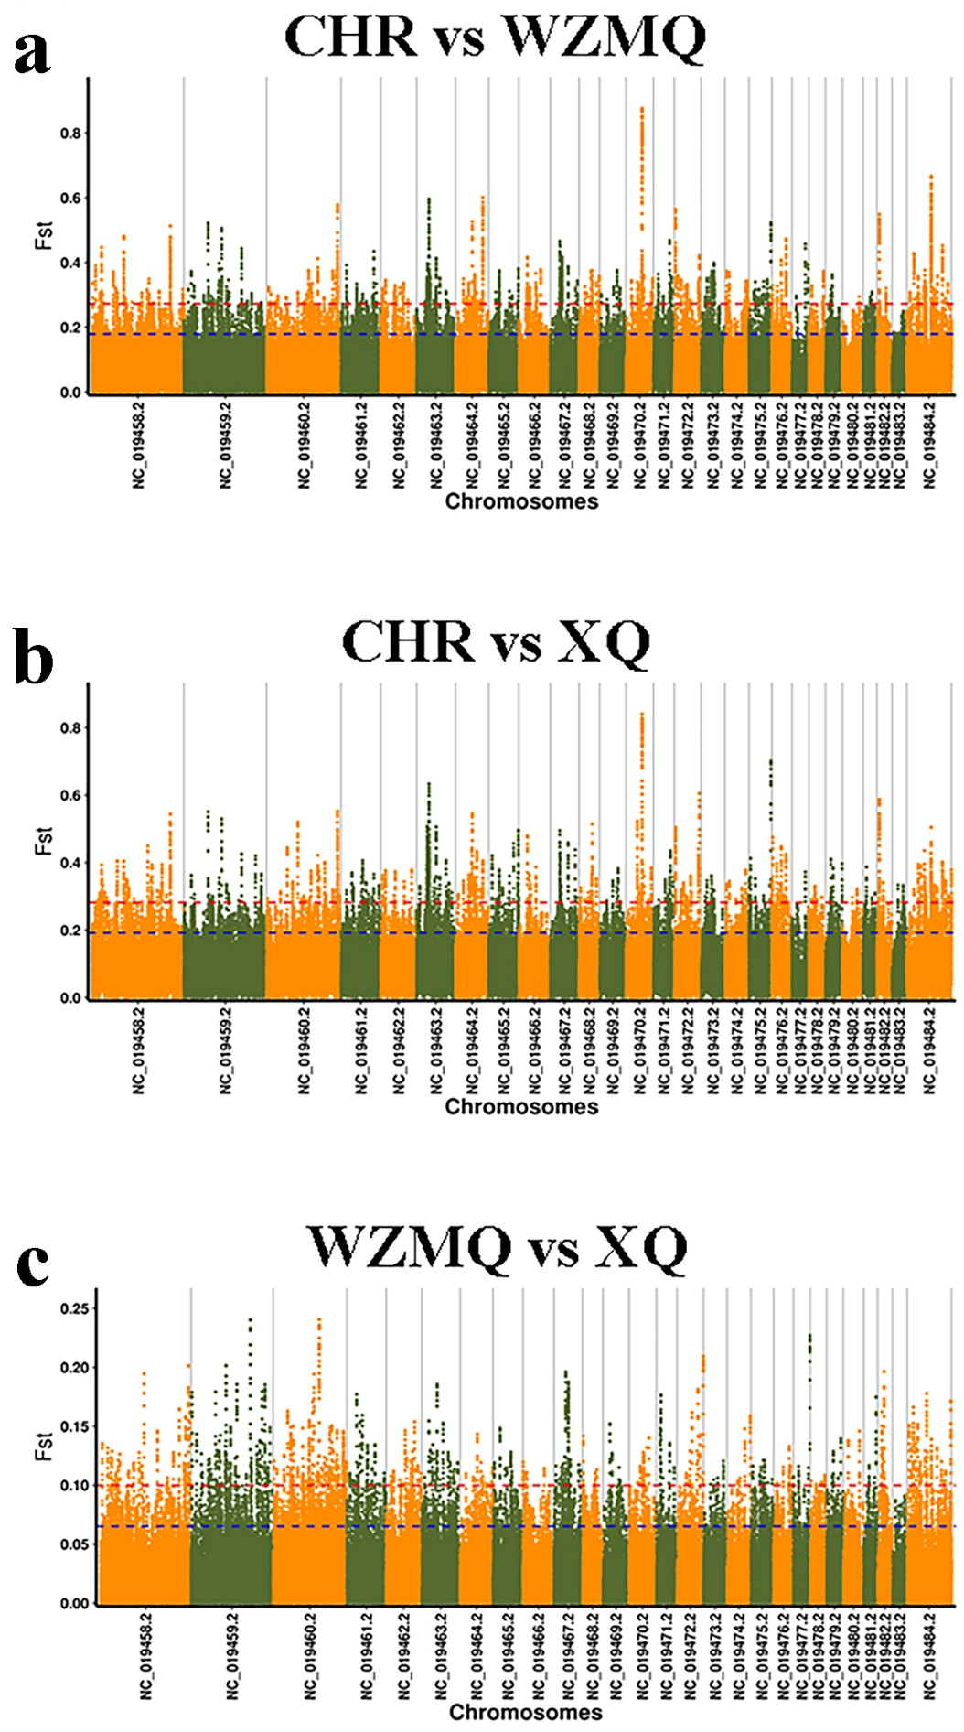
Figure S1. Three kinds of sheep Fst diagram. (a) represents CHR vs WZMQ. (b) represents CHR vs XQ. (c) represents WZMQ vs XQ.

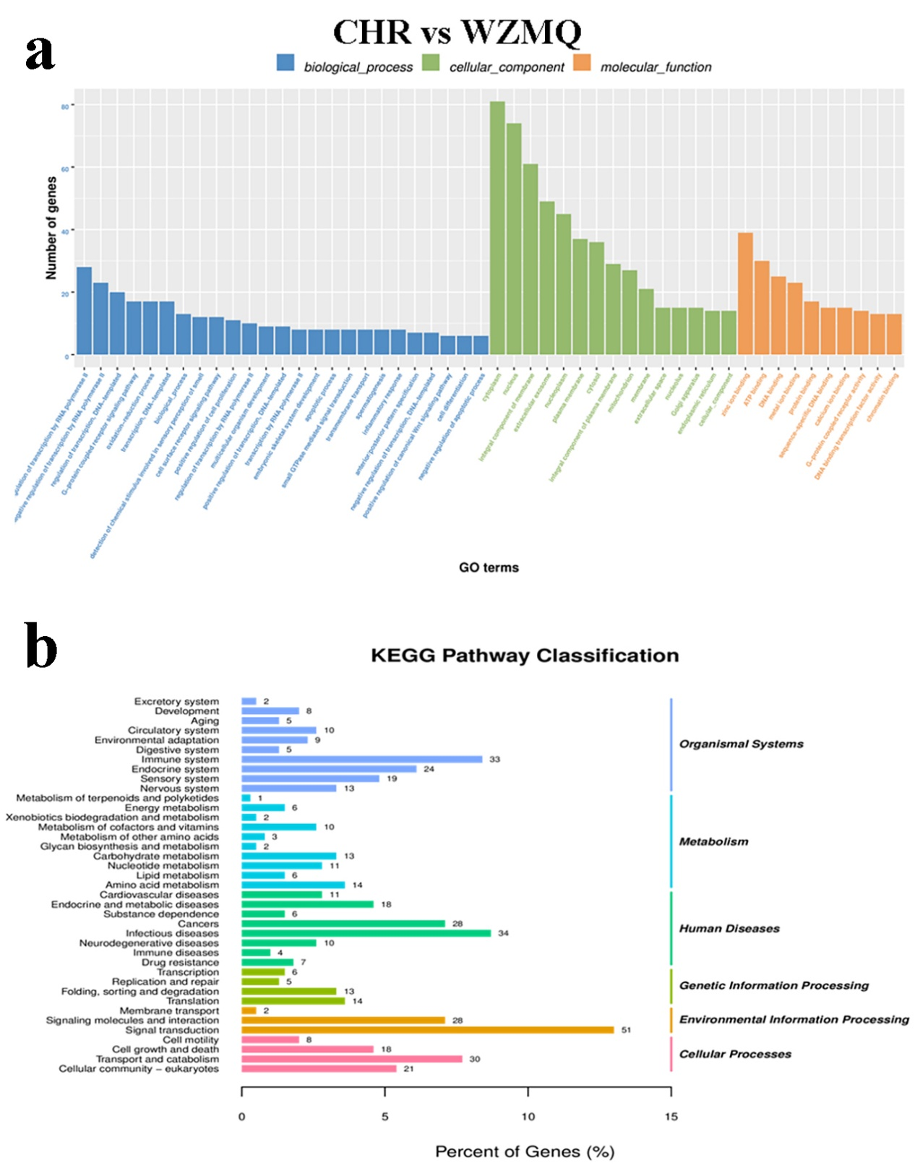
Figure S2. GO enrichment map and KEGG pathway map for CHR vs WZMQ. (a) GO enrichment map. (b) KEGG pathway map.

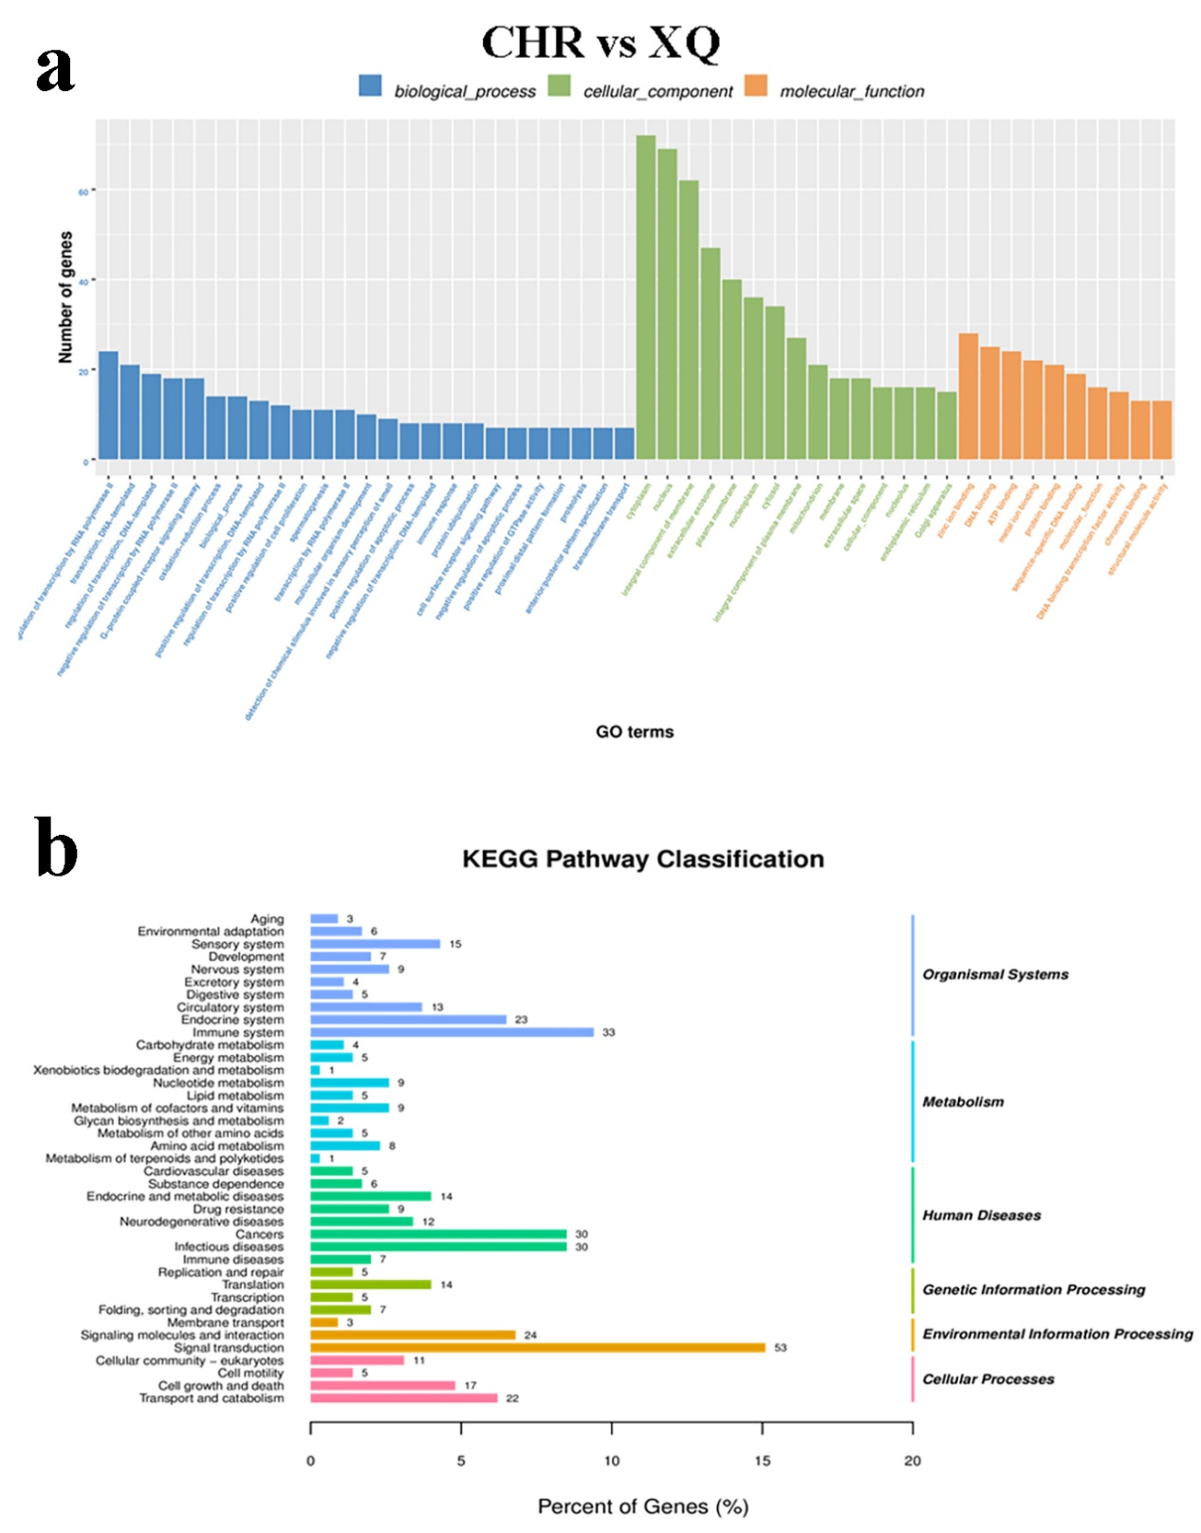
Figure S3. GO enrichment map and KEGG pathway map for CHR vs XQ. (a) GO enrichment map. (b) KEGG pathway map.

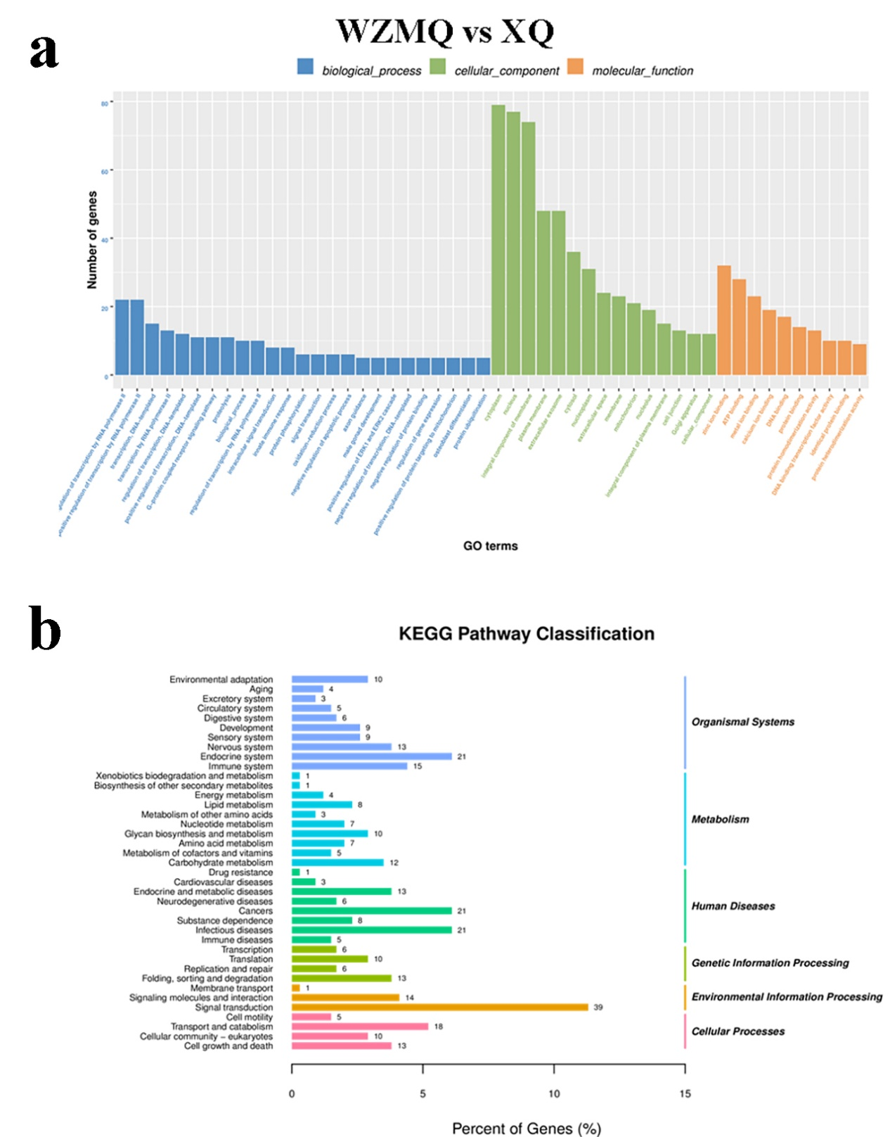
Figure S4. GO enrichment map and KEGG pathway map for WZMQ vs XQ. (a) GO enrichment map. (b) KEGG pathway map.

