Supplementary materials
Figure S1 (Figure 1d supplementary dots)
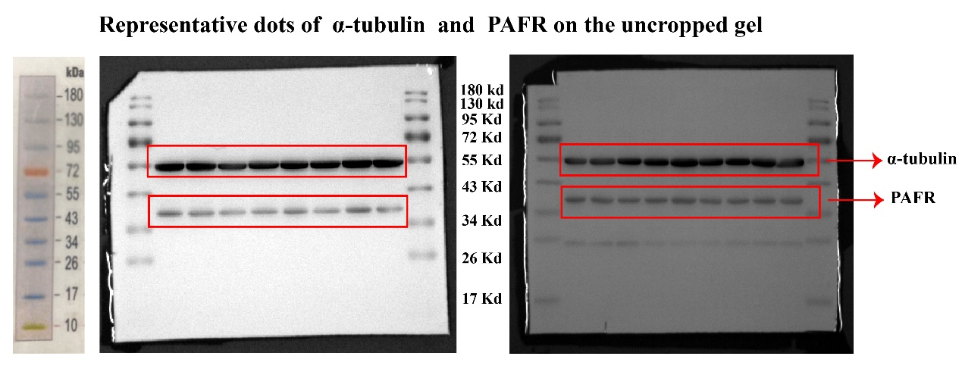

Figure S2 (Figure 4e supplementary dots)
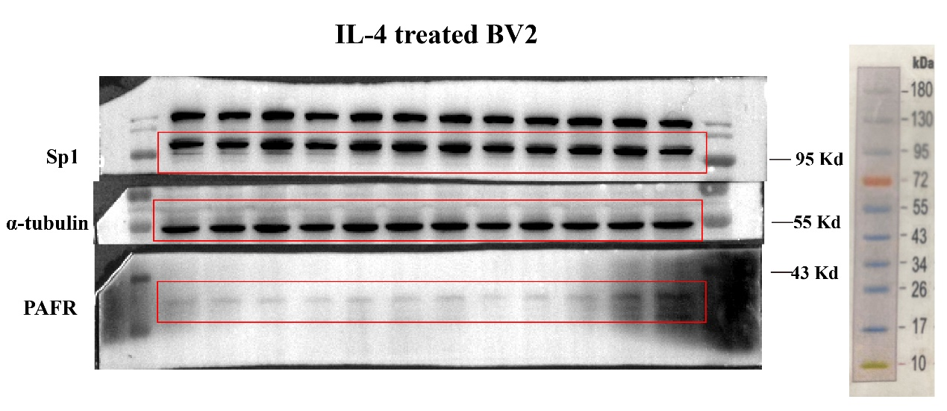

Figure S3 (Figure 5 supplementary dots)
Figure 5e (supplementary dots)
Figure 5f (supplementary dots)

Figure 5g (supplementary dots)

Figure 5h (supplementary dots)
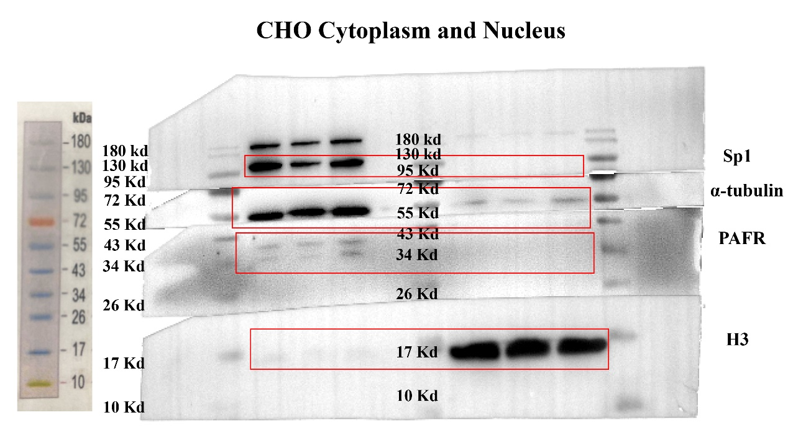

Figure 5i&5j (supplementary dots)

