SUPPLEMENTAL TABLE
Table S1. List of primer and siRNA sequences.
Gene | Forward 5'->3' | Reverse 5'->3' | Applications
p63 | GTCACGGAGGTGGTGAAGC | ACATACTGGGCATGGCTGTT | DNA-binding domain
ΔNp63 (ΔN) | GGAAAACAATGCCCAGACTC | GGACTGGTGGACGAGGAG | ΔNp63 transactivation domain
p63α | CACAGATTGCAGCATTGTCA | ATCGCATGTCGAAATTGCTC | SAM domain
TAp63 (TA) | AGTCCAGAGGTTTTCCAGCA | TTGTTTGTCGCACCATCTTC | TAp63 transactivation domain
p53 | GTCTGGGCTTCTTGCATTCT | CTCCGTCATGTGCTGTGACT | DNA damage response
BAX | CTGAGCAGATCATGAAGACAGG | ATCCTCTGCAGCTCCATGTT | DNA damage response
CDKN1A | CAGCAGAGGAAGACCATGTG | GGCGTTTGGAGTGGTAGAAA | DNA damage response
CDKN2A | CGGAAGGTCCCTCAGACATC | CCCTGTAGGACCTTCGGTGA | DNA damage response
GADD45A | ACGAGGACGACGACAGAGAT | GCAGGATCCTTCCATTGAGA | DNA damage response
NOXA | AAGAAGGCGCGCAAGAAC | TCCTGAGCAGAAGAGTTTGGA | DNA damage response
CK14 | GGCCTGCTGAGATCAAAGAC | CATACTTGGTGCGGAAGTCA | p63 upregulation marker
Fst | TCTGCCAGTTCATGGAGGAC | CCCGTTGAAAATCATCCACT | p63 upregulation marker
GPX-2 | TGATTGAGAATGTGGCTTCG | TTTTTGGACAAGGGTGAAGG | p63 upregulation marker
CYGB | AGAAAGTGCCAGGCGAGAT | TCCTCCATGTGCTTGAACTG | p63 upregulation marker
Oct3/4 | GACAGGGGGAGGGGAGGAGCTAGG | CTTCCCTCCAACCAGTTGCCCCAAAC | Yamanaka factor
Sox2 | GGGAAATGGGAGGGGTGCAAAAGAGG | TTGCGTGAGTGTGGATGGGATTGGTG | Yamanaka factor
c-Myc | GCGTCCTGGGAAGGGAGATCCGGAGC | TTGAGGGGCATCGTCGCGGGAGGCTG | Yamanaka factor
Klf4 | CCCACACAGGTGAGAAACCT | ATGTGTAAGGCGAGGTGGTC | Yamanaka factor
CD49f | ACGTGATCCGGAAATATGGA | CTCCCGTTCTGTTGGCTCT | Keratinocyto marker
CD71 | AAGGCCAATGTCACAAAACC | AAGTCCTCTCCTGGCTCCTC | Keratinocyto marker
BIRC5 | GGACCACCGCATCTCTACAT | TCTCCGCAGTTTCCTCAAAT
Ki67 | CGTCCCAGTGGAAGAGTTGT | ATATTGCCTCCTGCTCATGG
GAPDH-1 | GGTGAAGGTCGGAGTCAACG | AATTTGCCATGGGTGGAATC | Internal standard
GAPDH-2 | CGAGATCCCTCCAAAATCAA | TTCACACCCATGACGAACAT | Internal standard
siRNA sequence
siRNA ΔNp63 | GUGUGCUGGUACCUUAUGA-dTdT | UCAUAAGGUACCAGCACAC-dTdT | Target DNA-binding domain
ChIP-qPCR primer
Bax promoter | TAAAAATTAACCAGGGGCGG | TCACTGTGTTGCCCAGGCTG
CDKN1A promoter | CTGTGGCTCTGATTGGCTTT | CCCTTCCTCACCTGAAAACA

Table S2. List of primary and secondary antibodies.
Target antigen | Clone | Supplier | Conjugation | Catalog no. | Species | Experiment | Conc.
E-cadherin | polyclonal | abcam | unconjugated | Ab53033 | Rb | IF | 1:200
CK5 | polyclonal | abcam | unconjugated | ab53121 | Rb | IF | 1:200
CD49f | EPR18124 | abcam | unconjugated | ab181551 | Rb | IF | 1:200
p300 | EPR23495-268 | abcam | unconjugated | ab275378 | Rb | IF | 1:100
Acetyl-p53 | Lys382 | Cell Signaling Technology | unconjugated | 2525 | Rb | Wes | 1:1000
p53 | 7F5 | Cell Signaling Technology | unconjugated | 2527 | Rb | Wes, ChIP | 1:1000, 1:200
Bax | polyclonal | Cell Signaling Technology | unconjugated | 2772 | Rb | Wes | 1:1000
p21 | 12D1 | Cell Signaling Technology | unconjugated | 2947 | Rb | Wes, IF | 1:1000, 1:50
Cleaved Caspase-3 | Asp175 | Cell Signaling Technology | unconjugated | 9661 | Rb | FCM | 1:800
ΔNp63 | E6Q3O | Cell Signaling Technology | unconjugated | 67825 | Rb | Wes, IF | 1:1000, 1:1600
GPX2 | polyclonal | Novus biological | unconjugated | NBP3-03209 | Rb | Wes | 1:1000
SSEA4 | MC813 | abcam | unconjugated | ab16287 | Ms | IF | 1:200
ΔNp63(p40) | BC28 | abcam | unconjugated | ab172731 | Ms | IF | 1:50
CK14 | LL002 | invitrogen | unconjugated | MA5-11599 | Ms | Wes, IF | 1:200, 1:100
γH2AX | JBW301 | Merck | unconjugated | 05-636 | Ms | IF | 1:800
p63 | 4A4 | Millipore Sigma | unconjugated | MAB4135 | Ms | IF | 1:200
GPX2 | 496010 | R&D systems | unconjugated | MAB5470 | Ms | IF | 1:100
CYGB | 4C7E11 | proteintech | unconjugated | 60228-1-lg | Ms | Wes, IF | 1:500, 1:200
GAPDH | 1E6D9 | proteintech | HRP | HRP-60004 | Ms | Wes | 1:4000
p53 | DO-1 | Santa Cruz Biotechnology | unconjugated | sc-126 | Ms | Wes | 1:300
Secondary antibodies
Target antigen | Clone | Supplier | Conjugation | Catalog no. | Species | Experiment | Conc.
IgG |  | abcam | AF488 | ab150077 | Rb | FCM | 1:1000-2000
IgG |  | abcam | AF594 | ab150076 | Rb | IF | 1:200
IgG |  | ThermoFisher Scientific | AF488 | A11029 | Ms | IF | 1:200
IgG |  | SantaCruz Biotechnology | HRP | sc-2357 | Rb | Wes | 1:3000-5000
IgG |  | SantaCruz Biotechnology | HRP | sc-516102 | Ms | Wes | 1:3000-5000
Western blot: Wes, Flow Cytometry : FCM, Immunofluorescence: IF, Ms: Mouse, Rb: Rabbit

SUPPLEMENTAL FIGURES
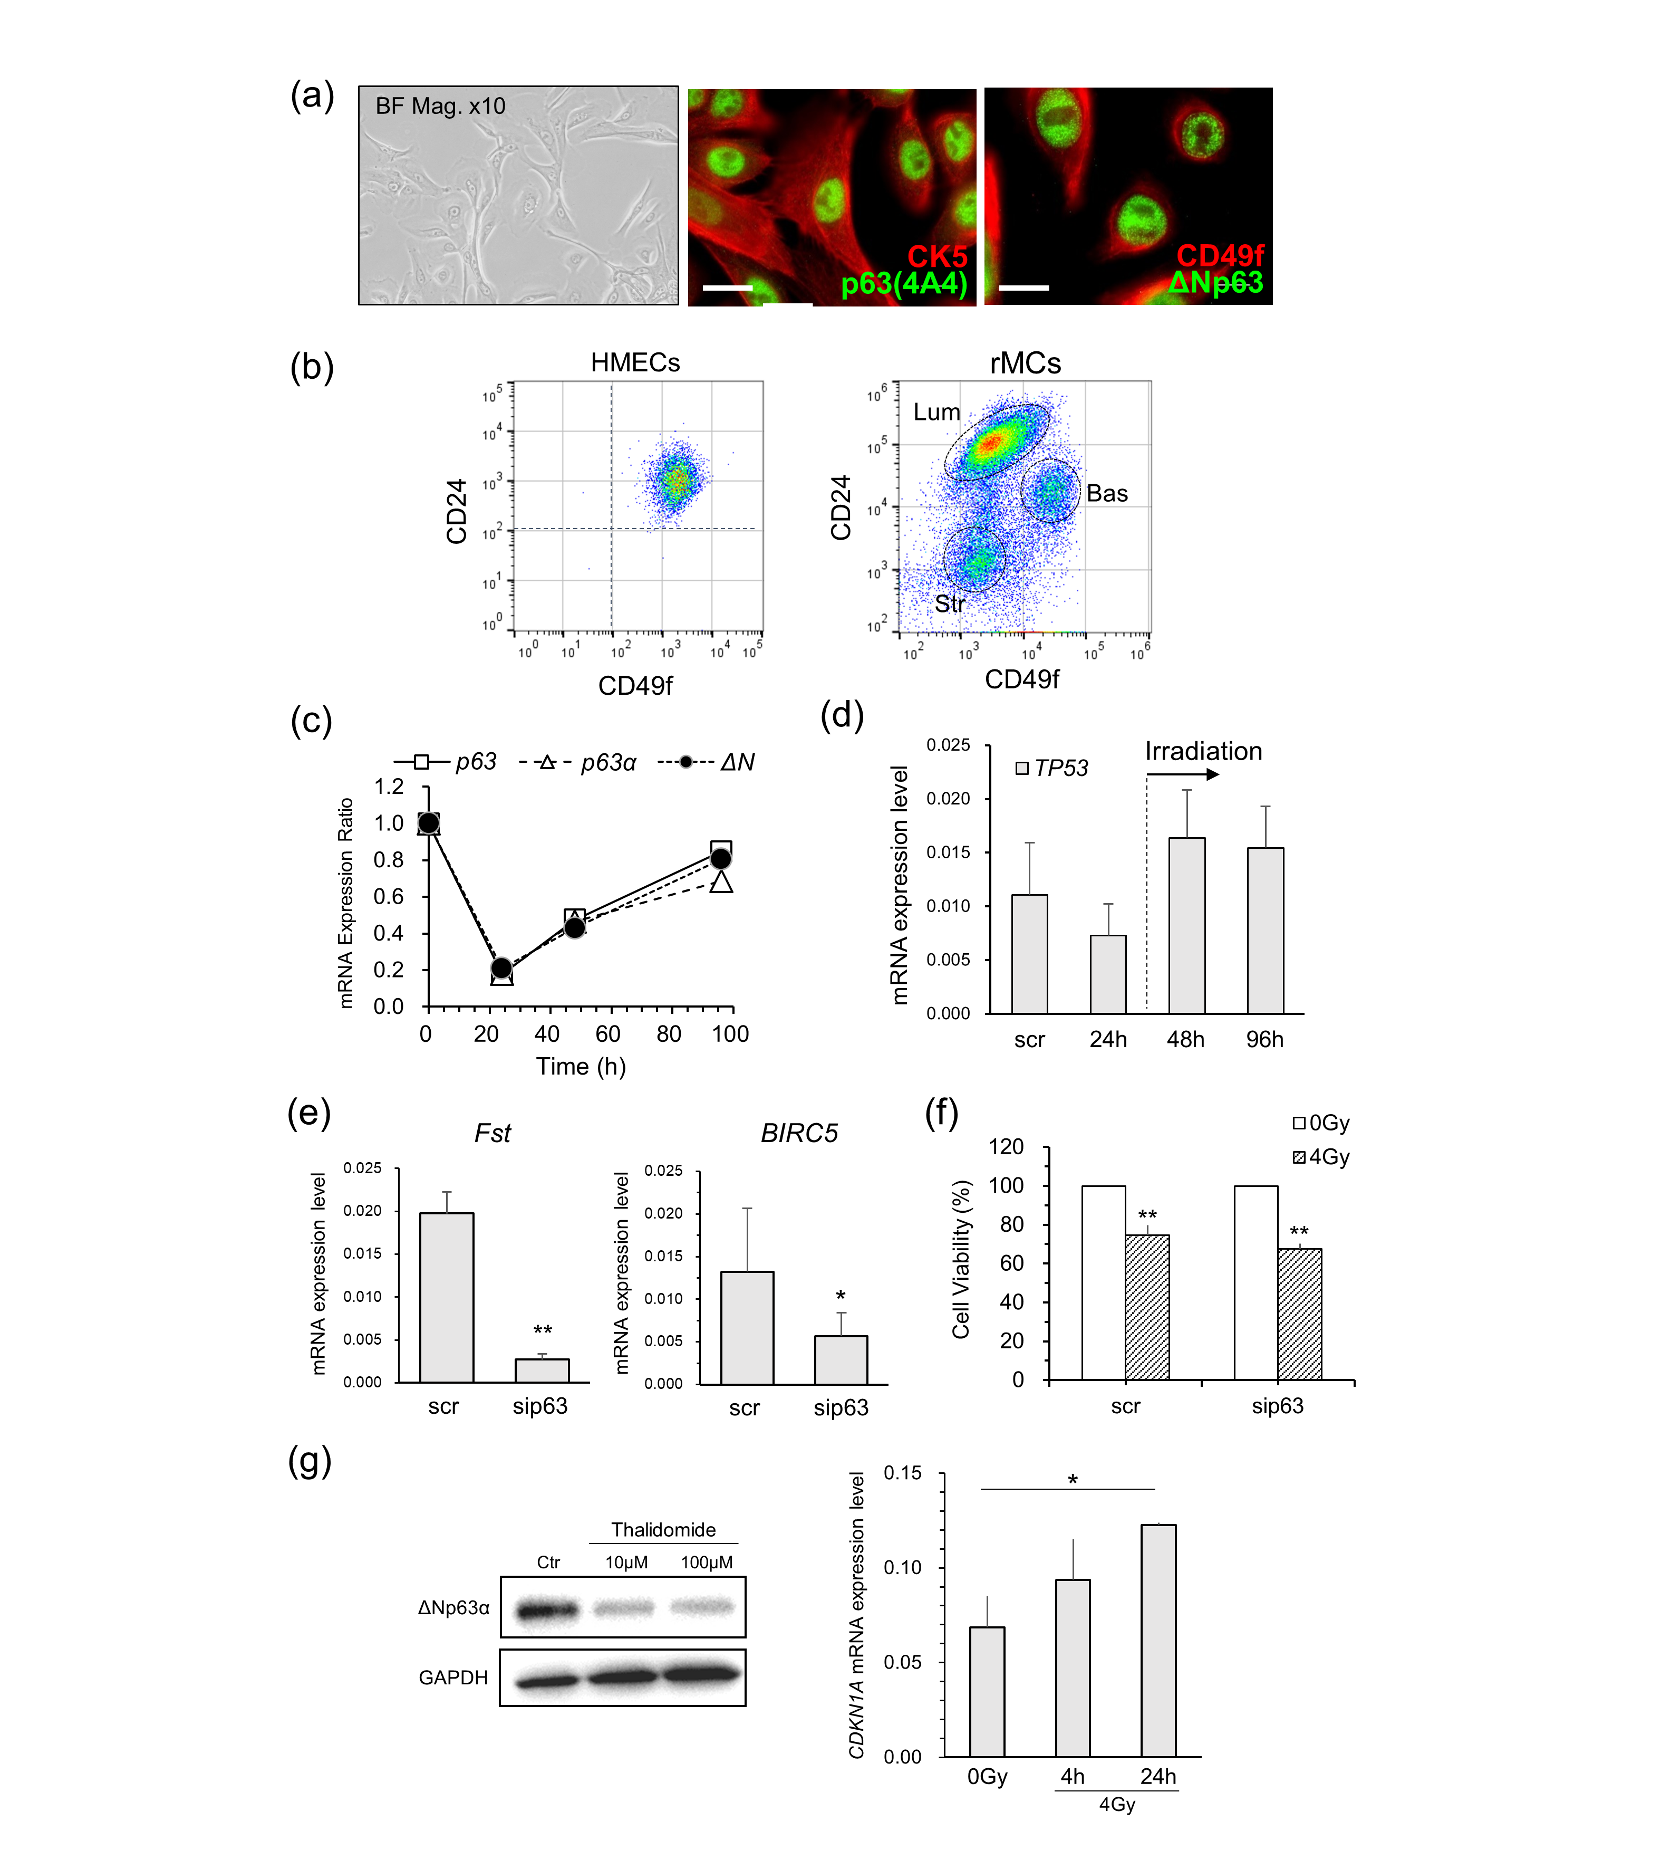
Fig.S1 (a) BF and IF images of HMECs. Anti-p63 (4A4) antibody detects all isoforms of p63. (b) FCM data of HMECs and primary rat mammary gland cells (rMCs), stained by CD49f and CD24 anitibodies, which are major markers of mammary epithelial cells. Lum, Bas, and Str described in figure represent luminal, basal, and stromal cells, respectively. (c) mRNA expression ratios of p63, p63α, and ΔN, shown in Fig.1a. Data were acquired by RT-qPCR in 0-96 h after siRNA treatment, which were normalized with scr-treated HMECs. (d) Time-dependent variation of TP53 mRNA level of HMECs during 96 h after siRNA treatment. (e) mRNA expression levels of Fst, Birc5, and Ki67 after siRNA treatment. Data are means and SE of at least three independent assays. (f) Cell viabilities of HMECs at 48 h post-irradiation, assessed by using 3-(4,5-dimethylthiazol-2-yl)-5-(3-carboxymethoxyphenyl)-2-(4-sulfophenyl)-2H-tetrazolium salt solution (MTS, Promega Inc., Madison, WI). (g) Left panel: Western blotting analysis of ΔNp63α protein expressing in HMECs at 24 h after thalidomide treatment. GAPDH was used as a loading control. Right panel: CDKN1A mRNA expression measured by RT-qPCR. All values in mRNA expression data were scaled to the expression level of GAPDH as an internal control. *P < 0.05, **P < 0.01 by Student’s t test.

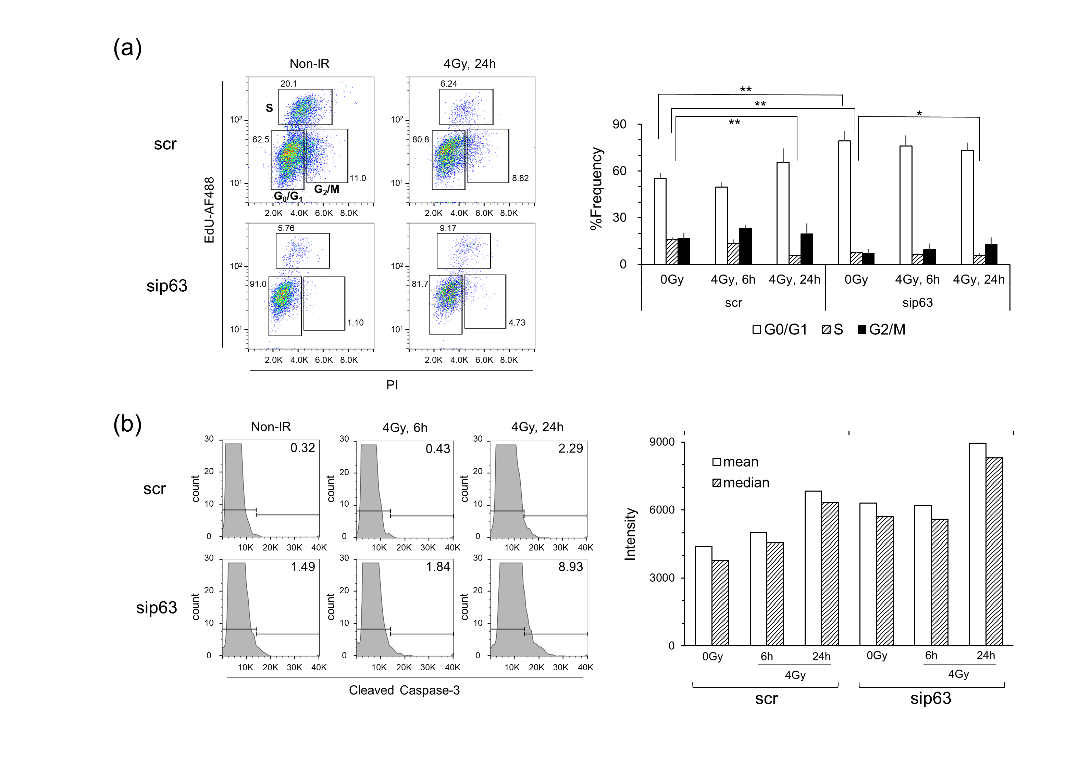
Fig.S2 (a) Representative cell cycle analysis of sip63-treated HMECs after X-irradiation. The left panel shows EdU versus Propidium Iodide (PI) staining plots, where each number in figures represents the frequency of G₀/G₁, S, and G₂/M phase, respectively. The right panel shows the histogram for each phase. Data represent the means and SEs of at least three independent assays. *P < 0.05, **P < 0.01 by Student’s t test. (b) The frequencies of CC3-positive apoptotic cells detected by FCM, and mean and median intensities.

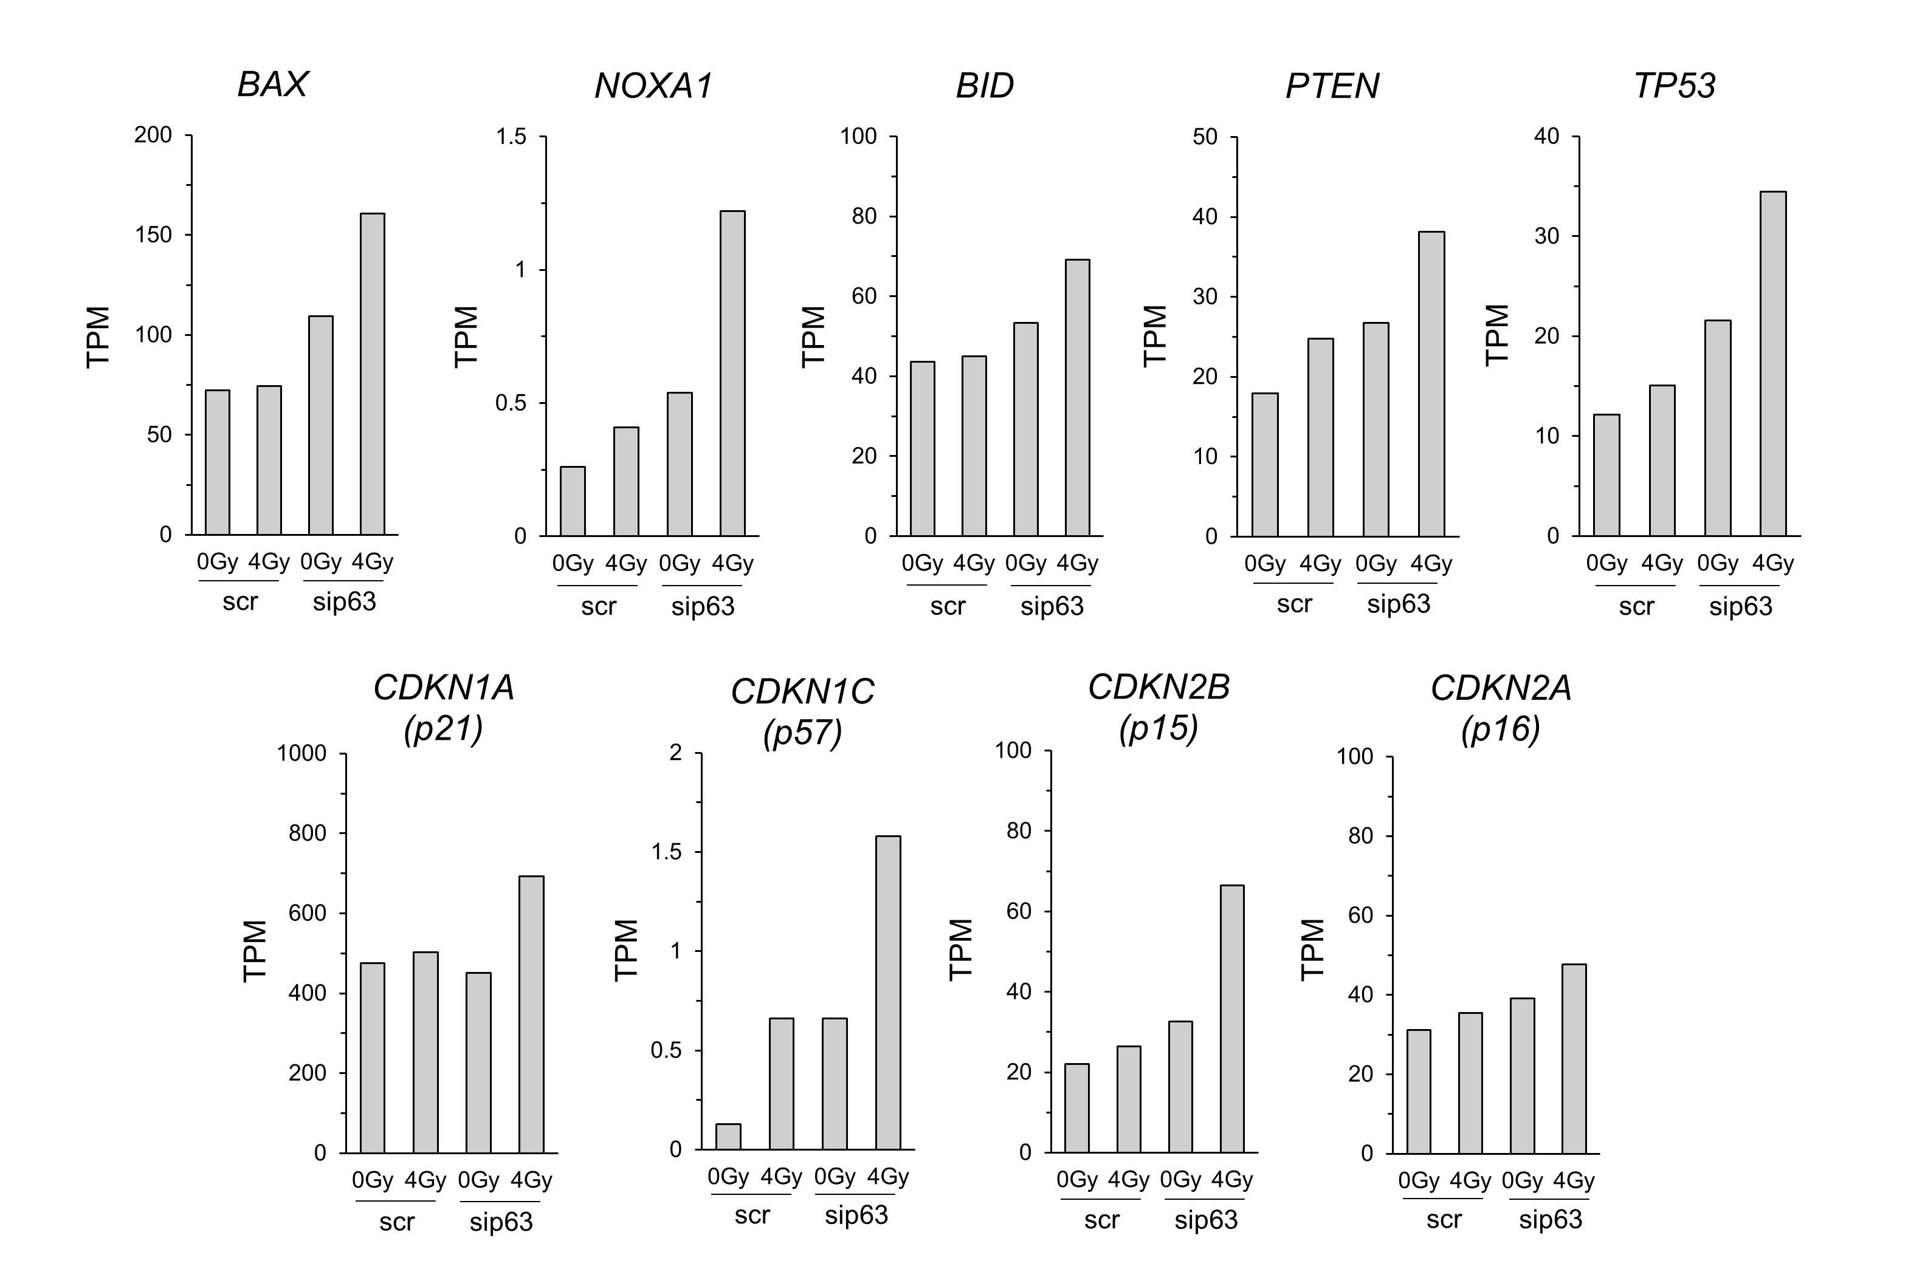
Fig.S3 Normalized expression levels of 10 genes shown as TPM (transcripts per million) from RNA-seq data, partly containing genes corresponding to Fig.1g.

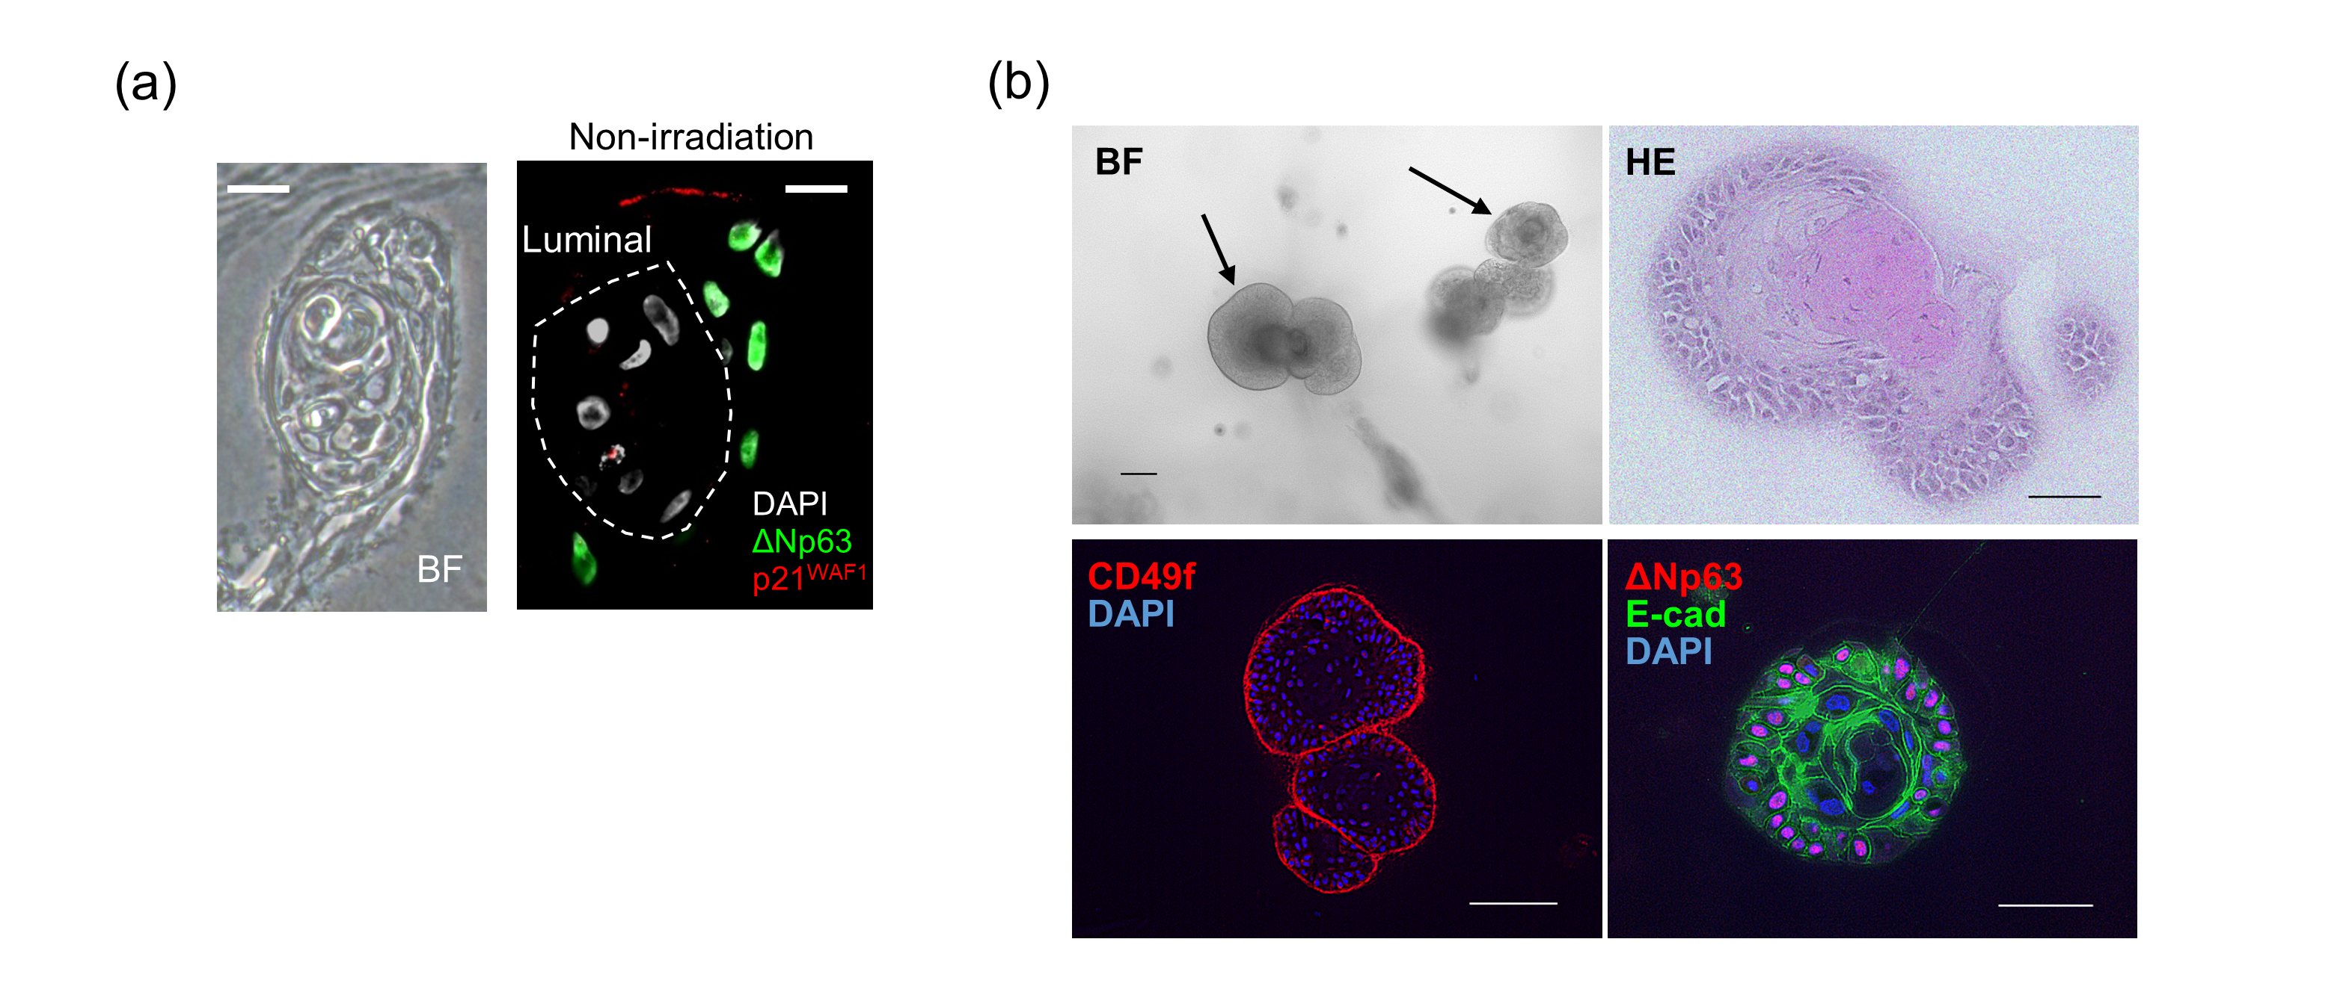
Fig.S4 (a) BF and IF images of mammary organoid generated from single HMEC. IF image shows non-irradiated condition. White, green, and red colors show DAPI, ΔNp63, and p21, respectively. Scale bar, 10μm. (b) BF and IF images of sphere-type colonies generated in collagen gels from single HMEC. E-cad shows anti-E-cadherin antibody. Scale bar, 100μm.
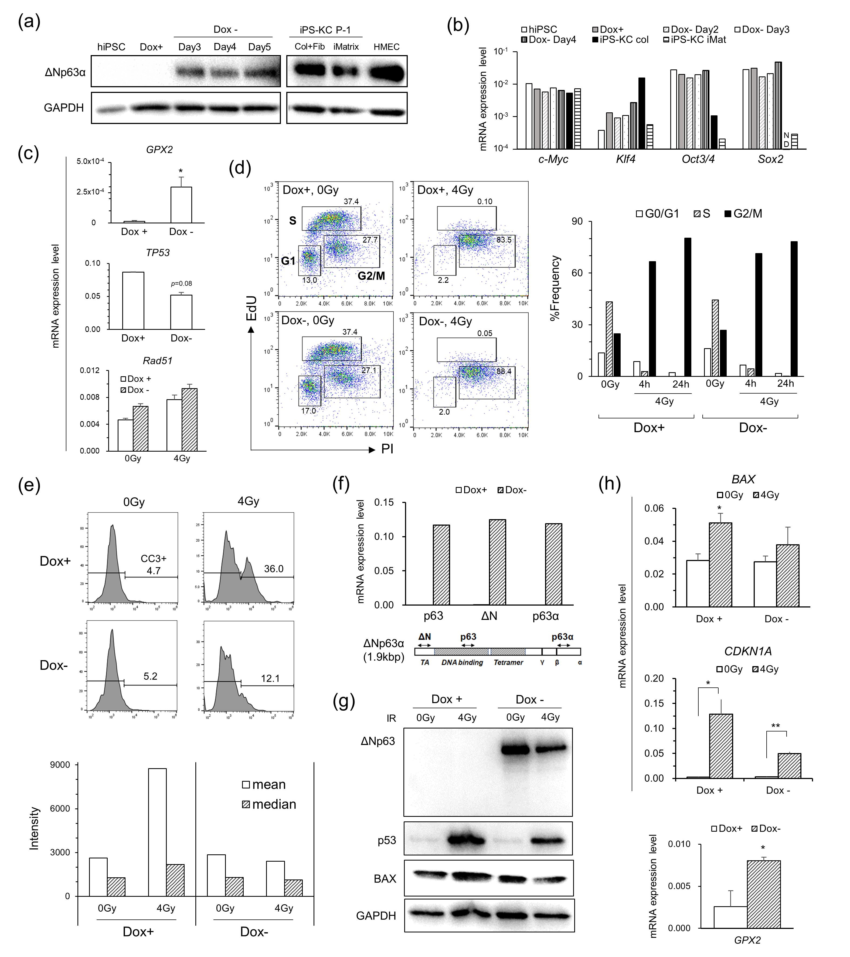
Fig.S5 (a) Detection of ΔNp63α protein expressing in iPS-DN and iPS-KC. GAPDH was used as a loading control. P-1: Passage 1, Col: collagen I coating, Fib: fibronectin coating. (b) iPS cell markers measured by RT-qPCR. All values were scaled to the expression level of GAPDH as an internal control. iMat: iMatrix-511 coating. (c) mRNA expression levels of GPX2, TP53, and Rad51 in iPS-DN with or without ΔNp63α expression, respectively. (d) Representative cell cycle phases in iPS-DN with or without ΔNp63α expression at 24 h after X-irradiation, which were detected by FCM. (e) Representative FCM data of iPS-DNs post-irradiation, showing the frequency of CC3-positive apoptotic cells (top panel) and the mean and median intensities (bottom panel). (f-h) Analytic results of human B cell-derived iPSCs ectopically expressing ΔNp63α. All data in figure were tested by Student’s t test (*P < 0.05, **P < 0.01).
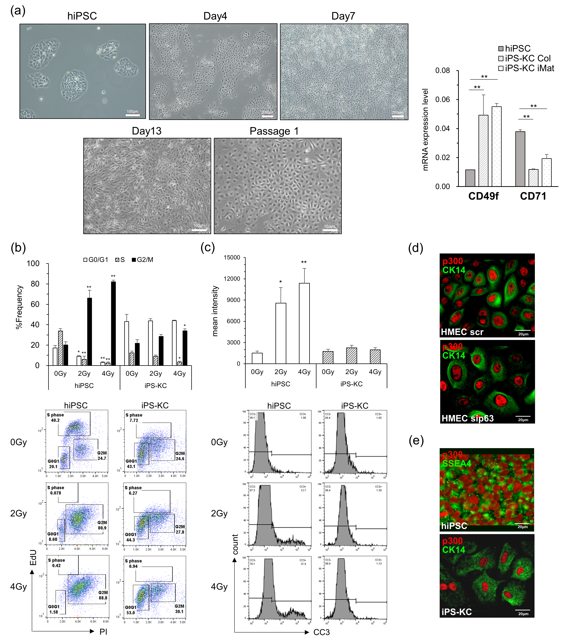
Fig.S6 (a) Left panel: Representative BF images of hiPSCs to iPS-KCs. The treatment of retinoic acid and bone morphogenetic protein 4 was done up to Day 4. Right panel: mRNA expression levels of CD49f and CD71 in hiPSCs and iPS-KCs Passage 1, measured by RT-qPCR. GAPDH was used as an internal control. (b) Top panel: the frequencies of each cell cycle phase in hiPSCs and iPS-KCs at 24 h after X-irradiation. Bottom panel: representative EdU/PI plot. (c) Top panel: the mean intensities of hiPSCs and iPS-KCs at 24 h post-irradiation. Bottom panel: representative FCM data post-irradiation. Data represent the means and SEs of at least three independent assays. *P < 0.05, **P < 0.01 by Student’s t test. (d,e) IF images of p300 protein expression in HMECs, hiPSCs, and iPS-KCs. CK14 and SSEA-4 were used as a cell marker.


Fig.S7 Overall view of protein assay shown in Fig. 1h. siRNA-treated HMECs were irradiated with 4 or 8 Gy of X-rays, and the proteins were extracted in bulk after a certain time, and then electrophoresed.

