Electronic supplementary information

Plant Cell Reports

Cre-mediated autoexision of selectable marker genes in soybean, cotton, canola and maize transgenic plants

Xudong Ye*, Zarir Vaghchhipawala, Edwards J. Williams†, Changlin Fu, Jinyuan Liu, Fengming Lu, Erin L. Hall, Shirley X. Guo, LaRee Frank, Larry A. Gilbertson

Bayer Crop Science, 700 Chesterfield Pkwy, St. Louis, MO 63017, USA

* Corresponding author:

Xudong Ye

ORCID 0000-0001-5104-6947

Email: xudong.ye@bayer.com

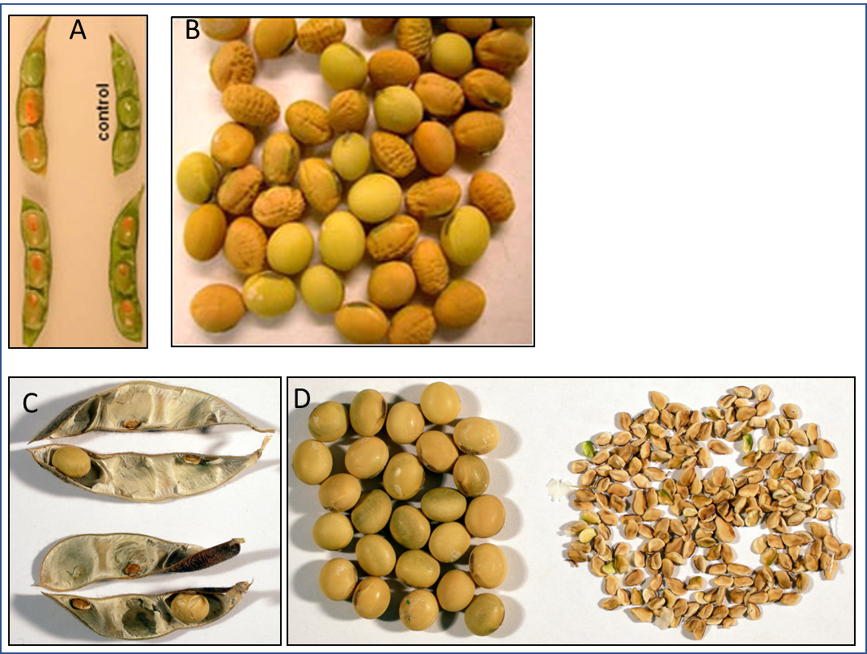
Fig. S1: Transgene phenotype as a seed marker in soybean (US Pat. No. US9540700B2). A: immature seeds expressing crtB (phytoene synthase) driven by a napin promoter; B: mature seeds expressing crtB driving by the napin promoter (orange); C: normal vs. aborted seeds in pods transformed with P-eUSP88-splA (sucrose phosphorylase); D) isolated normal seeds vs. aborted seeds with splA.

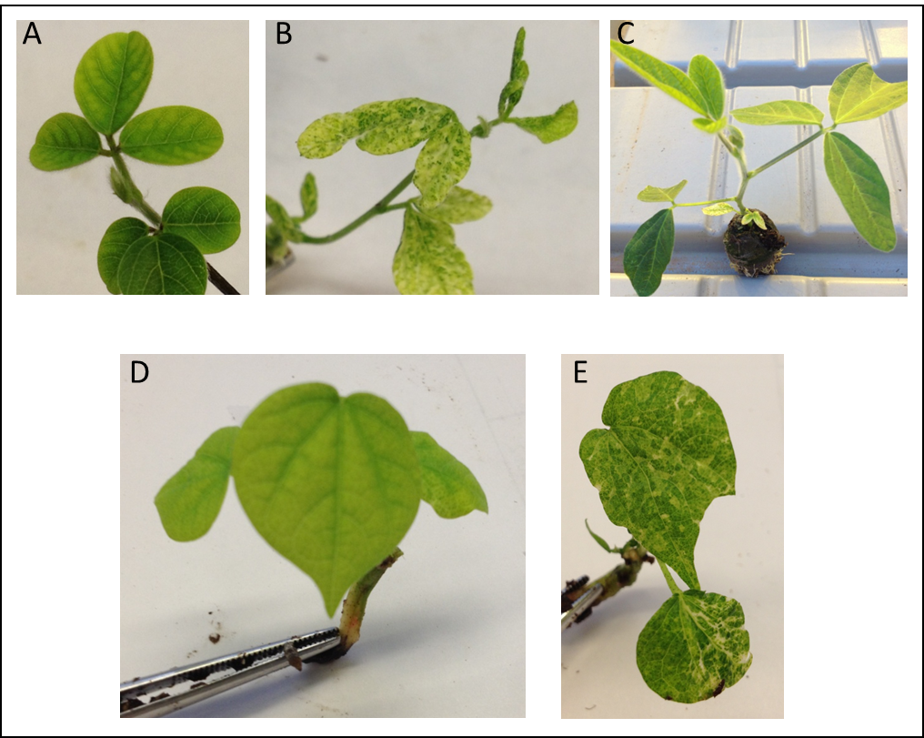
Fig. S2: Cre leaky expression in leaves from Arabidopsis CDC45 promoter causes marker gene premature excision and aberrant phenotype during spectinomycin selection. A: soybean normal leaf control; B: speckling soybean trifolia phenotype during shoot elongation under spectinomycin selection in tissue culture; C: the speckling soybean leaf phenotype was recovered in soil plug; D: cotton normal leaf control; E: speckling cotton leaf phenotype during shoot elongation under spectinomycin selection.

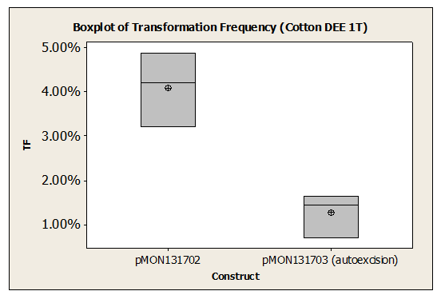
Fig. S3: P-At.CDC45-cre auto-excision construct (pMON131703) resulted in decreased cotton transformation frequency

Table S1: Summary of marker gene auto-excision in plants using recombinases
Cre expression | Species | Specific promoter or treatment | Excision efficiency | Reference
Inducible recombinase expression
Heat shock inducible | Maize | Soybean hsp17.5E, transgenic callus 42⁰C for 5 h, regenerate | NA | Zhang et al. 2003
Heat shock inducible | Tobacco | Soybean hsp, transgenic leaf 42⁰C for 2 h 3x, regenerate | Progeny, 30–80% | Wang et al. 2005
Heat shock inducible | Potato | hsp70, transgenic internode, 38⁰C various time, regenerate | Progeny, 4.7% | Cuellar et al. 2006
Heat shock inducible | Tobacco | Arabidopsis HSP81-1, plant 37⁰C for 16 h 2x | Leaves, >90% | Liu et al. 2005
Heat shock inducible | Arabidopsis | Arabidopsis HSP81-1, T2 seedlings 37⁰C for 16 h 2x | T3 seedlings, 20% | Roy et al. 2008
Heat shock inducible | Maize | Hsp17.7, Hsp26 promoters | T0 plants, 50-97% | Wang et al. 2020
Cold inducible | Barley | wcs120 promoter, germinating seeds 4 °C 3 days | Seed, 90-100% | Éva et al. 2018
Stress-inducible | Tobacco | FLP/FRT system, H2O2 inducible promoter | T0 plant, 13–41% | Woo et al. 2009
Salicylic acid-inducible | Tomato | salicylic acid induction, tobacco PR-1a promoter | T0, 41% | Ma et al. 2009
Chemical inducible | Arabidopsis | G10-90 promoter, induction by β-estradiol | Progeny, 29-66% | Zuo et al. 2001
Chemical inducible | Rice | G10-90 promoter, induction by β-estradiol for 2 weeks | Progeny, 30% | Sreekala et al. 2005
Chemical inducible | Tomato | G10-90 promoter, shoot induction by β-estradiol | Progeny, 15% | Zhang et al. 2006
Chemical inducible | apricot | G10-90 promoter, shoot induction by β-estradiol | T0 buds, 11.3% | Petri et al. 2012
Chemical inducible | Tobacco | G10-90 promoter, Transgenic leaf disks regenerated on -estradiol | 9.4% shoots | Garcia-Almodovar et al. 2014
Germline preferred recombinase expression
Seed-specific | Canola | Napin seed specific promoter | Progeny, 13~81% | Kopertekh et al. 2009
Seed-specific | Tobacco | Napin seed specific promoter | Progeny, ~90% | Kopertekh et al. 2010
Seed specific | Tobacco | Arabidopsis cruciferin C promoter | Progeny, 10.2% | Mlynarova et al. 2008
Germline specific | Arabidopsis | AP1 germline promoters | Progeny, 83–100% | Verweire et al. 2007
Germline specific | Arabidopsis | CLAVATA3 promoter | Progeny, 100% | Van Ex et al. 2009
Pollen-specific | Tobacco | BGP1, PAB5 promoters | Progeny, 100% | Luo et al. 2007
Microspore-specific | Tobacco | Tobacco NTM 19 pollen specific promoter | Hemizygous, >99% | Mlynarova et al. 2006
Embryo specific | Banana | Rice embryo-globulin REG-2 promoter | Progeny, 41.7 % | Chong-Pérez et al. 2013
Pollen- and embryo-specific | Tobacco | Arabidopsis DLL promoter | Progeny, 96.2% | Polóniová et al. 2015
Embryo-specific | Soybean | Arabidopsis app1 promoter | T0 plants, 30% | Li et al. 2007
Floral specific | Rice | OsMADS45 promoter | Progeny, 37/5% | Bai et al. 2008
Developmentally regulated | Maize | Ole, Glb1, End2, and Ltp2 promoters | T0 plants, 25–100% | Wang et al. 2020
Note: Other than specifically indicated, all references use Cre/lox recombination system.
Additional references:
Liu HK, Yang C, Wei ZM. (2005) Heat shock-regulated site-specific excision of extraneous DNA in transgenic plants. Plant Sci. 168:997-1003.
Mlynárová L, Conner AJ, Nap JP. (2006) Directed microspore-specific recombination of transgenic alleles to prevent pollen-mediated transmission of transgenes. Plant Biotechnol J. 4(4):445-52.
Moravcíková J, Vaculková E, Bauer M, Libantová J. (2008) Feasibility of the seed specific cruciferin C promoter in the self excision Cre/loxP strategy focused on generation of marker-free transgenic plants. Theor Appl Genet. 117(8):1325-34.
Roy SD, Saxena M, Bhomkar PS, Pooggin M, Hohn T, Bhalla-Sarin N. (2008) Generation of marker free salt tolerant transgenic plants of Arabidopsis thaliana using the gly I gene and cre gene under inducible promoters. Plant Cell Tiss Organ Cult. 95:1–11
Woo HJ, Cho HS, Lim SH, Shin KS, Lee SM, Lee KJ, Kim DH, Cho YG. (2009) Auto-excision of selectable marker genes from transgenic tobacco via a stress inducible FLP/FRT site-specific recombination system. Transgenic Res. 18(3):455-65.
Zhang Y, Li H, Ouyang B, Lu Y, Ye Z. (2006) Chemical-induced autoexcision of selectable markers in elite tomato plants transformed with a gene conferring resistance to lepidopteran insects. Biotechnol Lett. 28(16):1247-53.

Table S2: Impact of P-At.CDC45-cre-T-At.Cdc45 cassette on soybean transformation frequency
Expt group | Construct | Explants | TF
A1 | pMON131702 | 3352 | 4.77%
A2 | pMON131703 | 3419 | 2.90%
B1 | pMON131702 | 2682 | 7.38%
B2 | pMON131703 | 3486 | 2.21%
C1 | pMON131702 | 3449 | 3.48%
C2 | pMON131703 | 3484 | 2.04
Note: TF: transformation frequency. TF drastically drop in pMON131703 with the cre autoexcision cassette. Eighty single copy events were advanced, many of which missed LB detection.
Table S3: Analysis of marker excision in cotton plants transformed with pMON131703 (P-At.Cdc45-cre-T-At.Cdc45
Batch of screening | # of R0 events | Events with 1:3 segregation | Events with 1:15 segregation | Epidermal  /chimeric | Unexcised  R0 lines
1 | 16 | 5 | 2 | 7 | 2
2 | 24 | 11 | 3 | 7 | 3
3 | 24 | 11 | 8 | 2 | 3
4 | 27 | 14 | 4 | 5 | 4
Totals | 91 | 41 | 17 | 21 | 12
Note: Four batches of planting were performed for R1 seeds from 91 R0 events due to space limitation.

Table S4: Analysis of marker excision in canola plants transformed with pMON417179 (P-Gm.Rsp1-cre)
Canola pMON417179 R0 line | Analyzed R1 seeds | Hemizygous GOI+/aadA- | Homozygous GOI+/aadA-
BN_Gm.RSP-1 | 88 | 0 | 0
BN_Gm.RSP-2 | 88 | 0 | 0
BN_Gm.RSP-3 | 88 | 0 | 0
BN_Gm.RSP-4 | 88 | 8 | 5
BN_Gm.RSP-5 | 88 | 0 | 0
BN_Gm.RSP-6 | 88 | 0 | 0
BN_Gm.RSP-7 | 88 | 0 | 0
BN_Gm.RSP-8 | 88 | 0 | 0
BN_Gm.RSP-9 | 88 | 0 | 0
BN_Gm.RSP-10 | 88 | 0 | 0
BN_Gm.RSP-11 | 88 | 0 | 0
BN_Gm.RSP-12 | 88 | 0 | 0
Note: BN_Gm.RSP-Brassica napus plant transformed with the construct bearing cre driven by soybean RSP1 promoter. GOI+ gene of interest positive; aadA- aadA marker gene negative.

Table S5: Analysis of marker excision in canola plants transformed with pMON263567 (P-napin-cre-T-napin)
Canola pMON263567  R0 event | Analyzed R1 seeds | Total GUS+ MF R1 plant | Homozygous GUS+ MF R1 plants
BN_Bn.napin-1 | 88 | 0 | 0
BN_Bn.napin-2 | 88 | 0 | 0
BN_Bn.napin-3 | 88 | 0 | 0
BN_Bn.napin-4 | 88 | 0 | 0
BN_Bn.napin-5 | 88 | 0 | 0
BN_Bn.napin-6 | 88 | 0 | 0
BN_Bn.napin-7 | 88 | 0 | 0
BN_Bn.napin-8 | 88 | 0 | 0
BN_Bn.napin-9 | 88 | 0 | 0
Total | 792 | 0 | 0
Note: BN_Bn.napin-Brassica napus plant transformed with the construct bearing cre driven by napin promoter

Table S6: Screening marker-free corn plants in R1 seeds transformed with pMON243825 (P-At.CDC45-cre-T-nos)
R0 event | R1 total | Total GUS+ MF R1 plant | Homozygous GUS+ MF R1 plants
ZM_At.CDC45-1 | 39 | 8 | 1
ZM_At.CDC45-2 | 17 | 1 | 0
ZM_At.CDC45-3 | 3 | 0 | 0
ZM_At.CDC45-4 | 41 | 3 | 0
ZM_At.CDC45-5 | 36 | 8 | 2
ZM_At.CDC45-6 | 41 | 7 | 0
ZM_At.CDC45-7 | 41 | 8 | 2
ZM_At.CDC45-8 | 41 | 3 | 0
Total | 259 | 38 | 5
Note: ZM_At.CDC45-Zea mays plant transformed with the construct bearing cre driven by Arabidopsis CDC45 promoter

