Novel vitamin K3 analogous containing 3-N-substituted aromatic and piperazin rings with selective in vitro anticancer activity against HeLa, U87 MG, and MCF-7

Aesha FSH. Abdassalamª , Nahide Gulsah Denizª, Cigdem Sayilª*, Evren Onay-Ucar ^{b}, Elif Mertoglu^{b}, Nazli Arda^{b,c}

ªIstanbul University-Cerrahpasa, Engineering Faculty, Department of Chemistry, Division of Organic Chemistry, Avcilar, 34320, Istanbul, Turkey
^{b}Department of Molecular Biology and Genetics, Faculty of Science, Istanbul University, Turkey
^{c}Center for Research and Practice in Biotechnology and Genetic Engineering

ORCID of the authors
http://orcid.org/0000-0001-8910-4970 (Aesha F.SH. Abdassalam)
http://orcid.org/0000-0001-7977-7274 (Nahide Gulsah Deniz)
https://orcid.org/0000-0001-9611-3533 (Cigdem Sayil)
https://orcid.org/0000-0003-1152-4881 (Evren Onay-Ucar)
https://orcid.org/0000-0002-3606-4722 (Elif Mertoglu)
https://orcid.org/0000-0002-1043-5652 (Nazli Arda)
E-mail address of the corresponding author: sayil@iuc.edu.tr

Lists of figures: Page no
Figure S1 ¹H NMR spectrum of compound 3 3
Figure S2 ¹³C(APT) NMR spectrum of compound 3 3
Figure S3 Mass spectra [+ESI] of compound 3 4
Figure S4 FTIR spectrum of compound 3 4
Figure S5 ¹H NMR spectrum of compound 5 5
Figure S6 ¹³C(APT) NMR spectrum of compound 5 5
Figure S7 Mass spectra [+ESI] of compound 5 6
Figure S8 FTIR spectrum of compound 5 6
Figure S9 ¹H NMR spectrum of compound 7 7
Figure S10 ¹³C(APT) NMR spectrum of compound 7 7
Figure S11 Mass spectra [+ESI] of compound 7 8
Figure S12 FTIR spectrum of compound 7 8
Figure S13 ¹H NMR spectrum of compound 9 9
Figure S14 ¹³C(APT) NMR spectrum of compound 9 9
Figure S15 Mass spectra [+ESI] of compound 9 10
Figure S16 FTIR spectrum of compound 9 10
Figure S17 ¹H NMR spectrum of compound 11 11
Figure S18 ¹³C(APT) NMR spectrum of compound 11 11
Figure S19 Mass spectra [+ESI] of compound 11 12
Figure S20 FTIR spectrum of compound 11 12

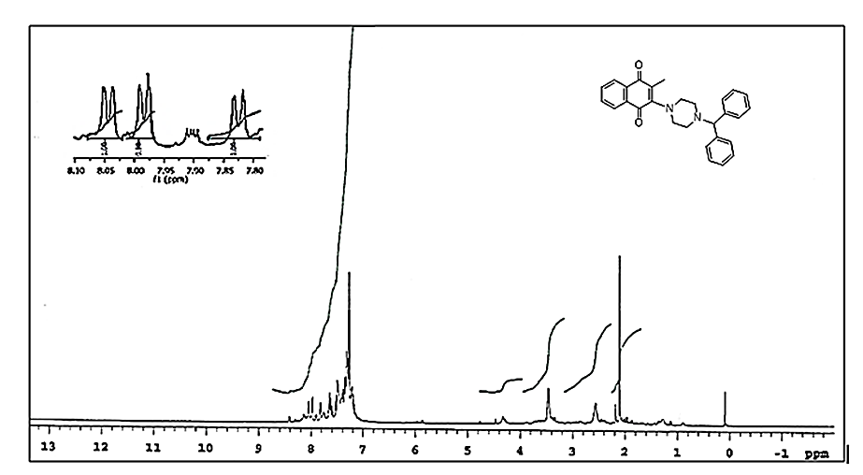
Figure S1: ¹H NMR (CDCl₃) spectrum of compound 3
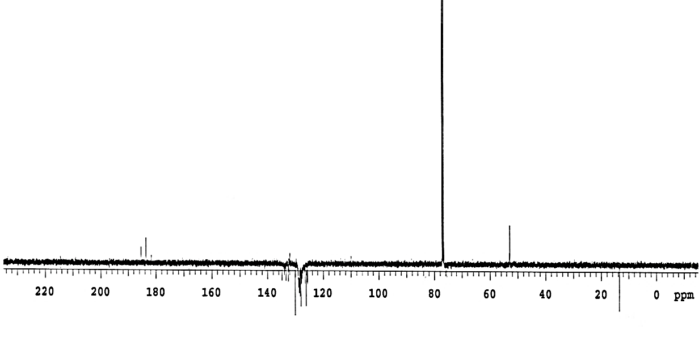
Figure S2: ¹³C (APT) NMR (CDCl₃) spectrum of compound 3.

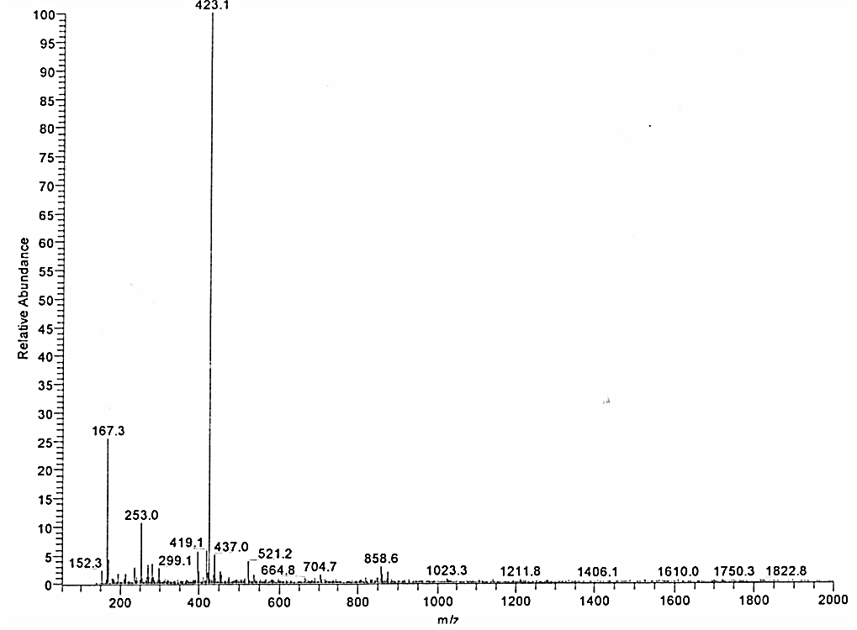
Figure S3: Mass spectrum [+ESI] of compound 3.
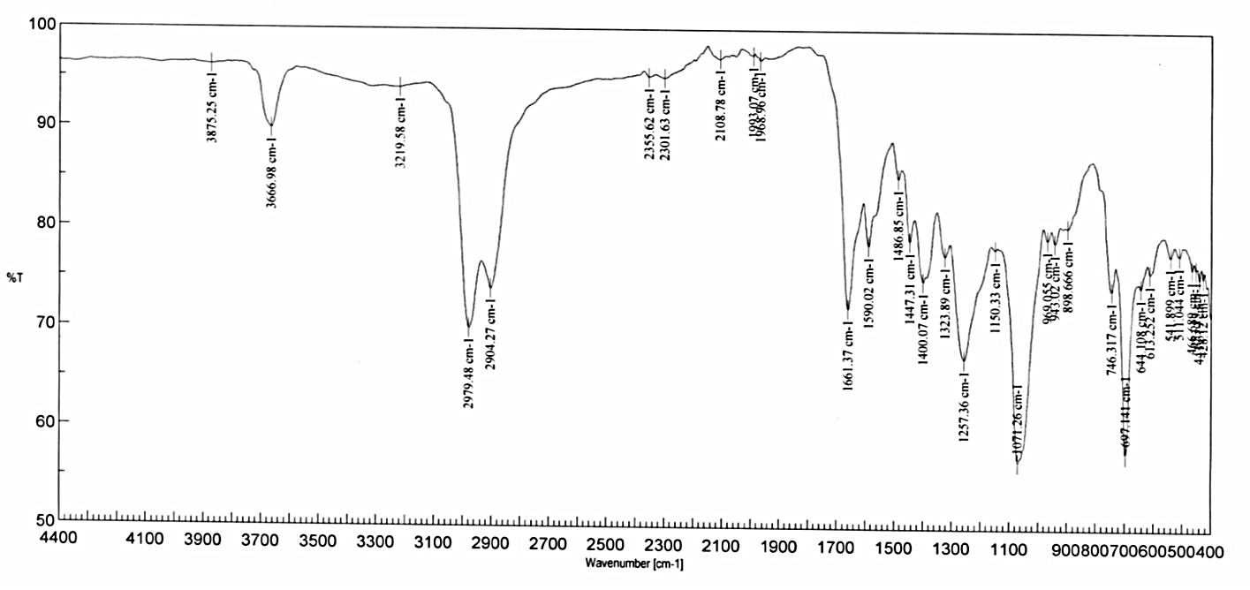
Figure S4: FTIR (KBr) spectrum of compound 3.
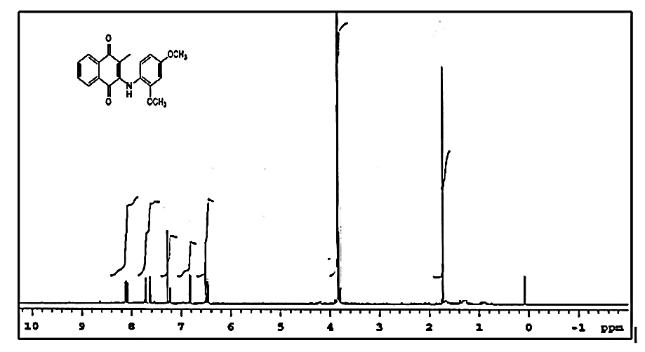
Figure S5: ¹H NMR (CDCl₃) spectrum of compound 5.

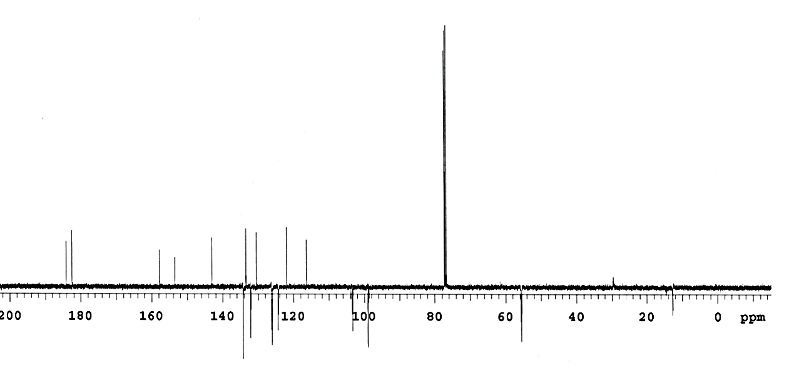
Figure S6: ¹³C (APT) NMR spectrum of compound 5.
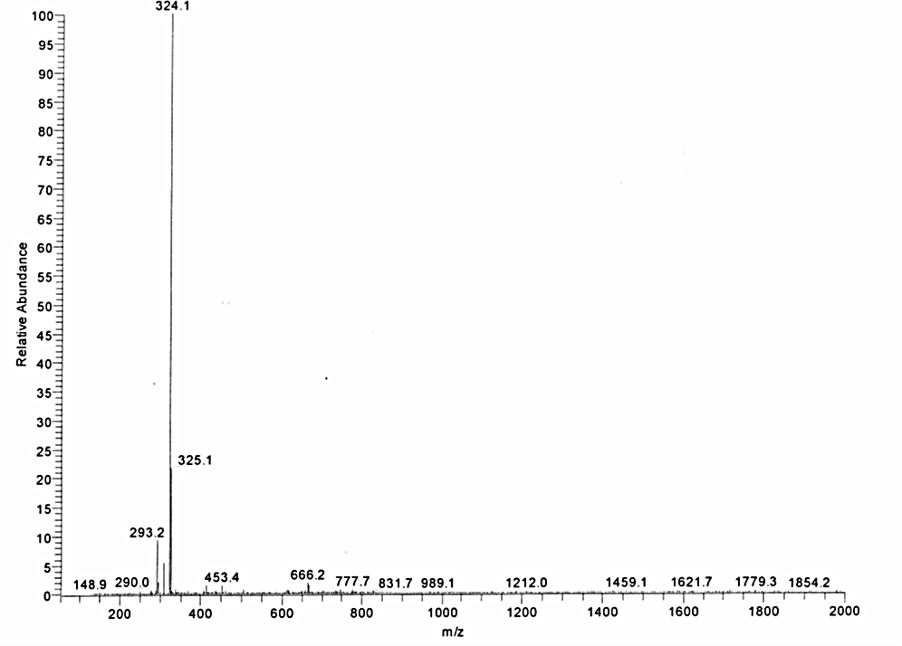
Figure S 7: Mass spectrum [+ESI] of compound 5.

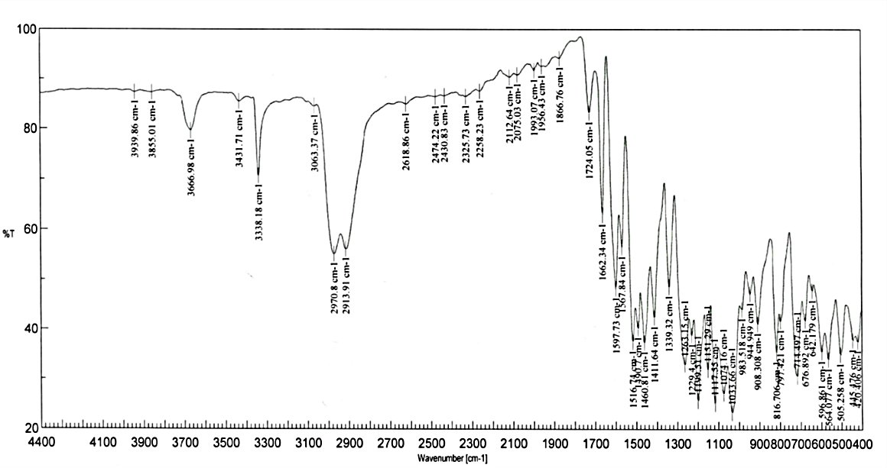
Figure S 8: FTIR (KBr) spectrum of compound 5.

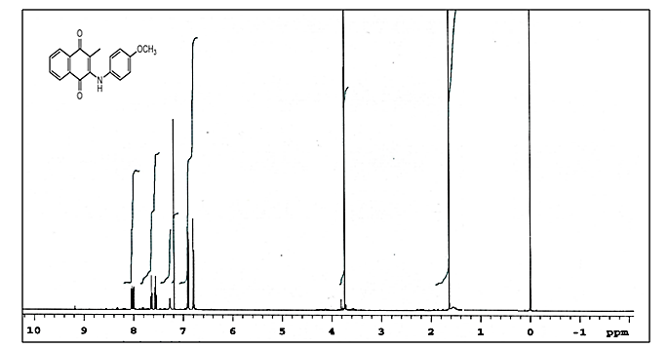
Figure S9 : ¹H NMR (CDCl₃) spectrum of compound 7.

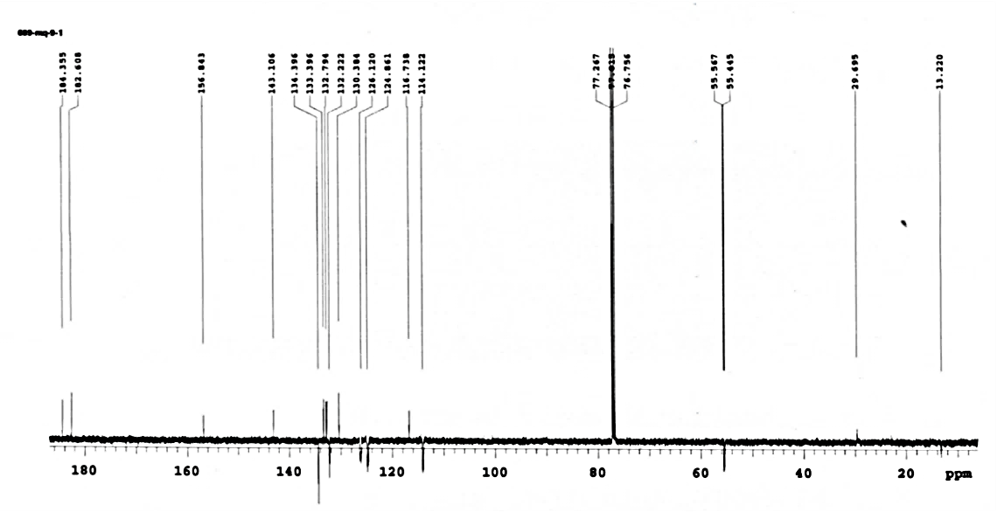
Figure S 10: ¹³C (APT) NMR (CDCl₃) spectrum of compound 7.

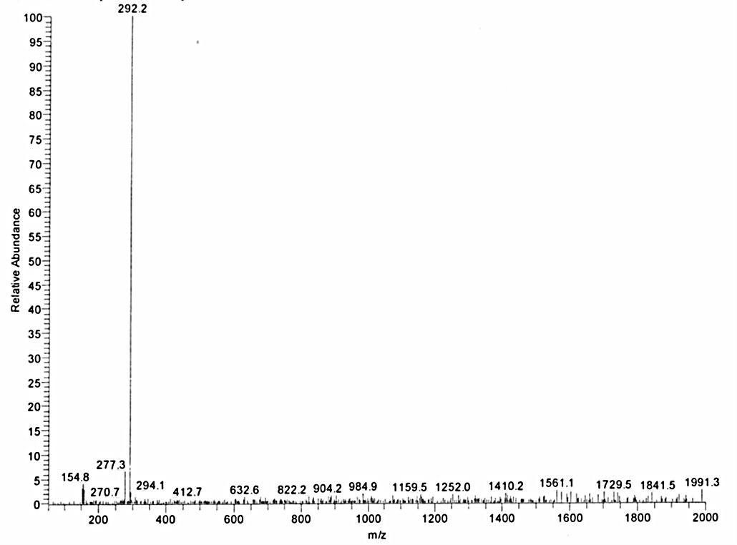
Figure S 11: Mass spectrum [+ESI] of compound 7.

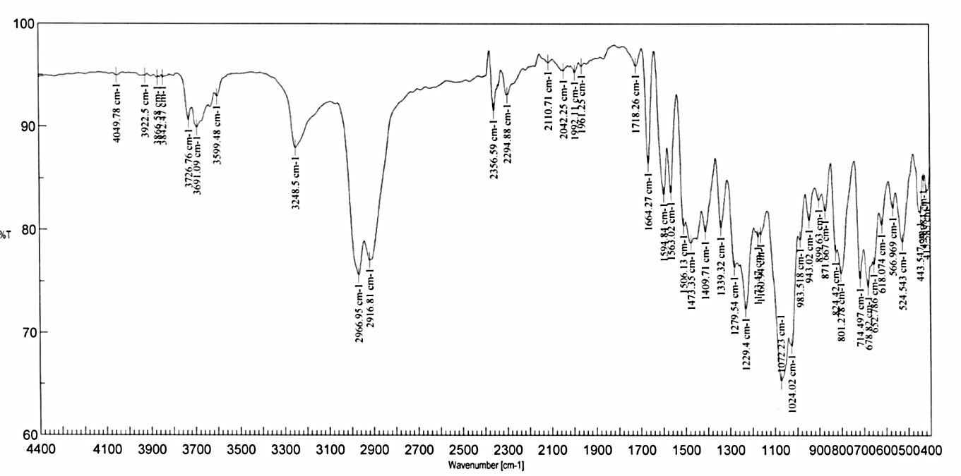
Figure S 12: FTIR (KBr) spectrum of compoun 7.

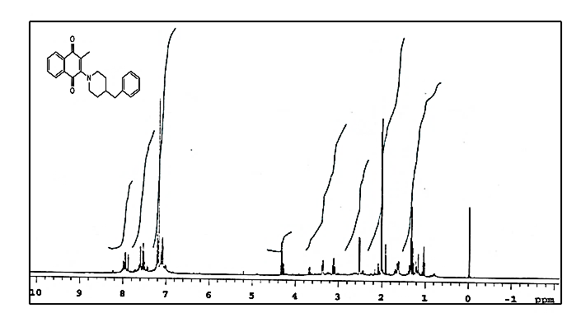
Figure S 13: ¹H NMR (CDCl₃) spectrum of compound 9.

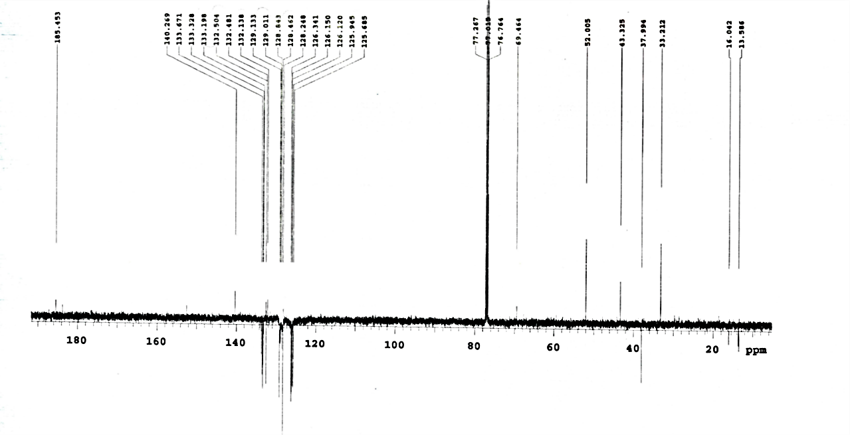
Figure S 14: ¹³C (APT) NMR (CDCl3) spectrum of compound 9.

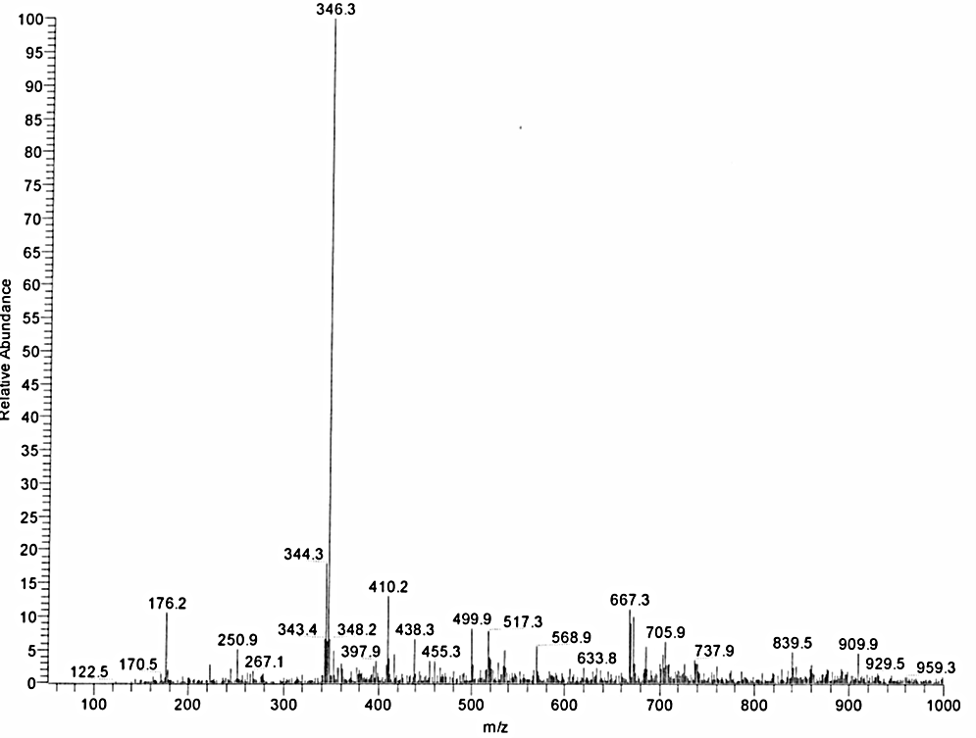
Figure S 15: Mass spectrum[+ESI] of compound 9.

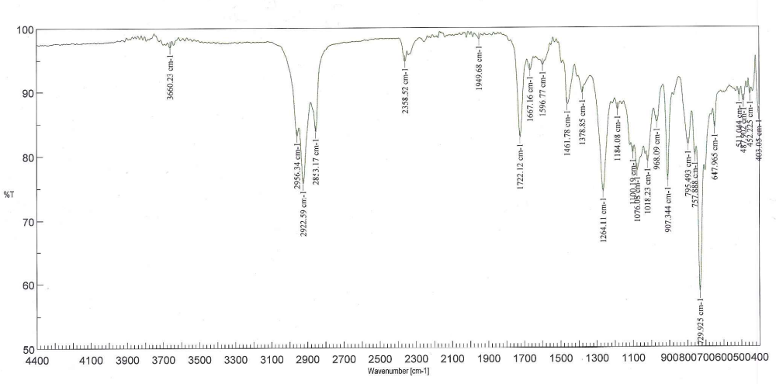
Figure S 16: FTIR (KBr) spectrum of compound 9.

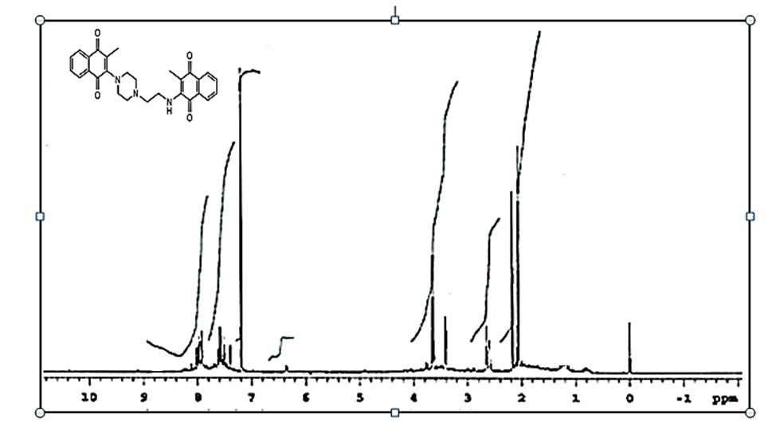
Figure S 17: ¹H NMR (CDCl₃) spectrum of compound 11.

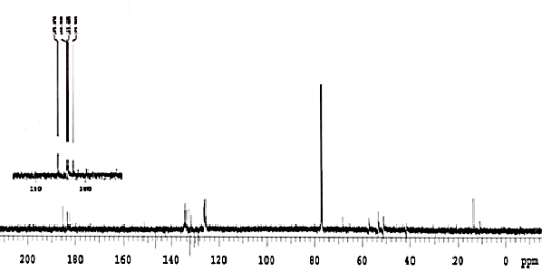
Figure S 18: ¹³C (APT) NMR (CDCl₃) spectrum of compound 11.

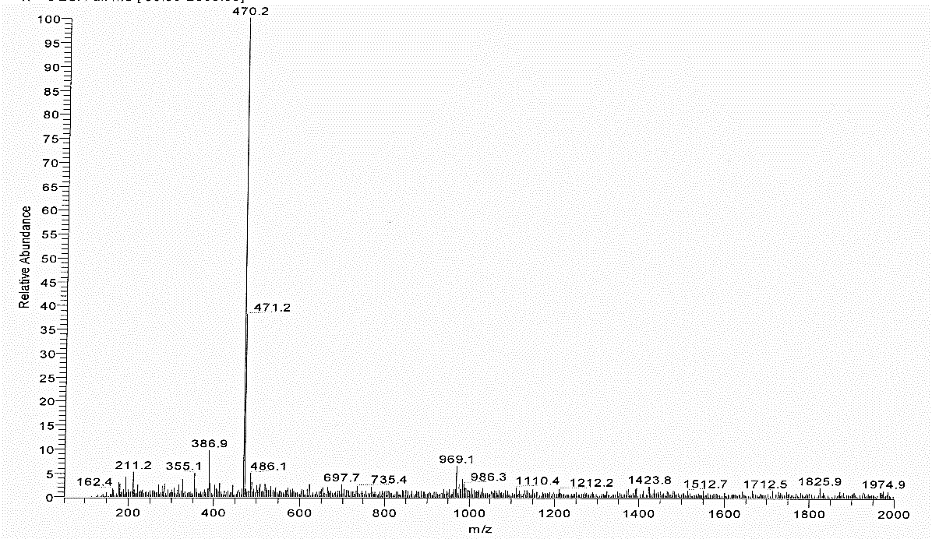
Figure S 19: Mass spectrum [+ESI] of compound 11.

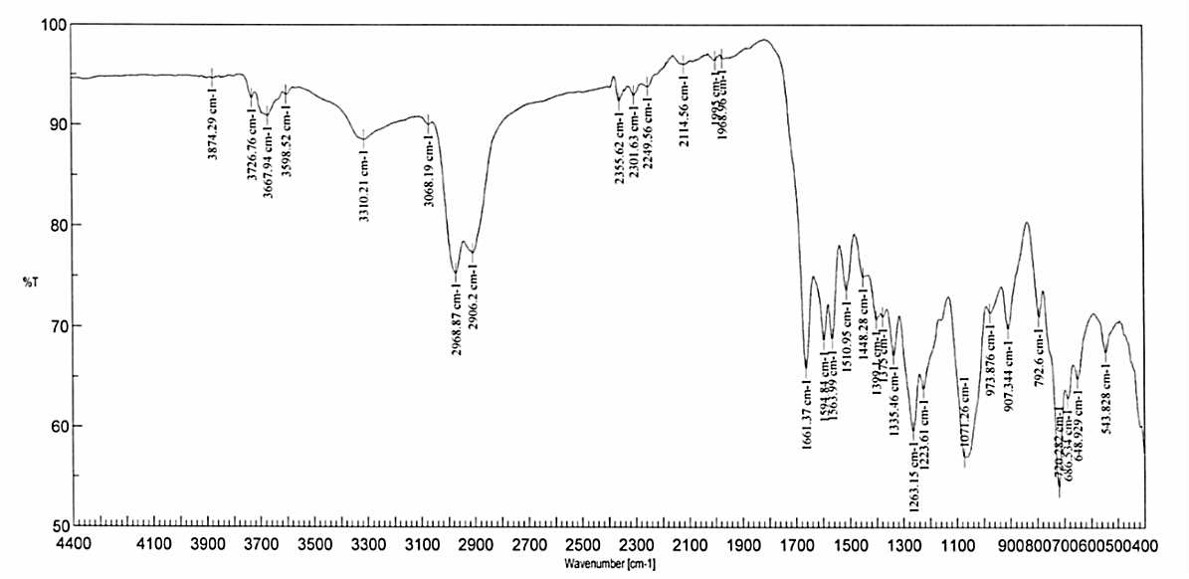
Figure S 20: FTIR (KBr) spectrum of compound 11.

