Enhanced fear limits behavioral flexibility in a mouse model of autism spectrum disorder

Supplement

Table S1. The numbers of subjects used in each experiment. For those mice tested in reversal learning (Tasks 1–3), the number in each parenthesis indicates the number of mice tested in eye close responses before being test in reversal learning. For those mice tested in eye closure response, the number in each parenthesis indicates the number of mice that were later tested in reversal learning.

 | Adult male WT | Adult male KO | Adult female WT | Adult female KO | Juvenile male WT | Juvenile Male KO
Task 1 | 10 | 10(1) | 12(11) | 10(3) | 10 | 11
Task 2 | 10 | 10 |  |  | 10 | 11
Task 3 | 10(8) | 10(4)
Eye response | 12(8) | 10(5) | 11(11) | 10(3)
Rescue | 11 | 10
Total | 45 | 45 | 12 | 17 | 20 | 22

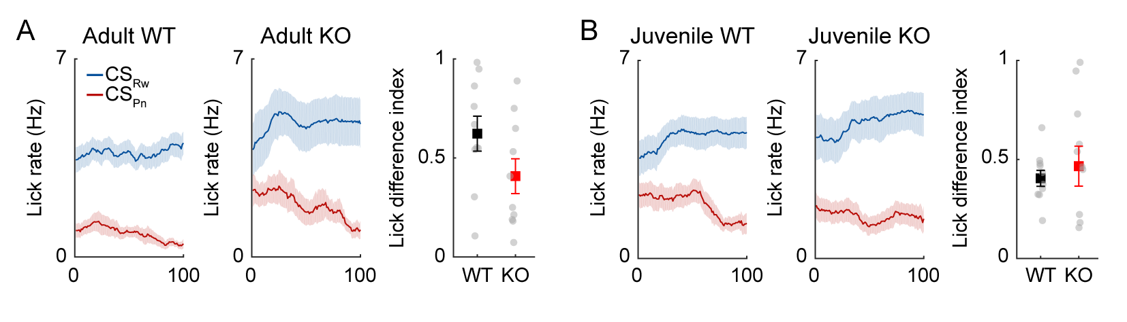
Supplementary figure 1. Anticipatory licking behavior is similar between adult and juvenile male mice before reversal onset. Shown are anticipatory lick rate profiles (mean+SEM across mice) of adult and juvenile male WT and Shank2-KO mice during the first 100 trials before reversal onset (left and middle) and the 100-trial averages (right; circles, individual animal data; square and error bar, mean+SEM across mice) in the first reversal session. Two-way ANOVA of anticipatory lick rates revealed no significant age or genotype effect (main effect of age, F_{(1,37)} = 0.907, p = 0.347; main effect of genotype, F_{(1,37)} = 0.835, p = 0.367; age×genotype interaction, F_{(1,37)} = 2.707; p = 0.108). Two-way ANOVA of the number of trials needed to reach the reversal criterion revealed no significant age or genotype effect, either (main effect of age, F_{(1,37)} = 1.811, p = 0.187; main effect of genotype, F_{(1,37)} = 1.572, p = 0.218; age×genotype interaction, F_{(1,37)} = 0.070; p = 0.793). These results indicate that juvenile WT and Shank2-KO mice, like adult mice, were well trained in the task before reversal onset.

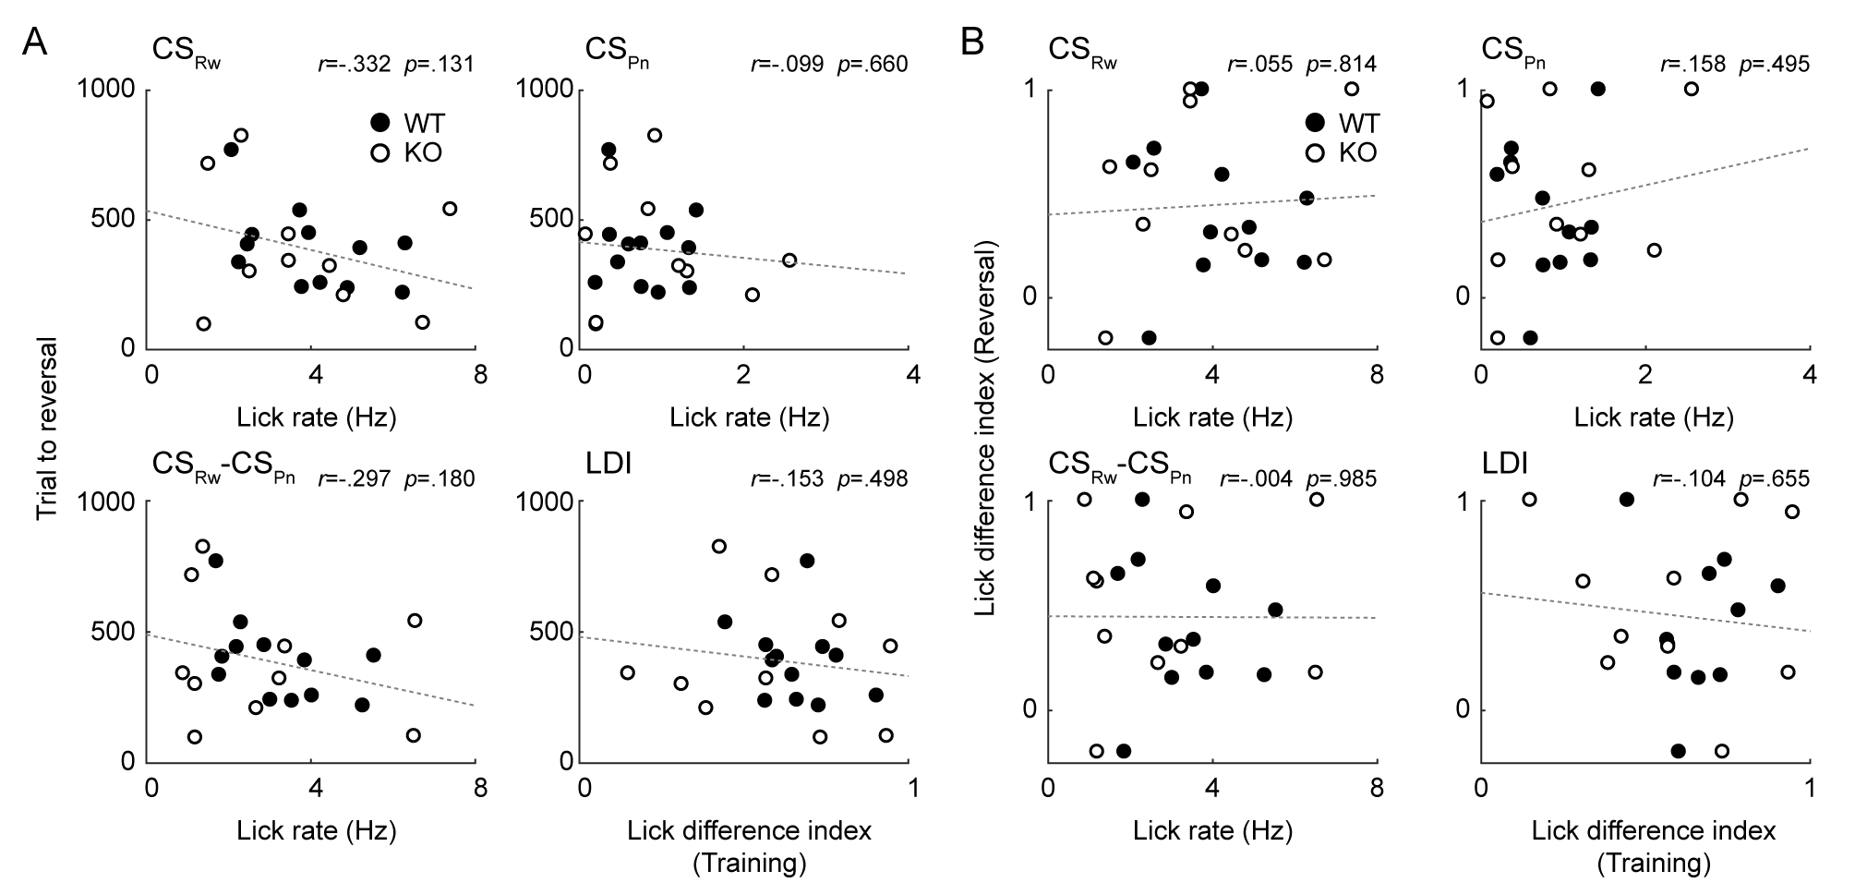
Supplementary figure 2. No significant relationship between reversal performance and acquisition performance in female mice. Results of adult female WT (n = 12) and Shank2-KO (n = 10) mice in Task 1 reversal learning. The results are presented as described for Fig. 3H, I.

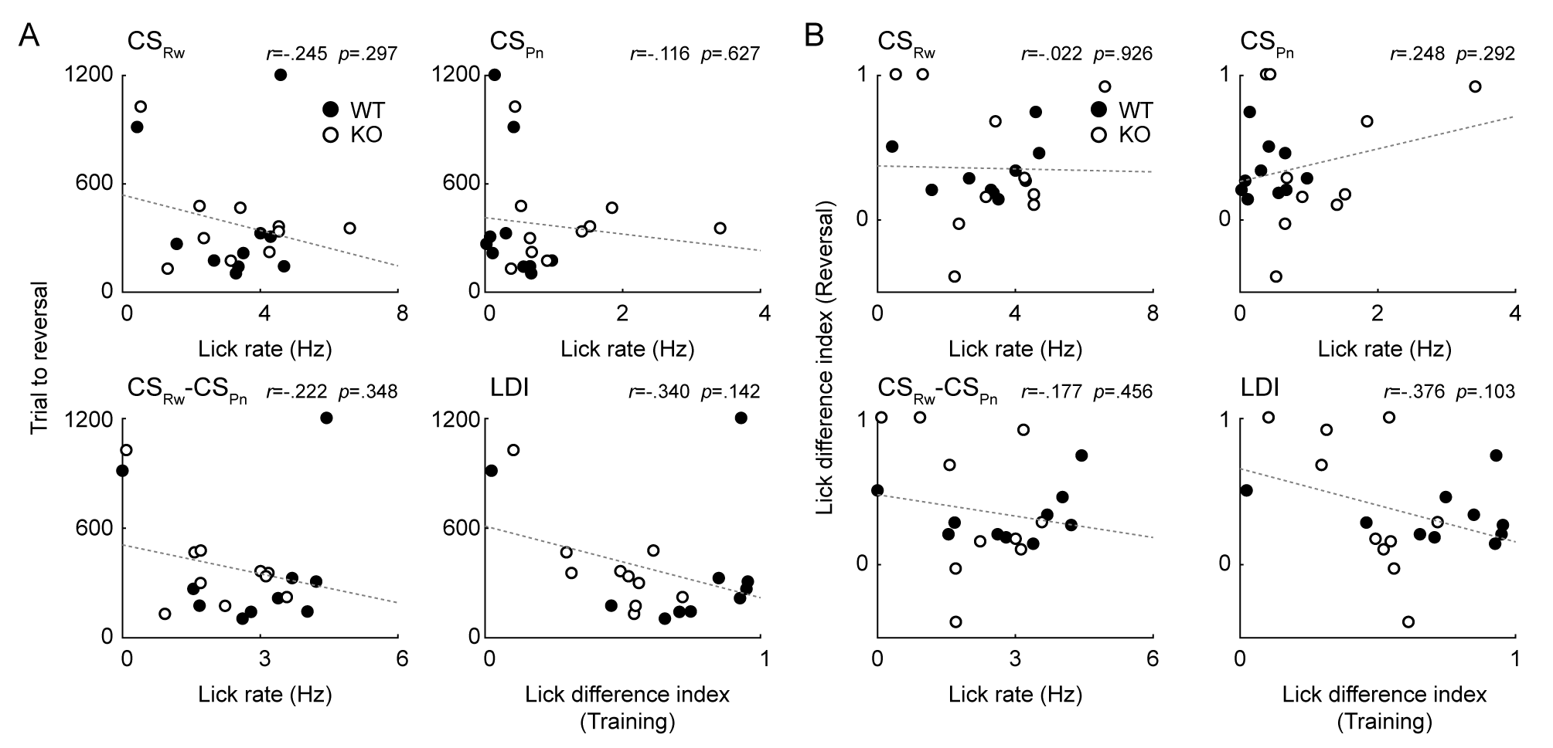
Supplementary figure 3. No significant relationship between reversal performance and acquisition performance in Task 2 reversal learning. Results of adult male WT (n = 10) and Shank2-KO (n = 10) mice. The results are presented as described for Fig. 3H, I.
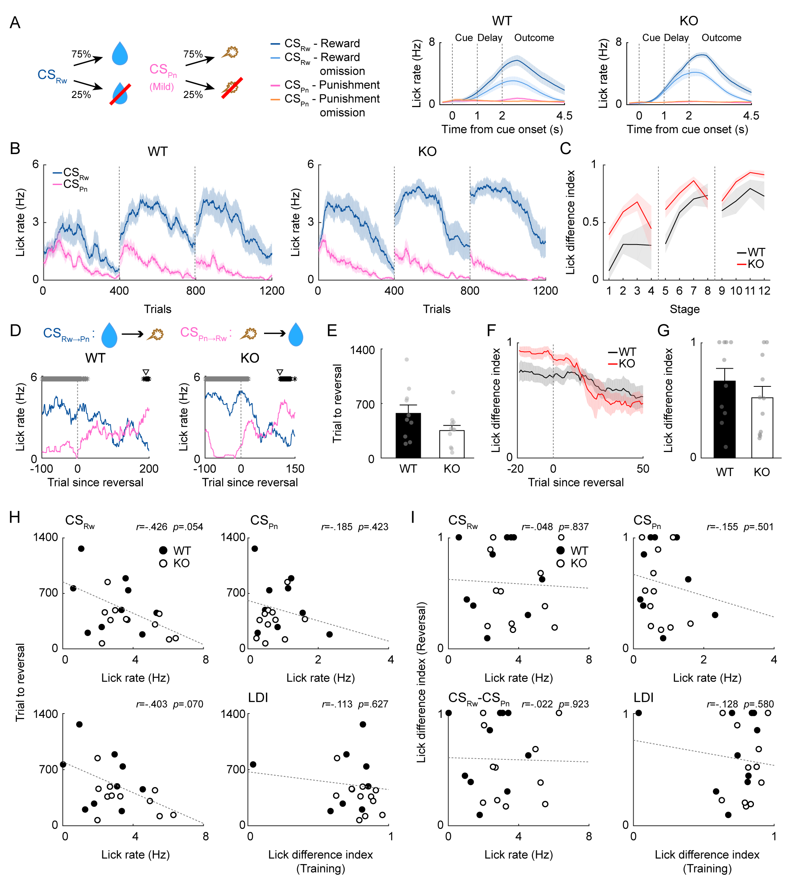
Supplementary figure 4. Juvenile Shank2-KO mice exhibit intact learning in reward-probability reversal. Results of reversal training with a mild air puff (5 ms, 3 psi; Task 2) in juvenile male WT (n = 10) and Shank2-KO (n = 11) mice in Task 2. The results are presented as described for Fig. 3.

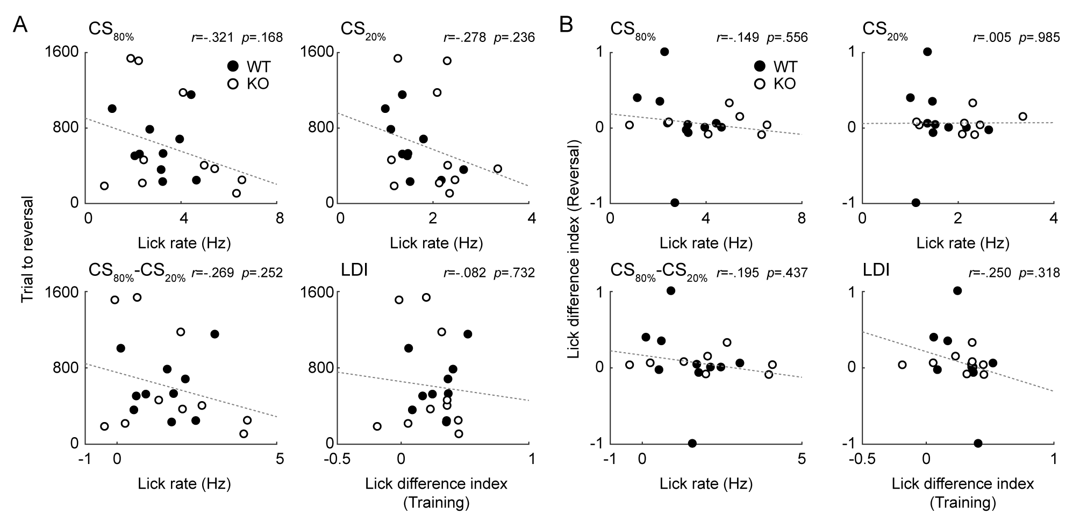
Supplementary figure 5. No significant relationship between reversal performance and acquisition performance in reward-probability reversal. Results of adult male WT (n = 10) and Shank2-KO (n = 10) mice in Task 3. The results are presented as described for Fig. 3H, I.

