Ultrafine and Fairly Long Carboxylated Cellulose Nanofibers Prepared by a Hydrated Multi-carboxylic Acid Deep Eutectic Solvent

Xiaochao Shi,^{1,a} Zengbin Wang,^{2,a} Qinqin Xia,¹ Yongzhuang Liu,¹ Wenshuai Chen,¹ Haipeng Yu^{1,*} Kai Zhang^{2,*}

¹ Key Laboratory of Bio-based Material Science and Technology of Ministry of Education, Northeast Forestry University, Harbin 150040, China
² Sustainable Materials and Chemistry, Dept. Wood Technology and Wood-based Composites, University of Göttingen, Göttingen 37077, Germany

* Email: kai.zhang@uni-goettingen.de (K.Z.); yuhaipeng20000@nefu.edu.cn (H.Y.)

Figure S1. The investigation of DESs from different formulas to prepare the optimal C-CNFs. TEM image of the C-CNFs processed by DESs (a) CA:ChCl=1:1, (b) CA:ChCl=2:1, (c) CA:ChCl=3:1 and (d) CA:ChCl=4:1. Change rules of (e) carboxyl content versus aspect ratio, (f) yield versus zeta potential and (g) DP versus DS of the C-CNFs prepared using different DESs.

Figure S2. The investigation of H-DESs from different formulas to prepare the optimal C-CNFs. TEM image of the C-CNFs processed by H-DESs and DES (a) CA:ChCl=3:1, (b) CA:ChCl:H₂O=3:1:1, (c) CA:ChCl:H₂O=3:1:2 and (d) CA:ChCl:H₂O=3:1:3. Change rules of (e) carboxyl content versus aspect ratio, (f) yield versus zeta potential and (g) DP versus DS of the C-CNFs prepared using different H-DESs and DESs.

Figure S3. XRD and crystallinity of the C-CNFs prepared under different mass ratios of ChCl:CA:H₂O. (a) XRD patterns; (b,c) Relative crystallinity.
Figure S4. (a) FTIR diagram of pure CA, CA aqueous solution, and H-DES. (b) Dehydration of polycarboxylic acid to form cyclic anhydride and ChCl and H₂O inhibits the formation of cyclic anhydride and preserves the carboxylic site reaction pathway.

In the FTIR spectra, we attribute the absorption peaks at approximately 1701 cm⁻¹ to the C=O stretching of carboxylic acid. It is worth noting that three new absorption peaks in CA aqueous solution appear at 1850 cm⁻¹, 1800 cm⁻¹ and 1077 cm⁻¹, which corresponds to the symmetric, asymmetric stretching of C=O, and stretching of C-O-C bonds of a cyclic anhydride, respectively, indicating that CA is easily dehydrated to form five-membered cyclic carboxylic anhydrides. The formation of this cyclic anhydride is not conducive to the release of carboxyl sites and grafting multi-carboxyl functional groups, thus affecting the carboxyl content of cellulose.

Figure S5. Conductivity titration test on the C-CNFs prepared by the optimal H-DES (CA:ChCl:H₂O = 3:1:1).

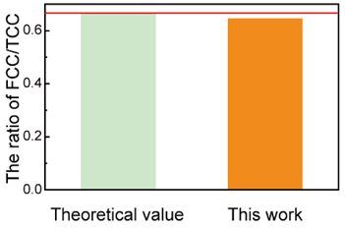
Figure S6. The comparison of theoretical value and tested value of FCC/TCC ratio.

Figure S7. TGA and DTG images of the CNF film and C-CNF film.

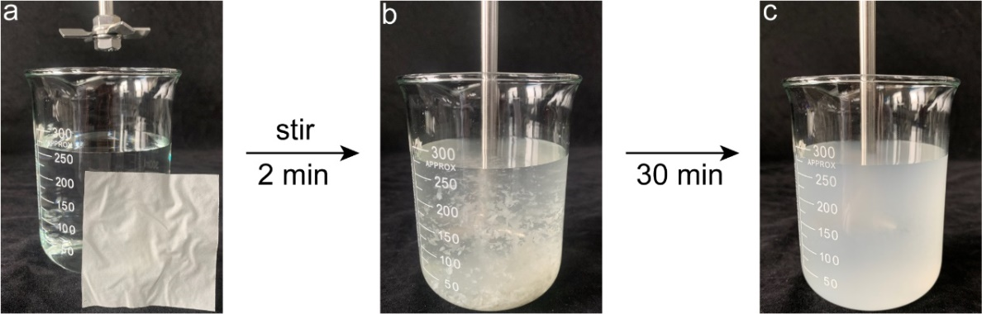
Figure S8. (a) One piece of the C-CNF film was cut into 6 cm × 6 cm in size and immersed in water, then (b) stirred for one minute, causing the film to begin to redisperse. The stirring rate was 1000 rpm. (c) After stirring for 30 min, the C-CNF film in water reconstructs a uniform slurry.

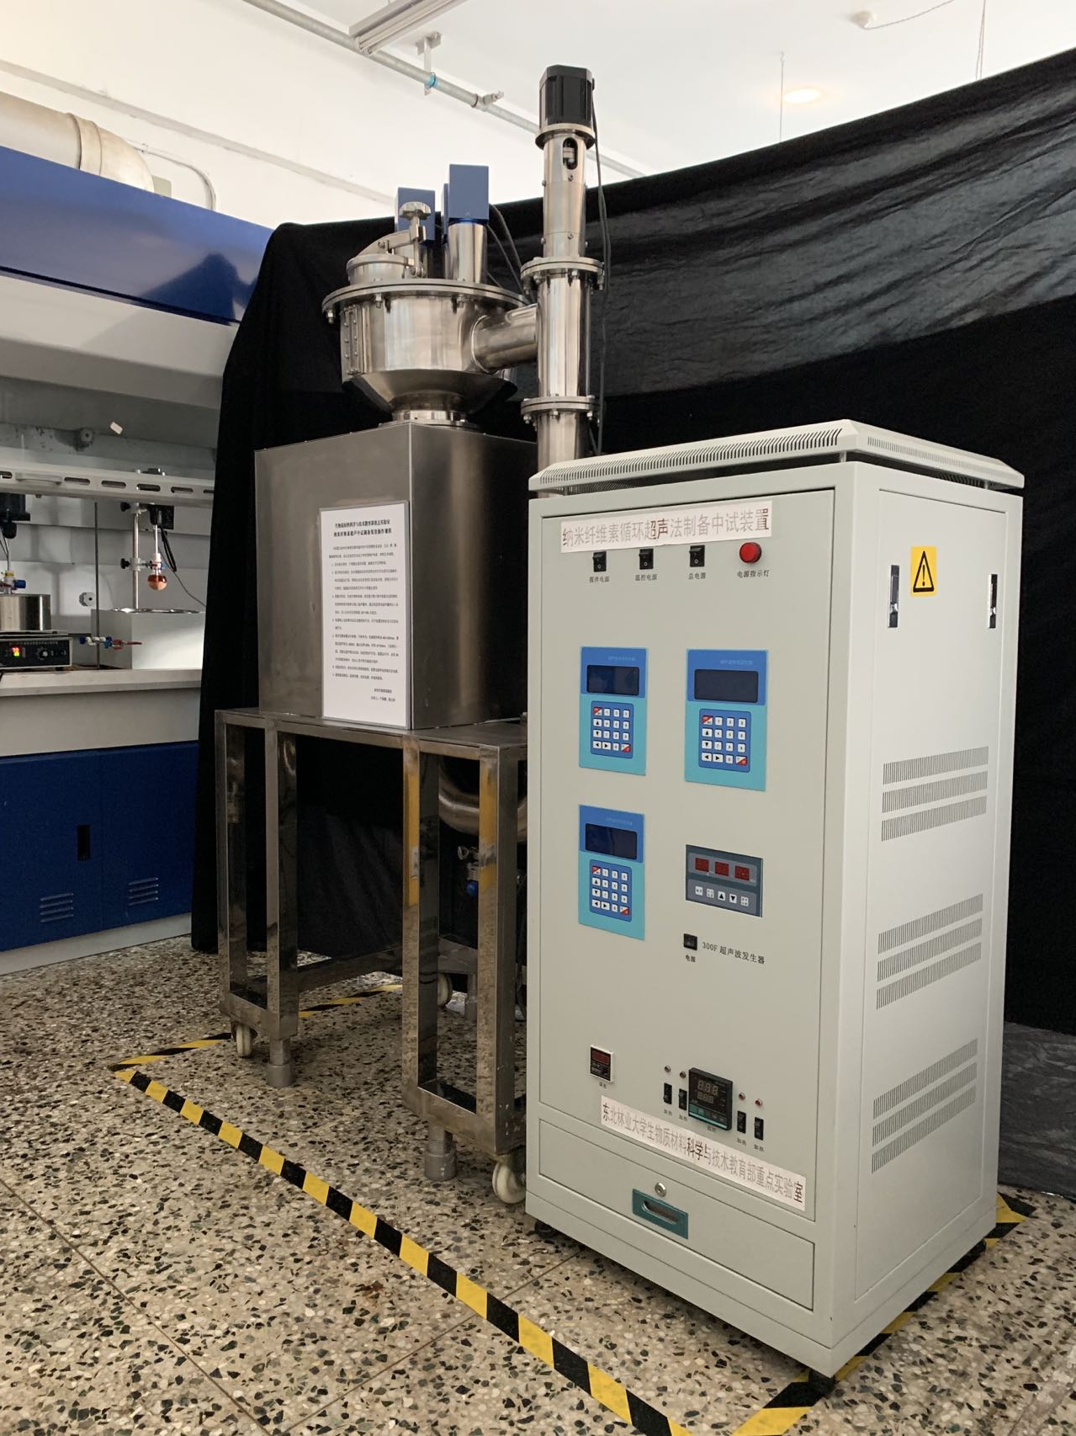
Figure S9. Photography of the pilot-scale circulated ultrasonic apparatus.

Figure S10. Relationship between storage modulus (G’), loss modulus (G’’) and angular frequency. (a) The solid content of CNFs and C-CNFs is 2 wt%. (b) The solid content of C-CNFs is 10 wt%.

Figure S11. The yield and carboxyl content of C-CNFs prepared by four cycles reuse of the H-DES.

Figure S12. The C-CNF film preparation flow chart. Pour the paste into a mould and dry it at room temperature for a week to get a complete film. Put the film into the grinding machine and get the C-CNF suspension, which can be recycled.

Table S1: Common preparation methods and corresponding data of C-CNF were compared with this work.
Raw materials | Chemical pretreatment | Mechanical  method | Mass ratio | Yield (%) | -COOH (mmol/g) | Length  (μm) | Width  (nm) | Aspect ratio | ZP  (mV) | DP | DS | Refs
Kraft pulp | TEMPO  (pH 10, 10 h) | Homogenization | 1:100 | 20 | 1.2 | 0.93 | 4 | 232 |  | 386 |  | Ref 13
 |  |  |  | 30 | 1.3 | 0.58 | 4 | 145 |  | 316 |  | Ref 13
 |  |  |  | 65 | 1.7 | 0.51 | 4 | 128 |  | 307 |  | Ref 13
 |  |  |  |  | 1.5 | 0.87 | 4 | 217 |  |  |  | Ref 14
Kraft pulp | TEMPO  (pH 10.5, 7 h) | Homogenization | 1:100 |  | 1.38 |  |  | 1000 | -45.8 |  |  | Ref 15
Bagasse pulp | Citric acid (100℃, 4h) | Ultrasonication |  | 32.2 | 0.65 | 0.25 | 21 | 12 |  |  |  | Ref 10
Bagasse pulp | Citric acid (100℃, 4h) | Ultrasonication |  | 63.4 | 0.3 | 0.65 | 32 | 20 |  |  |  | Ref 10
Dissolving pulp | Oxalic acid (110℃, 1h) | Ultrasonication | 18:63 | 80.6 | 1.2 | 0.185 | 18 | 10 |  |  | 0.35 | Ref 16
Delignified bark | Oxalic acid (110℃, 5min) | Homogenization | 15:58 | 81.5 | 1.53 | 0.228 | 3.2 | 60 |  |  | 0.30 | Ref 17
Kraft pulp | Maleic acid (120℃, 2h) | Homogenization | 1:10 | 87.9 | 0.47 | 0.15 | 6 | 25 | -46 | 241 |  | Ref 18
Kraft pulp | Maleic acid (120℃, 2h) | Homogenization | 1:10 | 5 | 0.27 | 0.592 | 8.1 | 73 |  |  |  | Ref 19
Kraft pulp | Oxalic acid (100℃, 45min) | Microfluidization | 1:8 | 11.4 | 0.19 | 0.48 | 5.2 | 93 | -43.3 | 239 |  | Ref 20
Bagasse pulp | Oxalic acid (100℃, 2h) | Ultrasonication | 1:50 | 59.7 | 0.37 | 0.411 | 25 | 16 |  |  |  | Ref 21
Bagasse pulp | Tartaric acid  (100℃, 4h) | Ultrasonication | 1:50 | 37.1 | 0.3 | 0.569 | 41 | 14 | -24.2 |  |  | Ref 21
Bagasse pulp | Citric acid (100℃, 2h) | Ultrasonication | 1:50 | 25.9 | 0.45 | 0.394 | 28 | 14 |  |  |  | Ref 21
Ramie cellulose | Citric acid+HCl  (140℃, 3h) | Homogenization | 13:310 | 20 | 1.88 | 0.22 | 12 | 18 |  |  | 0.18 | Ref 11
Ramie cellulose | Malic acid+HCl  (140℃, 3h) | Homogenization | 13:310 | 20 | 1.62 | 0.22 | 12 | 18 |  |  | 0.22 | Ref 11
Ramie cellulose | Malonic acid + HCl  (140℃, 3h) | Homogenization | 13:310 | 19 | 1.11 | 0.22 | 12 | 18 |  |  | 0.16 | Ref 11
Bamboo pulp | Citric acid + H₂SO₄  (100℃, 4h) | Ultrasonication | 1:100 | 70 | 1.18 | 0.35 | 15 | 23 | -45.9 |  | 0.2 | Ref 22
MCC | Citric acid+HCl  (140℃, 3h) | Hydrolysis | 1:50 | 85.5 | 1.28 | 0.248 | 18.4 | 13 | -40.5 |  | 0.12 | Ref 23
MCC | Citric acid + HCl (80℃, 4h) | Hydrolysis | 1:50 | 82.5 | 1.39 | 0.216 | 15.9 | 13 | -46.6 |  |  | Ref 24
Thermomechanical pulp | DES (ChCl:OA) (80℃, 3h) | Blending |  | 39 | 0.29 | 0.35 | 6.9 | 50 |  |  |  | Ref 25
Thermomechanical pulp | DES ChCl:OA:p-TA (80℃, 3h) | Blending |  | 66 | 0.43 | 0.5 | 5.9 | 85 |  |  |  | Ref 25
Cellulose pulp | DES (ChCl:OA) (100℃, 2h) | Microfluidization | 1.2:120 | 68 | 0.20 | 0.39 | 13.6 | 28 |  |  |  | Ref 26
Cellulose pulp | DES (ChCl:OA) (120℃, 2h) | Microfluidization | 1.2:120 | 73 | 0.23 | 0.353 | 9.9 | 36 |  |  |  | Ref 26
Bagasse pulp | DES (ChCl:OA: AlCl₃·6H₂O) (100℃) | Ultrasonication | 0.1:10 | 56.2 | 0.74 | 0.475 | 15.34 | 31 | -32 |  |  | Ref 27
Bagasse pulp | DES (ChCl:LA: AlCl₃·6H₂O) (100℃) | Ultrasonication | 0.1:10 | 62.6 | 0.84 | 0.575 | 16.84 | 34 | -35 |  |  | Ref 27
Wheat fibers | Cyclic anhydrides  (90℃, 5h) | Microfluidization | 1:11.5 | 40 | 0.9 | 0.5 | 4.4 | 113 | -49.9 | 960 | 0.15 | Ref 28
Wheat fibers | Cyclic anhydrides  (90℃, 5h) | Microfluidization | 1:11.5 | 20 | 3.8 | 0.5 | 5.4 | 92 | -44.6 | 725 | 0.67 | Ref 28
Wheat fibers | Cyclic anhydrides  (90℃, 5h) | Microfluidization | 1:11.5 | 38 | 1.0 | 0.5 | 6.1 | 82 | -42.7 | 925 | 0.17 | Ref 28
Bamboo pulp | Maleic  Anhydride  (30℃, 1h) | Homogenization | 0.1:10 | 23.7 | 1.79 | 0.525 | 8.5 | 62 |  |  | 0.35 | Ref 29
(r-MDF) fibers | Ammonium persulfate  (90℃, 5h) | Grinder | 1:100 | 55.5 | 0.14 | 0.221 | 14.8 | 15 |  |  |  | Ref 30
Wood pulp | H-DES CA:ChCl:H₂O (130℃, 3h) | Ultrasonication | 18:100 | 90.1 | 1.50 | 10 | 3 | 4000 | -46.6 | 530 | 0.42 | This work

