Supplementary Materials
Aging reprogramming liver endothelial zonation triggers steatohepatitis by inactivating pericentral endothelium-derived C-kit
Juan-Li Duan^{1,*} (duan_juan_li@126.com)
Jing-Jing Liu^{1,*} (ljj05080086@126.com)
Bai Ruan^{1,2,*} (bairuan@fmmu.edu.cn)
Jian Ding¹ (424214545@qq.com)
Zhi-Qiang Fang¹ (zhiqiang_fang@163.com)
Hao Xu¹ (772040662@qq.com)
Ping Song¹ (songping000123@163.com)
Chen Xu¹ (18580760921@163.com)
Zhi-Wen Li¹ (2434730042@qq.com)
Wei Du¹ (dw41@qq.com)
Lin Wang^{1,#} (fierywang@163.com)
¹Department of Hepatobiliary Surgery, Xi-Jing Hospital, Fourth Military Medical University, Xi’an 710032, China.
²Center of Clinical Aerospace Medicine & Department of Aviation Medicine, Fourth Military Medical University, Xi’an 710032, China.
*These authors contributed equally to this study.
#Correspondence to: Lin Wang, Department of Hepatobiliary Surgery, Xi-Jing Hospital, Fourth Military Medical University, Xi'an 710032, China, Email: fierywang@163.com; Fax: (86)-29-8324627.
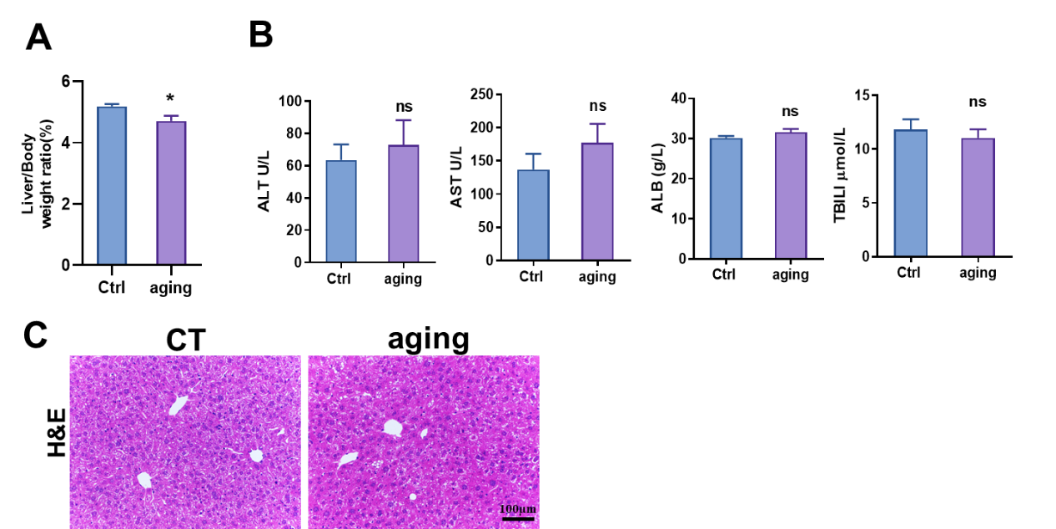
Fig. S1 (A) Liver to body weigh ratios in younger control and aged mice. (B) Serum ALT, AST, ALB and TBIL levels in younger control and aged mice. (C) H&E staining of liver of younger control and aged mice. Bars represent means ± SD, n=3 to 6; ns, no significance.

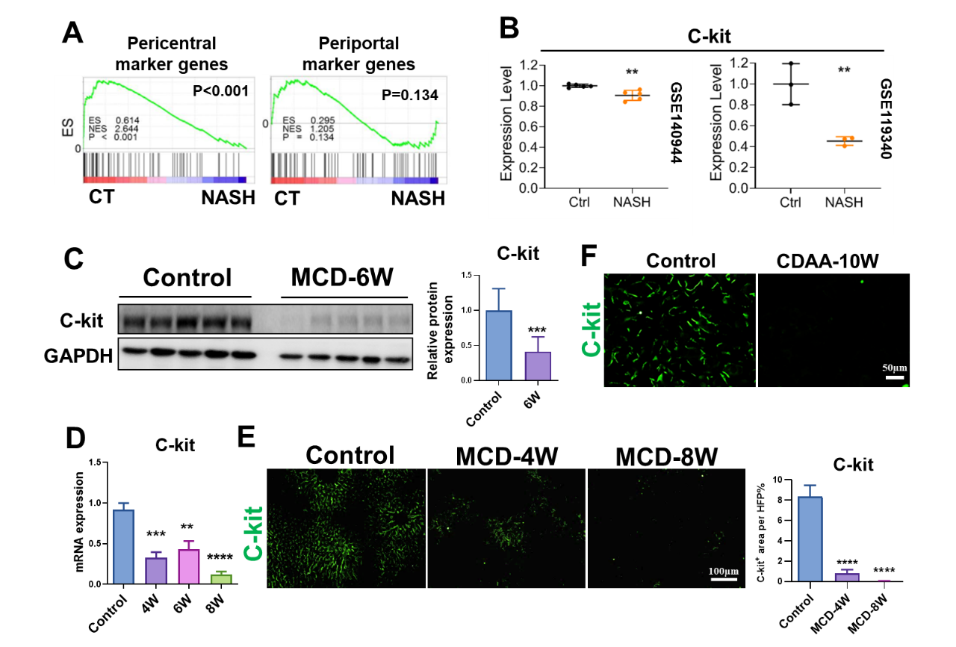
Fig. S2 (A) GSEA analyses of the expressions of the pericentral and periportal marker genes in LSECs isolated from the NASH mice and the control. (B) The relative mRNA levels of C-kit according to the previously published RNA-seq data (GEO: GSE140944 and GSE119340) for LSECs isolated from NASH mice. (C) WB analysis of C-kit in LSECs of MCD diet-treated mice and the control. The gray ratio of C-kit and GAPDH was quantitatively compared. (D) qRT-PCR analyses of C-kit in LSECs of MCD-treated mice and the control. (E) IF staining of C-kit in MCD-treated liver and control liver. The positive areas of C-kit staining were quantified. (F) IF staining of C-kit in CDAA-treated liver and control liver. Bars represent means ± SD, n=3 to 5; *P < 0.05, **P < 0.01, ***P < 0.001, ****P < 0.0001.

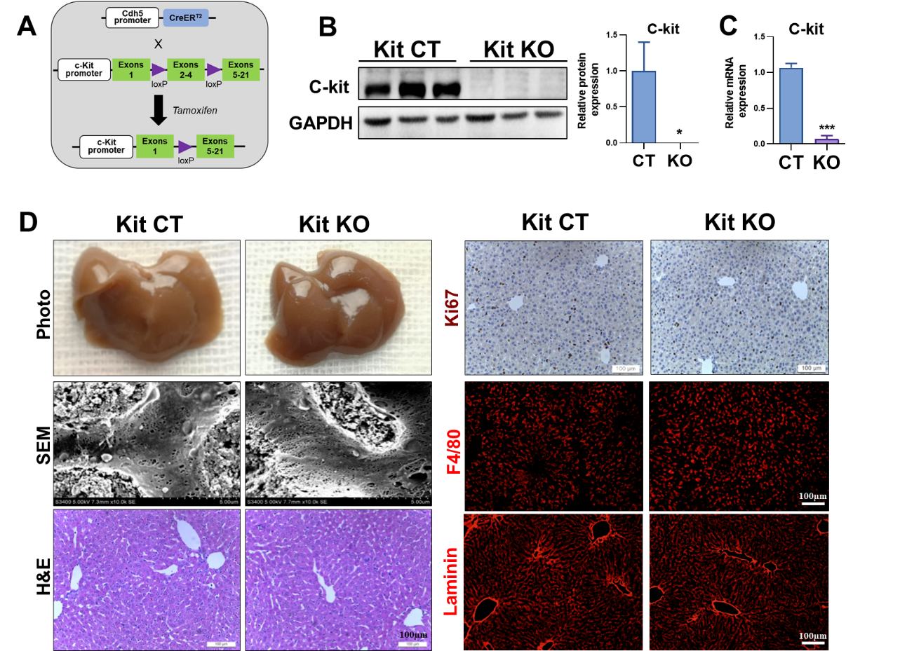
Fig. S3 (A) The strategy of establishment of Cdh5-CreER Kitflox/flox mice. (B) WB analyses of LSEC C-kit in control and C-kit KO mice. The gray ratio of C-kit and GAPDH was quantitatively compared. (C) The mRNA level of C-kit in LSECs isolated from control and C-kit KO mice. (D) The photo, SEM images, H&E staining, Ki67 IHC staining, F4/80 and laminin IF staining of liver of control and C-kit KO mice. Bars represent means ± SD, n=3; *P < 0.05, ***P < 0.001.

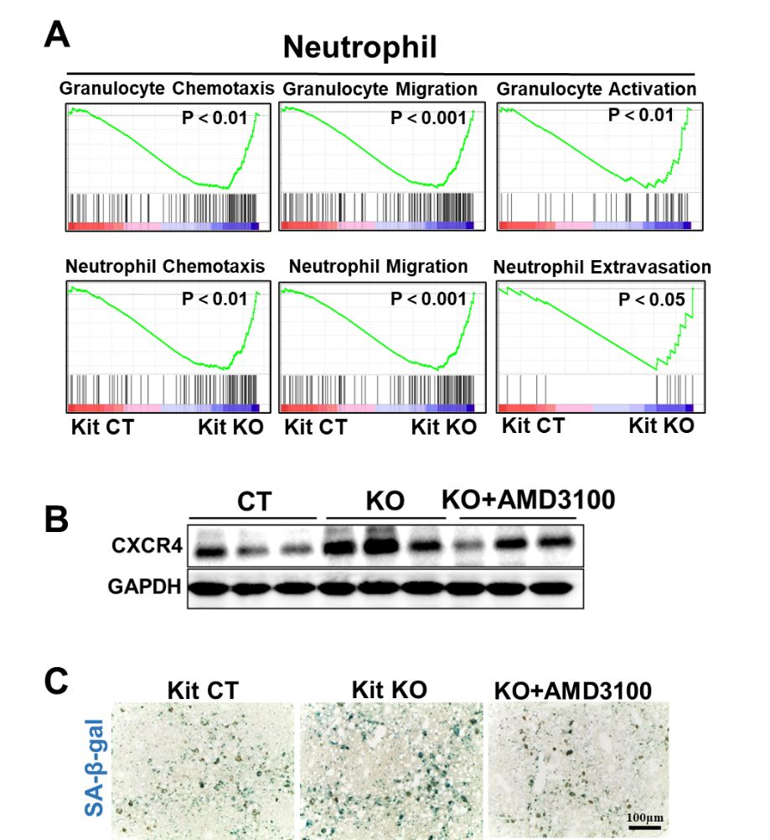
Fig. S4 (A) GSEA analyses of pathways concerning Granulocyte or neutrophil chemotaxis, migration, activation and extravasation. (B) WB analyses of CXCR4 in isolated LSECs of control, C-kit KO and C-kit KO plus AMD3100 mice. (C) SA-β-gal staining for liver of control, C-kit KO and C-kit KO plus AMD3100 mice.

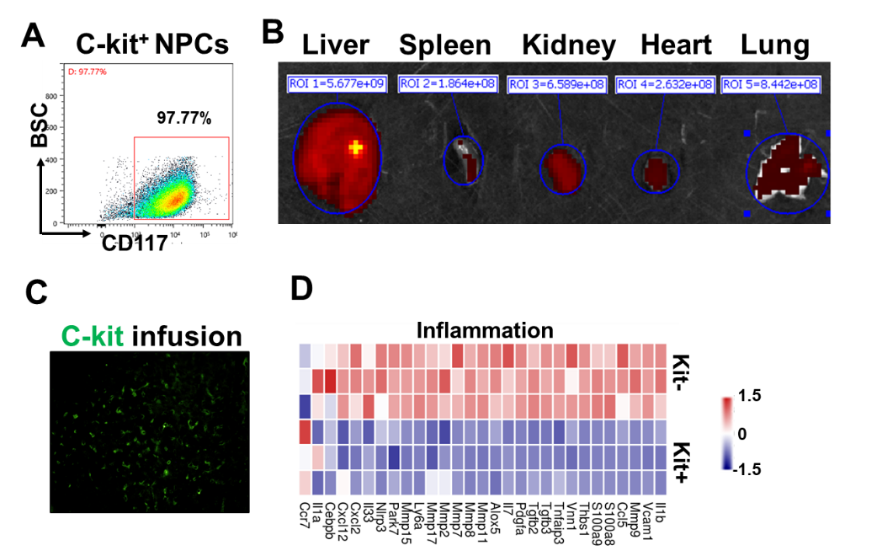
Fig. S5 (A) FACS analysis of CD117+ LSECs isolated by magnetic beads. (B) Spectrum assay showed the engraftment of GFP-labelled C-kit+ LSECs in different organs, such as liver, spleen, kidney, heart and lung. (C) GFP-labelled C-kit+ LSECs were detected in the liver under fluorescent microscope. (D) Heatmap of the expression of inflammation-associated genes in LSECs of C-kit+ and C-kit- group.
Supplementary Table1.Antibodies used in this study
Antibody | Supplier | Cat.No | Purpose
Lyve-1 | Reliatech | 103-M130 | IF
Laminin | Abcam | ab11575 | IF
α-SMA | Abcam | ab124964 | IF
Desmin | Abcam | ab32362 | IF
Ki67 | Millipore | AB9260 | IF/IHC
C-kit | R＆D | AF1356 | WB/IF
CXCR4 | Proteintech | 60042-1-lg | WB
GAPDH | Proteintech | 10494-1-AP | WB
F4/80 | Invitrogen | 14-4801-82 | IF
CD11b-APC | Biolegend | 101211 | FACS
F4/80-PE | Biolegend | 123110 | FACS
Goat anti-Rabbit-HRP | Abbkine | 21020 | WB
Rabbit anti-Mouse-HRP | Abbkine | 21010 | WB
HPR, Rabbit anti-Goat | Abbkine | 21030 | wb
Goat anti Rabbit Cy3 | Jackson Immuno Research | 111-165-003 | IF
Goat anti Rabbit FITC | Jackson Immuno Research | 111-095-003 | IF
VE-Cadherin | R＆D | AF1002 | IF
SDF1 | Proteintech | 17402-1-AP | IF
MPO | Servicebio | GB11224 | IHC

Supplementary Table2. Primers used for qRT-PCR
Gene | Forward(5’-3’) | Reverse(5’-3’) | size
β-actin | GGCTGTATTCCCCTCCATCG | CCAGTTGGTAACAATGCCATG | 153
Collagen1 | GCTCCTCTTAGGGGCCACT | ATTGGGGACCCTTAGGCCAT | 91
C-kit | GCCTGACGTGCATTGATCC | AGTGGCCTCGGCTTTTTCC | 110
Cd36 | ATGGGCTGTGATCGGAACTG | TTTGCCACGTCATCTGGGTTT | 233
Nr2f2 | CATCGAGAACATTTGCGAACTG | GTCGGCTGACATGGGTGAAG | 226
Il-6 | CTGCAAGAGACTTCCATCCAG | AGTGGTATAGACAGGTCTGTTGG | 131
Mgll | AGGCGAACTCCACAGAATGTT | ACAAAAGAGGTACTGTCCGTCT | 75
Hsl | GATTTACGCACGATGACACAGT | ACCTGCAAAGACATTAGACAGC | 114
Acadvl | ACTACTGTGCTTCAGGGACAA | GCAAAGGACTTCGATTCTGCC | 152
Tgf-b | CTTCGACGTGACAGACGCT | GCAGGGGCAGTGTAAACTTATT | 85
Acc1 | GATGAACCATCTCCGTTGGC | GACCCAATTATGAATCGGGAGTG | 65
Fasn | GGAGGTGGTGATAGCCGGTAT | TGGGTAATCCATAGAGCCCAG | 140
Pparα | AGAGCCCCATCTGTCCTCTC | ACTGGTAGTCTGCAAAACCAAA | 153
Fatp2 | TCCTCCAAGATGTGCGGTACT | TAGGTGAGCGTCTCGTCTCG | 166
Cxcr4 | GACTGGCATAGTCGGCAATG | AGAAGGGGAGTGTGATGACAAA | 131
Sm22 | CCAACAAGGGTCCATCCTACG | ATCTGGGCGGCCTACATCA | 134
α-Sma | CCCAGACATCAGGGAGTAATGG | TCTATCGGATACTTCAGCGTCA | 104
Desmin | GTGGATGCAGCCACTCTAGC | TTAGCCGCGATGGTCTCATAC | 218
Pdgfβ | CATCCGCTCCTTTGATGATCTT | GTGCTCGGGTCATGTTCAAGT | 92
Timp1 | CGAGACCACCTTATACCAGCG | ATGACTGGGGTGTAGGCGTA | 108
IL-1β | GAAATGCCACCTTTTGACAGTG | TGGATGCTCTCATCAGGACAG | 116
Tnf-α | CCCTCACACTCAGATCATCTTCT | GCTACGACGTGGGCTACAG | 61
Gata4 | CCCTACCCAGCCTACATGG | ACATATCGAGATTGGGGTGTCT | 139
P16 | CGCAGGTTCTTGGTCACTGT | TGTTCACGAAAGCCAGAGCG | 127
P21 | CCTGGTGATGTCCGACCTG | CCATGAGCGCATCGCAATC | 103
Ccl2 | TTAAAAACCTGGATCGGAACCAA | GCATTAGCTTCAGATTTACGGGT | 121
Il1-α | CGAAGACTACAGTTCTGCCATT | GACGTTTCAGAGGTTCTCAGAG | 126
P53 | GCGTAAACGCTTCGAGATGTT | TTTTTATGGCGGGAAGTAGACTG | 144
P27 | TCAAACGTGAGAGTGTCTAACG | CCGGGCCGAAGAGATTTCTG | 103

