Supplementary File

Predictability of Indian Ocean Precipitation and its North Atlantic teleconnections during early Winter

Muhammad Adnan Abid^{*1,3}, Fred Kucharski^{1,3}, Franco Molteni², Mansour Almazroui^{3,4}

- Earth System Physics, The Abdus Salam International Centre for Theoretical Physics (ICTP), Trieste, Italy
- European Centre for Medium-Range Weather Forecasts, Reading, United Kingdom
- Centre of Excellence for Climate Change Research (CECCR)/Department of Meteorology, King Abdulaziz University, Jeddah, Saudi Arabia
- Climatic Research Unit, School of Environmental Sciences, University of East Anglia, Norwich, U.K.

June 2022

Submitted
to

npj Climate and Atmospheric Science

Corresponding author:
Muhammad Adnan Abid
Email: mabid@ictp.it
Earth system Physics, Abdus Salam International Centre for Theoretical Physics (ICTP),
I-34151, Trieste, Italy

Supplementary Fig1. Monthly observed correlation of the IOD with Niño3.4 Sea Surface Temperatures (SSTs) index for the period 1981-2019.

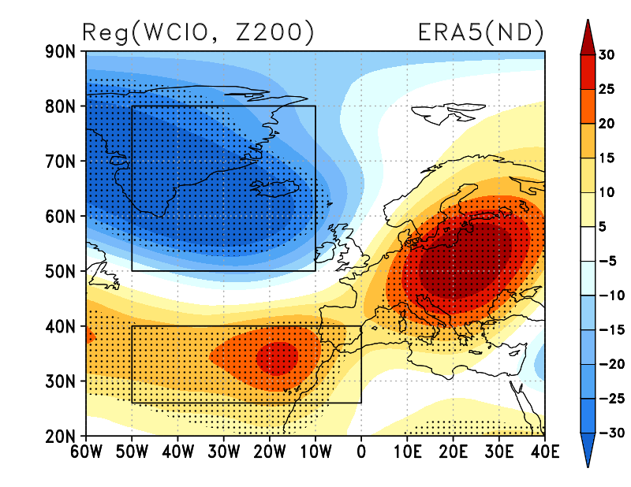

Supplementary Fig2. Regression of 200-hPa geopotential height anomalies (Z200) onto the Western-Central Indian Ocean (WCIO) precipitation anomaly index. In the current study, North Atlantic Oscillation (NAO) Index is defined based on the box highlighting the Azores [26:40 °N; 310:360 °E] - Iceland [50:80 °N; 310:350 °E].

