Supplemental Material

Early Initiation of Renal Replacement Therapy in Intensive Care Unit Patients with Acute Respiratory Distress Syndrome and Sepsis with or without Renal Failure: A Retrospective Cohort Study Based on Propensity Score Matching

Content of Supplemental Material
Supplemental Table
Supplemental Table 1. Definition of study variables.
Supplemental Table 2. Missing rates of study variables.
Supplemental Table 3. Baseline characteristics between patients with early RRT v.s. no early RRT before PSM.
Supplemental Table 4. Baseline characteristics between patients with early RRT v.s. no early RRT after PSM with a maximal matching ratio of 1-to-2.

Supplemental Figure
Supplemental Figure 1. Forest plot of the sensitivity and subgroup analysis for 90-day mortality.
Supplemental Figure 2. A love plot illustrating the covariate balance before and after PSM with a maximal matching ratio of 1-to-2.

Supplemental Table 1. Definition of study variables.
Variables | Definition | Continuous/Categorical/Binary
Demographics
Age | Years after birth | Continuous
Sex | Female and Male | Binary, Female/Male
Previous History
Hypertension | Self-reported use of medications to control blood pressure or previously measured SBP ≥140mmHg or DBP ≥90mmHg | Binary, Yes/No
Diabetes | Self-reported use of medications/lifestyle intervention to control blood glucose or physician-diagnosed type 2 diabetes mellitus | Binary, Yes/No
CAD | Self-reported history of CAD | Binary, Yes/No
Ischemic stroke | Self-reported history of ischemic stroke | Binary, Yes/No
Cancer | Self-reported history of Cancer | Binary, Yes/No
On-admission clinical characteristics
SBP | SBP measured on admission | Continuous, in mmHg
DBP | DBP measured on admission | Continuous, in mmHg
Heart rate | Heart rate measured on admission | Continuous, in beats per minute
Serum creatinine | Serum creatinine measured on admission | Continuous, in umol/L
Oxygenation index | The ratio of PaO₂ to FiO₂ was obtained by arterial blood gas analysis on admission | Continuous, in mmHg
GCS score | GCS score evaluated on admission | Continuous
SOFA Score | SOFA score evaluated on admission | Continuous
Emergency surgical operation | Surgical procedures in the first 24 h of admission | Binary, Yes/No
Invasive mechanical ventilation | Invasive mechanical ventilation during the entire ICU stays | Binary, Yes/No
Other in-hospital treatment within 24 hours of admission
Antibiotics | Antibiotics use within 24h after admission | Binary, Yes/No
Sedative/analgesic | Sedative and analgesic use within 24h after admission (including: propofol, dexmedetomidine, midazolam, opioids etc.) | Binary, Yes/No
Vasoactive medications | Vasoactive medications (norepinephrine/dopamine) use within 24h after admission | Binary, Yes/No
Blood component transfusions | Blood component transfusions (red cells, platelets, plasma, cryoprecipitated AHF, and granulocytes) use within 24h after admission | Binary, Yes/No
Abbreviations: DBP, diastolic blood pressure; GCS, Glasgow Coma Scale; SBP, systolic blood pressure; SOFA, Sequential Organ Failure Assessment.
Supplemental Table 2. Missing rates of study variables.
Variables | Missing, N (%)  n=762
Fluid intake | 3 (0.39)
Fluid outtake | 3 (0.39)
Blood component transfusion | 2 (0.26)

Supplemental Table 3. Baseline characteristics between patients with early RRT v.s. no early RRT before PSM.
Characteristics | Total n=745 | Early RRT n=263 | No Early RRT n=482 | P Value
Demographics
Age, year | 62.1±16.6 | 59.2±16.4 | 63.7±16.5 | <0.001
Male, n (%) | 456 (61.2) | 162 (61.6) | 294 (61.0) | 0.940
Previous history
Hypertension, n (%) | 404 (54.2) | 158 (60.1) | 246 (51.0) | 0.021
Diabetes, n (%) | 230 (30.9) | 92 (35.0) | 138 (28.6) | 0.081
CAD, n (%) | 178 (23.9) | 62 (23.6) | 116 (24.1) | 0.930
Ischemic stroke, n (%) | 151 (20.3) | 51 (19.4) | 100 (20.7) | 0.700
Cancer, n (%) | 92 (12.3) | 22 (8.40) | 70 (14.5) | 0.014
On-admission clinical characteristics
SBP, mmHg | 138±36.0 | 143±39.2 | 135±33.8 | 0.005
DBP, mmHg | 70.2±19.1 | 71.0±20.5 | 69.8±18.3 | 0.390
Heart rate, bpm | 102±24.4 | 100±24.9 | 103±24.1 | 0.170
Serum creatinine, umol/L | 234±291 | 460±384 | 111±87.2 | <0.001
Oxygenation index, mmHg | 177±67.4 | 184±68.3 | 174±66.6 | 0.034
GCS Score | 13 (7 to 15) | 14 (7 to 15) | 12 (7 to 15) | 0.110
SOFA Score | 11 (8 to 14) | 12 (9 to 15) | 10 (8 to 14) | <0.001
Emergency surgical operation, n (%)
 | 82 (11.0) | 16 (6.10) | 66 (13.7) | 0.001
Invasive mechanical ventilation, n (%)
 | 469 (63.0) | 138 (52.5) | 331 (68.7) | <0.001
Other in-hospital treatment within 24 hours of admission
Antibiotics, n (%) | 659 (88.5) | 216 (82.1) | 443 (91.9) | <0.001
Sedative and analgesic, n (%) | 236 (31.7) | 142 (54.0) | 310 (64.3) | 0.006
Vasoactive medications, n (%) | 236 (31.7) | 77 (29.3) | 159 (33.0) | 0.320
Blood component transfusion, n (%) | 257 (34.5) | 108 (41.1) | 149 (30.9) | 0.006
Abbreviations: CAD, coronary artery disease; DBP, diastolic blood pressure; GCS, Glasgow Coma Scale; SBP, systolic blood pressure; PSM, propensity score matching; SOFA, Sequential Organ Failure Assessment.
Supplemental Table 4. Baseline characteristics between patients with early RRT v.s. no early RRT after PSM with a maximal matching ratio of 1-to-2.
Characteristics | Total n=299 | Early RRT n=102 | No Early RRT n=197 | P Value
Demographics
Age, year | 58.4±17.4 | 58.1±16.6 | 58.6±17.8 | 0.840
Male, n (%) | 166 (55.5) | 56 (54.9) | 110 (55.8) | 0.900
Previous history
Hypertension, n (%) | 144 (48.2) | 48 (47.1) | 96 (48.7) | 0.810
Diabetes, n (%) | 96 (32.1) | 30 (29.4) | 66 (33.5) | 0.520
CAD, n (%) | 60 (20.1) | 19 (18.6) | 41 (20.8) | 0.760
Ischemic stroke, n (%) | 54 (18.1) | 19 (18.6) | 35 (17.8) | 0.870
Cancer, n (%) | 30 (10.0) | 11 (10.8) | 19 (9.60) | 0.840
On-admission clinical characteristics
SBP, mmHg | 131±36.0 | 131±38.6 | 131±34.7 | 0.880
DBP, mmHg | 68.1±19.2 | 68.0±20.7 | 68.1±18.4 | 0.960
Heart rate, bpm | 103±23.2 | 102±25.1 | 104±22.3 | 0.610
Serum creatinine, umol/L | 163±112 | 170±110 | 159±113 | 0.420
Oxygenation index, mmHg | 179±68.8 | 180±71.4 | 178±67.7 | 0.810
GCS Score | 14 (7 to 15) | 13.5 (7 to 15) | 14 (6 to 15) | 0.770
SOFA Score | 11 (8 to 16) | 11 (8 to 15) | 11 (8 to 16) | 0.610
Emergency surgical operation, n (%)
 | 31 (10.4) | 11 (10.8) | 20 (10.2) | 0.840
Invasive mechanical ventilation, n (%)
 | 188 (62.9) | 62 (60.8) | 126 (64.0) | 0.610
Other in-hospital treatment within 24 hours of admission
Antibiotics, n (%) | 265 (88.6) | 90 (88.2) | 175 (88.8) | 0.850
Sedative and analgesic, n (%) | 180 (60.2) | 61 (59.8) | 119 (60.4) | 1.000
Vasoactive medications, n (%) | 117 (39.1) | 38 (37.3) | 79 (40.1) | 0.710
Blood component transfusion, n (%) | 101 (33.8) | 36 (35.3) | 65 (33.0) | 0.700
Abbreviations: CAD, coronary artery disease; DBP, diastolic blood pressure; GCS, Glasgow Coma Scale; SBP, systolic blood pressure; PSM, propensity score matching; SOFA, Sequential Organ Failure Assessment.
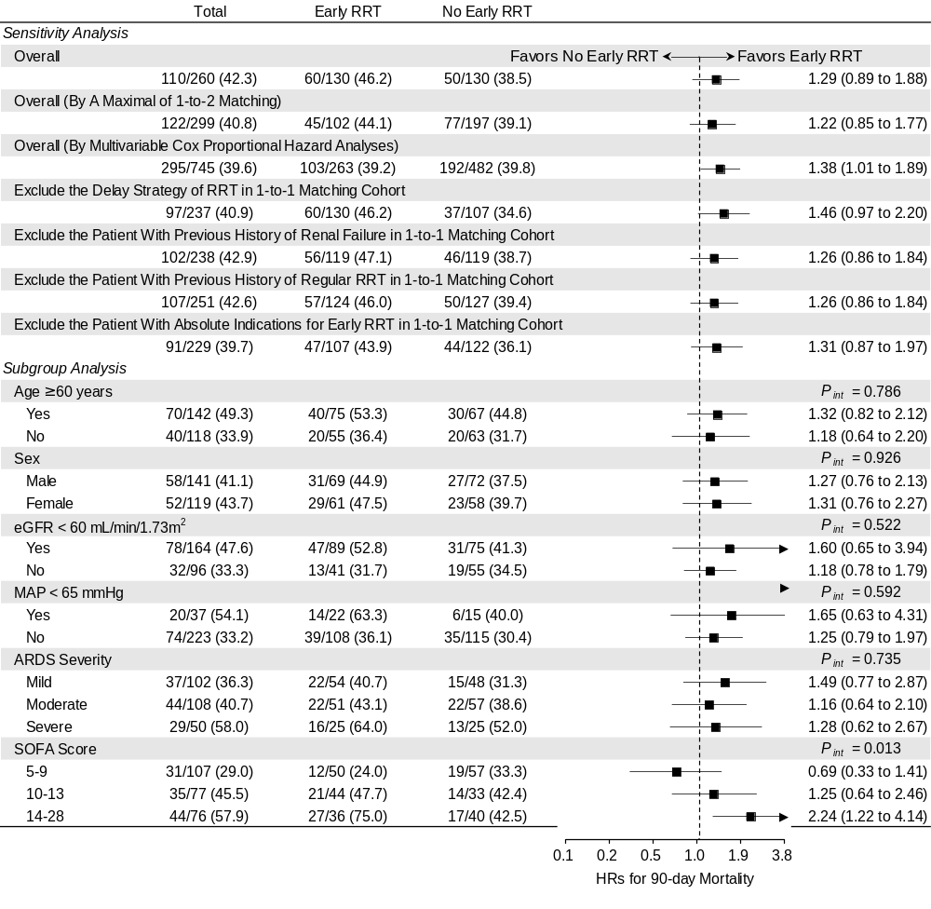
Supplemental Figure 1. Forest plot of the sensitivity and subgroup analysis for 90-day mortality. Abbreviations: ARDS, acute respiratory distress syndrome; CI, confidence intervals; eGFR, estimated glomerular filtration rate; HR, hazard ratio; MAP, mean arterial pressure; RRT, renal replacement therapy.

Supplemental Figure 2. A love plot illustrating the covariate balance before and after PSM with a maximal matching ratio of 1-to-2. Abbreviations: CAD, coronary heart disease; DBP, diastolic blood pressure; GCS, Glasgow Coma Scale; SBP, systolic blood pressure; SOFA, Sequential Organ Failure Assessment.

