Supplementary Information

Vertical distribution of microplastics in the sediment profiles of the Taihu Lake, eastern China
Yinan Huang^{1, 2}, Jiajia Fan^{2*}, Huan Liu³ and Xiancai Lu³
¹Ocean College, Zhejiang University, Hangzhou 310058, Zhejiang, China
²School of Life and Environmental Sciences, Hangzhou Normal University, Hangzhou 311121, China
³Key Laboratory of Surficial Geochemistry, MOE; School of Earth Sciences and Engineering Nanjing University, Nanjing, Jiangsu 210023, China
*Corresponding author postal address: School of Life and Environmental Sciences, Hangzhou Normal University, Hangzhou 311121, Zhejiang, china

* Correspondence: fanjiajia@hznu.edu.cn

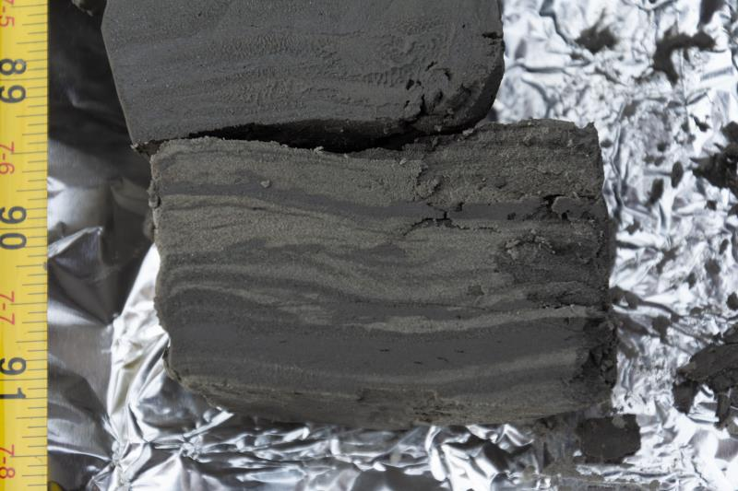
Figure S1 Photographs of the laminar structure of the sediment with the buried depth of 91.3 cm from the Taihu Lake.
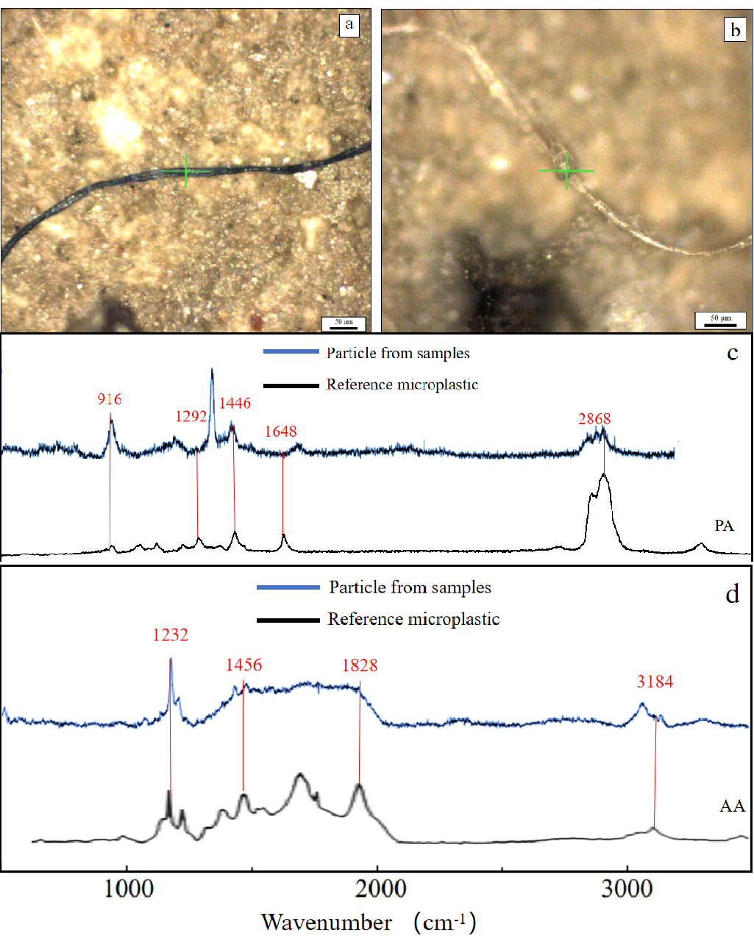
Figure S2 Photographs and Raman spectra of microplastics collected from the sampling sites. Photos were taken using Raman spectroscopy, the photos are corresponding to (a) PA, (b) AA, and the scale bar is 50 μm. Raman spectra of the collected sample particles (in blue) matched with their Raman reference library = (in black). Representative spectra of typical microplastics are corresponding to (c) PA, (d) AA.

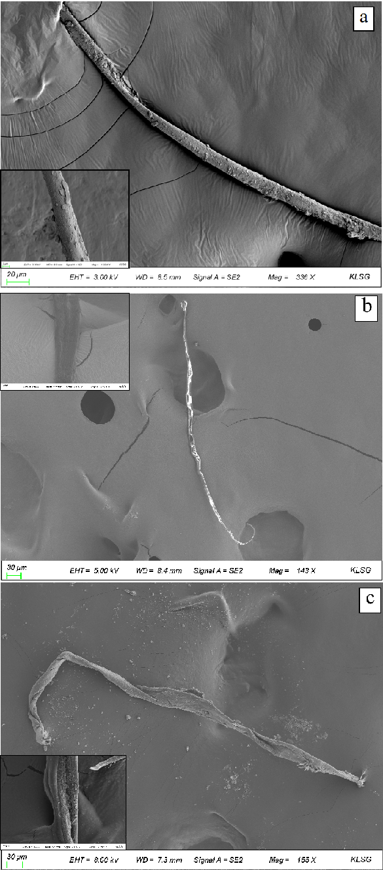
Figure S3 Photographs of microplastics collected from the sampling sites. Photos were taken using SEM, the photos are corresponding to (a) AA, (b) CA, and (c) PA

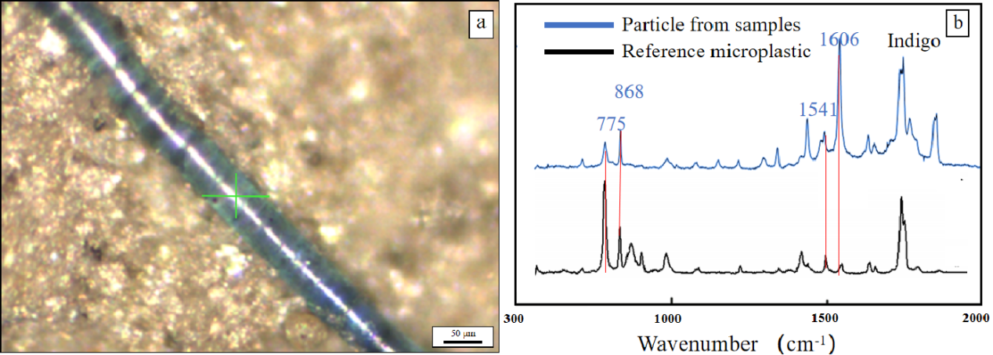
Figure S4 (a) Image of Raman spectroscopy (scale bar is 50 μm) and (b) Raman spectra of indigo dye from 12–16 cm layer of site NTH. Raman spectra of the dye (in blue) matched with their Raman reference library = (in black).

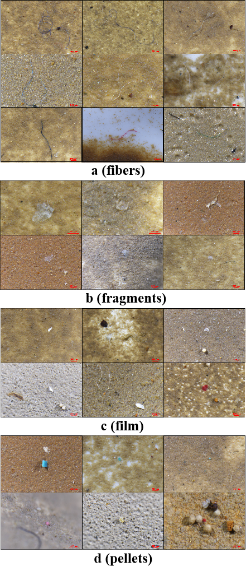
Figure S5 Photographs of typical microplastics collected from the sampling sites. Photos were taken using stereo microscope, the photos are corresponding to (a) fiber, (b) fragment, (c) film, and (d) pellet, the scale bar is 250 μm.

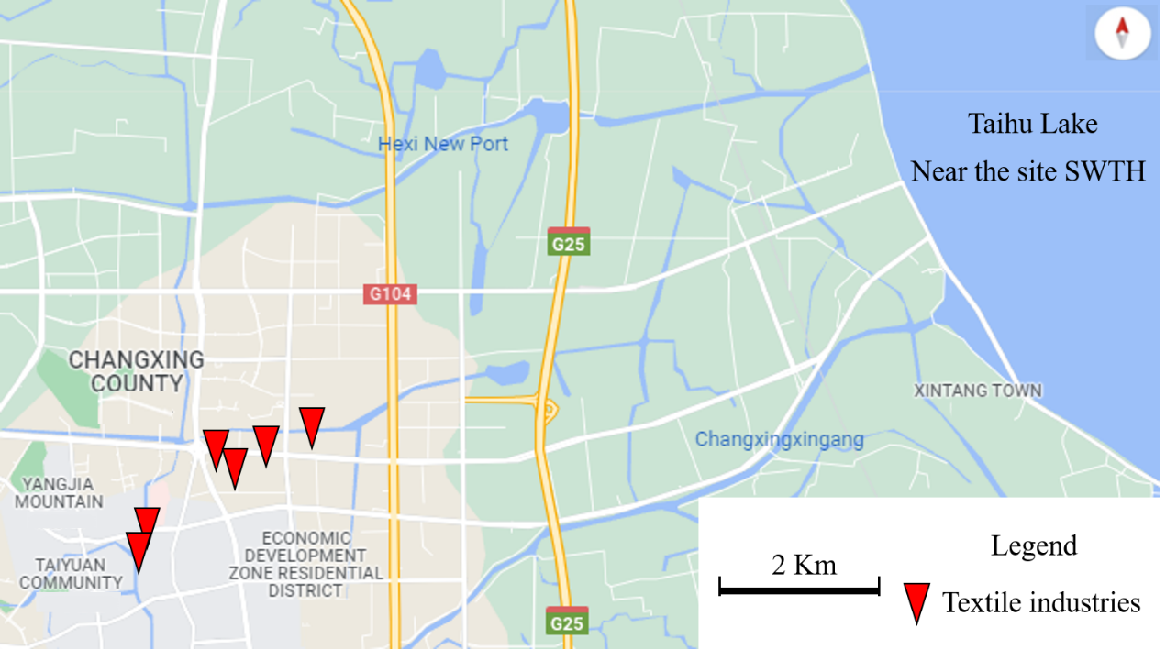

Figure S6 The geographical map around Changxing Town from Google Map. There are many textile industries (red triangle) in the economic development zone.

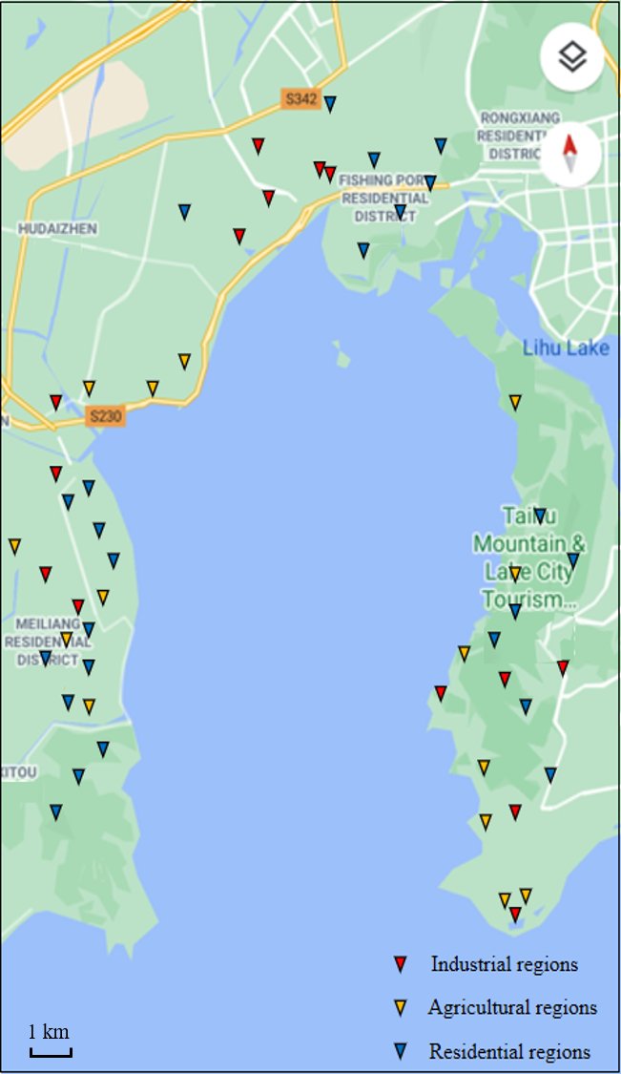

Figure S7 The geographical map around Meiliang Bay from Google Map. There are many industrial (red triangle), agricultural (yellow triangle) and residential area regions (blue triangle).

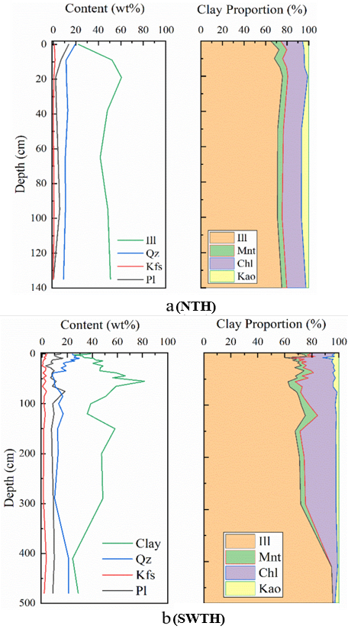
Figure S8 (a) Image of the abundance of clay minerals in the sediment of site NTH and (b) Image of the abundance of clay minerals in the sediment of site SWTH.

Table S1 Correspondence between shapes of microplastics and their colors, the scale bar is 20 μm.
