Supplemental Online Content

eData 1. Result of sensitivity analysis – Baseline
eData 2. Result of sensitivity analysis – The proportion of asymptomatic cases = 50%
eData 3. Result of sensitivity analysis – Varying contact rates at schools = 0.8 times from the baseline
eData 4. Result of sensitivity analysis – Varying contact rates at schools = 1.2 times from the baseline
eData 5. Result of sensitivity analysis – Vaccine efficacy = lower bound of 95% confidence interval
eData 6. Result of sensitivity analysis – Vaccine efficacy = upper bound of 95% confidence interval

eData 1. Result of sensitivity analysis – Baseline
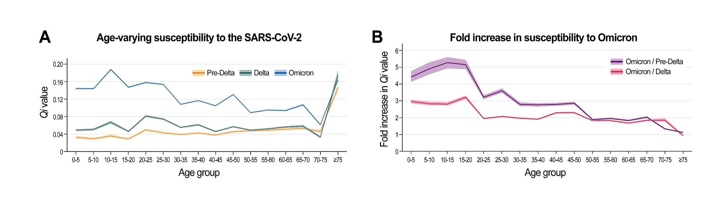

 | Pre-Delta |  |  |  | Delta |  |  |  | Omicron |  |  |  | Omicron/Delta |  |  |  | Omicron/Pre-Delta
 | 2.50% | 50% | 97.50% |  | 2.50% | 50% | 97.50% |  | 2.50% | 50% | 97.50% |  | 2.50% | 50% | 97.50% |  | 2.50% | 50% | 97.50%
[0,5) | 0.030 | 0.033 | 0.035 |  | 0.046 | 0.049 | 0.051 |  | 0.143 | 0.144 | 0.146 |  | 3.077 | 2.964 | 2.854 |  | 4.762 | 4.420 | 4.131
[5,10) | 0.027 | 0.029 | 0.032 |  | 0.048 | 0.051 | 0.053 |  | 0.142 | 0.144 | 0.145 |  | 2.946 | 2.831 | 2.741 |  | 5.294 | 4.923 | 4.578
[10,15) | 0.033 | 0.036 | 0.038 |  | 0.064 | 0.067 | 0.070 |  | 0.186 | 0.188 | 0.190 |  | 2.920 | 2.813 | 2.719 |  | 5.599 | 5.278 | 4.938
[15,20) | 0.027 | 0.029 | 0.030 |  | 0.044 | 0.046 | 0.048 |  | 0.146 | 0.147 | 0.149 |  | 3.310 | 3.213 | 3.120 |  | 5.448 | 5.157 | 4.895
[20,25) | 0.047 | 0.049 | 0.052 |  | 0.079 | 0.081 | 0.084 |  | 0.157 | 0.158 | 0.160 |  | 1.990 | 1.950 | 1.915 |  | 3.344 | 3.214 | 3.100
[25,30) | 0.041 | 0.043 | 0.044 |  | 0.072 | 0.074 | 0.077 |  | 0.152 | 0.154 | 0.155 |  | 2.107 | 2.068 | 2.027 |  | 3.742 | 3.611 | 3.489
[30,35) | 0.037 | 0.039 | 0.041 |  | 0.053 | 0.055 | 0.057 |  | 0.107 | 0.108 | 0.109 |  | 2.007 | 1.967 | 1.923 |  | 2.904 | 2.788 | 2.687
[35,40) | 0.040 | 0.042 | 0.044 |  | 0.059 | 0.061 | 0.063 |  | 0.116 | 0.117 | 0.118 |  | 1.950 | 1.908 | 1.873 |  | 2.865 | 2.763 | 2.665
[40,45) | 0.036 | 0.038 | 0.039 |  | 0.044 | 0.046 | 0.047 |  | 0.104 | 0.105 | 0.106 |  | 2.343 | 2.285 | 2.236 |  | 2.899 | 2.789 | 2.698
[45,50) | 0.044 | 0.046 | 0.048 |  | 0.055 | 0.057 | 0.058 |  | 0.129 | 0.130 | 0.132 |  | 2.354 | 2.304 | 2.259 |  | 2.955 | 2.862 | 2.766
[50,55) | 0.046 | 0.047 | 0.049 |  | 0.047 | 0.049 | 0.051 |  | 0.088 | 0.089 | 0.090 |  | 1.855 | 1.817 | 1.781 |  | 1.931 | 1.878 | 1.829
[55,60) | 0.047 | 0.049 | 0.051 |  | 0.050 | 0.052 | 0.054 |  | 0.094 | 0.095 | 0.096 |  | 1.860 | 1.826 | 1.787 |  | 2.000 | 1.948 | 1.903
[60,65) | 0.049 | 0.051 | 0.053 |  | 0.054 | 0.056 | 0.059 |  | 0.092 | 0.094 | 0.095 |  | 1.709 | 1.672 | 1.625 |  | 1.880 | 1.833 | 1.780
[65,70) | 0.050 | 0.053 | 0.055 |  | 0.055 | 0.058 | 0.061 |  | 0.105 | 0.107 | 0.109 |  | 1.897 | 1.841 | 1.783 |  | 2.092 | 2.030 | 1.962
[70,75) | 0.043 | 0.046 | 0.049 |  | 0.030 | 0.033 | 0.035 |  | 0.060 | 0.061 | 0.063 |  | 1.962 | 1.855 | 1.774 |  | 1.379 | 1.330 | 1.291
[75,+) | 0.141 | 0.147 | 0.153 |  | 0.166 | 0.176 | 0.187 |  | 0.161 | 0.164 | 0.166 |  | 0.972 | 0.933 | 0.892 |  | 1.144 | 1.118 | 1.087

eData 2. Result of sensitivity analysis – The proportion of asymptomatic cases = 50%
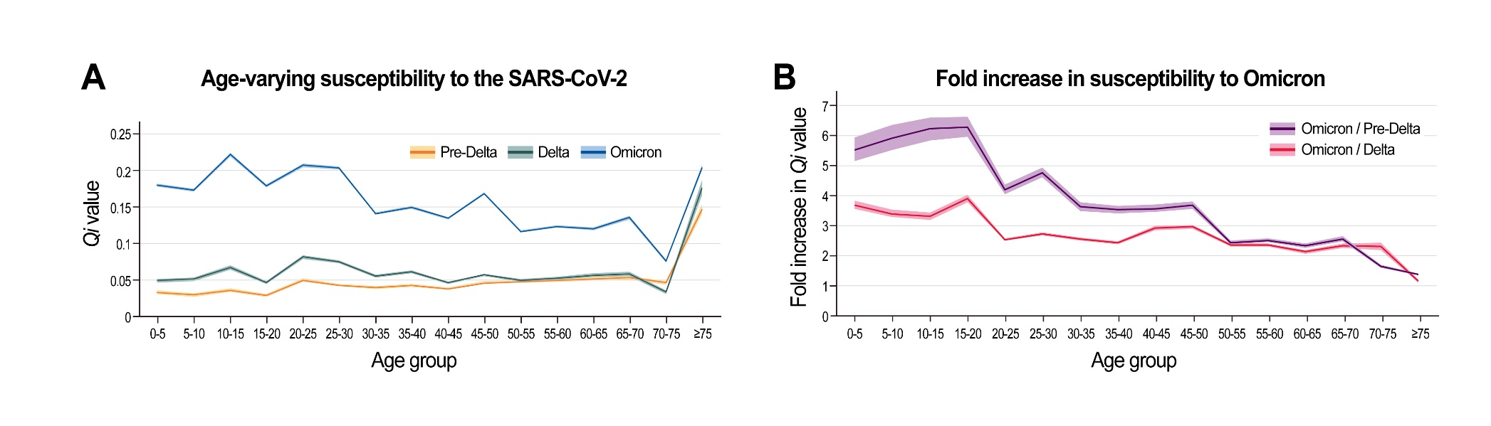

 | Pre-Delta |  |  |  | Delta |  |  |  | Omicron |  |  |  | Omicron/Delta |  |  |  | Omicron/Pre-Delta
 | 2.50% | 50% | 97.50% |  | 2.50% | 50% | 97.50% |  | 2.50% | 50% | 97.50% |  | 2.50% | 50% | 97.50% |  | 2.50% | 50% | 97.50%
[0,5) | 0.030 | 0.033 | 0.035 |  | 0.046 | 0.049 | 0.051 |  | 0.178 | 0.180 | 0.182 |  | 3.837 | 3.700 | 3.561 |  | 5.937 | 5.516 | 5.154
[5,10) | 0.027 | 0.029 | 0.032 |  | 0.048 | 0.051 | 0.053 |  | 0.171 | 0.173 | 0.175 |  | 3.535 | 3.403 | 3.300 |  | 6.352 | 5.917 | 5.512
[10,15) | 0.033 | 0.036 | 0.038 |  | 0.064 | 0.067 | 0.070 |  | 0.219 | 0.222 | 0.224 |  | 3.441 | 3.319 | 3.211 |  | 6.599 | 6.228 | 5.832
[15,20) | 0.027 | 0.029 | 0.030 |  | 0.044 | 0.046 | 0.048 |  | 0.177 | 0.179 | 0.181 |  | 4.028 | 3.913 | 3.797 |  | 6.630 | 6.280 | 5.958
[20,25) | 0.047 | 0.049 | 0.052 |  | 0.079 | 0.081 | 0.084 |  | 0.205 | 0.207 | 0.209 |  | 2.597 | 2.551 | 2.503 |  | 4.363 | 4.204 | 4.052
[25,30) | 0.041 | 0.043 | 0.044 |  | 0.072 | 0.074 | 0.077 |  | 0.201 | 0.203 | 0.205 |  | 2.786 | 2.737 | 2.682 |  | 4.947 | 4.778 | 4.615
[30,35) | 0.037 | 0.039 | 0.041 |  | 0.053 | 0.055 | 0.057 |  | 0.139 | 0.141 | 0.142 |  | 2.612 | 2.565 | 2.506 |  | 3.780 | 3.636 | 3.500
[35,40) | 0.040 | 0.042 | 0.044 |  | 0.059 | 0.061 | 0.063 |  | 0.148 | 0.149 | 0.151 |  | 2.494 | 2.444 | 2.396 |  | 3.664 | 3.540 | 3.411
[40,45) | 0.036 | 0.038 | 0.039 |  | 0.044 | 0.046 | 0.047 |  | 0.133 | 0.134 | 0.136 |  | 2.998 | 2.928 | 2.867 |  | 3.709 | 3.574 | 3.459
[45,50) | 0.044 | 0.046 | 0.048 |  | 0.055 | 0.057 | 0.058 |  | 0.167 | 0.168 | 0.170 |  | 3.039 | 2.976 | 2.917 |  | 3.813 | 3.697 | 3.572
[50,55) | 0.046 | 0.047 | 0.049 |  | 0.047 | 0.049 | 0.051 |  | 0.115 | 0.116 | 0.118 |  | 2.416 | 2.366 | 2.322 |  | 2.515 | 2.445 | 2.384
[55,60) | 0.047 | 0.049 | 0.051 |  | 0.050 | 0.052 | 0.054 |  | 0.121 | 0.123 | 0.124 |  | 2.412 | 2.360 | 2.312 |  | 2.593 | 2.518 | 2.461
[60,65) | 0.049 | 0.051 | 0.053 |  | 0.054 | 0.056 | 0.059 |  | 0.118 | 0.120 | 0.122 |  | 2.188 | 2.137 | 2.080 |  | 2.407 | 2.342 | 2.278
[65,70) | 0.050 | 0.053 | 0.055 |  | 0.055 | 0.058 | 0.061 |  | 0.133 | 0.135 | 0.138 |  | 2.406 | 2.331 | 2.258 |  | 2.654 | 2.571 | 2.485
[70,75) | 0.043 | 0.046 | 0.049 |  | 0.030 | 0.033 | 0.035 |  | 0.074 | 0.076 | 0.078 |  | 2.438 | 2.307 | 2.197 |  | 1.713 | 1.654 | 1.599
[75,+) | 0.141 | 0.147 | 0.153 |  | 0.166 | 0.176 | 0.187 |  | 0.200 | 0.204 | 0.207 |  | 1.208 | 1.159 | 1.109 |  | 1.423 | 1.390 | 1.353

eData 3. Result of sensitivity analysis – Varying contact rates at schools = 0.8 times from the baseline
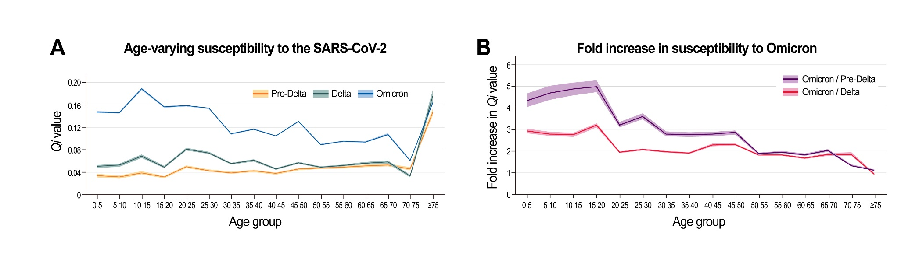

 | Pre-Delta |  |  |  | Delta |  |  |  | Omicron |  |  |  | Omicron/Delta |  |  |  | Omicron/Pre-Delta
 | 2.50% | 50% | 97.50% |  | 2.50% | 50% | 97.50% |  | 2.50% | 50% | 97.50% |  | 2.50% | 50% | 97.50% |  | 2.50% | 50% | 97.50%
[0,5) | 0.031 | 0.034 | 0.037 |  | 0.048 | 0.050 | 0.053 |  | 0.145 | 0.147 | 0.149 |  | 3.049 | 2.938 | 2.823 |  | 4.674 | 4.334 | 4.045
[5,10) | 0.029 | 0.031 | 0.034 |  | 0.050 | 0.053 | 0.055 |  | 0.145 | 0.146 | 0.148 |  | 2.896 | 2.789 | 2.705 |  | 5.041 | 4.696 | 4.375
[10,15) | 0.036 | 0.039 | 0.042 |  | 0.065 | 0.068 | 0.072 |  | 0.187 | 0.189 | 0.191 |  | 2.859 | 2.759 | 2.664 |  | 5.183 | 4.891 | 4.583
[15,20) | 0.029 | 0.031 | 0.033 |  | 0.047 | 0.049 | 0.051 |  | 0.155 | 0.157 | 0.158 |  | 3.300 | 3.205 | 3.107 |  | 5.290 | 5.002 | 4.740
[20,25) | 0.047 | 0.049 | 0.052 |  | 0.079 | 0.081 | 0.084 |  | 0.157 | 0.159 | 0.160 |  | 1.995 | 1.953 | 1.915 |  | 3.350 | 3.219 | 3.103
[25,30) | 0.041 | 0.043 | 0.044 |  | 0.072 | 0.074 | 0.077 |  | 0.152 | 0.154 | 0.155 |  | 2.108 | 2.070 | 2.028 |  | 3.743 | 3.616 | 3.491
[30,35) | 0.037 | 0.039 | 0.041 |  | 0.053 | 0.055 | 0.057 |  | 0.107 | 0.108 | 0.109 |  | 2.010 | 1.971 | 1.925 |  | 2.908 | 2.795 | 2.689
[35,40) | 0.040 | 0.042 | 0.044 |  | 0.059 | 0.061 | 0.063 |  | 0.116 | 0.117 | 0.118 |  | 1.951 | 1.911 | 1.871 |  | 2.867 | 2.768 | 2.665
[40,45) | 0.036 | 0.038 | 0.039 |  | 0.044 | 0.046 | 0.047 |  | 0.104 | 0.105 | 0.106 |  | 2.344 | 2.284 | 2.231 |  | 2.901 | 2.789 | 2.693
[45,50) | 0.044 | 0.046 | 0.048 |  | 0.055 | 0.057 | 0.058 |  | 0.129 | 0.130 | 0.132 |  | 2.351 | 2.303 | 2.260 |  | 2.951 | 2.862 | 2.768
[50,55) | 0.046 | 0.047 | 0.049 |  | 0.047 | 0.049 | 0.051 |  | 0.088 | 0.089 | 0.090 |  | 1.856 | 1.816 | 1.782 |  | 1.932 | 1.877 | 1.831
[55,60) | 0.047 | 0.049 | 0.051 |  | 0.050 | 0.052 | 0.054 |  | 0.094 | 0.095 | 0.096 |  | 1.862 | 1.827 | 1.788 |  | 2.002 | 1.949 | 1.904
[60,65) | 0.049 | 0.051 | 0.053 |  | 0.054 | 0.056 | 0.059 |  | 0.093 | 0.094 | 0.095 |  | 1.714 | 1.672 | 1.627 |  | 1.885 | 1.832 | 1.783
[65,70) | 0.050 | 0.053 | 0.055 |  | 0.055 | 0.058 | 0.061 |  | 0.105 | 0.107 | 0.109 |  | 1.907 | 1.842 | 1.789 |  | 2.102 | 2.032 | 1.970
[70,75) | 0.043 | 0.046 | 0.049 |  | 0.030 | 0.033 | 0.035 |  | 0.060 | 0.061 | 0.063 |  | 1.959 | 1.852 | 1.772 |  | 1.376 | 1.328 | 1.290
[75,+) | 0.141 | 0.147 | 0.153 |  | 0.166 | 0.176 | 0.187 |  | 0.162 | 0.164 | 0.166 |  | 0.975 | 0.932 | 0.891 |  | 1.148 | 1.117 | 1.087

eData 4. Result of sensitivity analysis – Varying contact rates at schools = 1.2 times from the baseline
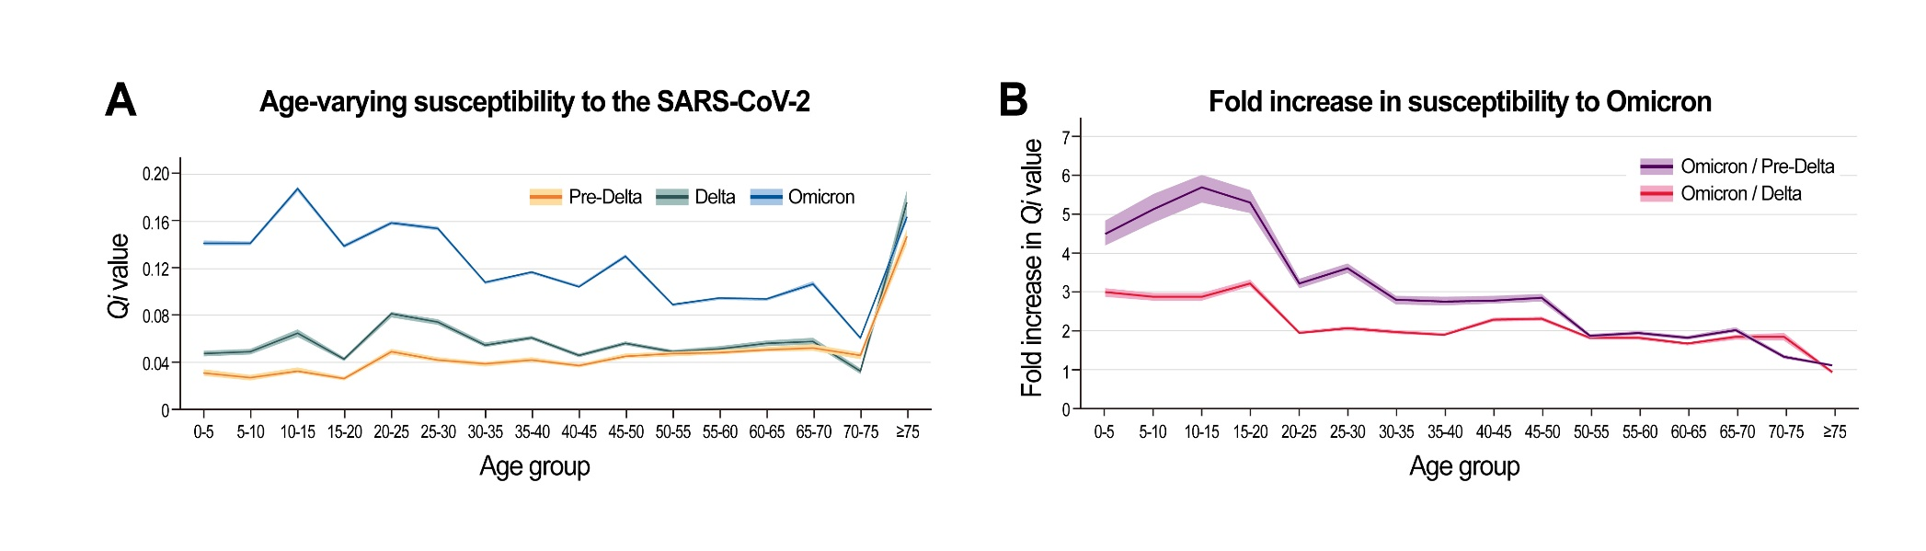

 | Pre-Delta |  |  |  | Delta |  |  |  | Omicron |  |  |  | Omicron/Delta |  |  |  | Omicron/Pre-Delta
 | 2.50% | 50% | 97.50% |  | 2.50% | 50% | 97.50% |  | 2.50% | 50% | 97.50% |  | 2.50% | 50% | 97.50% |  | 2.50% | 50% | 97.50%
[0,5) | 0.029 | 0.032 | 0.034 |  | 0.045 | 0.047 | 0.050 |  | 0.140 | 0.142 | 0.143 |  | 3.097 | 2.988 | 2.880 |  | 4.837 | 4.494 | 4.206
[5,10) | 0.025 | 0.027 | 0.030 |  | 0.047 | 0.049 | 0.051 |  | 0.139 | 0.141 | 0.143 |  | 2.985 | 2.871 | 2.780 |  | 5.522 | 5.139 | 4.788
[10,15) | 0.031 | 0.033 | 0.036 |  | 0.062 | 0.065 | 0.068 |  | 0.185 | 0.187 | 0.189 |  | 2.980 | 2.872 | 2.773 |  | 6.015 | 5.679 | 5.309
[15,20) | 0.025 | 0.026 | 0.028 |  | 0.041 | 0.043 | 0.045 |  | 0.137 | 0.139 | 0.140 |  | 3.327 | 3.229 | 3.136 |  | 5.610 | 5.302 | 5.022
[20,25) | 0.047 | 0.049 | 0.052 |  | 0.079 | 0.081 | 0.084 |  | 0.157 | 0.159 | 0.160 |  | 1.991 | 1.953 | 1.915 |  | 3.343 | 3.216 | 3.100
[25,30) | 0.041 | 0.043 | 0.045 |  | 0.072 | 0.074 | 0.077 |  | 0.152 | 0.154 | 0.155 |  | 2.109 | 2.069 | 2.028 |  | 3.743 | 3.611 | 3.487
[30,35) | 0.037 | 0.039 | 0.041 |  | 0.053 | 0.055 | 0.057 |  | 0.107 | 0.108 | 0.109 |  | 2.009 | 1.970 | 1.922 |  | 2.906 | 2.793 | 2.685
[35,40) | 0.040 | 0.042 | 0.044 |  | 0.059 | 0.061 | 0.063 |  | 0.116 | 0.117 | 0.118 |  | 1.952 | 1.909 | 1.870 |  | 2.868 | 2.763 | 2.661
[40,45) | 0.036 | 0.038 | 0.039 |  | 0.044 | 0.046 | 0.047 |  | 0.104 | 0.105 | 0.106 |  | 2.341 | 2.284 | 2.235 |  | 2.895 | 2.787 | 2.697
[45,50) | 0.044 | 0.046 | 0.048 |  | 0.055 | 0.057 | 0.058 |  | 0.129 | 0.130 | 0.132 |  | 2.354 | 2.303 | 2.260 |  | 2.953 | 2.860 | 2.765
[50,55) | 0.046 | 0.047 | 0.049 |  | 0.047 | 0.049 | 0.051 |  | 0.088 | 0.089 | 0.090 |  | 1.857 | 1.820 | 1.782 |  | 1.933 | 1.880 | 1.829
[55,60) | 0.047 | 0.049 | 0.051 |  | 0.050 | 0.052 | 0.054 |  | 0.094 | 0.095 | 0.096 |  | 1.863 | 1.824 | 1.783 |  | 2.002 | 1.945 | 1.899
[60,65) | 0.049 | 0.051 | 0.053 |  | 0.054 | 0.056 | 0.059 |  | 0.092 | 0.094 | 0.095 |  | 1.708 | 1.670 | 1.622 |  | 1.879 | 1.830 | 1.777
[65,70) | 0.050 | 0.053 | 0.055 |  | 0.055 | 0.058 | 0.061 |  | 0.105 | 0.107 | 0.109 |  | 1.899 | 1.841 | 1.784 |  | 2.094 | 2.029 | 1.964
[70,75) | 0.043 | 0.046 | 0.049 |  | 0.030 | 0.033 | 0.035 |  | 0.060 | 0.061 | 0.062 |  | 1.959 | 1.853 | 1.763 |  | 1.376 | 1.328 | 1.283
[75,+) | 0.141 | 0.147 | 0.153 |  | 0.166 | 0.176 | 0.187 |  | 0.160 | 0.164 | 0.167 |  | 0.968 | 0.931 | 0.893 |  | 1.140 | 1.116 | 1.089

eData 5. Result of sensitivity analysis – Vaccine efficacy = lower bound of 95% confidence interval
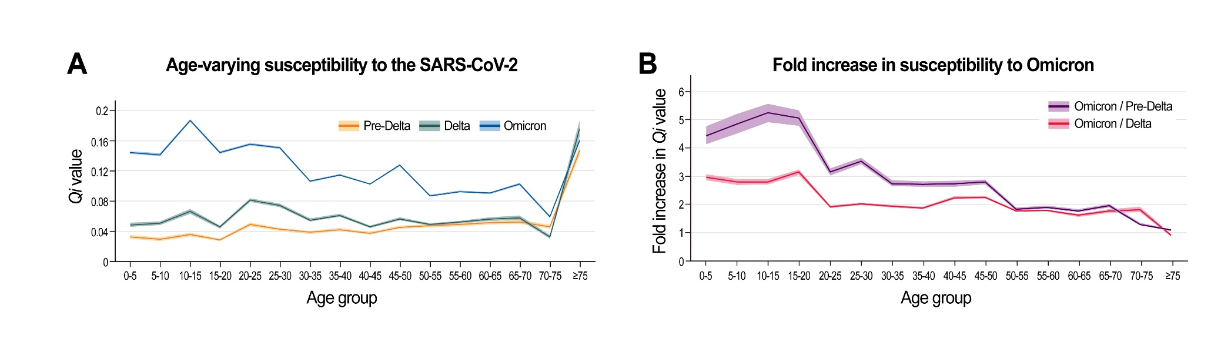

 | Pre-Delta |  |  |  | Delta |  |  |  | Omicron |  |  |  | Omicron/Delta |  |  |  | Omicron/Pre-Delta
 | 2.50% | 50% | 97.50% |  | 2.50% | 50% | 97.50% |  | 2.50% | 50% | 97.50% |  | 2.50% | 50% | 97.50% |  | 2.50% | 50% | 97.50%
[0,5) | 0.030 | 0.033 | 0.035 |  | 0.046 | 0.049 | 0.051 |  | 0.143 | 0.144 | 0.146 |  | 3.080 | 2.966 | 2.856 |  | 4.766 | 4.423 | 4.133
[5,10) | 0.027 | 0.029 | 0.032 |  | 0.048 | 0.051 | 0.053 |  | 0.140 | 0.141 | 0.143 |  | 2.896 | 2.788 | 2.702 |  | 5.204 | 4.847 | 4.513
[10,15) | 0.033 | 0.036 | 0.038 |  | 0.064 | 0.067 | 0.070 |  | 0.185 | 0.187 | 0.189 |  | 2.907 | 2.797 | 2.705 |  | 5.575 | 5.248 | 4.912
[15,20) | 0.027 | 0.029 | 0.030 |  | 0.044 | 0.046 | 0.048 |  | 0.143 | 0.144 | 0.146 |  | 3.241 | 3.151 | 3.057 |  | 5.335 | 5.058 | 4.797
[20,25) | 0.047 | 0.049 | 0.052 |  | 0.079 | 0.081 | 0.084 |  | 0.154 | 0.155 | 0.157 |  | 1.949 | 1.910 | 1.874 |  | 3.274 | 3.148 | 3.034
[25,30) | 0.041 | 0.043 | 0.044 |  | 0.072 | 0.074 | 0.077 |  | 0.149 | 0.151 | 0.152 |  | 2.065 | 2.027 | 1.986 |  | 3.666 | 3.539 | 3.417
[30,35) | 0.037 | 0.039 | 0.041 |  | 0.053 | 0.055 | 0.057 |  | 0.105 | 0.106 | 0.107 |  | 1.972 | 1.934 | 1.890 |  | 2.854 | 2.741 | 2.641
[35,40) | 0.040 | 0.042 | 0.044 |  | 0.059 | 0.061 | 0.063 |  | 0.114 | 0.115 | 0.116 |  | 1.919 | 1.876 | 1.841 |  | 2.820 | 2.717 | 2.621
[40,45) | 0.036 | 0.038 | 0.039 |  | 0.044 | 0.046 | 0.047 |  | 0.102 | 0.102 | 0.104 |  | 2.295 | 2.233 | 2.185 |  | 2.839 | 2.726 | 2.637
[45,50) | 0.044 | 0.046 | 0.048 |  | 0.055 | 0.057 | 0.058 |  | 0.126 | 0.128 | 0.129 |  | 2.300 | 2.254 | 2.209 |  | 2.886 | 2.800 | 2.705
[50,55) | 0.046 | 0.047 | 0.049 |  | 0.047 | 0.049 | 0.051 |  | 0.086 | 0.087 | 0.088 |  | 1.814 | 1.778 | 1.742 |  | 1.888 | 1.837 | 1.789
[55,60) | 0.047 | 0.049 | 0.051 |  | 0.050 | 0.052 | 0.054 |  | 0.091 | 0.093 | 0.094 |  | 1.817 | 1.780 | 1.741 |  | 1.954 | 1.899 | 1.854
[60,65) | 0.049 | 0.051 | 0.053 |  | 0.054 | 0.056 | 0.059 |  | 0.090 | 0.091 | 0.092 |  | 1.657 | 1.615 | 1.568 |  | 1.823 | 1.770 | 1.717
[65,70) | 0.050 | 0.053 | 0.055 |  | 0.055 | 0.058 | 0.061 |  | 0.101 | 0.103 | 0.105 |  | 1.828 | 1.768 | 1.716 |  | 2.017 | 1.950 | 1.888
[70,75) | 0.043 | 0.046 | 0.049 |  | 0.030 | 0.033 | 0.035 |  | 0.058 | 0.059 | 0.061 |  | 1.910 | 1.805 | 1.727 |  | 1.342 | 1.294 | 1.257
[75,+) | 0.141 | 0.147 | 0.153 |  | 0.166 | 0.176 | 0.187 |  | 0.158 | 0.160 | 0.163 |  | 0.951 | 0.912 | 0.873 |  | 1.119 | 1.093 | 1.065

eData 6. Result of sensitivity analysis – Vaccine efficacy = upper bound of 95% confidence interval
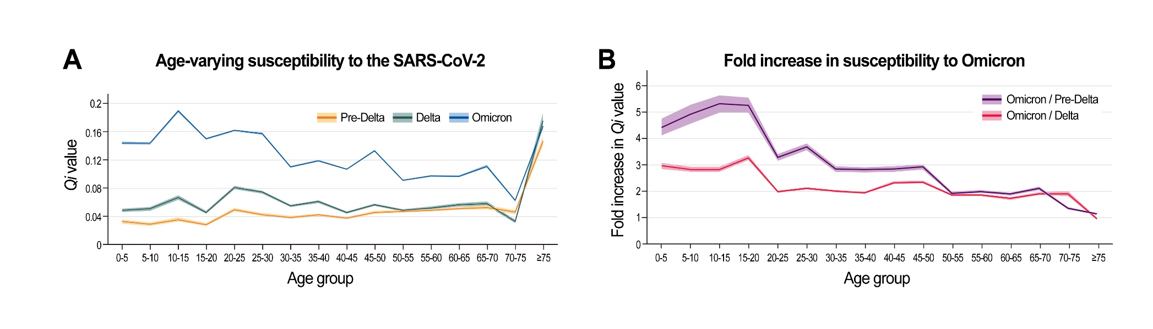

 | Pre-Delta |  |  |  | Delta |  |  |  | Omicron |  |  |  | Omicron/Delta |  |  |  | Omicron/Pre-Delta
 | 2.50% | 50% | 97.50% |  | 2.50% | 50% | 97.50% |  | 2.50% | 50% | 97.50% |  | 2.50% | 50% | 97.50% |  | 2.50% | 50% | 97.50%
[0,5) | 0.030 | 0.033 | 0.035 |  | 0.046 | 0.049 | 0.051 |  | 0.143 | 0.144 | 0.146 |  | 3.078 | 2.964 | 2.852 |  | 4.763 | 4.419 | 4.128
[5,10) | 0.027 | 0.029 | 0.032 |  | 0.048 | 0.051 | 0.053 |  | 0.142 | 0.144 | 0.145 |  | 2.939 | 2.828 | 2.735 |  | 5.282 | 4.918 | 4.568
[10,15) | 0.033 | 0.036 | 0.038 |  | 0.064 | 0.067 | 0.070 |  | 0.187 | 0.189 | 0.191 |  | 2.940 | 2.834 | 2.743 |  | 5.639 | 5.317 | 4.982
[15,20) | 0.027 | 0.029 | 0.030 |  | 0.044 | 0.046 | 0.048 |  | 0.148 | 0.150 | 0.151 |  | 3.374 | 3.277 | 3.175 |  | 5.553 | 5.259 | 4.981
[20,25) | 0.047 | 0.049 | 0.052 |  | 0.079 | 0.081 | 0.084 |  | 0.160 | 0.162 | 0.163 |  | 2.033 | 1.992 | 1.953 |  | 3.416 | 3.283 | 3.161
[25,30) | 0.041 | 0.043 | 0.044 |  | 0.072 | 0.074 | 0.077 |  | 0.156 | 0.157 | 0.159 |  | 2.153 | 2.113 | 2.072 |  | 3.822 | 3.689 | 3.566
[30,35) | 0.037 | 0.039 | 0.041 |  | 0.053 | 0.055 | 0.057 |  | 0.109 | 0.110 | 0.111 |  | 2.045 | 2.004 | 1.957 |  | 2.960 | 2.841 | 2.734
[35,40) | 0.040 | 0.042 | 0.044 |  | 0.059 | 0.061 | 0.063 |  | 0.118 | 0.119 | 0.120 |  | 1.986 | 1.946 | 1.906 |  | 2.918 | 2.819 | 2.712
[40,45) | 0.036 | 0.038 | 0.039 |  | 0.044 | 0.046 | 0.047 |  | 0.106 | 0.107 | 0.108 |  | 2.392 | 2.331 | 2.280 |  | 2.960 | 2.845 | 2.751
[45,50) | 0.044 | 0.046 | 0.048 |  | 0.055 | 0.057 | 0.058 |  | 0.132 | 0.133 | 0.135 |  | 2.408 | 2.352 | 2.307 |  | 3.022 | 2.921 | 2.825
[50,55) | 0.046 | 0.047 | 0.049 |  | 0.047 | 0.049 | 0.051 |  | 0.090 | 0.091 | 0.092 |  | 1.902 | 1.861 | 1.824 |  | 1.980 | 1.923 | 1.873
[55,60) | 0.047 | 0.049 | 0.051 |  | 0.050 | 0.052 | 0.054 |  | 0.096 | 0.097 | 0.098 |  | 1.908 | 1.867 | 1.826 |  | 2.051 | 1.991 | 1.944
[60,65) | 0.049 | 0.051 | 0.053 |  | 0.054 | 0.056 | 0.059 |  | 0.096 | 0.097 | 0.098 |  | 1.774 | 1.728 | 1.680 |  | 1.951 | 1.894 | 1.840
[65,70) | 0.050 | 0.053 | 0.055 |  | 0.055 | 0.058 | 0.061 |  | 0.109 | 0.111 | 0.113 |  | 1.973 | 1.911 | 1.853 |  | 2.176 | 2.108 | 2.040
[70,75) | 0.043 | 0.046 | 0.049 |  | 0.030 | 0.033 | 0.035 |  | 0.061 | 0.062 | 0.064 |  | 2.004 | 1.898 | 1.810 |  | 1.408 | 1.361 | 1.317
[75,+) | 0.141 | 0.147 | 0.153 |  | 0.166 | 0.176 | 0.187 |  | 0.164 | 0.167 | 0.169 |  | 0.991 | 0.951 | 0.908 |  | 1.167 | 1.140 | 1.107

