Supplementary material
Drug sensitivity and working concentration of Fer-1 against PC12 cells
PC12 cells were treated with Fer-1 at various concentrations for 24h, and the viability of PC12 cells was significantly decreased with the increase of Fer-1 concentration (≥40mM), and the difference was statistically significant compared with the control group (P<0.05) (Figure S1a). Figure S1b shows the effect of low Fer-1 concentration on PC12 cell viability induced by Aβ₂₅₋₃₅. When Fer-1 concentration was 5μmM, PC12 cell viability was significantly increased compared to the model group, and the difference was statistically significant (P<0.05).
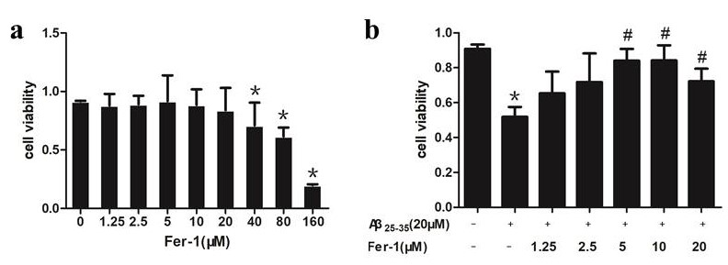
Figure S1. a: The cell viability of PC12 cells subjected to different concentrations of Fer-1 by CKK8 assay; b: Effects of different concentrations of Fer-1 on the viability of PC12 cells induced by Aβ₂₅₋₃₅ by CKK8 assay. Data are mean ± SEM from three independent experiments.*P<0.05 vs. control, #P<0.05 vs model group.

Drug sensitivity and working concentration of Sen in PC12 cells
After treated with various dose of Sen for 24h, the cell viability of PC12 cells was promoted by low concentration and inhibited by high concentration of Sen. With the further increase of Sen concentration (≥480 μM), the cell viability of PC12 cells was significantly decreased, and the difference was statistically significant compared with the control group (P<0.05) (Figure S2a). Figure S2b shows the effect of low concentration of Sen on the viability of PC12 cells induced by Aβ₂₅₋₃₅. When the concentration of Sen was 60 μM, the viability of PC12 cells was significantly increased compared with the model group, with statistical significance (P<0.05).
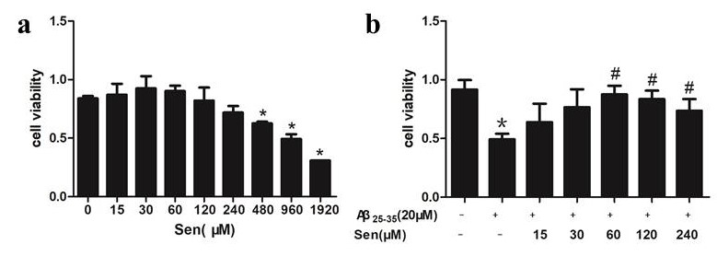
Figure S2. a: The cell viability of PC12 cells subjected to different concentrations of Sen by CKK-8 assay. b: Effects of different concentrations of Sen on the viability of PC12 cells induced by Aβ₂₅₋₃₅ by CKK-8 assay. Data are mean ± SEM from three independent experiments.*P<0.05 vs. control, #P<0.05 vs model group.

