Supporting Information
Ultralight and superelastic nanofiber aerogels with in-situ loaded polypyrrole for high-efficient Cr(VI) adsorption

Dan Li · Huipeng Liu · Ziwen Wang · Zeqian Zhang · Chengzhong Wang* · Biao Zhao · Kai Pan*

Beijing University of Chemical Technology, Beijing 100029, China; Beijing Key Laboratory of Advanced Functional Polymer Composites, Beijing 100029, China

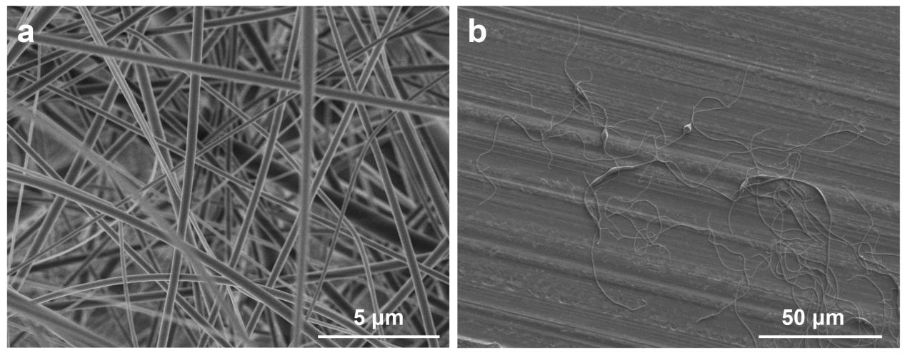
Fig. S1. SEM images of (a) the CA nanofibers prepared by electrospinning, and (b) the short CA nanofibers that dispersed into deionized water

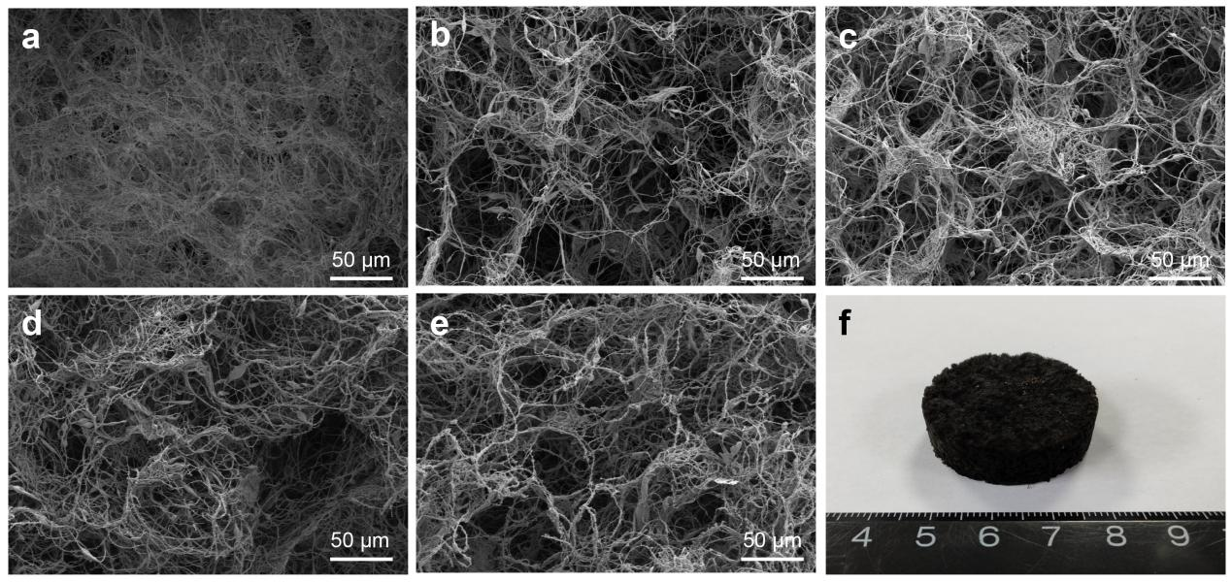
Fig. S2. SEM images of different pore structures of aerogels with pyrrole:APS mole ratio of is (a) 0, (b) 0.5:1, (c) 1:1, (d) 2:1, (e) 3:1, (f) 5:1.

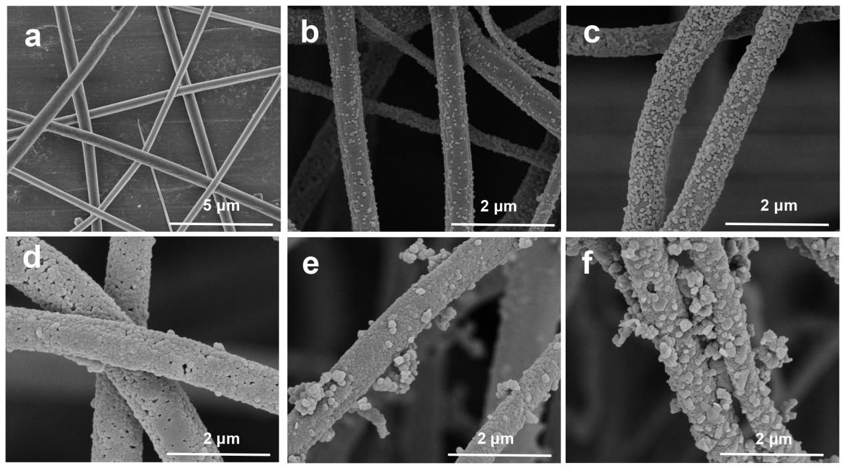
Fig. S3. SEM images of different nanofiber surface coating when pyrrole:APS mole ratio is (a) 0, (b) 0.5:1, (c) 1:1, (d) 2:1, (e) 3:1, (f) 5:1.

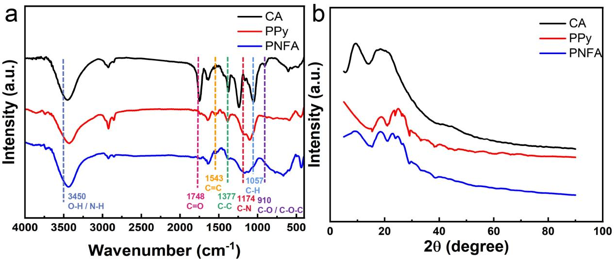
Fig. S4. (a) FTIR spectra, and (b) XRD patterns of CA nanofiber, PPy and PNFA.

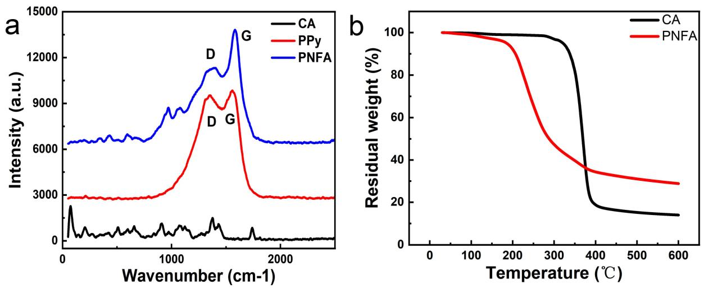
Fig. S5. (a) Raman spectra of CA nanofiber, PPy and PNFA, and (b) TG curves of CA nanofiber and PNFA in nitrogen.

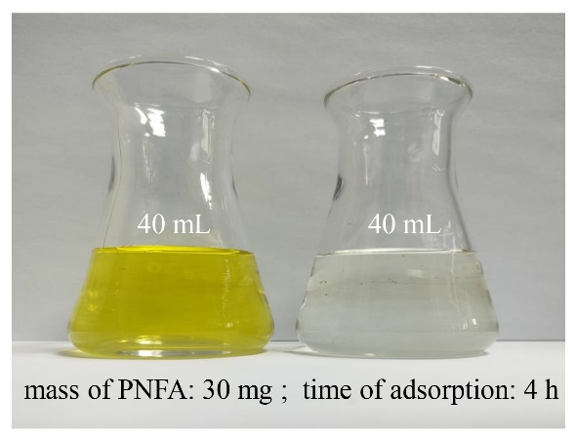
Fig. S6. Digital photos of Cr(VI) solution before and after adsorption.

