Supplementary Figure
Figure S1. Modeling and evaluation of TMEM16A structure. A and C. "Local quality estimate" of the TMEM16A structure in the Ca²⁺-free and Ca²⁺-bound states obtained by the QMEANBrane method. B and D. TMEM16A Ramachandran plot of Ca²⁺-free and Ca²⁺-bound states.
Figure S2. The pore size of TMEM16A at 100 ns at different voltages. A and B. Pore map of Ca²⁺-free and Ca²⁺-bound TMEM16A.

Figure S1
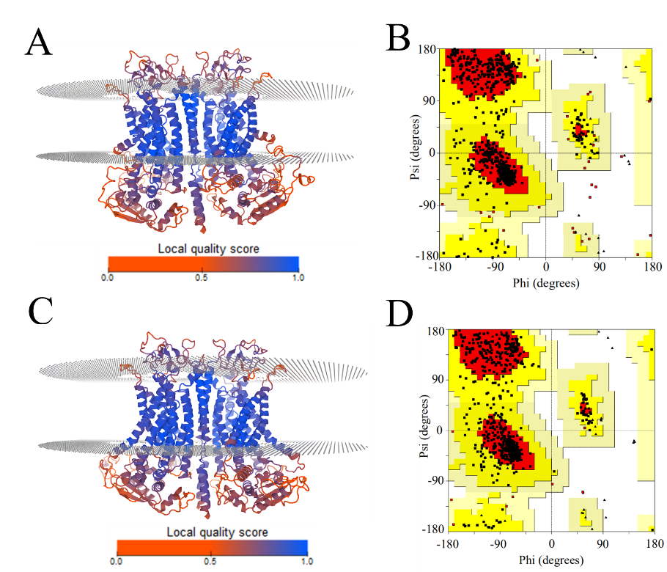

Figure S2
