Pubmed
- Mediterranean Diet
- Diets, Mediterranean
- Mediterranean Diets
- Diabetes Mellitus, Noninsulin-Dependent
- Diabetes Mellitus, Ketosis-Resistant
- Diabetes Mellitus, Ketosis Resistant
- Ketosis-Resistant Diabetes Mellitus
- Diabetes Mellitus, Non Insulin Dependent
- Diabetes Mellitus, Non-Insulin-Dependent
- Non-Insulin-Dependent Diabetes Mellitus
- Diabetes Mellitus, Stable
- Stable Diabetes Mellitus
- Diabetes Mellitus, Type II
- NIDDM
- Diabetes Mellitus, Noninsulin Dependent
- Diabetes Mellitus, Maturity-Onset
- Diabetes Mellitus, Maturity Onset
- Maturity-Onset Diabetes Mellitus
- Maturity Onset Diabetes Mellitus
- MODY
- Diabetes Mellitus, Slow-Onset
- Diabetes Mellitus, Slow Onset
- Slow-Onset Diabetes Mellitus
- Type 2 Diabetes Mellitus
- Noninsulin-Dependent Diabetes Mellitus
- Noninsulin Dependent Diabetes Mellitus
- Maturity-Onset Diabetes
- Diabetes, Maturity-Onset
- Maturity Onset Diabetes
- Type 2 Diabetes
- Diabetes, Type 2
- Diabetes Mellitus, Adult-Onset
- Adult-Onset Diabetes Mellitus
- Diabetes Mellitus, Adult Onset

#9 |  |  | Search: (("Diet, Mediterranean"[Mesh]) OR (((Mediterranean Diets[Title/Abstract]) OR (Diets, Mediterranean[Title/Abstract])) OR (Mediterranean Diet[Title/Abstract]))) AND (("Diabetes Mellitus, Type 2"[Mesh]) OR (((((((((((((((((((((((((((((((Diabetes Mellitus, Noninsulin-Dependent[Title/Abstract]) OR (Diabetes Mellitus, Ketosis-Resistant[Title/Abstract])) OR (Diabetes Mellitus, Ketosis Resistant[Title/Abstract])) OR (Ketosis-Resistant Diabetes Mellitus[Title/Abstract])) OR (Diabetes Mellitus, Non Insulin Dependent[Title/Abstract])) OR (Diabetes Mellitus, Non-Insulin-Dependent[Title/Abstract])) OR (Non-Insulin-Dependent Diabetes Mellitus[Title/Abstract])) OR (Diabetes Mellitus, Stable[Title/Abstract])) OR (Stable Diabetes Mellitus[Title/Abstract])) OR (Diabetes Mellitus, Type II[Title/Abstract])) OR (NIDDM[Title/Abstract])) OR (Diabetes Mellitus, Noninsulin Dependent[Title/Abstract])) OR (Diabetes Mellitus, Maturity-Onset[Title/Abstract])) OR (Diabetes Mellitus, Maturity Onset[Title/Abstract])) OR (Maturity-Onset Diabetes Mellitus[Title/Abstract])) OR (Maturity Onset Diabetes Mellitus[Title/Abstract])) OR (MODY[Title/Abstract])) OR (Diabetes Mellitus, Slow-Onset[Title/Abstract])) OR (Diabetes Mellitus, Slow Onset[Title/Abstract])) OR (Slow-Onset Diabetes Mellitus[Title/Abstract])) OR (Type 2 Diabetes Mellitus[Title/Abstract])) OR (Noninsulin-Dependent Diabetes Mellitus[Title/Abstract])) OR (Noninsulin Dependent Diabetes Mellitus[Title/Abstract])) OR (Maturity-Onset Diabetes[Title/Abstract])) OR (Diabetes, Maturity-Onset[Title/Abstract])) OR (Maturity Onset Diabetes[Title/Abstract])) OR (Type 2 Diabetes[Title/Abstract])) OR (Diabetes, Type 2[Title/Abstract])) OR (Diabetes Mellitus, Adult-Onset[Title/Abstract])) OR (Adult-Onset Diabetes Mellitus[Title/Abstract])) OR (Diabetes Mellitus, Adult Onset[Title/Abstract]))) | 524 | 13:53:36
#8 |  |  | Search: ((("Diet, Mediterranean"[Mesh]) OR (((Mediterranean Diets[Title/Abstract]) OR (Diets, Mediterranean[Title/Abstract])) OR (Mediterranean Diet[Title/Abstract]))) AND (("Diabetes Mellitus, Type 2"[Mesh]) OR (((((((((((((((((((((((((((((((Diabetes Mellitus, Noninsulin-Dependent[Title/Abstract]) OR (Diabetes Mellitus, Ketosis-Resistant[Title/Abstract])) OR (Diabetes Mellitus, Ketosis Resistant[Title/Abstract])) OR (Ketosis-Resistant Diabetes Mellitus[Title/Abstract])) OR (Diabetes Mellitus, Non Insulin Dependent[Title/Abstract])) OR (Diabetes Mellitus, Non-Insulin-Dependent[Title/Abstract])) OR (Non-Insulin-Dependent Diabetes Mellitus[Title/Abstract])) OR (Diabetes Mellitus, Stable[Title/Abstract])) OR (Stable Diabetes Mellitus[Title/Abstract])) OR (Diabetes Mellitus, Type II[Title/Abstract])) OR (NIDDM[Title/Abstract])) OR (Diabetes Mellitus, Noninsulin Dependent[Title/Abstract])) OR (Diabetes Mellitus, Maturity-Onset[Title/Abstract])) OR (Diabetes Mellitus, Maturity Onset[Title/Abstract])) OR (Maturity-Onset Diabetes Mellitus[Title/Abstract])) OR (Maturity Onset Diabetes Mellitus[Title/Abstract])) OR (MODY[Title/Abstract])) OR (Diabetes Mellitus, Slow-Onset[Title/Abstract])) OR (Diabetes Mellitus, Slow Onset[Title/Abstract])) OR (Slow-Onset Diabetes Mellitus[Title/Abstract])) OR (Type 2 Diabetes Mellitus[Title/Abstract])) OR (Noninsulin-Dependent Diabetes Mellitus[Title/Abstract])) OR (Noninsulin Dependent Diabetes Mellitus[Title/Abstract])) OR (Maturity-Onset Diabetes[Title/Abstract])) OR (Diabetes, Maturity-Onset[Title/Abstract])) OR (Maturity Onset Diabetes[Title/Abstract])) OR (Type 2 Diabetes[Title/Abstract])) OR (Diabetes, Type 2[Title/Abstract])) OR (Diabetes Mellitus, Adult-Onset[Title/Abstract])) OR (Adult-Onset Diabetes Mellitus[Title/Abstract])) OR (Diabetes Mellitus, Adult Onset[Title/Abstract])))) AND (randomized controlled trial[Publication Type] OR randomized[Title/Abstract] OR placebo[Title/Abstract]) | 139 | 13:50:46
#7 |  |  | Search: randomized controlled trial[Publication Type] OR randomized[Title/Abstract] OR placebo[Title/Abstract] | 927,315 | 13:49:51
#6 |  |  | Search: ("Diabetes Mellitus, Type 2"[Mesh]) OR (((((((((((((((((((((((((((((((Diabetes Mellitus, Noninsulin-Dependent[Title/Abstract]) OR (Diabetes Mellitus, Ketosis-Resistant[Title/Abstract])) OR (Diabetes Mellitus, Ketosis Resistant[Title/Abstract])) OR (Ketosis-Resistant Diabetes Mellitus[Title/Abstract])) OR (Diabetes Mellitus, Non Insulin Dependent[Title/Abstract])) OR (Diabetes Mellitus, Non-Insulin-Dependent[Title/Abstract])) OR (Non-Insulin-Dependent Diabetes Mellitus[Title/Abstract])) OR (Diabetes Mellitus, Stable[Title/Abstract])) OR (Stable Diabetes Mellitus[Title/Abstract])) OR (Diabetes Mellitus, Type II[Title/Abstract])) OR (NIDDM[Title/Abstract])) OR (Diabetes Mellitus, Noninsulin Dependent[Title/Abstract])) OR (Diabetes Mellitus, Maturity-Onset[Title/Abstract])) OR (Diabetes Mellitus, Maturity Onset[Title/Abstract])) OR (Maturity-Onset Diabetes Mellitus[Title/Abstract])) OR (Maturity Onset Diabetes Mellitus[Title/Abstract])) OR (MODY[Title/Abstract])) OR (Diabetes Mellitus, Slow-Onset[Title/Abstract])) OR (Diabetes Mellitus, Slow Onset[Title/Abstract])) OR (Slow-Onset Diabetes Mellitus[Title/Abstract])) OR (Type 2 Diabetes Mellitus[Title/Abstract])) OR (Noninsulin-Dependent Diabetes Mellitus[Title/Abstract])) OR (Noninsulin Dependent Diabetes Mellitus[Title/Abstract])) OR (Maturity-Onset Diabetes[Title/Abstract])) OR (Diabetes, Maturity-Onset[Title/Abstract])) OR (Maturity Onset Diabetes[Title/Abstract])) OR (Type 2 Diabetes[Title/Abstract])) OR (Diabetes, Type 2[Title/Abstract])) OR (Diabetes Mellitus, Adult-Onset[Title/Abstract])) OR (Adult-Onset Diabetes Mellitus[Title/Abstract])) OR (Diabetes Mellitus, Adult Onset[Title/Abstract])) | 207,958 | 13:46:31
#5 |  |  | Search: ((((((((((((((((((((((((((((((Diabetes Mellitus, Noninsulin-Dependent[Title/Abstract]) OR (Diabetes Mellitus, Ketosis-Resistant[Title/Abstract])) OR (Diabetes Mellitus, Ketosis Resistant[Title/Abstract])) OR (Ketosis-Resistant Diabetes Mellitus[Title/Abstract])) OR (Diabetes Mellitus, Non Insulin Dependent[Title/Abstract])) OR (Diabetes Mellitus, Non-Insulin-Dependent[Title/Abstract])) OR (Non-Insulin-Dependent Diabetes Mellitus[Title/Abstract])) OR (Diabetes Mellitus, Stable[Title/Abstract])) OR (Stable Diabetes Mellitus[Title/Abstract])) OR (Diabetes Mellitus, Type II[Title/Abstract])) OR (NIDDM[Title/Abstract])) OR (Diabetes Mellitus, Noninsulin Dependent[Title/Abstract])) OR (Diabetes Mellitus, Maturity-Onset[Title/Abstract])) OR (Diabetes Mellitus, Maturity Onset[Title/Abstract])) OR (Maturity-Onset Diabetes Mellitus[Title/Abstract])) OR (Maturity Onset Diabetes Mellitus[Title/Abstract])) OR (MODY[Title/Abstract])) OR (Diabetes Mellitus, Slow-Onset[Title/Abstract])) OR (Diabetes Mellitus, Slow Onset[Title/Abstract])) OR (Slow-Onset Diabetes Mellitus[Title/Abstract])) OR (Type 2 Diabetes Mellitus[Title/Abstract])) OR (Noninsulin-Dependent Diabetes Mellitus[Title/Abstract])) OR (Noninsulin Dependent Diabetes Mellitus[Title/Abstract])) OR (Maturity-Onset Diabetes[Title/Abstract])) OR (Diabetes, Maturity-Onset[Title/Abstract])) OR (Maturity Onset Diabetes[Title/Abstract])) OR (Type 2 Diabetes[Title/Abstract])) OR (Diabetes, Type 2[Title/Abstract])) OR (Diabetes Mellitus, Adult-Onset[Title/Abstract])) OR (Adult-Onset Diabetes Mellitus[Title/Abstract])) OR (Diabetes Mellitus, Adult Onset[Title/Abstract]) | 159,045 | 13:46:17
#4 |  |  | Search: "Diabetes Mellitus, Type 2"[Mesh] Sort by: Most Recent | 150,489 | 13:40:18
#3 |  |  | Search: ("Diet, Mediterranean"[Mesh]) OR (((Mediterranean Diets[Title/Abstract]) OR (Diets, Mediterranean[Title/Abstract])) OR (Mediterranean Diet[Title/Abstract])) | 7,071 | 13:39:28
#2 |  |  | Search: ((Mediterranean Diets[Title/Abstract]) OR (Diets, Mediterranean[Title/Abstract])) OR (Mediterranean Diet[Title/Abstract]) | 6,143 | 13:39:14
#1 |  |  | Search: "Diet, Mediterranean"[Mesh] Sort by: Most Recent | 4,353 | 13:38:08

Cochrance :
Mediterranean Diets; Mediterranean Diet; Diets, Mediterranean

Diabetes Mellitus, Adult-Onset; Maturity Onset Diabetes; Diabetes, Type 2; NIDDM; Diabetes Mellitus, Slow-Onset; Diabetes Mellitus, Adult Onset; Diabetes Mellitus, Slow Onset; Diabetes Mellitus, Non-Insulin-Dependent; Adult-Onset Diabetes Mellitus; Maturity-Onset Diabetes Mellitus; Noninsulin-Dependent Diabetes Mellitus; Diabetes Mellitus, Noninsulin-Dependent; Maturity-Onset Diabetes; Type 2 Diabetes Mellitus; Diabetes Mellitus, Type II; Diabetes Mellitus, Non Insulin Dependent; Ketosis-Resistant Diabetes Mellitus; Diabetes Mellitus, Ketosis Resistant; MODY; Slow-Onset Diabetes Mellitus; Diabetes Mellitus, Ketosis-Resistant; Diabetes, Maturity-Onset; Stable Diabetes Mellitus; Diabetes Mellitus, Maturity Onset; Non-Insulin-Dependent Diabetes Mellitus; Maturity Onset Diabetes Mellitus; Type 2 Diabetes; Diabetes Mellitus, Noninsulin Dependent; Noninsulin Dependent Diabetes Mellitus; Diabetes Mellitus, Maturity-Onset; Diabetes Mellitus, Stable

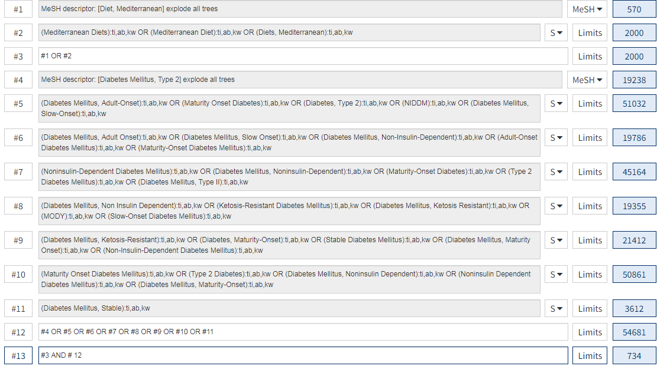

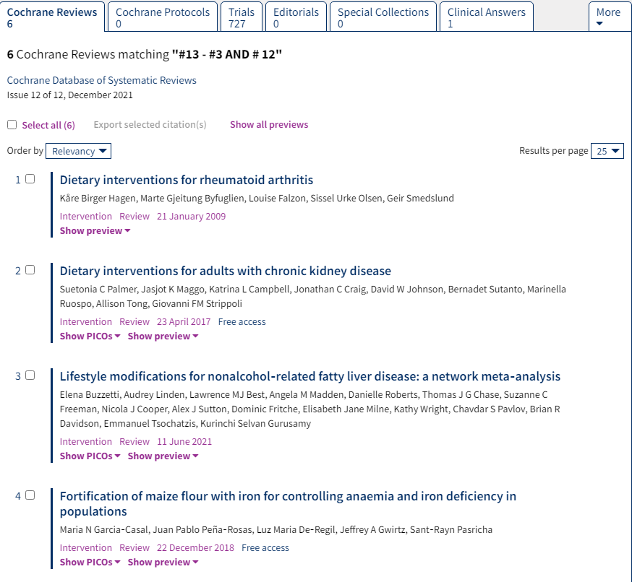
Embase
Session Results
.......................................................
No. Query Results Results Date
#7. #3 AND #6 1,175 29 Dec 2021
#6. #4 OR #5 10,004 29 Dec 2021
#5. 'diet, mediterranean':ab,ti OR meddiet:ab,ti 592 29 Dec 2021
#4. 'mediterranean diet'/exp 9,960 29 Dec 2021
#3. #1 OR #2 342,882 29 Dec 2021
#2. 'adult onset diabetes':ab,ti OR 'adult onset 256,598 29 Dec 2021
diabetes mellitus':ab,ti OR 'diabetes mellitus
type 2':ab,ti OR 'diabetes mellitus type
ii':ab,ti OR 'diabetes mellitus, maturity
onset':ab,ti OR 'diabetes mellitus, non insulin
dependent':ab,ti OR 'diabetes mellitus,
non-insulin-dependent':ab,ti OR 'diabetes
mellitus, type 2':ab,ti OR 'diabetes mellitus,
type ii':ab,ti OR 'diabetes type 2':ab,ti OR
'diabetes type ii':ab,ti OR 'diabetes, adult
onset; dm 2':ab,ti OR 'insulin independent
diabetes':ab,ti OR 'insulin independent diabetes
mellitus':ab,ti OR 'ketosis resistant diabetes
mellitus':ab,ti OR 'maturity onset
diabetes':ab,ti OR 'maturity onset diabetes
mellitus':ab,ti OR 'maturity onset diabetes of
the young':ab,ti OR niddm:ab,ti OR (niddm:ab,ti
AND 'non insulin dependent diabetes
mellitus':ab,ti) OR 'non insulin dependent
diabetes':ab,ti OR 'non-insulin-dependent
diabetes mellitus':ab,ti OR 'noninsulin dependent
diabetes':ab,ti OR 'noninsulin dependent diabetes
mellitus':ab,ti OR t2dm:ab,ti OR 'type 2
diabetes':ab,ti OR 'type 2 diabetes
mellitus':ab,ti OR 'type ii diabetes':ab,ti OR
'type ii diabetes mellitus':ab,ti
#1. 'non insulin dependent diabetes mellitus'/exp 292,671 29 Dec 2021

