Supplementary Information for

Revisiting Janzen's mountain passes hypothesis from a microbial perspective: why tropical mountains are so biodiverse?

Yazhou Zhang¹, Thomas W. Crowther³, Shijia Xu^{1,2}, J. Hogan Aaron⁴, Rensheng Zhao^{1,2}, Pengfei Song^{1,2}, Mufeng Cui^{1,2}, Xiaoyang Song¹, Min Cao¹, Jie Yang¹*

*Jie Yang
Email: yangjie@xtbg.org.cn

Methods
Study sites. Yunnan Province in southern China lies in the transitional region between the Hengduan Mountains and Asian tropics, where it borders Guizhou, Guangxi, Sichuan and Tibet in China and the countries of Myanmar, Laos and Vietnam [1]. Yunnan covers a total area of 394,000 km2 with terraced terrain and an average elevation of 2000 m [2]. It is mostly an uplifted, high elevation region with a terraced topography stretching from the northwest (maximum elevation at 6740 m) to the south (minimum at 76 m) [2]. The whole of Yunnan Province experiences a monsoonal climate, which leads to distinct rainy seasons (May-October) and dry seasons (November-April) [3]. Three major climatic zones are recognized in accordance with the three basal terrains: subalpine (ca. 3000 m), subtropical (ca. 2000 m) and tropical (ca. 600-800 m) [4]. Correspondingly, the vegetation in this province also comprises three regional types: montane coniferous forest on the Qinghai-Tibet Plateau; subtropical evergreen broad-leaved forest, and tropical forest [5]. The topographic configuration of Yunnan and its distinct dry and wet seasons are thought to have been critical to the development of biodiversity in this region, which is both a cradle and a museum of plant diversity [1]. Yunnan Province harbors fascinating biodiversity, e.g. ca. 18000 plant species [6], and thus this region is an ideal platform to study biodiversity [7].

Molecular analyses. PCR amplification of the fungal ITS genes V1 region was performed using the forward primer (5'-GGAAGTAAAAGTCGTAACAAGG-3') and the reverse primer (5'-GCTGCGTTCTTCATCGATGC-3'). The PCR components contained 5 μl of buffer (5×), 0.25 μl of Fast pfu DNA Polymerase (5U/μl), 2 μl (2.5 mM) of dNTPs, 1 μl (10 uM) of each Forward and Reverse primer, 1 μl of DNA Template, and 14.75 μl of ddH2O. Thermal cycling consisted of initial denaturation at 98 °C for 5 min, followed by 25 cycles consisting of denaturation at 98 °C for 30 s, annealing at 53 °C for 30 s, and extension at 72 °C for 45 s, with a final extension of 5 min at 72 °C. PCR amplicons were purified with Vazyme VAHTSTM DNA Clean Beads (Vazyme, Nanjing, China) and quantified using the Quant-iT PicoGreen dsDNA Assay Kit (Invitrogen, Carlsbad, CA, USA). After the individual quantification step, amplicons were pooled in equal amounts, and pair-end 2×250 bp sequencing was performed using the Illlumina NovaSeqplatform with NovaSeq 6000 SP Reagent Kit (500 cycles) at Shanghai Personal Biotechnology Co., Ltd (Shanghai, China).

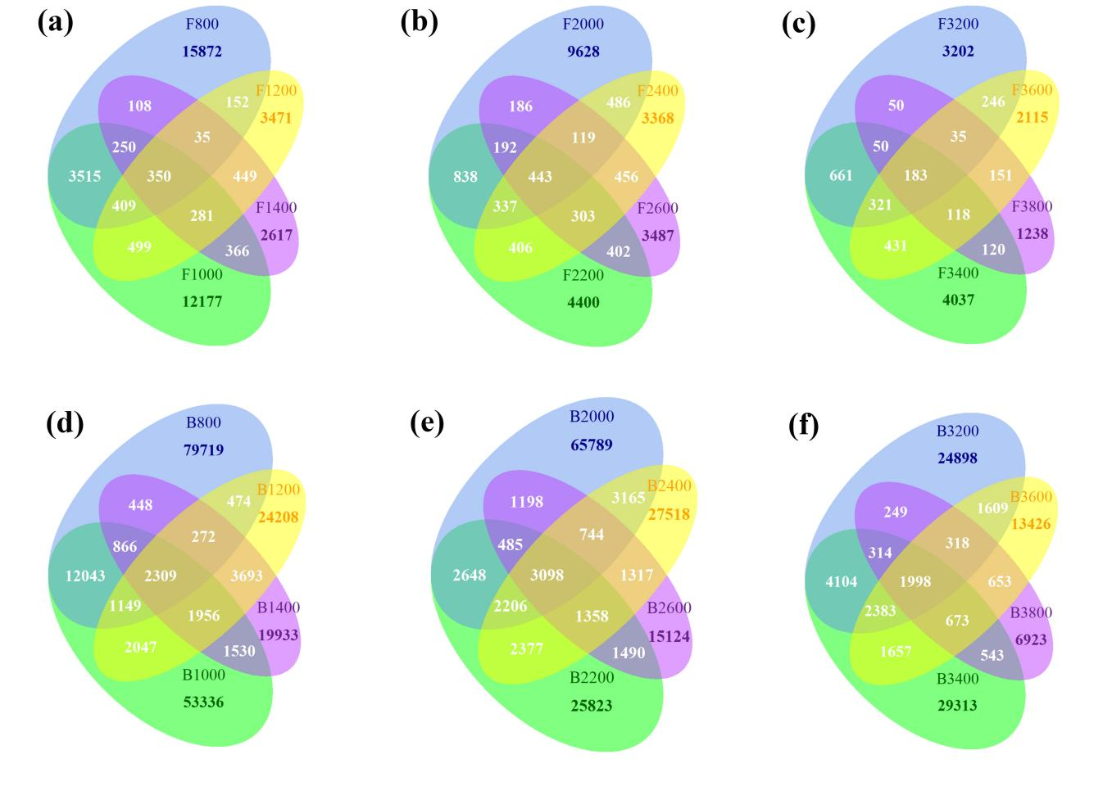
Figure S1. Venn diagrams that reflect shared and unique ASVs among elevations of tropical, subtropical and subalpine, respectively. (a-c): Fungi and (d-f): Bacteria. (a & d): tropical (elevation 800, 1000, 1200, 1400), (b & e): subtropical (elevation 2000, 2200, 2400, 2600), (c & f): subalpine (elevation 3200, 3400, 3600, 3800). White numbers indicate shared ASVs.
Note: Venn diagram was generated to visualize the shared and unique ASVs among altitudes of tropical, subtropical and subalpine, respectively using “VennDiagram” package [8], based on the occurrence of ASVs across altitudes regardless of their relative abundance.

Soil property measurements

Sample types | Test item | Instruments | Standard methods
Soil | water content | Oven | (LY/T 1213-1999)/  Determination of forest soil water content
Soil | total carbon | Macro Elemental CN Analyzer | Macro Elemental CN Analyzer/  Determination of total carbon in forest soil
Soil | total nitrogen | Macro Elemental CN Analyzer | Macro Elemental CN Analyzer/  Determination of total nitrogen in forest soil
Soil | dissolved nitrogen | Auto Kjeldahl Unit | (LY/T 1229-1999)/  Determination of hydrolyzable nitrogen in forest soil
Soil | total phosphorus | Atomic Absorption Spectrophotometer | (LY/T 1254-1999)/  Determ ination of total phosphorus in forest soil
Soil | total potassium | Atomic Absorption Spectrophotometer | (LY/T 1254-1999)/  Determ ination of total potassium in forest soil
Soil | available potassium | iCAP6300；IRIS Advantage | (LY/T 1236-1999 )/  Determination of available potassium in forest soil
Soil | pH | pH | (LY/T 1239-1999)/  Determination of pH value in forest soil
Table S1. All measurements were followed the protocols of Public Technology Service Center, Xishuangbanna Tropical Botanical Garden, Chinese Academy of Sciences (http://english.xtbg.cas.cn/ptsc/pl). The test item, instruments and standard methods are as following:

References

- Qian L, Chen J-H, Deng T, Sun H (2020). Plant diversity in Yunnan: Current status and future directions. Plant Divers. 42: 281-291.
- Yang YM, Wang J, Wang JH (2008). Studies on the Biodiversity and its Conservation in Yunnan, China. Science Press: Beijing.
- Song X, Cao M, Li J, Kitching RL, Nakamura A, Laidlaw MJ et al (2021). Different environmental factors drive tree species diversity along elevation gradients in three climatic zones in Yunnan, southern China. Plant Divers. 43: 433-443.
- Zhu H (2012). Biogeographical Divergence of the Flora of Yunnan, Southwestern China Initiated by the Uplift of Himalaya and Extrusion of Indochina Block. PloS one 7: e45601.
- Wu CY, Zhu YC, Jiang HQ (1987). Vegetation of Yunnan. Science Press: Beijing.
- Kunming Institute of Botany Chinese Academy of Sciences (2006). Flora of Yunnan. Science Press: Beijing.
- Li R, Kraft NJ, Yang J, Wang Y (2015). A phylogenetically informed delineation of floristic regions within a biodiversity hotspot in Yunnan, China. Sci Rep 5: 9396.
- Chen H (2021) VennDiagram: Generate High-Resolution Venn and Euler Plots. R package version 1.7.1. https://CRAN.R-project.org/package=VennDiagram

